NO1.

I=imread('HW2_einstein_orig.tif');

J = histeq(I);

imshow(J)

figure

imhist(I,64)

figure

imhist(J,64)

imwrite(J,'NO1-equalized.tif')

說明:用imread把照片讀進來，接著用matlab的內建函數J = histeq(I)把資料做histogram equalization，然後再用imwrite把J寫出成為檔案即可

Origin

C:\Users\user\AppData\Local\Microsoft\Windows\INetCache\Content.Word\NO1-histogram-origin.tif

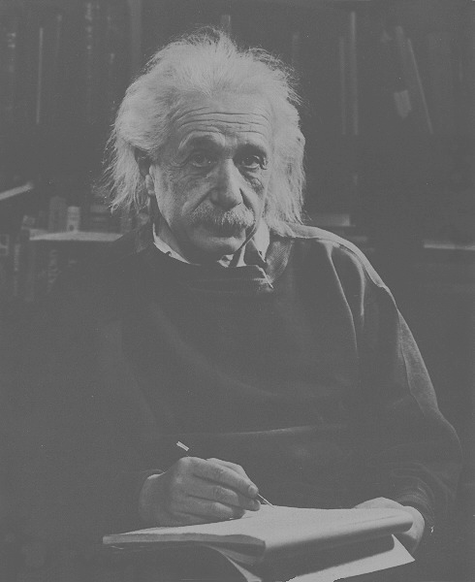

Equalized

C:\Users\user\AppData\Local\Microsoft\Windows\INetCache\Content.Word\NO1-equalized.tif