NO2.

使用Photoshop打開圖片後，點選image，然後點選Adjustment，然後點選Equalize後存檔即可

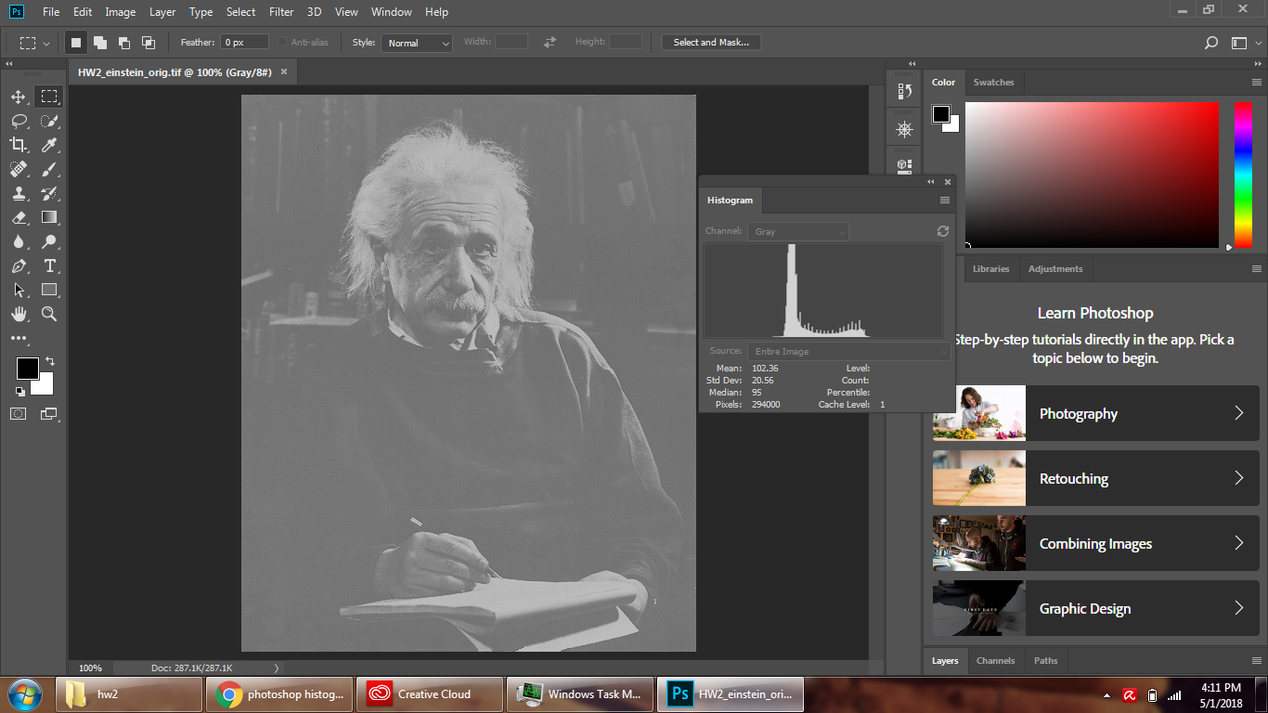

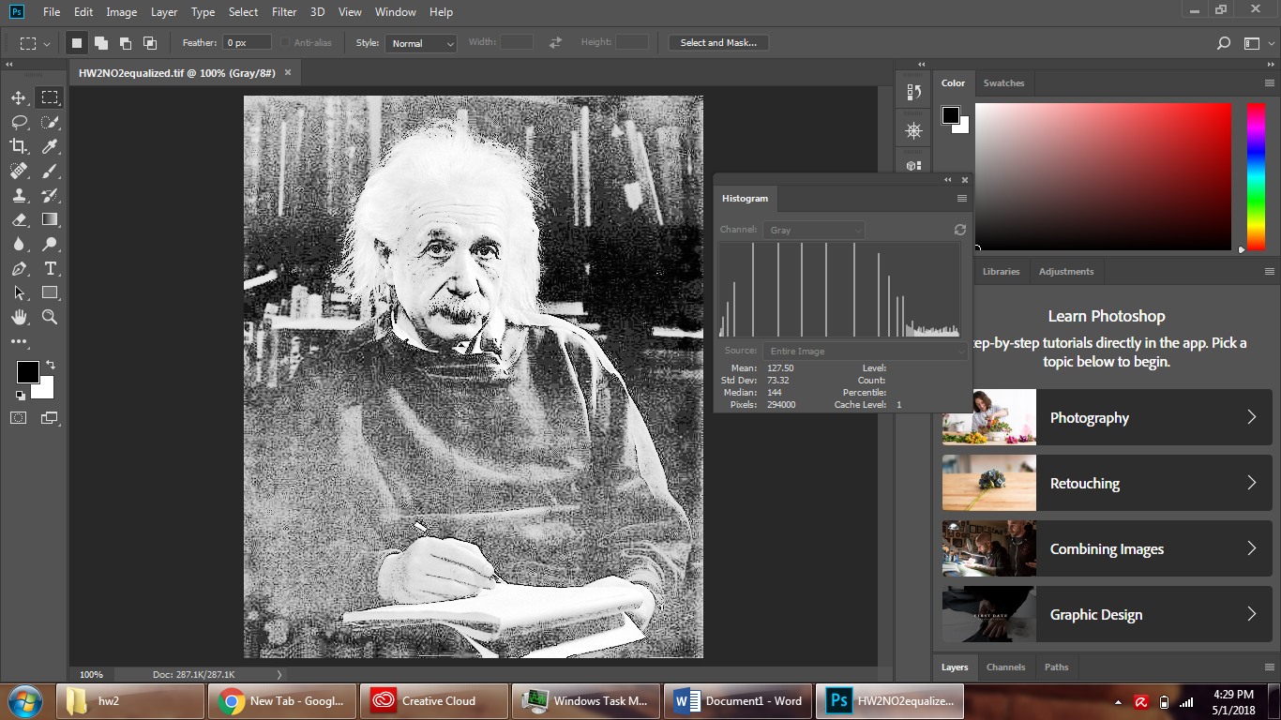

Origin

C:\Users\user\AppData\Local\Microsoft\Windows\INetCache\Content.Word\NO2-origin.tifC:\Users\user\AppData\Local\Microsoft\Windows\INetCache\Content.Word\NO2-histogram-origin.tif

Equalized

C:\Users\user\AppData\Local\Microsoft\Windows\INetCache\Content.Word\NO2-histogram-equalized.tif

