NO3.

clear;

clc;

close all;

A = imread('HW2_einstein_orig.tif');

Ref =imread('NO3Reforigin.pgm');

figure

imhist(Ref,64)

title('Reforigin')

Ref = imadjust(Ref,[ ],[ ],18);

imwrite(Ref,'NO3Ref.tif')

size(A)

size(Ref)

B = imhistmatch(A,Ref);

imwrite(B,'NO3histogramatching.tif')

figure

imhist(A,64)

title('A')

figure

imhist(Ref,64)

title('Ref')

figure

imhist(B,64)

title('B')

說明:原始照片讀進來，也讀進Ref的照片，把Ref的照片用imadjust做亮度降低，試過多次後大約設成imadjust (Ref,[],[],17)可使效果最好

Reforigin:

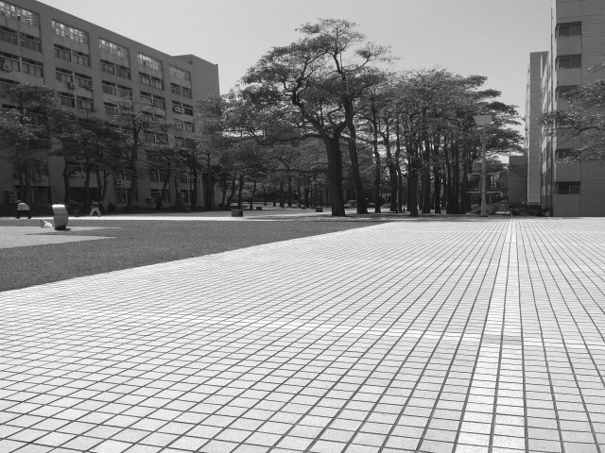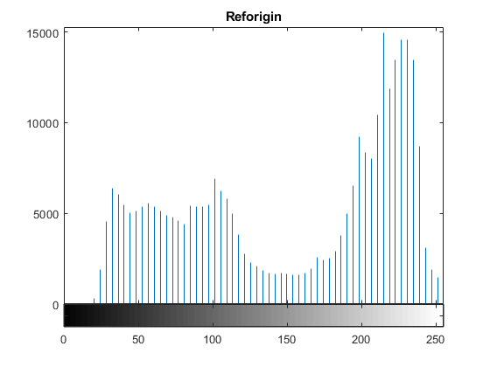

Ref:

C:\Users\user\AppData\Local\Microsoft\Windows\INetCache\Content.Word\Ref-histogram.tif

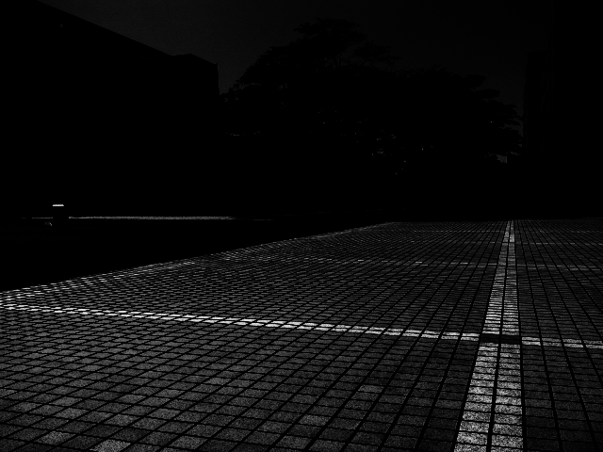

接著用內建函數size取得原圖和參考目標圖的size後，用內建函數imhistmatch(A,Ref)做histogram matching並輸出結果即可得到結果

Origin

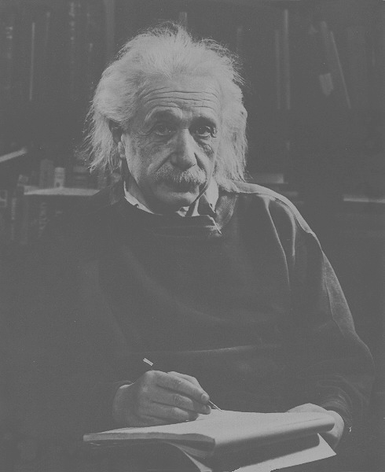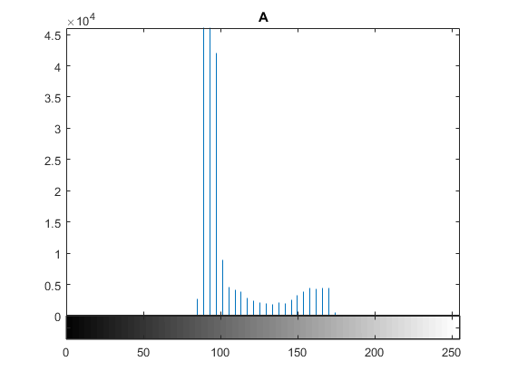

Histogram matching

C:\Users\user\AppData\Local\Microsoft\Windows\INetCache\Content.Word\NO3histogramatching.tif

