**torndb 数据库连接：**

1. Install mySQL database.

2. Install torndb:

pip install -i <http://pypi.douban.com/simple/> torndb

## http://www.cnblogs.com/weixliu/p/3559300.html

3. Install database connector for Python programming:

http://sourceforge.net/projects/mysql-python/

3. Establish the connection to mySQL:

1) 创建数据库和表格

mysql> create database mytorndb;

mysql> use mytorndb

mysql> status;

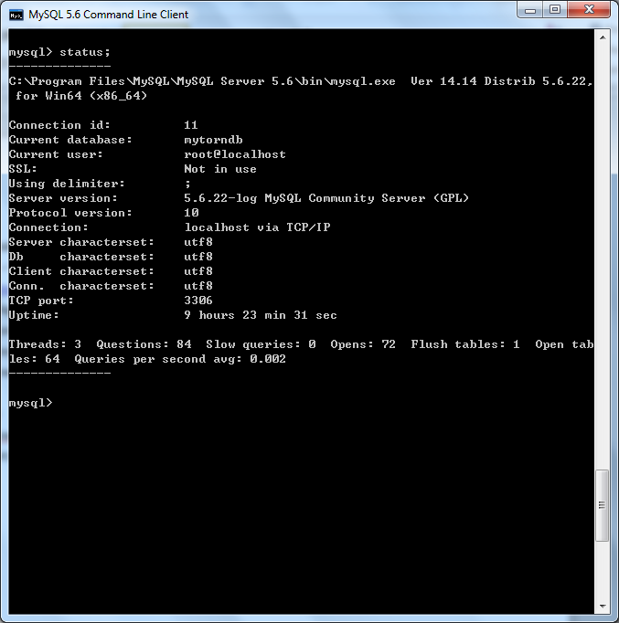

Mysql> create table mytable1(ID VARCHAR(5), Name VARCHAR(20));

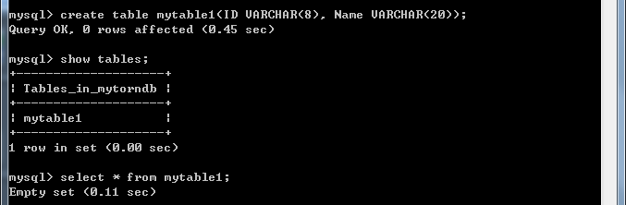

Mysql> insert mytable1 values(‘00001’, ‘ZhangSan’)

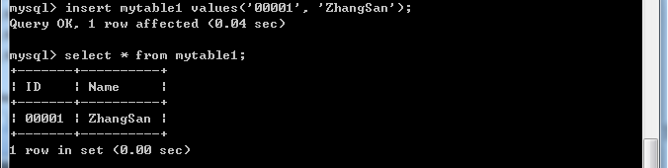

2) 建立torndb连接

>>> import torndb

>>> mydb1=torndb.Connection('localhost', "mytorndb", 'admin', "admin" )

##db=torndb.Connection(hostaddress,database name,user,password)

## locahost == 127.0.0.1 ##TCP port: 3306

>>> a = mydb1.get('select * from mytable1 where ID=00001')

>>> a

{'ID': u'00001', 'Name': u'ZhangSan'}

**tornado 支持的数据库操作：**

1). query

**def query**(self, query, *parameters, **kwparameters):  
 *"""*

*Returns a row list for the given query and parameters.*

*"""*

>>> a = db.query("select * from mytable1")

>>> a

[{'ID': u'00001', 'Name': u'ZhangSan'}, {'ID': u'00002', 'Name': u'LiSi'}]

2). Get

**def get**(self, query, *parameters, **kwparameters):  
 *"""*

*Returns the (singular) row returned by the given query.  
 If the query has no results, returns None. If it has  
 more than one result, raises an exception.  
 """*

>>> b = db.get("select * from mytable1")

Traceback (most recent call last):

File "<input>", line 1, in <module>

File "D:\Python27\lib\site-packages\torndb.py", line 152, in get

raise Exception("Multiple rows returned for Database.get() query")

Exception: Multiple rows returned for Database.get() query

>>> b = db.get("select * from mytable1 where ID=2")

>>> b

{'ID': u'00002', 'Name': u'LiSi'}

3). execute

**def execute**(self, query, *parameters, **kwparameters):  
*"""*

*Executes the given query, returning the lastrowid from the query.*

*"""*

>>> c = db.execute("insert mytable1 (ID, Name) VALUES('00003', 'ZhaoWu')")

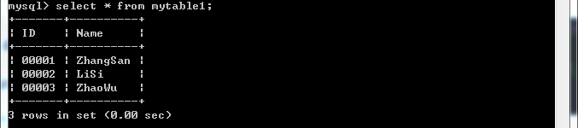

>>> d = db.execute("update mytable1 set Name='ZhaoLaosi' where ID=3")

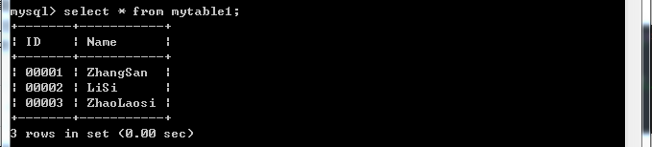

4). execute_rowcount

**def execute_rowcount**(self, query, *parameters, **kwparameters):  
*"""*

*Executes the given query, returning the rowcount from the query.*

*"""*

>>> db.execute_rowcount("select * from mytable1 where ID>1")

2L