TL;DR
- Gave gpt-6.1-sol sandbox w python and told it to plot and use tools to find/record earthquakes
- Its expensive but promising?
- Its bad at S waves and overcorrects in the self-learning loop

Main Question

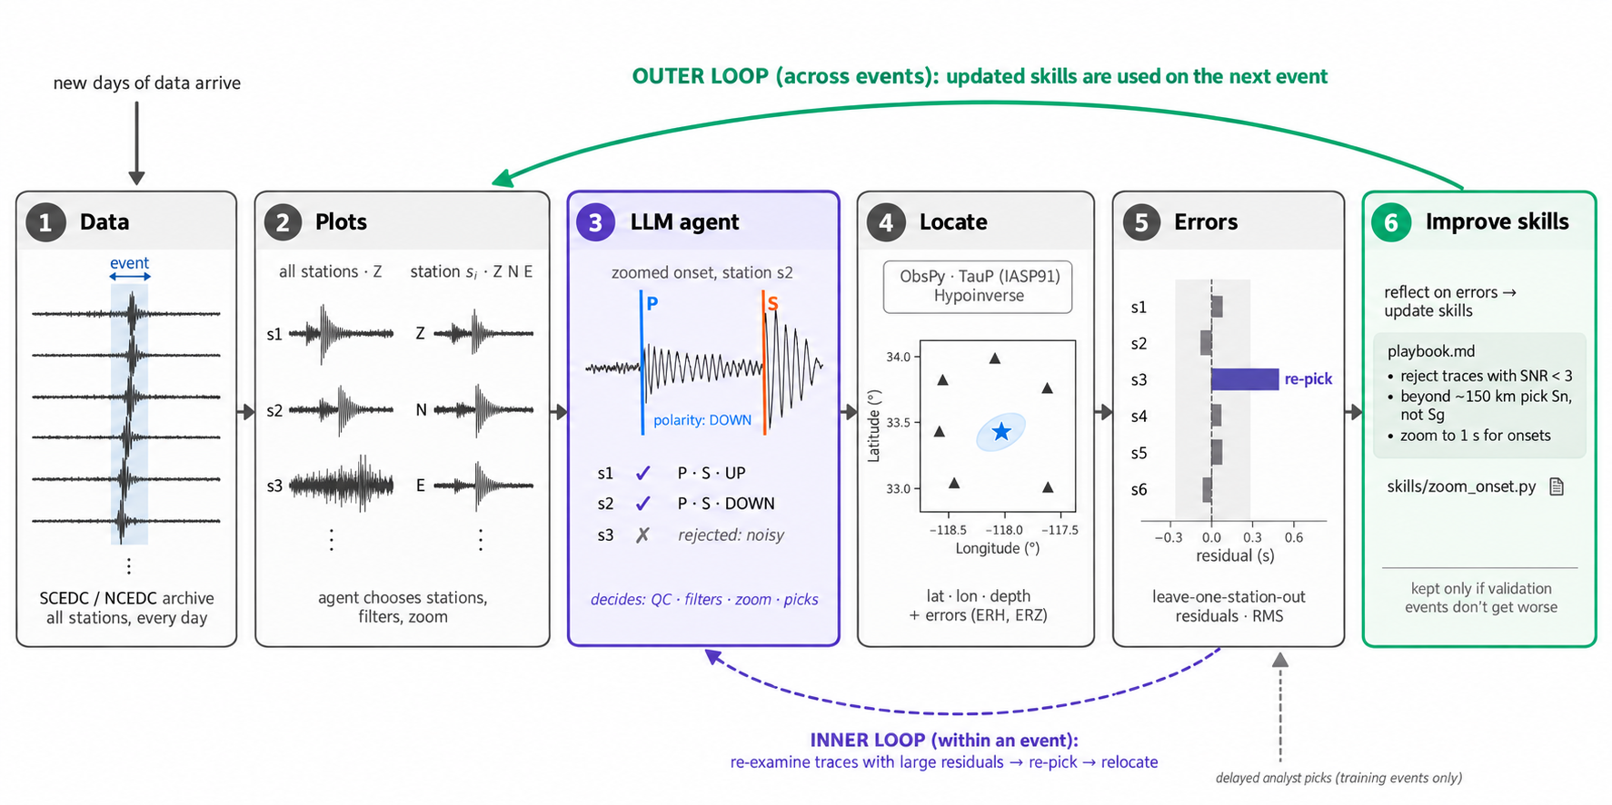

Motivation

High level ideas:
- How does AI for Science change as models approach perfect intelligence
- What type of tasks see big gains from harness improvements and will this matter if the models just get better?
- Can RSI loops change AI for Science deployments
  - I guess the motivating question underlying this is why are current AI systems not being used at massive scales in

Background

When an earthquake happens, dozens of seismometers in the region record the ground shaking. Each station produces a line over time, in three directions (up-down, north-south, east-west). Somewhere in that line, the first wave arrives (P, compression) A bit later a second, bigger wave arrives (S)

To turn those recordings into a catalog entry (where the earthquake was, how deep, how big), a seismic network does three things:

1. Pick the arrivals - Mark the exact moment the P wave and S wave arrive at each station
2. Read the first motion. At the very first wiggle of the P wave, did the ground move up or down? Collecting polarities across many stations tells you how the fault slipped.
3. Locate. Feed all the pick times into a program such as Hypoinverse. It knows how fast waves travel through the local rock and solves for the origin time and location that best explain when each station felt the waves. It also reports residuals: for each station, how far off its pick was from what the solved location predicts. Big residuals hint at a bad pick.

Historically, humans did all of this by eye. Over the last decade, deep-learning pickers took over step 1. The two standard ones are PhaseNet and EQTransformer. They are extremely good at the easy cases, and fast. But they have limits. They do not read polarity at all. They struggle with faint, emergent onsets where the wave fades in rather than arriving sharply. And they do not look at the whole picture: a human analyst looks at all stations together, notices that one station's pick does not fit the others, goes back and fixes it, and relocates. The pickers make each pick in isolation and never revisit.

Human review is still the final step at networks like the Southern California Seismic Network. Analysts hand-check events above about magnitude 2.5.

Goal

First experiment/research used Gemini as a narrow component: show it a seismogram image, ask one question, get an answer. The new project asks whether an LLM can be the analyst, not just a tool the analyst uses.

Concretely, you give an AI agent a computer sandbox with Python, the raw continuous recordings from the stations, and a short set of starter instructions describing how a seismologist works. Then you say: produce the catalog entry for this event. The agent decides for itself what to do. It plots the recordings, zooms in, picks arrivals, runs the locator, looks at the residuals, goes back and re-picks the stations that look wrong, reads polarities, and submits.

The second, more important part is the learning loop. After each practice event, the agent sees how it scored and writes lessons into a memory file: things like "my S picks tend to be late, check the horizontal components" or "do not throw out a station just because its residual is large, that may be the velocity model". The next run starts with that memory. The question is whether the agent actually gets better with experience, the way a junior analyst does.

2 claims to test:

- Can an agent do the analyst's job at the quality of the standard ML pickers?
- Does it improve by learning from its own mistakes?

Why this would matter

ML pickers are fixed functions: same input, same output, no explanation. An agent reasons, checks itself, explains every decision in a log, and improves without retraining. For a network, that could mean fewer events needing human review. For the science, it is an example of an AI doing an expert's full workflow with self learning.

Design choices:
- The test events all happened after the model's training cutoff. It cannot remember them.
- The sandbox has no network access. It cannot look anything up.
- The answer key lives outside the sandbox. The agent never sees it.
- The task prompt gives only a time window and a station list, not the location or magnitude.
- Learning only happens on practice events from 2025. Test events from 2026 are never used for learning.

Run PhaseNet and EQTransformer on the exact same data, with the same association and location steps. Run the human analysts' own picks through the same locator, to show the best possible result from this setup.

Pilot run:
Everything comes from Southern California Seismic Network, which publishes its continuous recordings for free on Amazon S3 (the SCEDC archive). We pull whole days of data for a box around Ridgecrest and Coso, about 30 stations. Each station records 100 samples per second on three components.
A simple classical trigger (STA/LTA, the ratio of short-term to long-term energy) scans those days and flags moments when several stations light up at once. Each flagged window becomes a task: 60 seconds before the trigger to 180 seconds after. On the host, outside the sandbox, we match each window to the official ComCat catalog to know which earthquake it is, and pull the human analysts' picks as the answer key. The agent never sees this matching.
The 25 events are split into three groups that never overlap.
Group | Events | When | Used for
Practice | 9 | 2025 | The agent learns on these. It gets graded feedback after each one.
Validation | 8 | 2025 | Choosing which memory snapshot is best. The agent never learns on these.
Test | 11 | July to Sept 2026 | Final scoring. Never used for learning, and all after the model's training cutoff, so it cannot remember them.
All events are magnitude 2.5 or above, because that is the threshold where SCSN analysts hand-time every pick. Below that, the "analyst" picks are often PhaseNet's output lightly reviewed, which would make the comparison circular.
For one event, the agent is dropped into a Docker container with no network. Inside it finds:
- The waveform file for that window and a station list with coordinates. Nothing else about the event: no location, no magnitude, no time of origin.
- A persistent bash shell and Python with ObsPy, NumPy, matplotlib, and Hypoinverse.
- A starter kit (seiskit) with basic functions: load data, plot a record section, plot one station, zoom, compute signal-to-noise, an automatic onset refiner (AIC), run Hypoinverse, and compute leave-one-station-out residuals.
- A read-only memory folder holding whatever it wrote after earlier practice events.
- A view_image tool. When it saves a plot it can look at the picture, the way an analyst looks at a screen.
The prompt tells it: “you are a seismic analyst working alone; turn these waveforms into a catalog entry; pick by eye and refine with numbers; locate; check the residuals; fix what does not fit; submit exactly once with every pick, every rejected station, and a reason. Every tool call must include a reason field. Those reasons are saved as the decision ledger.”
The model is OpenAI gpt-6.1-sol (training cutoff April 2026, before all test events). It costs about 50 to 75 cents per event.
Example decision ledger:
Magnitude 2.5 on 2026-09-23. It took 32 tool calls.
- Read the memory folder and the starter kit.
- Inventory the traces and plot a distance-ordered record section (all vertical channels stacked by distance, so arrivals form a sloping line). Reason given: "Identify coherent P/S moveout and station quality across the network before picking."
- Plot three-component panels for groups of stations, raw and filtered, and look at each group (six images).
- Check the two untriggered accelerometers rather than assuming they are usable.
- Zoom narrowly on each P onset and more widely on each S onset, and look at each zoom (about ten images). Reasons like "Validate shear onset candidates independently of the strongest pulses" and "Check lower-SNR P candidates rather than assigning impulsive quality automatically."
- Refine the visual picks with AIC inside the bracket it chose, and locate.
- Run leave-one-out residuals. Reason: "LOO identifies late S candidates at SRT/TOW2/SEV and influential close stations; broaden those windows and revisit ambiguous phases in a different band."
- Re-examine those stations and re-pick some S arrivals from earlier horizontal transitions.
- Read polarities separately: "Verify first quarter-cycle on raw and gently high-passed vertical traces."
- Test depth sensitivity and the effect of dropping the nearest station.
- Submit.
Grade for that event: 22 of 27 stations used, 5 rejected with reasons, epicenter 0.36 km from the official one, depth 0.6 km off, origin time 0.2 s off. Cost ~60 cents.
After each practice event a second session starts. The same agent now sees a feedback file: for each station, how far its pick was from the analyst's, which picks were false or missing, which polarities disagreed, the location error, and what PhaseNet got on the same event. Its memory folder is now writable, and it must update three things:
- README.md: the step-by-step procedure for next time.
- playbook.md: rules as short testable statements with the evidence behind them, plus a changelog.
- skills/: Python functions it wants to reuse, each with a test that must pass.
The harness commits the result to git and tags it, so after_0, after_5 and after_9 are literal git tags on the memory repo. Lessons must generalize: no event dates, IDs, or locations may be written, and a leak check enforces that.
Some of the rules it wrote after 5 events, paraphrased:
- Keep narrow, visually seeded P refinement. Evidence: 20/20, 18/19, 13/13 P matched across sessions with MAE 0.03 s.
- S needs a broad check at least 1 second before the tentative onset on both horizontals before narrow refinement. Evidence: in session 4 all 15 matched S picks were late by about 0.23 s, and the visual seeds were already late, so the numeric refiner was not the cause.
- Do not diagnose a station delay from residuals alone. Evidence: station SEV had a +1 s residual but its pick was only 0.02 s from the analyst.
- Do not flip polarity signs just because the last event disagreed. Evidence: four errors in session 1 were all DOWN versus analyst UP.
- Low RMS does not mean best location. Evidence: RMS 0.17 s coexisted with 1.8 km depth error.
It also withdrew claims when new evidence contradicted them. It had suspected station SEV was always late, then wrote "persistent station lateness is contradicted" after session 5.
Every arm goes through the same association step, the same Hypoinverse, and the same grader.
Arm | What it is
PhaseNet | Deep-learning picker with SCEDC-trained weights, then PyOcto association
EQTransformer | Deep-learning picker (original weights), then PyOcto association
Analyst picks | The human picks fed to Hypoinverse. A ceiling for what the locator can do with perfect picks
Agent after_0 | The agent with empty memory (no learning)
Agent after_5 | The agent after 5 practice events
Agent after_9 | The agent after 9 practice events
The anti-cheating list
- No network in the sandbox.
- Test events are all after the model's training cutoff.
- The answer key is never mounted in the sandbox.
- The task prompt gives only a time window and a station list.
- Learning happens only on practice events; test and validation events are never fed back.
- A leak check rejects memory text naming specific events, dates, or locations.
- The memory snapshot was chosen on the validation set, not the test set.
- The location is recomputed on the host from the submitted picks, so the agent cannot fake a location.
Results
The grader matches each agent pick to the nearest analyst pick on the same station within 2 seconds. From that it computes:
Main table: 11 test events, 216 analyst P picks
Arm | P recall | MAE | Within 0.1 s | Location | Polarity
Agent after_0 (no learning) | 87% | 0.02 s | 97% | 0.35 km | 96% on 114
Agent after_5, run 1 | 98% | 0.02 s | 98% | 0.31 km | 93% on 121
Agent after_5, run 2 | 98% | 0.02 s | 97% | 0.33 km | 95% on 126
Agent after_9 | 97% | 0.02 s | 99% | 0.36 km | 92% on 118
PhaseNet | 98% | 0.04 s | 89% | 0.37 km | none
EQTransformer | 100% | 0.05 s | 87% | 0.35 km | none
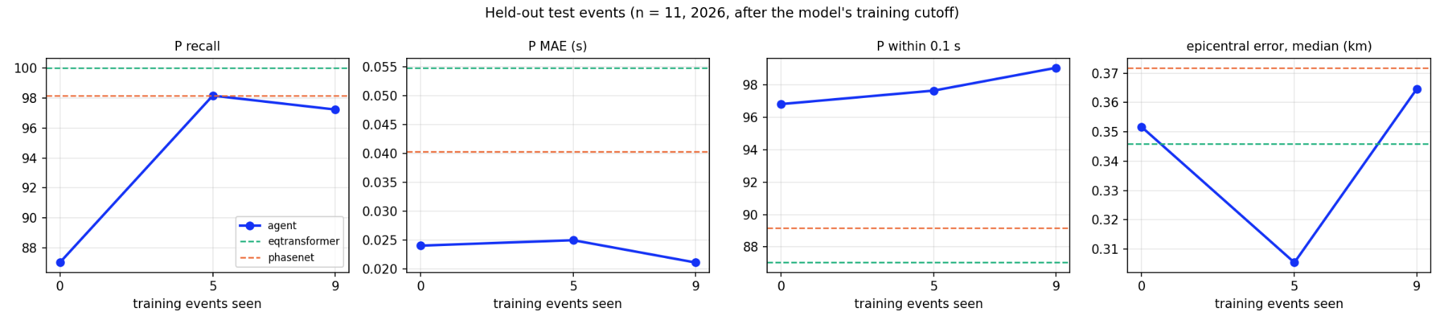
- P recall jumps from 87% to 98% at five events, reaching the PhaseNet line. That is the loop fixing the biggest problem: with empty memory the agent was too eager to throw out stations. The playbook rule "never erase a credible observed arrival just because the model fits it poorly" is what changed.
- P MAE sits at 0.02 s the whole time, well under both pickers at 0.04 and 0.05 s. Timing was excellent before any learning.
- Within 0.1 s climbs 97, 98, 99, all above the pickers at 87 to 89.
- Epicentral error dips at after_5 then rises at after_9, but the whole range is 0.31 to 0.37 km and every arm is inside it. Noise, not signal.
Hard vs clean onsets (fade in vs abrupt)
Analysts assign each pick a weight reflecting how sharp the onset looked. Splitting the shared picks by that weight:
Subset | Shared picks | Agent MAE | PhaseNet MAE | Ratio | p
Hard onsets, after_0 | 73 | 0.036 s | 0.069 s | 1.9x | 0.0009
Clean onsets, after_0 | 112 | 0.016 s | 0.019 s | 1.2x | 0.07
Hard onsets, after_5 | 50 | 0.027 s | 0.051 s | 1.9x | 0.0014
Clean onsets, after_5 | 52 | 0.018 s | 0.017 s | 0.9x | 0.2
On clean, impulsive onsets the agent and PhaseNet are about the same, and both are near the limit of how consistently humans themselves pick. On hard, emergent onsets the agent is about twice as precise, and by after_9 the ratio grew to 2.7x. Within 0.1 s on hard picks: agent 92 to 96% vs PhaseNet 75 to 82% and EQTransformer 87 to 88%.
The agent cannot out-read a picker on an obvious arrival, but it can out-decide one on an ambiguous arrival by choosing filter, window, and component.
The test is paired: for each shared station pick, who was closer to the analyst. In after_5 run 2 the agent was closer on 121 and farther on 70 against PhaseNet (p = 4e-7), and closer on 133, farther on 67 against EQTransformer (p = 5e-10). The two independent runs of after_5 match within 1 or 2 points on every metric, so this is not one lucky run.

Arm | S recall | Median error | Within 0.1 s
Agent after_0 | 72% | 0.090 s | 53%
Agent after_5 | 96% | 0.060 s | 65%
Agent after_9 | 78% | 0.080 s | 59%
PhaseNet | 83% | 0.070 s | 62%
EQTransformer | 99% | 0.050 s | 73%
We do really bad on S picks for some reason. S picks improved a lot from after_0 to after_5 and they got worse at after_9: the event-9 reflection added a stricter admission gate for S picks, and it cost recall. The agent remains behind EQTransformer on S (p = 7e-7) and level with PhaseNet.
Validation-set choice
On the 8 unseen 2025 events, which are smaller and noisier (PhaseNet manages only 65% within 0.1 s there), after_5 beat after_9:
Snapshot | P recall | S recall | Polarity | MAE
after_5 | 97% | 95% | 95% | 0.05 s
after_9 | 93% | 73% | 92% | 0.05 s
So after_5 was declared the snapshot before looking at test-set differences. That is why the final claim is about after_5.
Cost
Item | Cost
Per event, agent run | $0.50 to $0.75 (rising as the procedure grew longer)
Per event, reflection | about $0.07
9 training events plus reflections | about $6
Whole pilot (training, 3 snapshots, validation, 2 repeats) | about $60
Demonstrated:
- An LLM agent with no ML picker can produce picks at ML-picker quality on real post-cutoff earthquakes, with a full reasoning trail for every decision.
- Its P timing is significantly more precise than both pickers, and the advantage is concentrated on hard onsets, matching the hypothesis.
- It reads polarities at about 95% agreement with analysts. The pickers produce none.
- Self-written lessons closed the recall gap (87% to 98%) in five events. The lessons are legible, cite evidence, and get revised when contradicted.
Not demonstrated:
- Any advantage on S picks or on location.
- Monotonic learning. More training made S picks and polarity worse.
- Generality. One region, 11 test events, 2 repeats.

Reflection/Thoughts
- Theres not enough cycles or scale to meaningful see results
- Its super expensive
- I feel like there is something here though
- I think maybe the ground truth is also flawed because its based on human vibes – maybe earthquake cataloging is inherently imprecise and inaccurate, like it doesn’t make sense to calculate residuals and errors on something thats already not the TRUE truth?
- Are there expert traces of someone doing this because I’m confused where the error is coming from. I’d like to see where the agent picks and where the human picks but idk where to find human picks

