安装所需包
> pkgs <-unique("pkgs")
> pkgs2<-pkgs
> logi<- stringr::str_detect(pkgs2,"/")
> pkgs2[logi]<- stringr::str_match(pkgs[logi],".*/(.*)$")[,2]
> new <-!(sapply(pkgs2,requireNamespace,quietly=T))
> if (sum(new)>0){cat("pkgs to install：",pkgs[new],"\n")}else{cat("All pkgs already installed /n")}
> install pkgs
> if(any(new)) BiocManager::install(pkgs[new],ask=F,update = F)

GSE79962real和dataset数据相同；GSE79962new和TURE数据相同

读取数据GSE79962和GSE141864
install.packages(c('tidyverse','writexl'))
（报错时可替换）GSE79962 <- readr::read_csv("C:/Users/LL.Caroline/Documents/GSE79962_series_matrix.txt")
GSE79962 <-read.table("C:/Users/LL.Caroline/Documents/GSE79962_series_matrix.csv",header = TRUE, sep = ",",dec = ".",quote = "",comment.char = "",na.strings = c("NA"),fill = TRUE)
（同义句，报错替换）GSE141864 <- readr::read_csv("C:/Users/LL.Caroline/Documents/GSE141864_series_matrix.txt")
GSE141864 <-read.table("C:/Users/LL.Caroline/Documents/GSE141864_series_matrix.csv",header = TRUE, sep = ",",dec = ".",quote = "",comment.char = "",na.strings = c("NA"),fill = TRUE)
（也可自行GEO网站下载）expr1<-read_tsv(file = "geo/GSE141864_series_matrix.txt.gz",comment = "!")读取表达矩阵

library(devtools)
> install_github("jmzeng1314/AnnoProbe")
> library(AnnoProbe)
> ids=idmap('GPL6244',type='soft')
> head(ids)下载注释包GPL6244

if (!require("BiocManager", quietly = TRUE))+ install.packages("BiocManager")
BiocManager::install("hta20transcriptcluster.db")
library(hta20transcriptcluster.db)安装GPL17586注释包
hugene10sttranscriptcluster.db
hta20transcriptcluster()
> anno_GPL17586_bioc <- as.data.frame(hta20transcriptclusterSYMBOL)
> anno_GPL17586_bioc <- toTable(hta20transcriptclusterSYMBOL) 单独取出geneID和gene name
> anno_GPL17586_bioc2 <- toTable(hta20transcriptclusterENTREZID)
Library(GEOquery)
GPL17586<-getGEO(‘GPL6244’,destdir=”.”)
anno_GPL17586_geoquery <- Table(GPL17586)
anno_GPL17586_geoquery <- GPL17586@dataTable@table
all(anno_GPL17586_bioc$probe_id %in% anno_GPL17586_geoquery$ID)

as.vector(anno_GPL17586_bioc2)
ids=data.frame(gene_id=anno_GPL17586_geoquery$ID,median=apply(anno_GPL17586_geoquery,1,median))
table(ids$gene_id %in% anno_GPL17586_bioc$probe_id) 表达矩阵匹配情况
ids=ids[ids$gene_id %in% anno_GPL17586_bioc$probe_id,]
ids$symbol=anno_GPL17586_bioc[match(ids$gene_id,anno_GPL17586_bioc$probe_id),2]
length(unique(ids$symbol))
head(ids)
ids=ids[!duplicated(ids$symbol),]
dim(ids)
dat1=anno_GPL17586_geoquery[rownames(ids),]
dat1$symbol=ids[match(dat1$gene_id,ids$gene_id),3]

dat<-read.table("C:/Users/LL.Caroline/Documents/GPL17586_family111.soft.csv",header = FALSE, sep = ",",dec = ".",quote = "",comment.char = "",na.strings = c("NA"),fill = TRUE)探针id转换为GeneSymbol

GeneID转化GENEsymbol代码：
> dat<-read.table("C:/Users/LL.Caroline/Documents/GPL17586_family111.soft.csv",header = FALSE, sep = ",",dec = ".",quote = "",comment.char = "",na.strings = c("NA"),fill = TRUE) 注释信息文件
> GSE141864_geoquery01<-read.csv("C:/Users/LL.Caroline/Documents/GSE141864_series_matrix.csv",header = TRUE, sep = ",",dec = ".",quote = "",comment.char = "",na.strings = c("NA"),fill = TRUE) 表达矩阵文件
> s2e=dat[,c(1,3)]
> s2e<-anno_GPL17586_bioc
> ids=data.frame(gene_id=GSE141864$ID_REF,median=apply(GSE141864,1,median))#取出表达矩阵中待转换ID那列
> table(ids$gene_id %in% s2e$V1) #表达矩阵的geneid和genesymbol匹配情况
FALSE TRUE
2996 67539
> ids=ids[ids$gene_id %in% s2e$probe_id,]
> ids$symbol=s2e[match(ids$gene_id,s2e$probe_id),2]> length(unique(ids$symbol))
> ids=ids[!duplicated(ids$symbol),]
> dim(ids)
[1] 23217 3(不推荐，7万转换成功2万余个）
> dat2=GSE141864_geoquery01[rownames(ids),]#取出表达矩阵中ids有的行
> dat2$symbol=ids[match(dat2$ID_REF,ids$gene_id),3]
#把ids$symbol变为dat2的行名
> dat2=dat2[!duplicated(dat2$symbol),]
> sum(is.na(dat2$symbol))
- 0
> dat2<-na.omit(dat2)
> rownames(dat2)=as.vector(as.matrix(dat2[,46]))#把转换完的名字变成行名有遗漏值
> dat2$ID_REF<-NULL
> dat2$symbol<-NULL
> exp=as.matrix(dat2)
> write.table(dat2,"C:/Users/LL.Caroline/Documents/GSE141864TURE.csv",sep = ",")
----------------------------------------------------------
不用EXCEL提取基因ID

> rm(list = ls()) #清空变量
> gc()
> stringAsFactors = FALSE
> getwd()

> library(GEOquery)
> GPL17586<-getGEO("GPL17586",destdir = ".")
> GPL17586_anno<-Table(GPL17586)

> library(readr)
> library(dplyr)
> library(tidyverse)
> library(ggplot2)

dat2<- dat1 %>% filter(!is.na(ids))#删去gene_id空的行
rownames(dat2)=as.vector(as.matrix(dat2[,1]))

> library(tidyr)
> probe2symbol_df<-GPL6244_anno %>%
+ select(ID,gene_assignment) %>%
+ filter(gene_assignment !="---") %>%
+ separate(gene_assignment,c("drop","symbol"),sep = "//") %>%
+ select(-drop) 得到id和gene symbol的对应关系
> GSE79962 <-read.table("C:/Users/LL.Caroline/Documents/GSE79962_series_matrix.csv",header = TRUE, sep = ",",dec = ".",quote = "",comment.char = "",na.strings = c("NA"),fill = TRUE)
> GSE141864 <-read.table("C:/Users/LL.Caroline/Documents/GSE141864_series_matrix.csv",header = TRUE, sep = ",",dec = ".",quote = "",comment.char = "",na.strings = c("NA"),fill = TRUE)
> colnames(GSE79962)[1]<-"ID"

> GSE79962$ID<-as.character(GSE79962$ID)
> probe2symbol_df$ID<-as.character(probe2symbol_df$ID)
> GSE79962<-GSE79962 %>%
+ inner_join(probe2symbol_df,GSE79962,by="ID")%>%
+ select(-ID)%>%
+ select(symbol,everything())%>%
+ mutate(rowMean =rowMeans(.[grep("GSM",names(.))]))%>%
+ arrange(desc(rowMean))%>%
+ distinct(symbol,.keep_all = TRUE)%>%
+ select(-rowMean)%>%
+ tibble::column_to_rownames(colnames(.)[1])
---------------------------------------------------------------

pca_plot<- fviz_pca_ind(dat.pca,geom.ind = c("point"),habillage = group_list,palette = c("#00AFBB","#E7B800","red"),addEllipses = TRUE,label = "all", labelsize=3,pointsize=3,mean.point=FALSE)+
+ ggprism::theme_prism(border = TRUE, base_rect_size = 1.2)+
+ labs(title = '',x=paste0("PC1","(",round(pca[["eig"]][1,2],2),"%)"),y=paste0("PC2","(",round(pca[["eig"]][2,2],2),'%)'))+
+ theme(plot.title = element_text(hjust = 0.5),text = element_text(size=15))

差异分析（转录组数据edgeR法）
> dat3<-read.table("C:/Users/LL.Caroline/Documents/GSE79962real.csv",header = TRUE, sep = ",",dec = ".",quote = "",comment.char = "",na.strings = c("NA"),fill = TRUE)
> View(dat3)
> metadata<-read.table("C:/Users/LL.Caroline/Documents/GSE79962_targets.csv",header = TRUE, sep = ",",dec = ".",quote = "",comment.char = "",na.strings = c("NA"),fill = TRUE)
> View(metadata)
> design<-model.matrix(~ -1+factor(metadata$group))
> colnames(design)<-c("c","e")
> library(limma)
> counts=as.matrix(dat3)
> dgelist<-DGEList(counts=counts)
> keep<-rowSums(cpm(dgelist)>1)>=2
> dgelist<-dgelist[keep,,keep.lib.sizes=FALSE]
> counts<-calcNormFactors(dgelist,method = 'TMM')
> fit<-lmFit(dat3,design)
Converting data.frame to matrix, treating first column as gene IDs.
> contrast.matrix <-makeContrasts(e-c,levels = design)
> fit2<-contrasts.fit(fit,contrast.matrix)
> fit2<-eBayes(fit2)
> X<-topTable(fit2,adjust.method = 'fdr',coef = 1,p.value = 1,lfc<-log(1,2),number = 10000,sort.by = 'logFC')
> write.csv(X,'result.csv')
> ggplot(deg_data)+
+ geom_point(aes(logFC,-log10(adj.P.Val), shape=group,size=-log10(adj.P.Val)),color=deg_data$color,alpha=0.7)+
+ geom_vline(xintercept = 0,linetype = 'longdash')+
+ geom_hline(yintercept = 2,linetype = 'longdash')+
+ scale_size_continuous(range=c(0.2,3))+
+ theme(legend.position = 'none')
火山图
> BiocManager::install('EnhancedVolcano')
> library(EnhancedVolcano)
> data_deg <-read.table("C:/Users/LL.Caroline/Documents/result.csv",header = TRUE, sep = ",",dec = ".",quote = "",comment.char = "",na.strings = c("NA"),fill = TRUE)
> rownames(data_deg)<-data_deg$gene
> EnhancedVolcano(data_deg,lab=rownames(data_deg),x = "logFC",y='P.Value',pointSize = 1,colAlpha = 0.3,col = c("grey","grey","grey","red"),selectLab = c('MIR30E+ ','MIR29C','LDHA','RPPH1','HLF','MIR21','STAT3','HAMP','HMOX1','CP','ABCC5','POR','HILPDA','SLC39A14','MYC','STC1','PLIN2','SAT1'))++ theme(legend.position = 'none')

绘制热图
> library(pheatmap)
> df=read.table("C:/Users/LL.Caroline/Documents/0521real.csv",header = TRUE, sep = ",",dec = ".",quote = "",comment.char = "",na.strings = c("NA"),fill = TRUE)
> row.names(df)<-df$gene
> df<-df[,-1]
> pheatmap(df,color = colorRampPalette(c('#0000ff','#ffffff','#ff0000'))(50),border_color = '#ffffff',scale = 'none',cluster_rows = TRUE,cluster_cols = TRUE,show_rownames = TRUE,show_colnames = TRUE,fontsize = 2)
library(pheatmap)
library(tidyverse)
BiocManager::install("tidyverse")
library(magrittr)
install.packages("dplyr")
library(dplyr)
install.packages("tibble")
library(tibble)

genes_sig<-deg %>%
+ rownames_to_column("symbol") %>%
+ dplyr::select(symbol, logFC,Pvalue=adj.P.Val) %>%
+ arrange(Pvalue) %>%
+ dplyr::slice(1:50)%>%
+ pull(symbol)
heatmap_df<-dat2[genes_sig, ]#数据导入实现失败
annotation_col<- readr::read_csv("C:/Users/LL.Caroline/Documents/GSE79962_group.csv")
pheatmap(heatmap_df,scale = "row", border_color = NA,annotation_col = annotation_col, annotation_legend = T, treeheight_row = 30,treeheight_col = 30,fontsize = 7)

STRING网站制作PPI互作图
https://biit.cs.ut.ee/gprofiler/convert
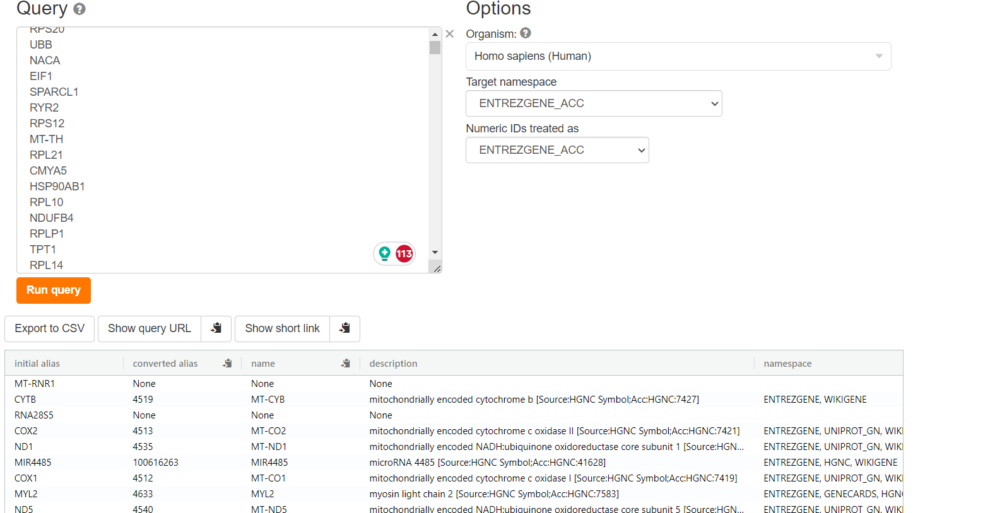

免疫浸润代码（处理CIBERSORT分析后数据）
install.packages("devtools")
devtools::install_github("Moonerss/CIBERSORT")
library(CIBERSORT)
data(LM22)
boxplot(exp79962,outline=FALSE,notch=F,las=2)
> exp79962=normalizeBetweenArrays(exp79962)
> boxplot(exp79962,outline=FALSE,notch=F,las=2)
> ciber_result<-cibersort(sig_matrix = LM22,mixture_file = exp79962,perm = 1000,QN=TRUE)

