 | He
 | He | Livermore Awesome Boltzmann Discrete Ordinates Computed Tomography and Radiography Simulator/LAB-DOCTORS  User Manual  Version 1.0  Classification  LLNL INTERNAL USE ONLY  Author: Xin Liu, Ph.D.  Venkatesh Sridhar, Ph.D.  Date: 10-18-2022
 | He | 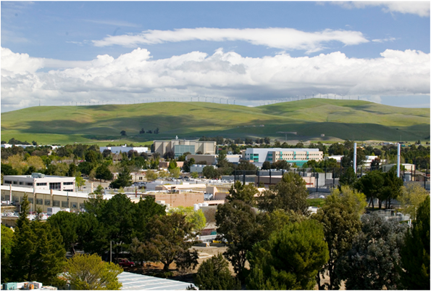

Disclaimer
Lawrence Livermore National Security, LLC, nor any of their employees makes any warranty, expressed or implied, or assumes any legal liability or responsibility for the accuracy, completeness, or usefulness of any information, apparatus, product, or process disclosed, or represents that its use would not infringe privately owned rights. Reference herein to any specific commercial product, process, or service by trade name, trademark, manufacturer, or otherwise does not necessarily constitute or imply its endorsement, recommendation, or favoring Lawrence Livermore National Security, LLC. The views and opinions of authors expressed herein do not necessarily state or reflect those of Lawrence Livermore National Security, LLC, and shall not be used for advertising or product endorsement purposes.
Lawrence Livermore National Laboratory is operated by Lawrence Livermore National Security, LLC, for the U.S. Department of Energy, National Nuclear Security Administration under Contract DE-AC52-07NA27344.

Contents
1 Introduction 5
2 Overview 5
2.1 Cautions & Warnings 5
3 Getting Started 6
3.1 How to Install LAB-DOCTORS 6
3.2 Required Files Provided by User 6
3.3 How to Run LAB-DOCTORS 7
3.4 How to Uninstall LAB-DOCTORS 7
4 Running LAB-DOCTORS 7
4.1 Geometry 8
4.2 Cross Section 9
4.2.1 Human Phantom 10
4.2.2 Water Phantom 11
4.3 Quadrature 11
4.4 Source 12
4.5 Detector 13
4.6 Solver 14
4.7 Input File 15
4.8 Launch Solver 15
5 Reference 16

List of Figures

Figure 4-1 LAB-DOCTORS GUI main window 8
Figure 4-2 Selection of CT data file from a file dialog 9
Figure 4-3 Multigroup cross section data file selection 10
Figure 4-4 Quadrature set selection 12
Figure 4-5 Cone beam source setup 13
Figure 4-6 Detector setup 14
Figure 4-7 Solver type selection 15
Figure 4-8 Input file generation 16

Introduction
The Livermore Awesome Boltzmann Discrete Ordinates Computed Tomography and Radiography Simulator (i.e. LAB-DOCTORS) is a computer code package for producing a neutral particle (e.g., photon) fluence distribution, including both primary and scattered, in a voxelized object and in the detector. Computed tomography (CT) and radiography using ionizing radiations have been applied extensively in nondestructive testing and medical diagnosis. A complete description of the particle fluence distribution and energy transfer is essential for estimating radiation doses and scatter contamination in designing an optimized imaging system. Different from Monte Carlo methods, LAB-DOCTORS calculates particle fluence distribution by solving the linear Boltzmann transport equation based on the discrete ordinates method (i.e., Sn method). This user manual provides the information necessary for the user to effectively use LAB-DOCTORS on a personal computer or through Livermore Computing (LC).

LAB-DOCTORS has been developed based on DOCTORS [ref1] since 2020 and was written by Xin Liu and Venkatesh Sridhar.

Overview
DOCTORS consists of a set of modules, each performing a well-defined processing task. The major modules of the current version are listed in the following:
• Geometry – load object volume and specify mesh grid, physical length and iso center.
• Cross Section – load multi-group cross section data and specify material type.
• Quadrature – select S_{n} order.
• Source – select source type and specify source energy spectrum, position, and profile.
• Detector – specify source to object distance (SOD) and object to detector distance (ODD).
• Solver – select solver type and check GPU if using NVidia GPU parallel computing.
• Input File – generate and edit the input file which can be read by the solver.
• Launch Solver – simply execute the calculation.

Cautions & Warnings
As we continue improve the functionality of LAB-DOCTORS, there are items which will be implemented in the future versions. The GPU parallel computing was tested using CUDA 11.0 and Nvidia Quadro 3000. It may not work on other platforms.

Getting Started

How to Install LAB-DOCTORS
LAB-DOCTORS is a C++ code package build upon Visual C++ on the Microsoft Windows platform or g++ on Linux platforms. The executable file of LAB-DOCTORS can be placed in any folder under the user’s home directory. Currently, both Windows and Linux version of the executable files are provided. Mac version of LAB-DOCTORS will be provided in the future release.

To improve the usability of LAB-DOCTORS, a graphical user interface (GUI) is developed to help users to generate an input file. The GUI is a cross platform and is written in Python and PyQt5. The Python source code of the GUI is distributed with the precompiled executable with supporting files.

Windows
For Windows users, copy or download the Python source code and the precompiled executable as well as a few supporting files into a folder. The user should put the user manual in the same folder where LAB-DOCTORS executable is located. The directory structure should look something like that shown in Figure 3.1.

Linux or LC
For Linux or LC users,

Required Files Provided by User

In order to run a successful simulation by LAB-DOCTORS, several data files are required. These data files can be placed in any folder. However, it is suggested to put all the data files in the same folder where DOCTORS is located for good file organization. The required files are:
- CT volume data file. This file is a 16-bit unsigned binary file, which contains CT number in every voxel of a 3D object. This data file can be easily generated from a series of DICOM images using ImageJ. It can also be generated numerically by a data processing tool, such as MATLAB or Python.
- Multi-group cross section data file. This file contains multi-group cross section data of a particular particle type, such as a photon. This data file is usually generated from ENDF/B data library using NJOY. NJOY2016 is an open source software, and is recommend to the user for the cross section data generation.
- Source energy spectrum. This file contains normalized energy spectrum of the source particle.

In addition to these required files, the user needs to provide the material type of the object, which describes the chemical element composition of each voxel. Two prebuild material types are available, namely, water and human body.

How to Run LAB-DOCTORS

To run LAB-DOCTORS, simply go to the folder where the LAB-DOCTORS executable and the Python GUI is located, and type the following command:

~$python labdoctors_main.py

It is also possible to run LAB-DOCTORS without using the GUI. Simply go to the folder where both the LAB-DOCTORS executable and the input file are located, and type the following command:
~$./labdoctors

How to Uninstall LAB-DOCTORS

To uninstall LAB-DOCTORS, simply delete the LAB-DOCTORS executable file or the whole folder containing LAB-DOCTORS and Python GUI files.

Running LAB-DOCTORS
When LAB-DOCTORS is launched through Python GUI, the main window will be opened as shown in Figure 1. The 7 tabs are “Geometry”, “Cross Section”, “Quadrature”, “Source”, “Detector”, “Solver”, and “Input File”. The user should click each tab and fill out the required information. Once the required information were filled out, an input file could be generated. If the input file is generated, the user can click the “Launch Solver” button at bottom to run the simulation.

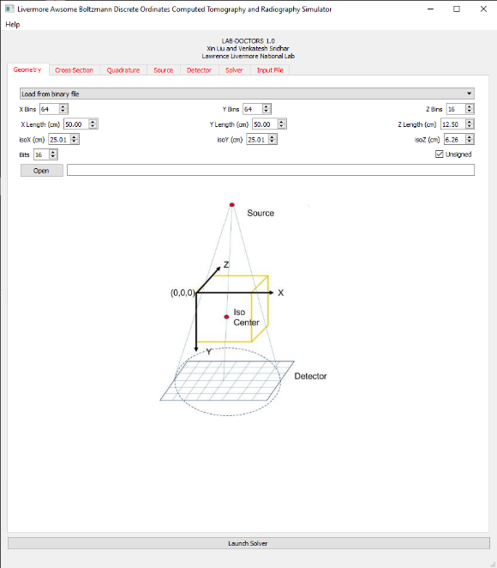
Figure 4-1 LAB-DOCTORS GUI main window

The following sub-sections provide detailed, step-by-step instructions on how to fill out the required information in each tab and run a successful simulation.

Geometry
The first tab is the “Geometry” input, as shown in Figure 4.1. In the current version of LAB-DOCTORS, the only supported format is unsinged 16-bit binary files whose size is known a priori. The user should first specify the number of mesh bins, physical length (in centimeters) in the X, Y, and Z directions, and the iso center positions, respectively. Default values as well as the 3D coordinates are shown in the main window. The coordinates setup in LAB-DOCTORS is shown in the system sketch. The source is on the negative Y axis, and the detector is on the positive Y axis. In the current version of LAB-DOCTORS, only rectangular mesh grid with uniform mesh size is supported. When the user clicks on the “Open” button, a file selection dialog is prompted as shown in Figure 4.2.

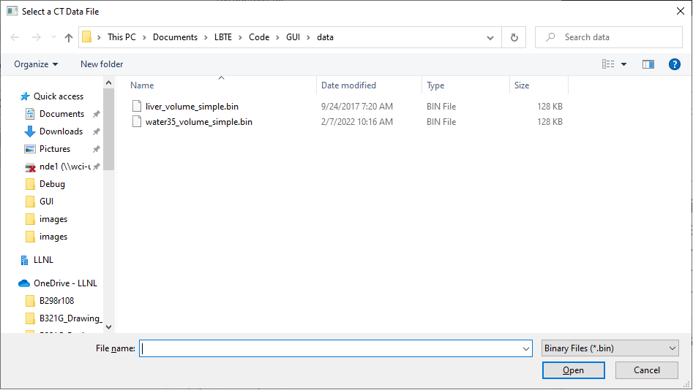
Figure 4-2 Selection of CT data file from a file dialog

Cross Section
The next tab is “Cross Section” input. The user should prepare the multigroup cross section data using NJOY. NJOY2016 is an open source software that can generate multigroup cross section data from ENDF/B data library. The cross section data required by LAB-DOCTORS is DTFR type of file generated by NJOY2016. DTFR type of data file is specially designed to be used with discrete ordinates methods. To use DTFR type of data file with DOCTORS, a header is needed to add necessary information. A sample of DTFR data file with header information is shown in Appendix A. The user can generate multiple cross section data files with different energy groups, order of Legendre expansion, etc. The Legendre order is also called the P_{n} order. High P_{n} order means the scattering is highly anisotropic, and low P_{n} order means scatter is nearly isotropic. Please note that the zeroth order, namely, P₀, is isotropic scattering.

As shown in Figure 4.3, the user simply click “Open” button to select the desired cross section data file. After the cross section data file is selected, the user can select the material type from the material library. In LAB-DOCTORS, the material type is defined as the name of the object materials, which could be a single element, compound, or mixture. The step of select material type is necessary for the CT-number-to-material conversion. To convert CT number of a voxel to a certain type of material, LAB-DOCTORS uses a threshold method. However, different objects with different element constituents may have same CT numbers. Therefore, predefined material types are provided, such that the CT number can be converted to a unique material in each voxel. Currently, LAB-DOCTORS provides two default material types: human phantom and water as shown in Figure 4.3. More material types will be added into the material library according to users needs in the future.

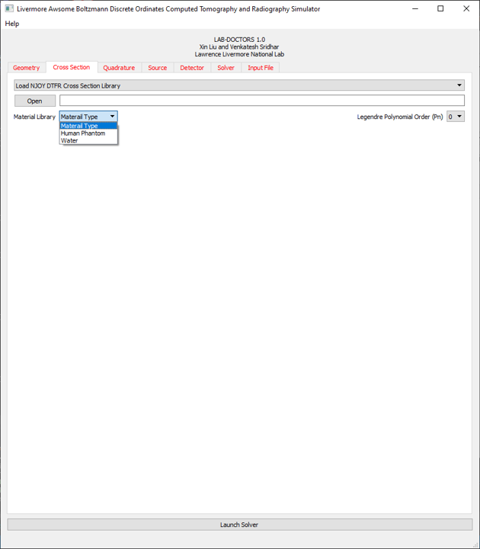
Figure 4-3 Multigroup cross section data file selection

Human Phantom
The human phantom is a relatively complex material type. The human body phantom contains air, lung, adipose, small intestine, and 15 types of bones. It also includes iron to represent metal implant in the human body. The CT number thresholds for the 20 different substances in human phantom are listed in Table 4.1

Table 4.1 CT number thresholds for human body phantom
Mat. | Air | Lung | Adi. | Int. | B1 | B2 | B3 | B4 | B5 | B6 | B7 | B8 | B9 | B10 | B11 | B12 | B13 | B14 | B15 | Fe
CT # | -950 | -100 | 15 | 129 | 200 | 300 | 400 | 500 | 600 | 700 | 800 | 900 | 1000 | 1100 | 1200 | 1300 | 1400 | 1500 | 300 | 65000

Further, the 20 substances are made up of 13 chemical elements including Hydrogen, Carbon, Nitrogen, Oxygen, Sodium, Magnesium, Phosphorus, Sulfur, Chlorine, Argon, Potassium, Calcium, and Iron. The weight-fraction of the 13 chemical elements for the 20 substances are listed in Table 4.2. With Table 4.1 and 4.2, the CT number of a voxel can be converted to a material with known chemical element concentrations. This information is used in LAB-DOCTORS to build the cross section for each voxel.

Table 4.2 Weight fraction of chemical elements for the 20 substances in human body.
 | H | C | N | O | Na | Mg | P | S | Cl | Ar | K | Ca | Fe
Air | 0.000 | 0.000 | 0.757 | 0.232 | 0.000 | 0.000 | 0.000 | 0.000 | 0.000 | 0.013 | 0.000 | 0.000 | 0.000
Lung | 0.103 | 0.105 | 0.031 | 0.749 | 0.002 | 0.000 | 0.002 | 0.003 | 0.003 | 0.000 | 0.002 | 0.000 | 0.000
Adipose | 0.112 | 0.508 | 0.012 | 0.364 | 0.001 | 0.000 | 0.000 | 0.001 | 0.001 | 0.000 | 0.000 | 0.000 | 0.000
Intestine | 0.100 | 0.163 | 0.043 | 0.684 | 0.004 | 0.000 | 0.000 | 0.004 | 0.003 | 0.000 | 0.000 | 0.000 | 0.000
Bone1 | 0.097 | 0.447 | 0.025 | 0.359 | 0.000 | 0.000 | 0.023 | 0.002 | 0.001 | 0.000 | 0.001 | 0.045 | 0.000
Bone2 | 0.091 | 0,414 | 0.027 | 0.368 | 0.000 | 0.001 | 0.032 | 0.002 | 0.001 | 0.000 | 0.001 | 0.063 | 0.000
Bone3 | 0.085 | 0.378 | 0.029 | 0.379 | 0.000 | 0.001 | 0.041 | 0.002 | 0.001 | 0.000 | 0.001 | 0.082 | 0.000
Bone4 | 0.085 | 0.378 | 0.029 | 0.379 | 0.000 | 0.001 | 0.041 | 0.002 | 0.001 | 0.000 | 0.001 | 0.082 | 0.000
Bone5 | 0.085 | 0.378 | 0.029 | 0.379 | 0.000 | 0.001 | 0.041 | 0.002 | 0.001 | 0.000 | 0.001 | 0.082 | 0.000
Bone6 | 0.085 | 0.378 | 0.029 | 0.379 | 0.000 | 0.001 | 0.041 | 0.002 | 0.001 | 0.000 | 0.001 | 0.082 | 0.000
Bone7 | 0.085 | 0.378 | 0.029 | 0.379 | 0.000 | 0.001 | 0.041 | 0.002 | 0.001 | 0.000 | 0.001 | 0.082 | 0.000
Bone8 | 0.085 | 0.378 | 0.029 | 0.379 | 0.000 | 0.001 | 0.041 | 0.002 | 0.001 | 0.000 | 0.001 | 0.082 | 0.000
Bone9 | 0.085 | 0.378 | 0.029 | 0.379 | 0.000 | 0.001 | 0.041 | 0.002 | 0.001 | 0.000 | 0.001 | 0.082 | 0.000
Bone10 | 0.085 | 0.378 | 0.029 | 0.379 | 0.000 | 0.001 | 0.041 | 0.002 | 0.001 | 0.000 | 0.001 | 0.082 | 0.000
Bone11 | 0.085 | 0.378 | 0.029 | 0.379 | 0.000 | 0.001 | 0.041 | 0.002 | 0.001 | 0.000 | 0.001 | 0.082 | 0.000
Bone12 | 0.085 | 0.378 | 0.029 | 0.379 | 0.000 | 0.001 | 0.041 | 0.002 | 0.001 | 0.000 | 0.001 | 0.082 | 0.000
Bone13 | 0.085 | 0.378 | 0.029 | 0.379 | 0.000 | 0.001 | 0.041 | 0.002 | 0.001 | 0.000 | 0.001 | 0.082 | 0.000
Bone14 | 0.085 | 0.378 | 0.029 | 0.379 | 0.000 | 0.001 | 0.041 | 0.002 | 0.001 | 0.000 | 0.001 | 0.082 | 0.000
Bone15 | 0.085 | 0.378 | 0.029 | 0.379 | 0.000 | 0.001 | 0.041 | 0.002 | 0.001 | 0.000 | 0.001 | 0.082 | 0.000
Iron | 0.000 | 0.000 | 0.000 | 0.000 | 0.000 | 0.000 | 0.000 | 0.000 | 0.000 | 0.000 | 0.000 | 0.000 | 1.000

Water Phantom
The water phantom is a relatively simple material type. The pure water phantom contains only two substances, namely water and air. The CT number thresholds for the two different substances in water phantom are listed in Table 4.3

Table 4.3 CT number thresholds for water phantom
Mat. | Air | Water
CT # | -66 | 60

Further, the two substances are made up of four chemical elements including Hydrogen, Nitrogen, Oxygen, and Argon. The weight-fraction of the four chemical elements for the two substances are listed in Table 4.4.

Table 4.4 Weight fraction of chemical elements for the two substances in water phantom.
 | H | N | O | Ar
Air | 0.000 | 0.755 | 0.232 | 0.013
Water | 0.112 | 0.000 | 0.888 | 0.000

Quadrature
To solve the linear Boltzmann transport equation, the angular variable in the transport equation is discretized into a finite number of directions. Each discrete direction can be viewed as a point on the surface of a unit sphere with an associated surface area which is the weight used in the numerical integration scheme. Th combination of the discrete direction and the its weight is referred to as quadrature set. The tab “Quadrature” allows the user to select Sn order (i.e. the number of discrete directions). As shown in Figure 4.4, the user can select Sn order from 2 to 60. In the current version of LAB-DOCTORS, the level-symmetric quadrature set is adopted for S_{n} order from 2 to 20. If Sn order is greater than 20, the Legendre-Chebyshev (P_{n}-T_{n}) quadrature sets are adopted. A graphical illustration of the level symmetry quadrature set (S8) is also displayed to show the angular discretization. In the future release of LAB-DOCTORS, custom quadrature sets will be supported if it is highly desirable.

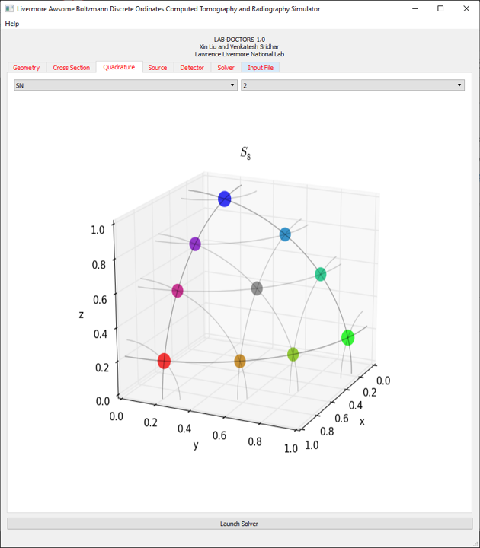
Figure 4-4 Quadrature set selection

Source
The “Source” tab defines the source type and energy spectrum. As shown in Figure 4.5, uses first specify the source type. There are 5 source types currently supported by LAB-DOCTORS. They are point source, fan beam source, multi-fan beam source, cone beam source, and multi-cone beam source. The multi-fan beam and multi-cone beam source are specifically used to simulate CT dosage within the object. The other three source types, namely, point source, fan beam, and cone beam source are used for Radiography scatter simulations.

The cone beam is the most used source type which is very easy to setup. As shown in Figure 4.5, the user needs to specify the source position (x, y, z), energy distribution (spectrum), and the cone angle in degrees. Please note the cone angle is the half cone angle in the cone beam setup.

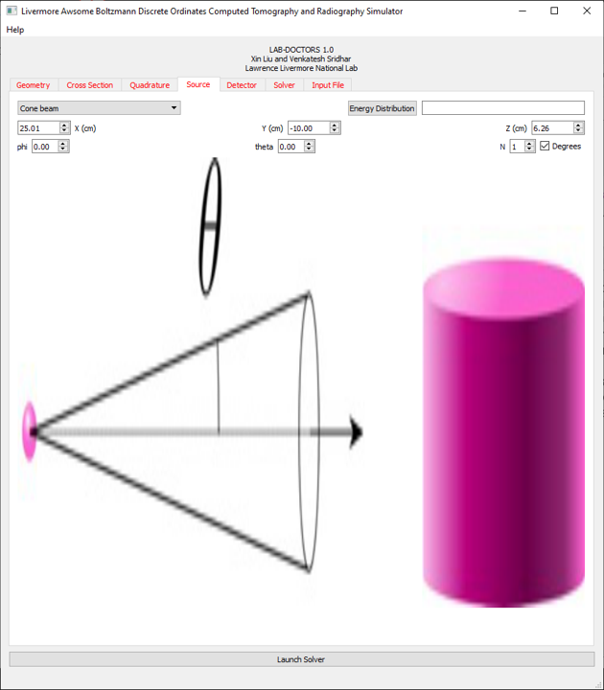
Figure 4-5 Cone beam source setup

Detector
The “Detector” tab defines the detector position and response function. As shown in Figure 4.6, uses first specify the source-to-object distance (SOD) and the object-to-detector distance (ODD). Then, click the “Update” button to calculate the geometry magnification ratio, which is used in LAB-DOCTORS to setup the detector. In LAB-DOCTORS, it is assumed that the source, iso center, and the detector center is on the same Y axis. The number of detector pixels along X and Z axis are same as the number of bins of the mesh volume. Therefore, these values are automatically filled when the “Update” button was clicked.

The “Detector Response Function” represents the probability of detector interaction with the polychromatic beam. It is determined by the detector material, thickness, and source energy spectrum. The user should prepare this file like the source energy spectrum. Currently, the default detector response function is unity, which is corresponding to a perfect detector response.

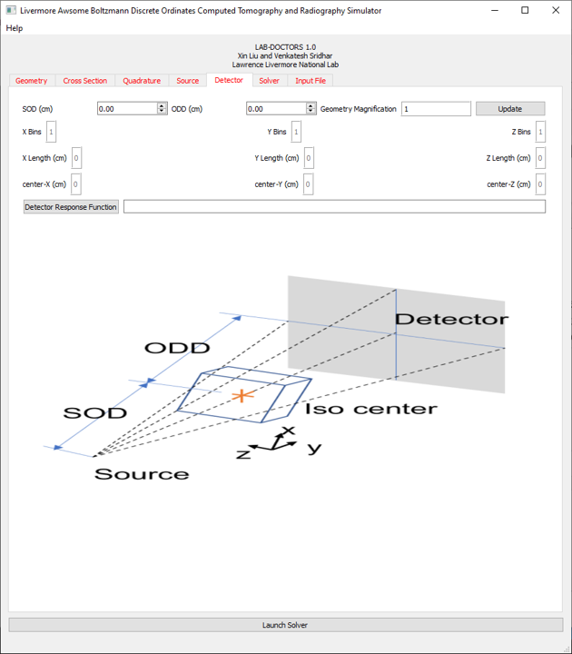
Figure 4-6 Detector setup

Solver
The “Solver” tab allows the user to select solver type and check if GPU parallel computing will be used as shown in Figure 4.7. Currently, two solver types are supported. They are isotropic and anisotropic solvers. Isotropic solver is recommended when the scattering can be approximately modeled as an isotropic process. Isotropic solver is fast and take less resources on both CPU and GPU. The anisotropic solver should be selected when the scattering cannot be modeled as an isotropic process. The user can check the “GPU” checkbox if Nvidia GPU card was installed. If only CPU was available, LAB-DOCTORS will be executed on CPU. However, it is highly recommended that running LAB-DOCTORS on GPU to reduce the lengthy computation time.

To simulate a CT scan, the user needs to specify the starting angle, angular range, and the number of angles. The default values are zero, 180 degree, and 1, respectively. To simulate a radiography, the number of angels should be one.

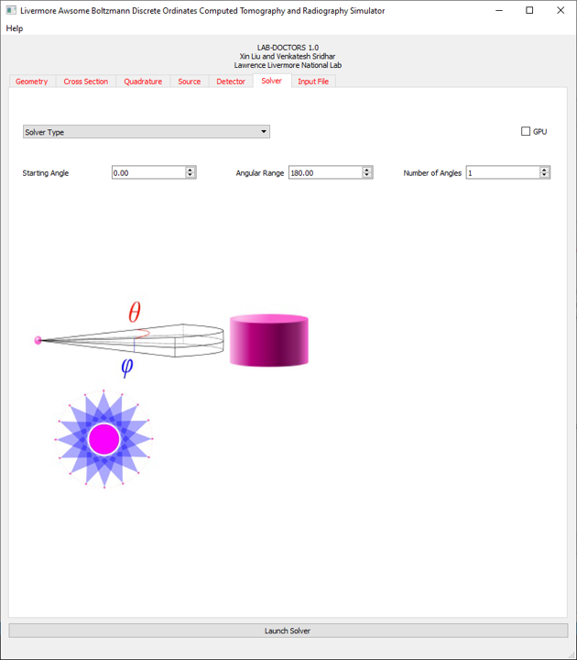
Figure 4-7 Solver type selection

Input File
The “Input File” tab allows the user to generate an input file to run LAB-DOCTORS. As shown in Figure 4.8, when the button “Update” is clicked, the input file will be shown in the edit box, and it can be saved to a file using the “Save” button. The user can also edit the input file manually in the edit box before saving the file.

Launch Solver
Once all the required information about a simulation were entered and saved as described in the previous sections, the final step is to launch solver. The “Launch Solver” button is located at bottom. Simply click the “Launch Solver” button, an open file dialog will pop up and allow the user to select the input file.

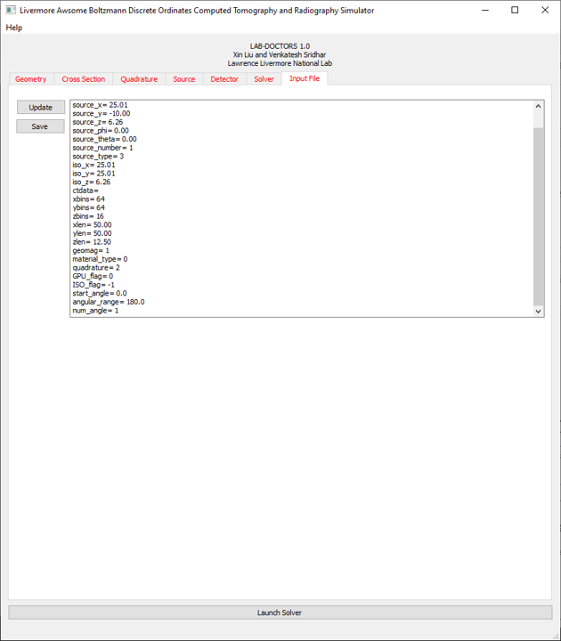
Figure 4-8 Input file generation

Reference
      - Norris, Edward T., and Xin Liu. "Photon fluence and dose estimation in computed tomography using a discrete ordinates Boltzmann solver." Scientific Reports 10, no. 1 (2020): 1-14.

Multigroup cross section library generation with NJOY2016
A.1 Theory

In particle transport simulation, the energy range 0 to $E_{0}$ is often divided into G intervals with the width $∆E_{g}=E_{g}-E_{g+1}$ , for g = 1, …, G. The convention of increasing group number corresponding with decreasing energy is generally accepted. When the particle flux and interaction cross section over each energy group are averaged, they become functions of group index rather than energy. The group averaged total cross section, can be calculated with equation (A1),

$σ_{t,g}\left(r\right)=\frac{\int_{∆E_{g}}{σ_{t}\left(r, E\right)φ\left(r,E\right)dE}}{\int_{∆E_{g}}{φ\left(r,E\right)dE}}$ (A1)

where $σ_{t}(r, E)$ is the continuous energy total cross section, and $φ(r, E)$ is the scalar flux. The group scalar flux is defined by equation(A2), which is typically unknown.

$ϕ_{g}\left(r\right)= \int_{ΔE_{g}}{φ\left(r,E\right)dE}$ (A2)

To solve this problem, the scalar flux $φ\left(r, E\right)$ is often assumed to be a product of a spectral weighting function $f(E)$ and the group scalar flux $ϕ_{g}(r)$ as shown in equation (A3).

$φ\left(r,E\right)≈f\left(E\right)ϕ_{g}\left(r\right), E_{g+1}≤E<E_{g}$ (A3)

When equation (A3) is substituted into equation (A1), the group cross section becomes equation (A4).

$σ_{t,g}\left(r\right)=\frac{\int_{∆E_{g}}{σ_{t}\left(r, E\right)f\left(E\right)dE}}{\int_{∆E_{g}}{f\left(E\right)dE}}$ (A4)

The spectral weighting function could be a constant if the width of the energy interval is narrow.

The creation of multigroup cross section library is handled by the NJOY software package. The NJOY nuclear data processing tool is a comprehensive computer code package for producing pointwise and multigroup nuclear cross sections from data in the ENDF library. NJOY originally started as a successor to the code package Multigroup Interpretation of Nuclear X-sections more commonly known at the time as MINX. Early in NJOY’s life, in the mid 1970’s, development was supported by the U.S. Fast Breeder Reactor and Weapons Programs. NJOY2016 is the latest release of the Fortran-based code package, an open source code which is freely available to the public.

NJOY2016 is a modular program consisting of the primary program module NJOY and 23 sub modules used by the primary program. The major modules used to create the photoatomic multigroup cross section files for LAB-DOCTORS are RECONR, GAMINR, and DTFR. These modules must be run in sequence as the output from one module is required to run the next.

A.2 RECONR Module

Creating a cross section library starts with data in an ENDF/B-VII file which must be input into the RECONR module. This module is used to reconstruct resonance cross sections from resonance parameters and reconstruct cross sections from ENDF nonlinear interpolation schemes. There are several options which must be input by the user to run this module. Those inputs are: the input/output files, a label for the file, the ENDF material number, the number of descriptive cards used, and the fractional reconstruction tolerance desired. This step is required primarily because the output format for this module is a pointwise ENDF (PENDF) which is required to run the GAMINR module.

A.3 GAMINR Module

The GAMINR module was created to produce complete and accurate multigroup photoatomic cross sections. As with RECONR this module has inputs which must be defined by the user. GAMINR requires the input of the original ENDF file as well as the PENDF output file created from RECONR as well as a designated output file. The basic options which must be defined are: ENDF material number, gamma group structure, weighting option, Legendre order, and the ENDF file/section to be processed.

There are pre-defined options in NJOY for the gamma group structure and weighting option. When either of these options are set as user defined addition inputs must be added to the input file. The energy group option requires the number of desired groups and a number of energy boundaries equal to the number of desired groups plus one, input in eV. The weighting information must be entered as a TAB1 record. The following format is used for a single interpolation range:

Float, Float, INT, INT, NR, NP
NBT, INT
E(1) C(1) …

where Float is a double value, INT is an integer, NR is the number of interpolation ranges, NP is the number of (E, C(E)) pairs, NBT is the index of the (E, C(E)) pair corresponding to the end of an interpolation range, and the last INT value is the interpolation law used. The output file from GAMINR is in the form of a groupwise ENDF file (GENDF).

A.4 DTFR Module

The DTFR module is used to prepare libraires for discrete-ordinate transport codes that accept the format designed for the Sn code DTF-IV. The transport table output of DTFR must be modified with a header before use in LAB-DOCTORS. This header contains a label, number of energy groups, energy group boundaries, Legendre order, number of materials, and ENDF material numbers for all materials.

The DTFR module requires the input of the GENDF and PENDF files which were created from the RECONR and GAMINR modules. The output file for the tables must be defined as well as the number of tables desired along with the number of energy groups. DTFR is also used as a quick plotting tool requiring several printing options which must be included in the input file but will not be discussed.

In addition, user must also enter table information. The position of the total cross section, in-group scattering, and total table length. DTFR also allows for special edits which, in this case, were used for three reactions: photon coherent scattering MT502 (ENDF reaction type numbers), photon incoherent scattering MT504, and photelectric absorption MT522. Finally, a material description, ENDF material number, index number, and temperature must be entered.

A.5 Header Information Added to DTFR Output File

The following is an example of header added to the DTFR output file.

3D Data Generation and Material Definition
Step1: Create unsigned 16bit binary 3D volume data using ImageJ

- If reconstruction has not been performed, use LTT to reconstruct the 3D volume into images (.tiff).
- Use ImageJ to load stack of images (.tiff) file.
- Save the image stack to a raw file, e.g. 32 bit real binary. Record the dimensions of the stacked volume (i.e. width, height, depth, number of pixels, etc.)
- Use the Python script to down sampling the volume data and convert the linear attenuation coefficient to HU CT data volume of 16 bit unsigned int, little endian.

Step2: Build multigroup cross section library using NJOY2016
- Determine the type of materials being scanned. E.g. Lexan phantom include Aluminum, Polycarbonate, and Carbon Steel (bolts).
- Determine the chemical elements in each material being scanned. E.g. the chemical elements in the Lexan phantom are: Aluminum, Hydrogen, Carbon, Oxygen and Iron.
- Create an input file for NJOY2016 to generate the multigroup cross section library. Details about using NJOY2016 can be found in the LAB-DOCTORS’s user manual.

Step3: Create spectrum using LTT
- Using LTT’s “Physics simulation” to generate Bremsstrahlung spectrum given the maximum energy and filer material and thickness.
- Determine the number of energy bins and the minimum energy.
- Plot the spectrum and save it to a text file.
- LTT can only generate uniform energy bins. To make nonuniform energy bins, one can generate finer energy bins first and pick the discreate spectrum value at desired energies.
- The spectrum dose not need to be normalized. LAB-DOCTORS normalizes the spectrum automatically.

Step4: Creating a new material type in LAB-DOCTORS source code
- In “materialutils.h”, define new material type.
- In “materialutils.cpp” define the material segmentation threshold in terms of Hounsfiled number, chemical elements, and the weight fraction of the chemical elements in each segmented material.
- In “ctdatamanager.cpp” and “ctdatamanager.h” define the function to covert CT Hunsfield number to a specific material defined in “materialutils.cpp”. This function could be created by copying and modifying the existing function “ctNumberToWater”.
- In “mcnpwriter.h” and “mcnpwriter.cpp”, define a new function to write the material in MCNP input file.

