Generalized ellipse 1

[Award] **8 pts**

[Category] **Math**

It is known that a circle is a curve in a plane that the distance from a given point is constant for every point on the curve. And an ellipse is a curve in a plane surrounding two focal points such that the sum of the distances to the two focal points is constant for every point on the curve.

We can generalize the definition of ellipse to [*n*-ellipse](https://en.wikipedia.org/wiki/N-ellipse). Given *n* points (called foci) in a plane, an *n*-ellipse is the locus of all points of the plane whose sum of distances to the *n* foci is a constant.

There is an equilateral triangle *ABC* of side length 1 in a plane. A 3-ellipse curve is the set of all points of the same plane whose sum of distances to the three points *A*, *B* and *C* is 3 (see the thick curve line in the picture). And the curve can be put inside the circle with a radius of 1.

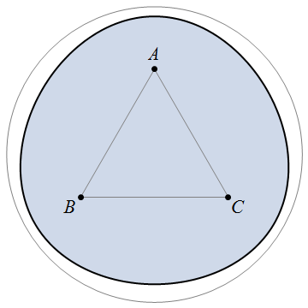

Find the enclosed area and circumference of the closed curve above. Give your answer rounded to 6 digits after the decimal point.

Answer format: [area],[circumference]

Example: 3.141593,6.283185 for a circle with a radius of 1.

[Answer] **2.571623,5.695965**