Generalized ellipse 2

[Award] **10 pts**

[Category] **Math**

The definition of [*n*-ellipse](https://en.wikipedia.org/wiki/N-ellipse) is as below: given *n* points (called foci) in a plane, an *n*-ellipse is the locus of all points of the plane whose sum of distances to the *n* foci is a constant. We can generalize the definition from plain to space, and the set of all points satisfying the constraint become a surface.

There is a [tetrahedron](https://en.wikipedia.org/wiki/Tetrahedron) ABCD of edge length 1 in a space. A 4-ellipse surface is the set of all points of the same space whose sum of distances to the 4 points *A*, *B*, *C* and *D* is 4 (see the blue solid in the picture).

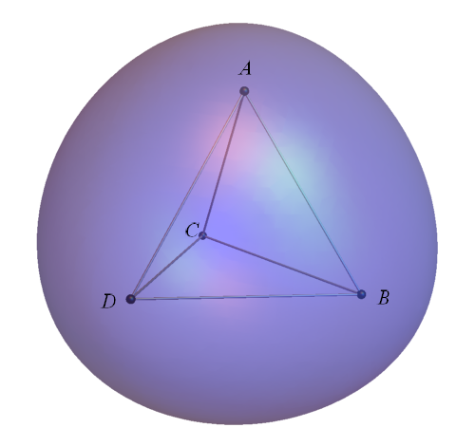

Find the enclosed volume and surface area of the closed surface above. Give your answer rounded to 6 digits after the decimal point.

Answer format: [volume],[surface area]

Example: 4.188790,12.566371 for a sphere of radius 1.

[Answer] **2.603557,9.168588**