Ginkgo leaf

[Award] **8 pts**

[Category] **Math**

There is a parabola with equation *y*2 = 4*x*. A line segment of length 8 moves along the parabola, with one end on the curve, and always perpendicular to the curve. The figure below shows the trajectory of the line segment when one end of it moving through the whole curve.

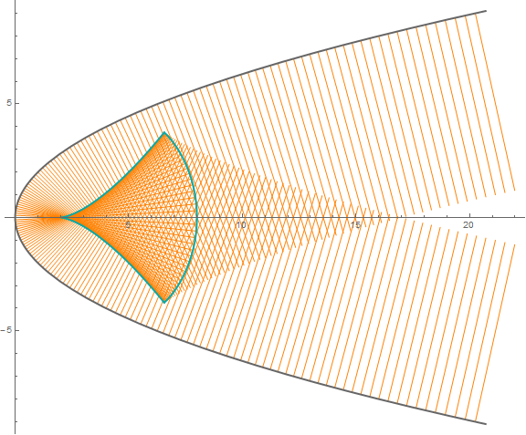

In the whole process of moving the line segment, some points were swept exactly 3 times. Interestingly, these points form a connected region which looks like a ginkgo leaf (blue line around in the figure).

Find the area of the “ginkgo leaf”. Give your answer rounded to 10 digits after the decimal point.

Thanks to **czp** for the idea.

[Answer] **21.2200819219**