Lattice points on the trace 1

[Award] **8 pts**

[Category] **Math**

Given a rectangle ABCD with side AB = CD = *a* and side BC = AD = *b*. A curve is traced by point D of the rectangle as point A slides along the x-axis and point B slides along the y-axis.

The curve with *a* = 2 and *b* = 4 is shown below.

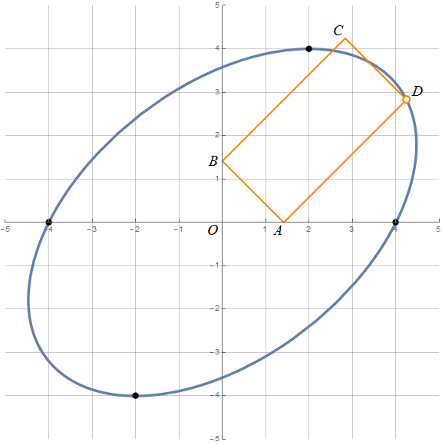

There are 4 lattice points (-4, 0), (-2, -4), (4, 0), (2, 4) on the curve above. Let *C*(*a*, *b*) be the number of distinct lattice points on the curve with the rectangle side *a* and *b*. For example, *C*(2, 4) = 4, C(5, 5) = 12 and C(6, 3) = 4.

Define *S*(n) = sum(*a* = 1, *n*, *b* = 1, *n*, *C*(*a*, *b*)). You are given *S*(10) = 432*, S*(50) = 10960 and *S*(100) = 44128.

Find *S*(108).

[Answer] **44547222554316120**