Lattice points on the trace 2

[Award] **8 pts**

[Category] **Math**

Given a square ABCD with side length *a*. A curve is traced by point D of the square as point A slides along the x-axis and point B slides along the y-axis.

The curve with *a* = 5 is shown below.

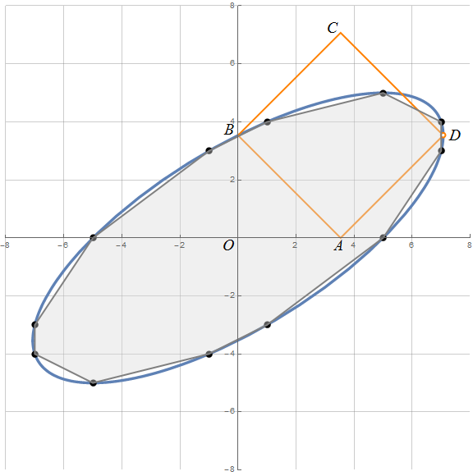

For positive integer *a*, it can be shown that at least 4 lattice points are on the curve. An inscribed polygon can be formed by the lattice points on the curve. Let *R*(a) be the ratio of the area of the inscribed polygon to the area of the closed curve with parameter *a*. Then R(5) = 0.942197263104.

For a <=100, the maximum value of *R*(*a*) is 0.992825486421, with a = 65.

Find the maximum value of *R*(*a*) and corresponding value *a* for *a* <= 1015. If there are two or more values of *a* taking the maximum value *R*, give the smallest *a*.

Answer format: [value of *a*],[value of *R*(*a*) (rounded to 12 digits after the decimal point)]

Example: 65,0.992825486421 for a <= 100.

[Answer] **990915569557225,0.999999999451**