1. I transform the door along with letter sized paper to the scale of an actual letter sized paper. i.e. one pixel is 1 milimeter. Then I took 3 points(corners) of the door in the original photo apply with transformation matrix. After it is done, I can calculate the distances pairwise by using Euclidean distance and the distances I got are the actual width and height because the scale after transformation is the actual scale in millimeter. The width is 905.54mm and height is 2125.51mm.

Derivation:

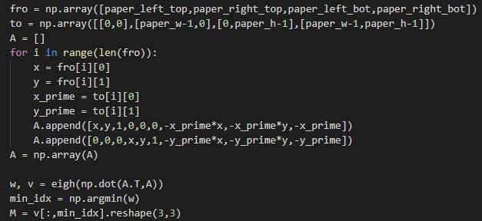

Result:

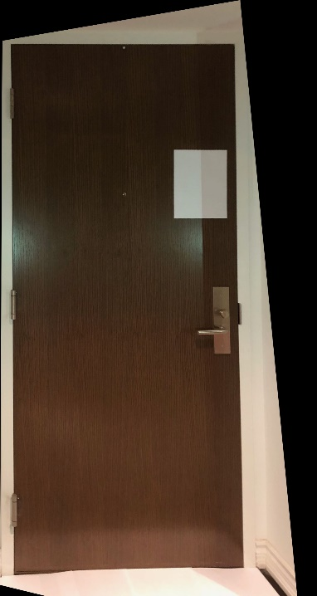

1. A.

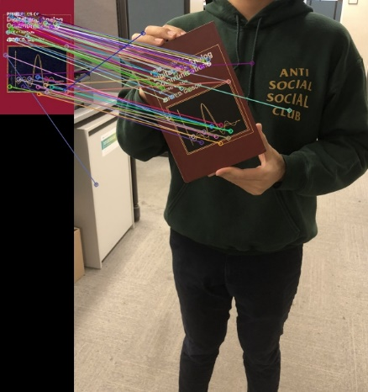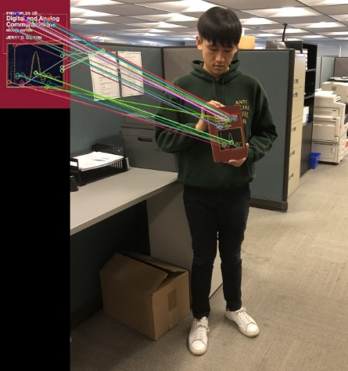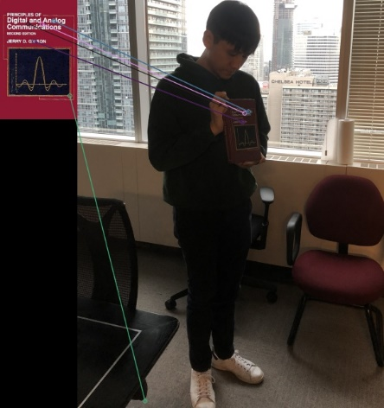

B. My visually estimates for image1,2 and 3 are 30%, 30%, 20% percent of outliers

The estimated minimum number of iterations is shown below:

|  |  |  |  |
| --- | --- | --- | --- |
|  | Image1 | Image2 | Image3 |
| Affine | 11 | 11 | 7 |
| Homography | 17 | 17 | 9 |

C and D. Use the above estimated minimum number of iterations to run the algorithm, the result is very bad.

Affine:

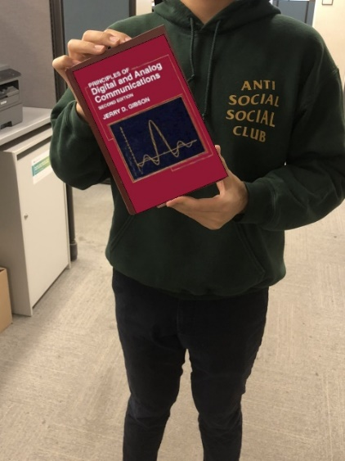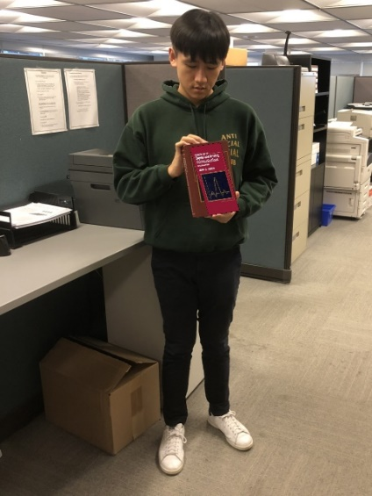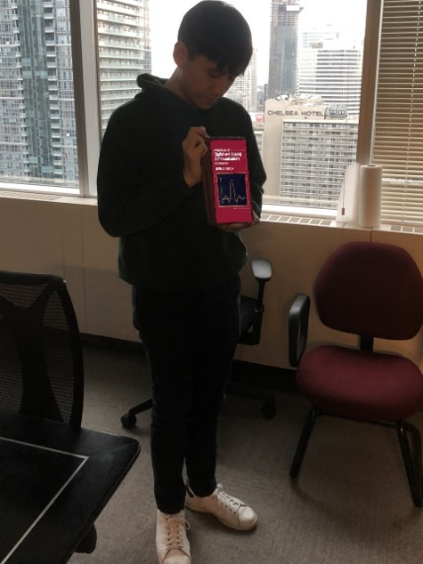

Homography:

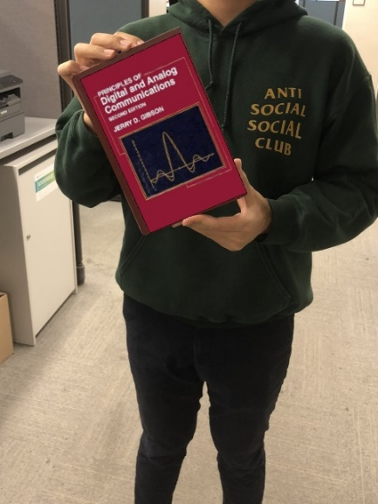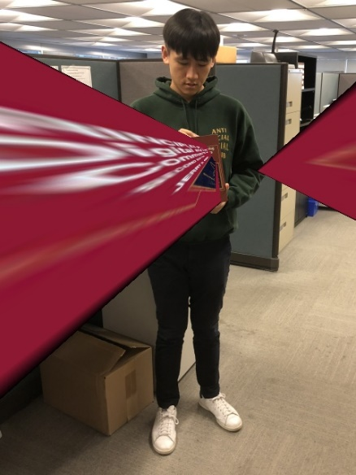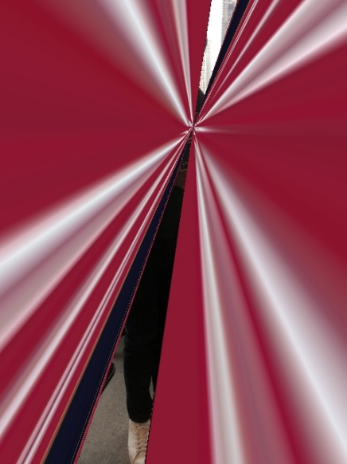

So, I manually set the percent of inliers to 50% for all three, this might be more accurate because visual might be deceiving. A lot of point should not be counted as inlier, but I accidentally counted them as inliers because they are parallel and seem to match the right place. However, when the matches are more crowded, even one-pixel scale matters a lot. Here are the results when I set all of them 50% inliers. ie. The actual inliers are way less than it appears.

Affine:

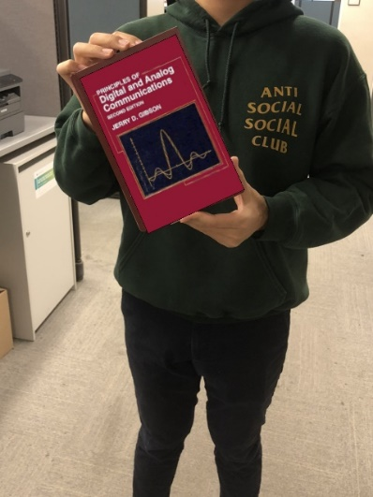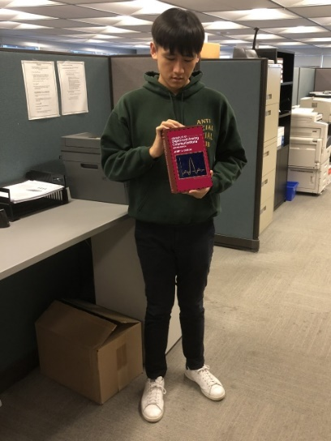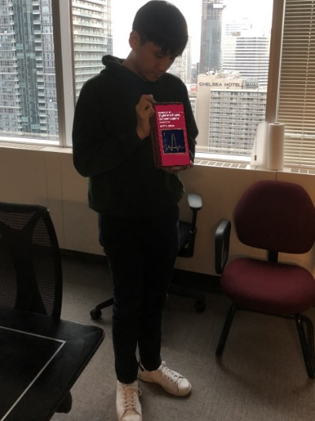

Homography:

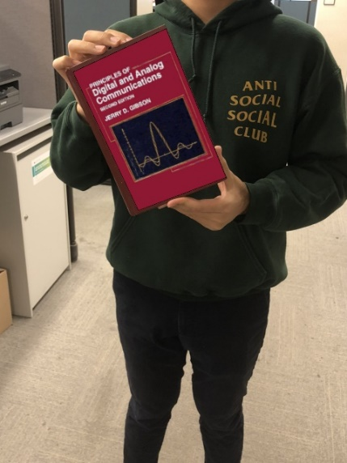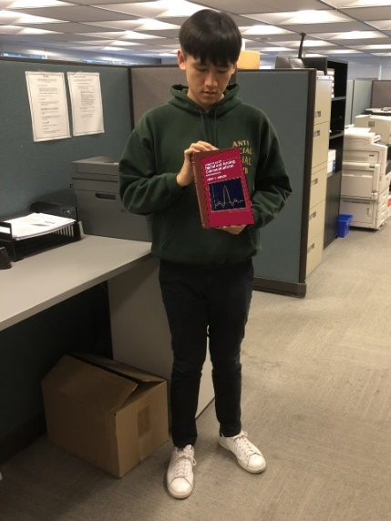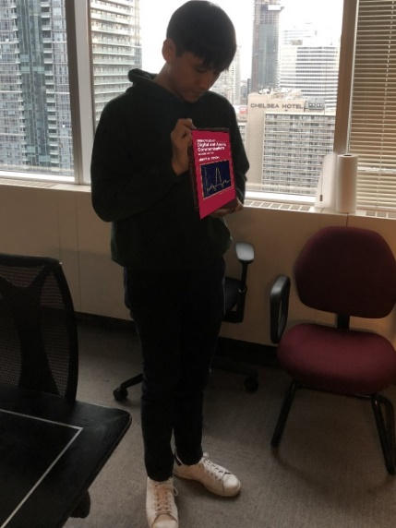

Conclusion for C and D:

RANSAC is more likely to success when you have a lot of data points and run enough iterations. The more data points, the more stable of the algorithm. Just like flip a coin 10 times, you may not get 50% of time of heads and 50% of time of tails, but when you increase number of trials to 100000, the chance would get close to 50:50. Enough iterations ensure we can find the best model among the trials. The difference between Affine and Homography is that Affine only requires 3 pairs of point to determine the transformation matrix but Homography requires 4 pairs. Generally, Homography would require more iterations than Affine to find the best matrix in the same condition (i.e. P=0.99, p=0.5)

E. I use both previous best matrix and find homography using second book cover and the picture I am holding the book. Here are the results.

Using RANSAC homography:

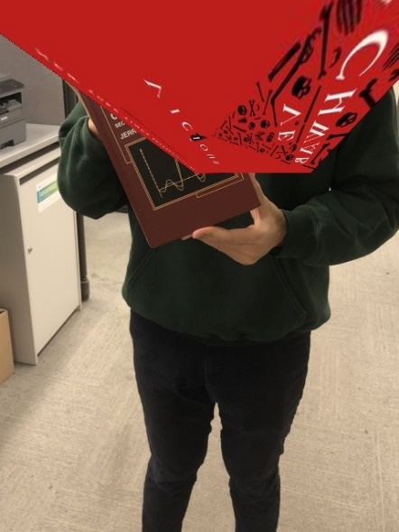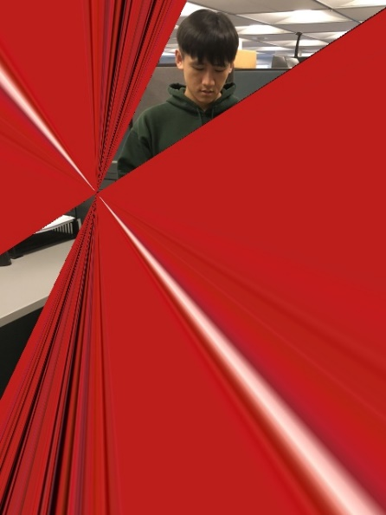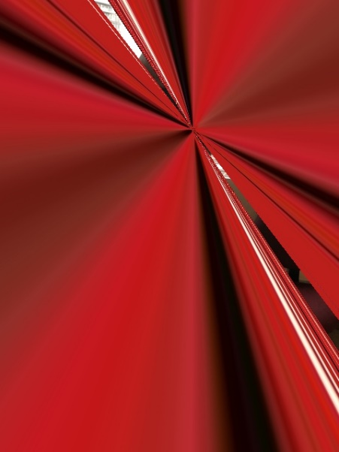.

Using previous best matrix:

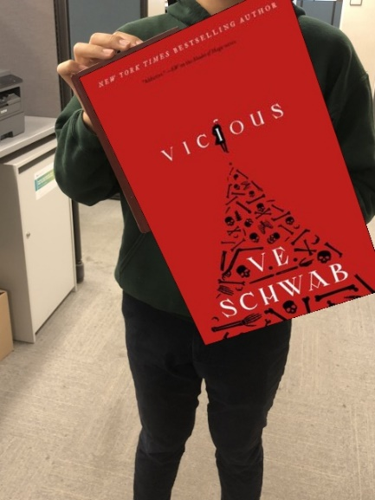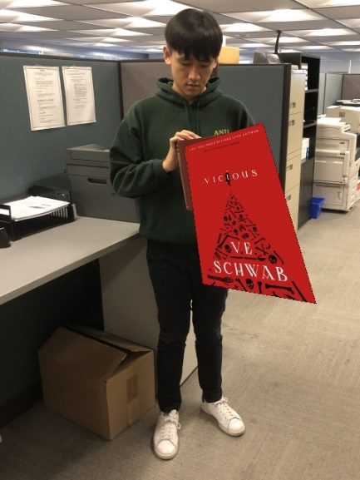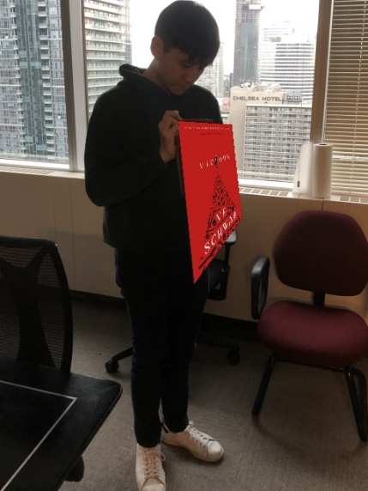\

As we can see above, the first set of images make sense because there are no matches so RANSAC can only select the “best model” among non-matched points. The second set of images are recovered well just the size of the book cover is a bit off because the second book cover is not as large as the first book cover.

1. I use project: https://github.com/SymenYang/Vanish-Point-Detection to help me find the vanish points, I can certainly extend the image and do a visual localization, but for the sake of accuracy, I decide to use open source algorithm to determine three vanish point. The photo I shot is 3024x4032

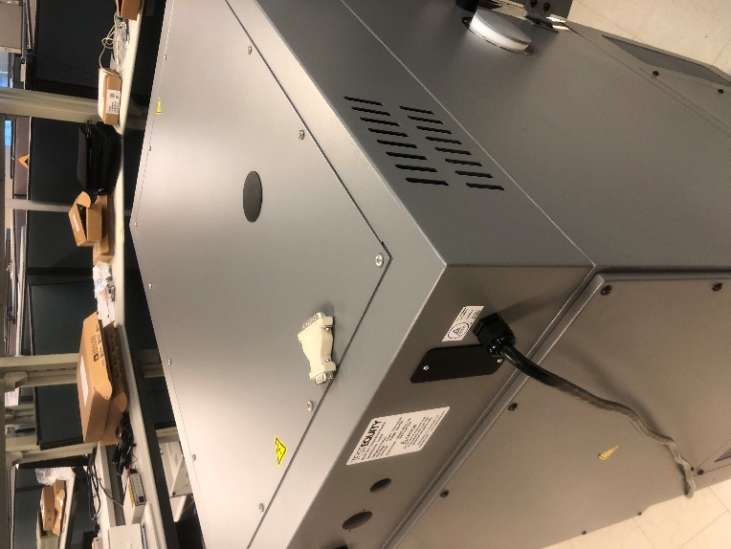

Photo I shot

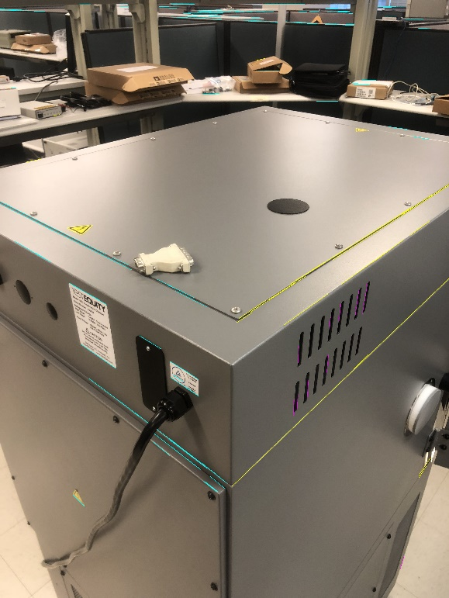

The output of the open source algorithm

I shot a photo and try to find 3 vanishing points by extending the parallel line in 3D but they will converge in 2D. The intercepts are the vanishing point. According to textbook [*Multiple View Geometry in Computer Vision*](http://www.robots.ox.ac.uk/~vgg/hzbook/) (pag. 226), we have intrinsic matrix K:

Three vanish point are

Each row can be computed as [xa*xb+ya*yb,xa*zb+xb*za,ya*zb+yb*za,za*zb] where , then stack rows together. Then we just need to find the null space of the matrix, that is w and solved K by a Cholesky factorization as .

Finally, we have

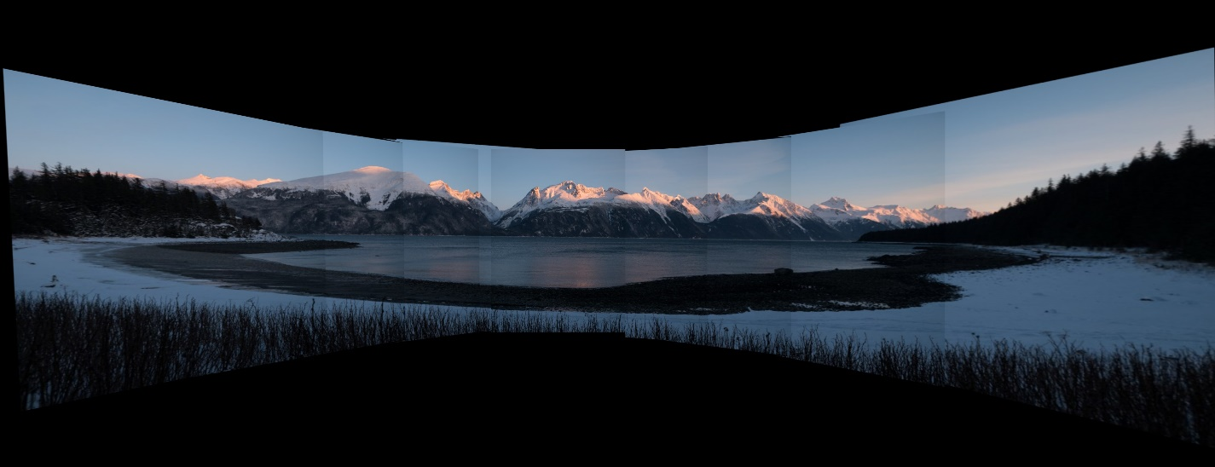

Without Blending.

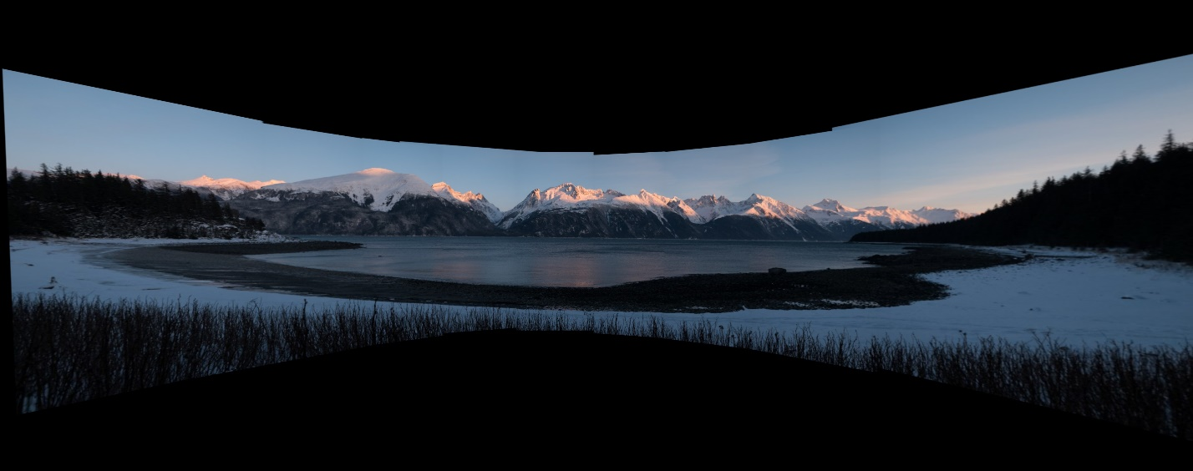

With Blending