1.tomcat端配置
###我用的测试机,从新安装的tomcat环境
- 安装jdk
- 安装jdk
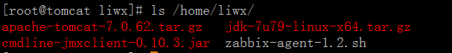
tar zxf jdk-7u79-linux-x64.tar.gz
mv jdk1.7.0_79/ /usr/local/
cd /usr/local/
ln -s jdk1.7.0_79/ jdk
- 配置java环境
echo '' >> /etc/profile
echo '# Set Environment' >> /etc/profile
echo 'JAVA_HOME=/usr/local/jdk' >> /etc/profile
echo 'CLASSPATH=.:$JAVA_HOME/lib/tools.jar' >> /etc/profile
echo 'PATH=$JAVA_HOME/bin:$PATH' >> /etc/profile
echo 'export JAVA_HOME CLASSPATH PATH ' >> /etc/profile

- 加载变量,测试是否生效
#使环境生效
source /etc/profile

#看到1.7 说明安装成功
[root@tomcat local]# java -version
java version "1.7.0_79"
Java(TM) SE Runtime Environment (build 1.7.0_79-b15)
Java HotSpot(TM) 64-Bit Server VM (build 24.79-b02, mixed mode)

- 安装tomcat
- 安装tomcat
tar xf apache-tomcat-7.0.62.tar.gz
mv apache-tomcat-7.0.62 /usr/local/
cd /usr/local/
ln -s apache-tomcat-7.0.62/ tomcat
- 启动和关闭tomcat
[root@tomcat local]# /usr/local/tomcat/bin/startup.sh
Using CATALINA_BASE: /usr/local/tomcat
Using CATALINA_HOME: /usr/local/tomcat
Using CATALINA_TMPDIR: /usr/local/tomcat/temp
Using JRE_HOME: /usr/local/jdk
Using CLASSPATH: /usr/local/tomcat/bin/bootstrap.jar:/usr/local/tomcat/bin/tomcat-juli.jar
Tomcat started.

[root@tomcat local]# ss -tnulp|grep java
tcp LISTEN 0 1 ::ffff:127.0.0.1:8005 :::* users:(("java",26250,47))
tcp LISTEN 0 100 :::8009 :::* users:(("java",26250,43))
tcp LISTEN 0 100 :::8080 :::* users:(("java",26250,42))

[root@tomcat local]# /usr/local/tomcat/bin/shutdown.sh
Using CATALINA_BASE: /usr/local/tomcat
Using CATALINA_HOME: /usr/local/tomcat
Using CATALINA_TMPDIR: /usr/local/tomcat/temp
Using JRE_HOME: /usr/local/jdk
Using CLASSPATH: /usr/local/tomcat/bin/bootstrap.jar:/usr/local/tomcat/bin/tomcat-juli.jar

- 配置jmx
- 编辑catalina.sh
#在tomcat端配置jmx,在自己安装的tomcat路径(/usr/local/tomcat/bin/catalina.sh)
vim /usr/local/tomcat/bin/catalina.sh
export CATALINA_OPTS="$CATALINA_OPTS -Dcom.sun.management.jmxremote"
export CATALINA_OPTS="$CATALINA_OPTS -Dcom.sun.management.jmxremote.port=10053"
export CATALINA_OPTS="$CATALINA_OPTS -Dcom.sun.management.jmxremote.authenticate=false"
export CATALINA_OPTS="$CATALINA_OPTS -Dcom.sun.management.jmxremote.ssl=false"
export CATALINA_OPTS="$CATALINA_OPTS -Djava.rmi.server.hostname=10.0.0.17" #本机自己IP

#可以放在开头
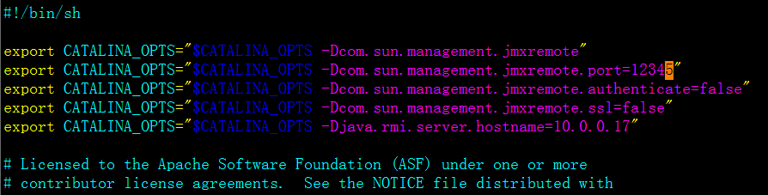:
CATALINA_OPTS="$CATALINA_OPTS
-Dcom.sun.management.jmxremote
-Dcom.sun.management.jmxremote.port=12345 -Dcom.sun.management.jmxremote.authenticate=false -Dcom.sun.management.jmxremote.ssl=false -Djava.rmi.server.hostname=10.0.0.7"
- 重启tomcat
[root@tomcat local]# /usr/local/tomcat/bin/shutdown.sh
Using CATALINA_BASE: /usr/local/tomcat
Using CATALINA_HOME: /usr/local/tomcat
Using CATALINA_TMPDIR: /usr/local/tomcat/temp
Using JRE_HOME: /usr/local/jdk
Using CLASSPATH: /usr/local/tomcat/bin/bootstrap.jar:/usr/local/tomcat/bin/tomcat-juli.jar
[root@tomcat local]# /usr/local/tomcat/bin/startup.sh
Using CATALINA_BASE: /usr/local/tomcat
Using CATALINA_HOME: /usr/local/tomcat
Using CATALINA_TMPDIR: /usr/local/tomcat/temp
Using JRE_HOME: /usr/local/jdk
Using CLASSPATH: /usr/local/tomcat/bin/bootstrap.jar:/usr/local/tomcat/bin/tomcat-juli.jar
Tomcat started.
[root@tomcat local]# ss -tnulp|grep java

###########################问题################################
- 注意重启tomcat,服务没有起来,日志报如下错误
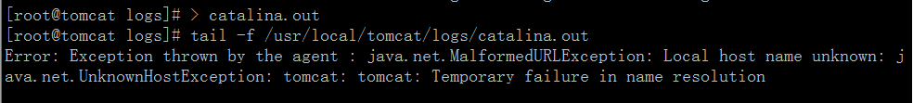

- 而且使用comline验证时,不能获取数据
java -jar cmdline-jmxclient-0.10.3.jar - 10.0.0.17:12345 java.lang:type=Memory NonHeapMemoryUsage
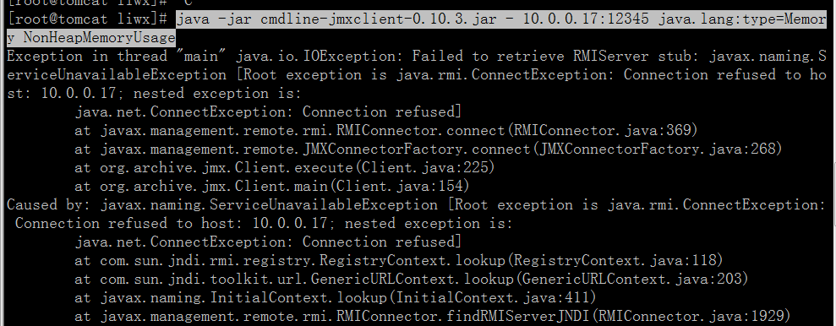

####此问题是本机host没有做解析导致
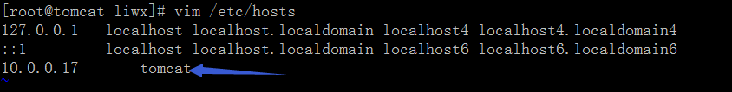

重启tomcat解决
sh /usr/local/tomcat/bin/startup.sh
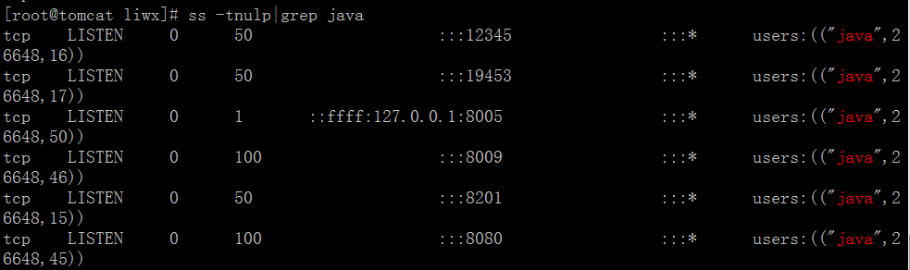

OK 以获取数据
[root@tomcat liwx]# java -jar cmdline-jmxclient-0.10.3.jar - 10.0.0.17:12345 java.lang:type=Memory NonHeapMemoryUsage
12/04/2015 12:29:03 +0800 org.archive.jmx.Client NonHeapMemoryUsage:
committed: 24313856
init: 24313856
max: 136314880
used: 16874112

2.zabbix-server端配置
#1.zabbix-java-gateway与zabbix-server可以在同一台机器,也可以在不同机器上面
#2.zabbix-java-gateway需要安装jmx

###我测试的时候把zabbix-java-gateway与zabbix-server装在同一台机器上

1.安装JMX
1)安装jdk
tar zxf jdk-7u79-linux-x64.tar.gz
mv jdk1.7.0_79/ /usr/local/
cd /usr/local/
ln -s jdk1.7.0_79/ jdk
2)配置java环境
echo '' >> /etc/profile
echo '# Set Environment' >> /etc/profile
echo 'JAVA_HOME=/usr/local/jdk' >> /etc/profile
echo 'CLASSPATH=.:$JAVA_HOME/lib/tools.jar' >> /etc/profile
echo 'PATH=$JAVA_HOME/bin:$PATH' >> /etc/profile
echo 'export JAVA_HOME CLASSPATH PATH ' >> /etc/profile

3)加载变量,测试是否生效
#使环境生效
source /etc/profile

#看到1.7 说明安装成功
[root@zabbix-server local]# java -version
java version "1.7.0_79"
Java(TM) SE Runtime Environment (build 1.7.0_79-b15)
Java HotSpot(TM) 64-Bit Server VM (build 24.79-b02, mixed mode)

2.安装zabbix-java-gateway
###注释###
源码安装的时候，加 --enable-java 参数，依赖关系有 java，java-devel
# ./configure --enable-java --prefix=/

#重新编译zabbix，所以，先备份之前配置文件。（zabbix_server.conf）
##示例
cd /root/zabbix-2.0.6
./configure ./configure --enable-java -prefix=/usr/local/zabbix --enable-server --enable-agent --with-mysql --with-net-snmp --with-libcurl --with-net-snmp --with-libcurl

make && make install
##########注释###########
1)yum安装zabbix-java-gateway
[root@zabbix-server zabbix]# cp zabbix_server.conf zabbix_server.conf.ori1
[root@zabbix-server zabbix]# yum install java java-devel zabbix-java-gateway

2)编辑zabbix_java_gateway.conf配置文件
[root@zabbix-server zabbix]# grep '^[a-Z]' /etc/zabbix/zabbix_java_gateway.conf
LISTEN_IP="10.0.0.7"
LISTEN_PORT=10052
PID_FILE="/var/run/zabbix/zabbix_java.pid"
START_POLLERS=50

3)编辑zabbix-server.conf配置文件
[root@zabbix-server zabbix]# grep '^[a-Z]' /etc/zabbix/zabbix_server.conf
LogFile=/var/log/zabbix/zabbix_server.log
LogFileSize=0
PidFile=/var/run/zabbix/zabbix_server.pid
DBHost=localhost
DBName=zabbix
DBUser=zabbix
DBPassword=zabbix
DBSocket=/var/lib/mysql/mysql.sock
JavaGateway=10.0.0.7
JavaGatewayPort=10052
StartJavaPollers=5
SNMPTrapperFile=/var/log/snmptt/snmptt.log
AlertScriptsPath=/usr/lib/zabbix/alertscripts
ExternalScripts=/usr/lib/zabbix/externalscripts

4)重启zabbix-java与zabbix-server
[root@zabbix-server zabbix]# vim /etc/zabbix/zabbix_java_gateway.conf^C
[root@zabbix-server zabbix]# /etc/init.d/zabbix-java-gateway restart
Shutting down zabbix java gateway: [ OK ]
Starting zabbix java gateway: [ OK ]
[ OK ]
[root@zabbix-server zabbix]# /etc/init.d/zabbix-server restart
Shutting down Zabbix server: [ OK ]
Starting Zabbix server: [ OK ]

5)查看服务状态
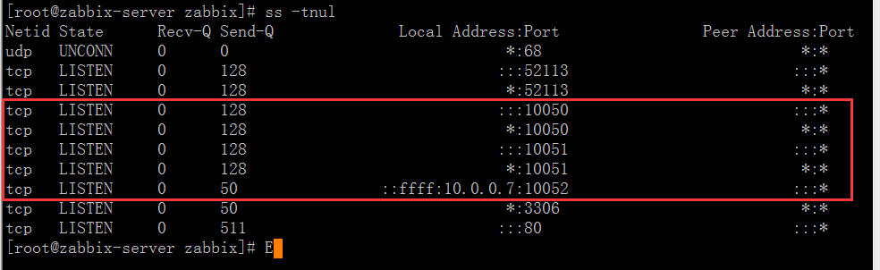

6)测试server端能否获取数据
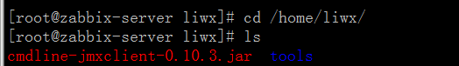
[root@zabbix-server liwx]# java -jar cmdline-jmxclient-0.10.3.jar - 10.0.0.17:10053 java.lang:type=Memory NonHeapMemoryUsage
12/15/2015 17:38:40 +0800 org.archive.jmx.Client NonHeapMemoryUsage:
committed: 24313856
init: 24313856
max: 136314880
used: 17730872

OK 配置完毕

- web端配置
1.导入监控tomcat的模板
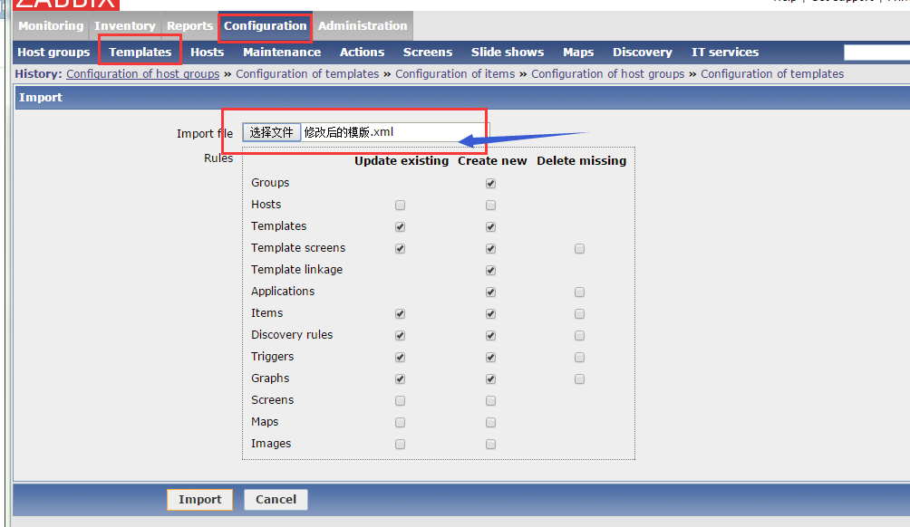
查看模板
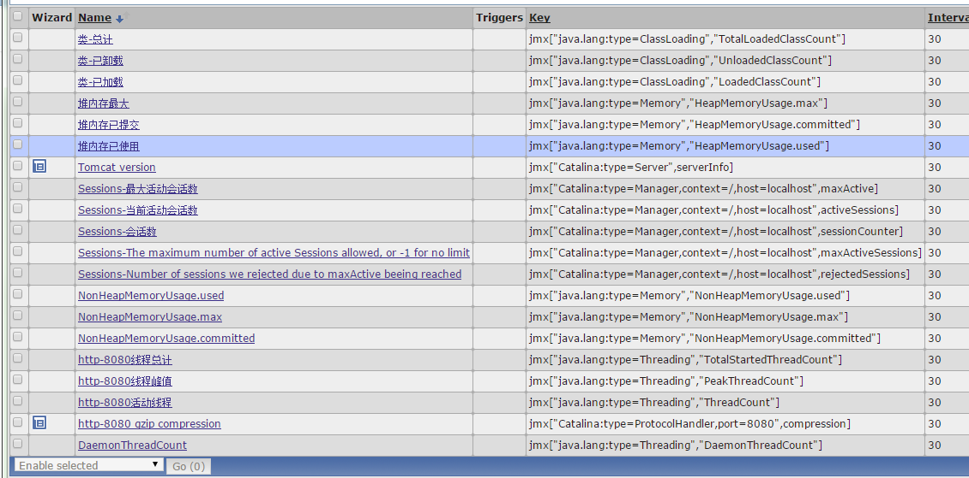

2设置被监控主机的JMX
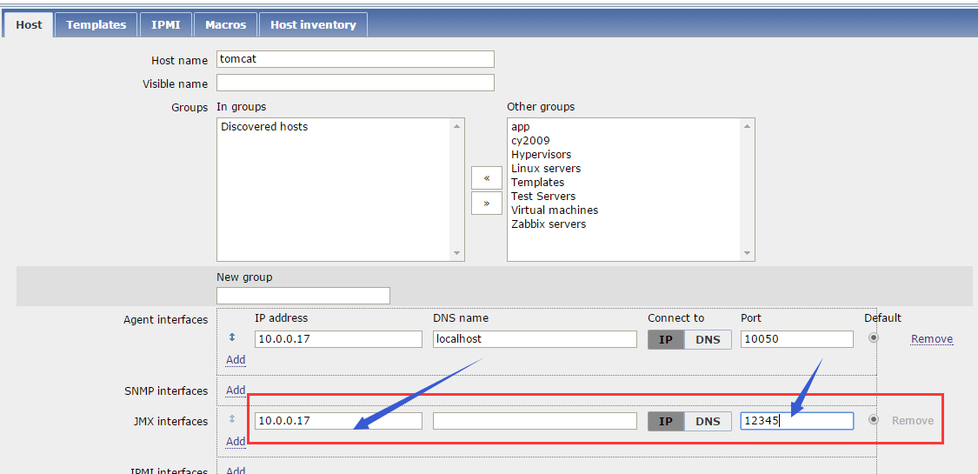

3)关联导入的模板
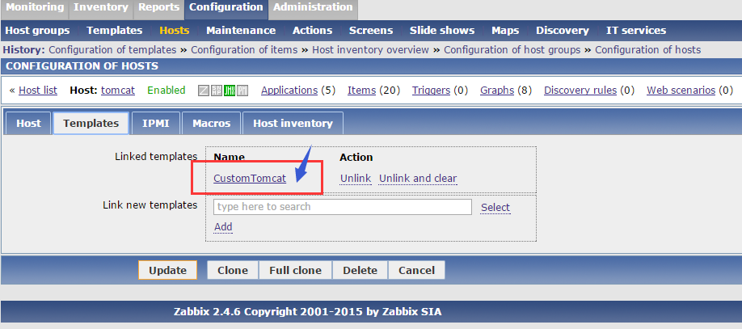

4)OK 等待几分钟就可以发现数据了
