参数化使用的方法：

1. 参数化用户名及密码：一一对应

正确用户名————》正确密码

错误用户名--------------》错误密码

正确用户名--------------》错误密码

登录过程随机匹配参数化中用户名和密码组合

结果：

只有用户名admin匹配到123456时才能登陆成功

其余匹配组合登录均失败。无法进行后续操作

1. 其余参数化组合大部分为随机迭代更新方式：（其余的

Select next row：顺序 唯一

Update value on：顺序更新 一次

也进行了相应的组合）  
其得到的结果如下：

1. 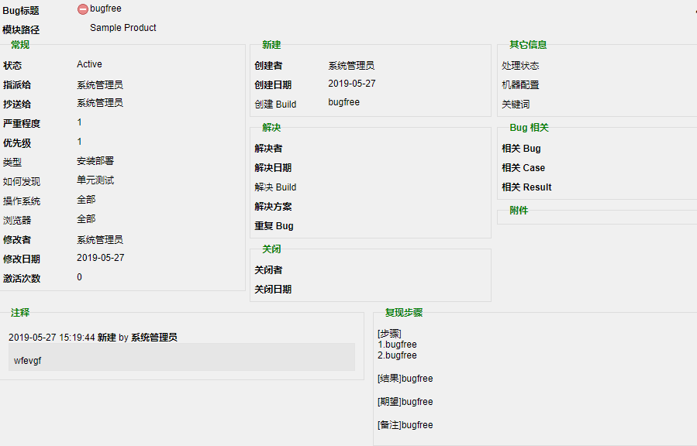
2. 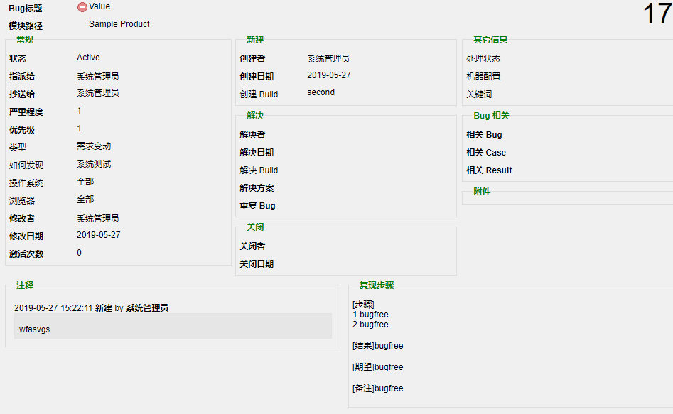
3. 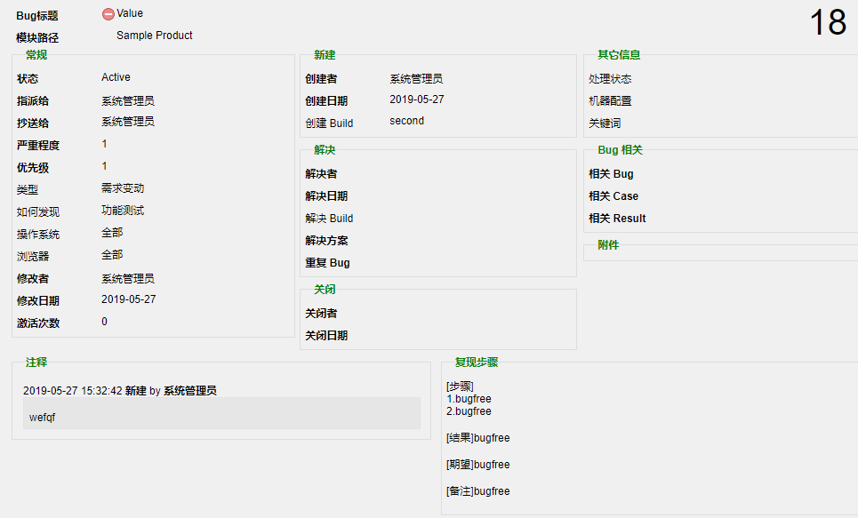
4. 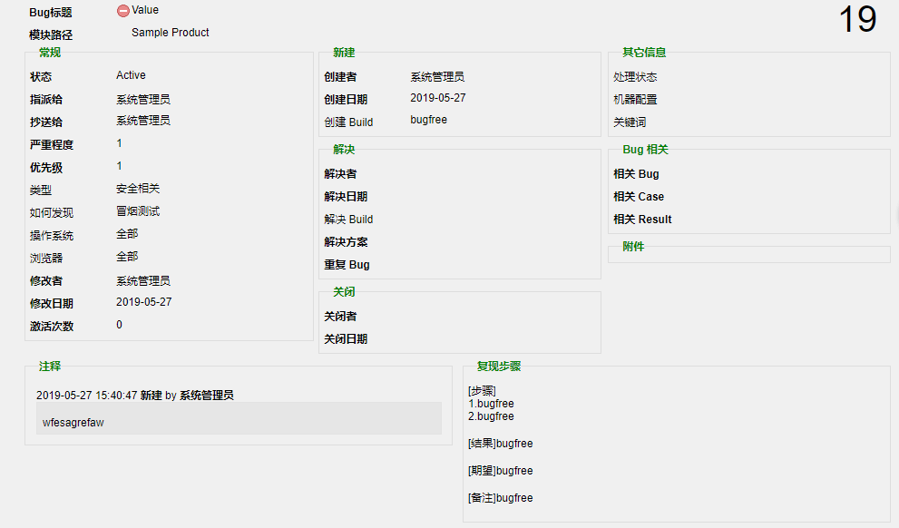

分析结果产生：

1. 相同的标题对应不同类型及如何发现
2. 随机生成标题，随机选择类型及发现
3. 实时更新生成时间

参数化组合方式（1.Sequential 2.Random3. Unique

1. Each interation （2）Each occurrence （3）Once）

九种组合方式：

**（**1）sequential       Once

生成5个测试bug，其中bug标题所有迭代中的取值均一样为value

 （2）unique      once

  生成5个测试bug，其中bug标题所有迭代中的取值以此为列表中

value dsfas dsag we dfwef

（3）Random  Once

生成5个测试bug，其中bug标题所有迭代中的取值为列表中随机抽取，分别为 value dfwef dsfas value dsfas

（4）Sequential      Each iteration

生成5个测试bug，其中bug标题所有迭代中的取值为列表中

value dsfas dsag we dfwef

（5）Unique     Each iteration

生成生成5个测试bug，每个用户每次迭代均随机去一个值生成五个不同

（6）Random     Each Iteration

生成5个测试bug，每个用户每次迭代依照title表里生成五个不同的标题value dsfas dsag we dfwef。

（7）Sequential        Each ocurrance

生成5个新建bug，每次遇到均取一个不同的title值分别是

value dsfas dsag we dfwef。

（8） unique          Each occurrance

 生成5个新建bug，每次遇到均取一个不同的title值。

 （如果要生成更多的bug，那么急需要参数列表中要有足够的参数。）

（9） Random       Each Occurrance

生成5个bug，每个标题每次遇到随机取一个值。

检查点：

通过使用tree视图惊醒检查点的插入

用到的函数方法包含（url 以及image）

函数实现：

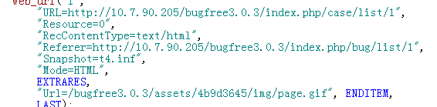

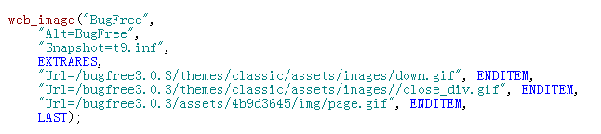

新建bug

脚本：

Action()

{

web_add_cookie("1_product=9e40f4f8ac90faa0dbba40b3445698512887b09as%3A1%3A%221%22%3B; DOMAIN=10.7.90.205");

web_add_cookie("pageSize=601e6f18f0f7d75f725d1c40e3c57164989e2c3as%3A2%3A%2220%22%3B; DOMAIN=10.7.90.205");

web_add_cookie("ac-cookie=%5B%7B%22data%22%3A%5B%22%E7%B3%BB%E7%BB%9F%E7%AE%A1%E7%90%86%E5%91%98%22%2C%22%E7%B3%BB%E7%BB%9F%E7%AE%A1%E7%90%86%E5%91%98%5Badmin%5D%22%5D%2C%22value%22%3A%22%E7%B3%BB%E7%BB%9F%E7%AE%A1%E7%90%86%E5%91%98%22%2C%22result%22%3A%22%E7%B3%BB%E7%BB%9F%E7%AE%A1%E7%90%86%E5%91%98%22%7D%5D; DOMAIN=10.7.90.205");

web_add_cookie("language=0a2b4a62849989ee73f383f7dc48db485efcaca8s%3A5%3A%22zh_cn%22%3B; DOMAIN=10.7.90.205");

lr_start_transaction("login");

web_url("login",

"URL=http://10.7.90.205/bugfree3.0.3/index.php/site/login",

"Resource=0",

"RecContentType=text/html",

"Referer=",

"Snapshot=t1.inf",

"Mode=HTML",

EXTRARES,

"URL=/bugfree3.0.3/themes/classic/assets/images/blue/seperate_line.png", ENDITEM,

"URL=/bugfree3.0.3/themes/classic/assets/images/blue/logo_login.png", ENDITEM,

LAST);

web_submit_form("login_2",

"Snapshot=t2.inf",

ITEMDATA,

"Name=LoginForm[username]", "Value=admin", ENDITEM,

"Name=LoginForm[password]", "Value=123456", ENDITEM,

"Name=LoginForm[language]", "Value=简体中文", ENDITEM,

"Name=LoginForm[rememberMe]", "Value=<OFF>", ENDITEM,

EXTRARES,

"URL=/bugfree3.0.3/themes/classic/assets/images/down.gif", "Referer=http://10.7.90.205/bugfree3.0.3/index.php/bug/list/1", ENDITEM,

"URL=/bugfree3.0.3/themes/classic/assets/images/active.png", "Referer=http://10.7.90.205/bugfree3.0.3/index.php/bug/list/1", ENDITEM,

"URL=/bugfree3.0.3/themes/classic/assets/images//close_div.gif", "Referer=http://10.7.90.205/bugfree3.0.3/index.php/bug/list/1", ENDITEM,

"URL=/bugfree3.0.3/assets/10643704/jui/css/base/images/ui-bg_flat_75_ffffff_40x100.png", "Referer=http://10.7.90.205/bugfree3.0.3/index.php/bug/list/1", ENDITEM,

"URL=/bugfree3.0.3/assets/10643704/jui/css/base/images/ui-icons_222222_256x240.png", "Referer=http://10.7.90.205/bugfree3.0.3/index.php/bug/list/1", ENDITEM,

"URL=/bugfree3.0.3/assets/10643704/jui/css/base/images/ui-bg_highlight-soft_75_cccccc_1x100.png", "Referer=http://10.7.90.205/bugfree3.0.3/index.php/bug/list/1", ENDITEM,

"URL=/bugfree3.0.3/assets/4b9d3645/img/page.gif", "Referer=http://10.7.90.205/bugfree3.0.3/index.php/bug/list/1", ENDITEM,

LAST);

web_submit_data("getProductModule",

"Action=http://10.7.90.205/bugfree3.0.3/index.php/search/getProductModule",

"Method=POST",

"RecContentType=text/html",

"Referer=http://10.7.90.205/bugfree3.0.3/index.php/bug/list/1",

"Snapshot=t3.inf",

"Mode=HTML",

ITEMDATA,

"Name=product_id", "Value=1", ENDITEM,

"Name=productmodule_id", "Value=0", ENDITEM,

LAST);

lr_think_time(7);

lr_end_transaction("login", LR_AUTO);

lr_start_transaction("edit");

web_url("edit",

"URL=http://10.7.90.205/bugfree3.0.3/index.php/info/edit?type=bug&action=opened&product_id=1",

"Resource=0",

"RecContentType=text/html",

"Referer=http://10.7.90.205/bugfree3.0.3/index.php/bug/list/1",

"Snapshot=t4.inf",

"Mode=HTML",

EXTRARES,

"URL=/bugfree3.0.3/themes/classic/assets/images/active.png", "Referer=http://10.7.90.205/bugfree3.0.3/index.php/info/edit?type=bug&action=opened&product_id=1", ENDITEM,

"URL=/bugfree3.0.3/assets/10643704/jui/css/base/images/ui-bg_flat_75_ffffff_40x100.png", "Referer=http://10.7.90.205/bugfree3.0.3/index.php/info/edit?type=bug&action=opened&product_id=1", ENDITEM,

"URL=/bugfree3.0.3/assets/10643704/jui/css/base/images/ui-bg_highlight-soft_75_cccccc_1x100.png", "Referer=http://10.7.90.205/bugfree3.0.3/index.php/info/edit?type=bug&action=opened&product_id=1", ENDITEM,

"URL=/bugfree3.0.3/assets/10643704/jui/css/base/images/ui-icons_222222_256x240.png", "Referer=http://10.7.90.205/bugfree3.0.3/index.php/info/edit?type=bug&action=opened&product_id=1", ENDITEM,

"URL=/bugfree3.0.3/assets/e520453c/themes/default/default.css", "Referer=http://10.7.90.205/bugfree3.0.3/index.php/info/edit?type=bug&action=opened&product_id=1", ENDITEM,

"URL=/bugfree3.0.3/assets/e520453c/themes/default/default.png", "Referer=http://10.7.90.205/bugfree3.0.3/index.php/info/edit?type=bug&action=opened&product_id=1", ENDITEM,

"URL=/bugfree3.0.3/assets/ab61b02b/indicator.gif", "Referer=http://10.7.90.205/bugfree3.0.3/index.php/info/edit?type=bug&action=opened&product_id=1", ENDITEM,

LAST);

lr_think_time(57);

web_submit_data("edit_2",

"Action=http://10.7.90.205/bugfree3.0.3/index.php/info/edit?type=bug&action=opened&product_id=1",

"Method=POST",

"EncType=multipart/form-data",

"RecContentType=text/html",

"Referer=http://10.7.90.205/bugfree3.0.3/index.php/info/edit?type=bug&action=opened&product_id=1",

"Snapshot=t5.inf",

"Mode=HTML",

ITEMDATA,

"Name=BugInfoView[deleted_file_id]", "Value=", ENDITEM,

"Name=BugInfoView[lock_version]", "Value=", ENDITEM,

"Name=BugInfoView[product_id]", "Value=1", ENDITEM,

"Name=isPageDirty", "Value=1", ENDITEM,

"Name=templateTitle", "Value=", ENDITEM,

"Name=BugInfoView[title]", "Value={title}", ENDITEM,

"Name=layer1_module", "Value=0", ENDITEM,

"Name=BugInfoView[productmodule_id]", "Value=0", ENDITEM,

"Name=BugInfoView[assign_to_name]", "Value=系统管理员", ENDITEM,

"Name=BugInfoView[mail_to]", "Value=系统管理员,", ENDITEM,

"Name=BugInfoView[severity]", "Value=1", ENDITEM,

"Name=BugInfoView[priority]", "Value=1", ENDITEM,

"Name=Custom[BugType]", "Value={bugtype}", ENDITEM,

"Name=Custom[HowFound]", "Value={Howfound}", ENDITEM,

"Name=Custom[BugOS]", "Value=全部", ENDITEM,

"Name=Custom[BugBrowser]", "Value=全部", ENDITEM,

"Name=Custom[OpenedBuild]", "Value={build}", ENDITEM,

"Name=Custom[ResolvedBuild]", "Value=", ENDITEM,

"Name=Custom[BugSubStatus]", "Value=", ENDITEM,

"Name=Custom[BugMachine]", "Value=", ENDITEM,

"Name=Custom[BugKeyword]", "Value=", ENDITEM,

"Name=BugInfoView[related_bug]", "Value=", ENDITEM,

"Name=BugInfoView[related_case]", "Value=", ENDITEM,

"Name=BugInfoView[related_result]", "Value=", ENDITEM,

"Name=attachment_file[]", "Value=", "File=yes", ENDITEM,

"Name=BugInfoView[action_note]", "Value={nolte}", ENDITEM,

"Name=BugInfoView[repeat_step]", "Value=[步骤]<br />\r\n"

"1.bugfree<br />\r\n"

"2.bugfree<br />\r\n"

"<br />\r\n"

"[结果]bugfree<br />\r\n"

"<br />\r\n"

"[期望]bugfree<br />\r\n"

"<br />\r\n"

"[备注]bugfree<br />\r\n"

"<br />", ENDITEM,

LAST);

web_url("web_url",

"URL=http://10.7.90.205/bugfree3.0.3/index.php/bug/14",

"TargetFrame=",

"Resource=1",

"Referer=",

"Mode=HTML",

LAST);

web_url("14",

"URL=http://10.7.90.205/bugfree3.0.3/index.php/bug/14",

"Resource=0",

"RecContentType=text/html",

"Referer=",

"Snapshot=t6.inf",

"Mode=HTML",

LAST);

web_url("getPreNextId",

"URL=http://10.7.90.205/bugfree3.0.3/index.php/search/getPreNextId?id=14&type=bug&product_id=1",

"Resource=0",

"RecContentType=text/html",

"Referer=http://10.7.90.205/bugfree3.0.3/index.php/bug/14",

"Snapshot=t7.inf",

"Mode=HTML",

LAST);

lr_end_transaction("edit", LR_AUTO);

return 0;

}

新建case

脚本：

Action()

{

web_add_cookie("1_product=9e40f4f8ac90faa0dbba40b3445698512887b09as%3A1%3A%221%22%3B; DOMAIN=10.7.90.205");

web_add_cookie("pageSize=601e6f18f0f7d75f725d1c40e3c57164989e2c3as%3A2%3A%2220%22%3B; DOMAIN=10.7.90.205");

web_add_cookie("ac-cookie=%5B%7B%22data%22%3A%5B%22%E7%B3%BB%E7%BB%9F%E7%AE%A1%E7%90%86%E5%91%98%22%2C%22%E7%B3%BB%E7%BB%9F%E7%AE%A1%E7%90%86%E5%91%98%5Badmin%5D%22%5D%2C%22value%22%3A%22%E7%B3%BB%E7%BB%9F%E7%AE%A1%E7%90%86%E5%91%98%22%2C%22result%22%3A%22%E7%B3%BB%E7%BB%9F%E7%AE%A1%E7%90%86%E5%91%98%22%7D%5D; DOMAIN=10.7.90.205");

web_add_cookie("language=0a2b4a62849989ee73f383f7dc48db485efcaca8s%3A5%3A%22zh_cn%22%3B; DOMAIN=10.7.90.205");

web_url("login",

"URL=http://10.7.90.205/bugfree3.0.3/index.php/site/login",

"Resource=0",

"RecContentType=text/html",

"Referer=",

"Snapshot=t1.inf",

"Mode=HTML",

EXTRARES,

"Url=/bugfree3.0.3/themes/classic/assets/images/blue/seperate_line.png", ENDITEM,

"Url=/bugfree3.0.3/themes/classic/assets/images/blue/logo_login.png", ENDITEM,

LAST);

lr_start_transaction("login");

web_submit_form("login_2",

"Snapshot=t2.inf",

ITEMDATA,

"Name=LoginForm[username]", "Value=admin", ENDITEM,

"Name=LoginForm[password]", "Value=123456", ENDITEM,

"Name=LoginForm[language]", "Value=简体中文", ENDITEM,

"Name=LoginForm[rememberMe]", "Value=1", ENDITEM,

EXTRARES,

"Url=/bugfree3.0.3/themes/classic/assets/images/down.gif", "Referer=http://10.7.90.205/bugfree3.0.3/index.php/bug/list/1", ENDITEM,

"Url=/bugfree3.0.3/themes/classic/assets/images/active.png", "Referer=http://10.7.90.205/bugfree3.0.3/index.php/bug/list/1", ENDITEM,

"Url=/bugfree3.0.3/themes/classic/assets/images//close_div.gif", "Referer=http://10.7.90.205/bugfree3.0.3/index.php/bug/list/1", ENDITEM,

"Url=/bugfree3.0.3/assets/10643704/jui/css/base/images/ui-bg_flat_75_ffffff_40x100.png", "Referer=http://10.7.90.205/bugfree3.0.3/index.php/bug/list/1", ENDITEM,

"Url=/bugfree3.0.3/assets/10643704/jui/css/base/images/ui-bg_highlight-soft_75_cccccc_1x100.png", "Referer=http://10.7.90.205/bugfree3.0.3/index.php/bug/list/1", ENDITEM,

"Url=/bugfree3.0.3/assets/10643704/jui/css/base/images/ui-icons_222222_256x240.png", "Referer=http://10.7.90.205/bugfree3.0.3/index.php/bug/list/1", ENDITEM,

"Url=/bugfree3.0.3/assets/4b9d3645/img/page.gif", "Referer=http://10.7.90.205/bugfree3.0.3/index.php/bug/list/1", ENDITEM,

LAST);

web_submit_data("getProductModule",

"Action=http://10.7.90.205/bugfree3.0.3/index.php/search/getProductModule",

"Method=POST",

"RecContentType=text/html",

"Referer=http://10.7.90.205/bugfree3.0.3/index.php/bug/list/1",

"Snapshot=t3.inf",

"Mode=HTML",

ITEMDATA,

"Name=product_id", "Value=1", ENDITEM,

"Name=productmodule_id", "Value=0", ENDITEM,

LAST);

lr_end_transaction("login",LR_AUTO);

lr_think_time(19);

web_url("1",

"URL=http://10.7.90.205/bugfree3.0.3/index.php/case/list/1",

"Resource=0",

"RecContentType=text/html",

"Referer=http://10.7.90.205/bugfree3.0.3/index.php/bug/list/1",

"Snapshot=t4.inf",

"Mode=HTML",

EXTRARES,

"Url=/bugfree3.0.3/assets/4b9d3645/img/page.gif", ENDITEM,

LAST);

web_submit_data("getProductModule_2",

"Action=http://10.7.90.205/bugfree3.0.3/index.php/search/getProductModule",

"Method=POST",

"RecContentType=text/html",

"Referer=http://10.7.90.205/bugfree3.0.3/index.php/case/list/1",

"Snapshot=t5.inf",

"Mode=HTML",

ITEMDATA,

"Name=product_id", "Value=1", ENDITEM,

"Name=productmodule_id", "Value=0", ENDITEM,

LAST);

web_url("edit",

"URL=http://10.7.90.205/bugfree3.0.3/index.php/info/edit?type=case&action=opened&product_id=1",

"Resource=0",

"RecContentType=text/html",

"Referer=http://10.7.90.205/bugfree3.0.3/index.php/case/list/1",

"Snapshot=t6.inf",

"Mode=HTML",

EXTRARES,

"Url=/bugfree3.0.3/assets/10643704/jui/css/base/images/ui-bg_highlight-soft_75_cccccc_1x100.png", "Referer=http://10.7.90.205/bugfree3.0.3/index.php/info/edit?type=case&action=opened&product_id=1", ENDITEM,

"Url=/bugfree3.0.3/assets/10643704/jui/css/base/images/ui-bg_flat_75_ffffff_40x100.png", "Referer=http://10.7.90.205/bugfree3.0.3/index.php/info/edit?type=case&action=opened&product_id=1", ENDITEM,

"Url=/bugfree3.0.3/assets/10643704/jui/css/base/images/ui-icons_222222_256x240.png", "Referer=http://10.7.90.205/bugfree3.0.3/index.php/info/edit?type=case&action=opened&product_id=1", ENDITEM,

"Url=/bugfree3.0.3/assets/e520453c/themes/default/default.css", "Referer=http://10.7.90.205/bugfree3.0.3/index.php/info/edit?type=case&action=opened&product_id=1", ENDITEM,

"Url=/bugfree3.0.3/assets/e520453c/themes/default/default.png", "Referer=http://10.7.90.205/bugfree3.0.3/index.php/info/edit?type=case&action=opened&product_id=1", ENDITEM,

LAST);

lr_start_transaction("newcase");

lr_think_time(28);

web_url("edit_2",

"URL=http://10.7.90.205/bugfree3.0.3/index.php/info/edit?type=case&action=opened&product_id=1",

"Resource=0",

"RecContentType=text/html",

"Referer=http://10.7.90.205/bugfree3.0.3/index.php/case/list/1",

"Snapshot=t7.inf",

"Mode=HTML",

EXTRARES,

"Url=/bugfree3.0.3/assets/10643704/jui/css/base/images/ui-bg_flat_75_ffffff_40x100.png", "Referer=http://10.7.90.205/bugfree3.0.3/index.php/info/edit?type=case&action=opened&product_id=1", ENDITEM,

"Url=/bugfree3.0.3/assets/10643704/jui/css/base/images/ui-bg_highlight-soft_75_cccccc_1x100.png", "Referer=http://10.7.90.205/bugfree3.0.3/index.php/info/edit?type=case&action=opened&product_id=1", ENDITEM,

"Url=/bugfree3.0.3/assets/10643704/jui/css/base/images/ui-icons_222222_256x240.png", "Referer=http://10.7.90.205/bugfree3.0.3/index.php/info/edit?type=case&action=opened&product_id=1", ENDITEM,

"Url=/bugfree3.0.3/assets/e520453c/themes/default/default.css", "Referer=http://10.7.90.205/bugfree3.0.3/index.php/info/edit?type=case&action=opened&product_id=1", ENDITEM,

"Url=/bugfree3.0.3/assets/e520453c/themes/default/default.png", "Referer=http://10.7.90.205/bugfree3.0.3/index.php/info/edit?type=case&action=opened&product_id=1", ENDITEM,

"Url=/bugfree3.0.3/assets/ab61b02b/indicator.gif", "Referer=http://10.7.90.205/bugfree3.0.3/index.php/info/edit?type=case&action=opened&product_id=1", ENDITEM,

"Url=/bugfree3.0.3/assets/10643704/jui/css/base/images/ui-bg_glass_75_e6e6e6_1x400.png", "Referer=http://10.7.90.205/bugfree3.0.3/index.php/info/edit?type=case&action=opened&product_id=1", ENDITEM,

"Url=/bugfree3.0.3/assets/10643704/jui/css/base/images/ui-bg_glass_55_fbf9ee_1x400.png", "Referer=http://10.7.90.205/bugfree3.0.3/index.php/info/edit?type=case&action=opened&product_id=1", ENDITEM,

"Url=/bugfree3.0.3/assets/10643704/jui/css/base/images/ui-bg_glass_75_dadada_1x400.png", "Referer=http://10.7.90.205/bugfree3.0.3/index.php/info/edit?type=case&action=opened&product_id=1", ENDITEM,

LAST);

lr_think_time(32);

web_submit_data("edit_3",

"Action=http://10.7.90.205/bugfree3.0.3/index.php/info/edit?type=case&action=opened&product_id=1",

"Method=POST",

"EncType=multipart/form-data",

"RecContentType=text/html",

"Referer=http://10.7.90.205/bugfree3.0.3/index.php/info/edit?type=case&action=opened&product_id=1",

"Snapshot=t8.inf",

"Mode=HTML",

ITEMDATA,

"Name=CaseInfoView[deleted_file_id]", "Value=", ENDITEM,

"Name=CaseInfoView[lock_version]", "Value=", ENDITEM,

"Name=CaseInfoView[product_id]", "Value=1", ENDITEM,

"Name=isPageDirty", "Value=1", ENDITEM,

"Name=templateTitle", "Value=", ENDITEM,

"Name=CaseInfoView[title]", "Value={title}", ENDITEM,

"Name=layer1_module", "Value=0", ENDITEM,

"Name=CaseInfoView[productmodule_id]", "Value=0", ENDITEM,

"Name=CaseInfoView[case_status]", "Value=Active", ENDITEM,

"Name=CaseInfoView[assign_to_name]", "Value=系统管理员", ENDITEM,

"Name=CaseInfoView[mail_to]", "Value=", ENDITEM,

"Name=CaseInfoView[priority]", "Value=1", ENDITEM,

"Name=Custom[CaseType]", "Value={casetype}", ENDITEM,

"Name=Custom[CaseMethod]", "Value={method}", ENDITEM,

"Name=Custom[CasePlan]", "Value={plan}", ENDITEM,

"Name=Custom[ScriptStatus]", "Value=未计划", ENDITEM,

"Name=Custom[ScriptedBy]", "Value=系统管理员", ENDITEM,

"Name=Custom[ScriptedDate]", "Value=2019-05-27", ENDITEM,

"Name=Custom[ScriptLocation]", "Value=", ENDITEM,

"Name=Custom[CaseKeyword]", "Value=", ENDITEM,

"Name=Custom[DisplayOrder]", "Value=0", ENDITEM,

"Name=CaseInfoView[related_bug]", "Value=", ENDITEM,

"Name=CaseInfoView[related_case]", "Value=", ENDITEM,

"Name=attachment_file[]", "Value=", "File=Yes", ENDITEM,

"Name=CaseInfoView[action_note]", "Value=newcase", ENDITEM,

"Name=CaseInfoView[case_step]", "Value=[步骤]<br />\r\n1.newcase<br />\r\n2.newcase<br />\r\n<br />\r\n[验证]newcase<br />\r\n<br />\r\n[备注]newcase<br />\r\n<br />", ENDITEM,

LAST);

web_image("BugFree",

"Alt=BugFree",

"Snapshot=t9.inf",

EXTRARES,

"Url=/bugfree3.0.3/themes/classic/assets/images/down.gif", ENDITEM,

"Url=/bugfree3.0.3/themes/classic/assets/images//close_div.gif", ENDITEM,

"Url=/bugfree3.0.3/assets/4b9d3645/img/page.gif", ENDITEM,

LAST);

web_link("newcase",

"Text=newcase",

"Snapshot=t10.inf",

LAST);

web_submit_data("getProductModule_3",

"Action=http://10.7.90.205/bugfree3.0.3/index.php/search/getProductModule",

"Method=POST",

"RecContentType=text/html",

"Referer=http://10.7.90.205/bugfree3.0.3/index.php/case/list/1",

"Snapshot=t11.inf",

"Mode=HTML",

ITEMDATA,

"Name=product_id", "Value=1", ENDITEM,

"Name=productmodule_id", "Value=0", ENDITEM,

LAST);

web_url("getPreNextId",

"URL=http://10.7.90.205/bugfree3.0.3/index.php/search/getPreNextId?id=5&type=case&product_id=1",

"Resource=0",

"RecContentType=text/html",

"Referer=http://10.7.90.205/bugfree3.0.3/index.php/case/5",

"Snapshot=t12.inf",

"Mode=HTML",

LAST);

lr_end_transaction("newcase",LR_AUTO);

return 0;

}