# 实验二 **熟悉常用的HDFS操作**

|  |  |  |  |  |
| --- | --- | --- | --- | --- |
| **地 点：** | B10楼 | 303房； | **实验台号：** |  |
| **实验日期与时间：** | 2023/3/16 | | **评 分：** |  |
| **预习检查纪录：** |  | | **实验教师：** | 焦青松 |

1. **实验目的**

**（1）.理解HDFS在Hadoop体系结构的角色。**

**(2).熟练使用HDFS操作常用的Shell命令**

**(3).熟悉HDFS操作常用的Java API。**

1. **实验平台**

(1).操作系统:Linux

(2).Hadoop版本:3.3.5

(3).JDK版本:19.3.0

(4).Java IDE:eclipse

1. **实验步骤（包括实验结果/截图）**



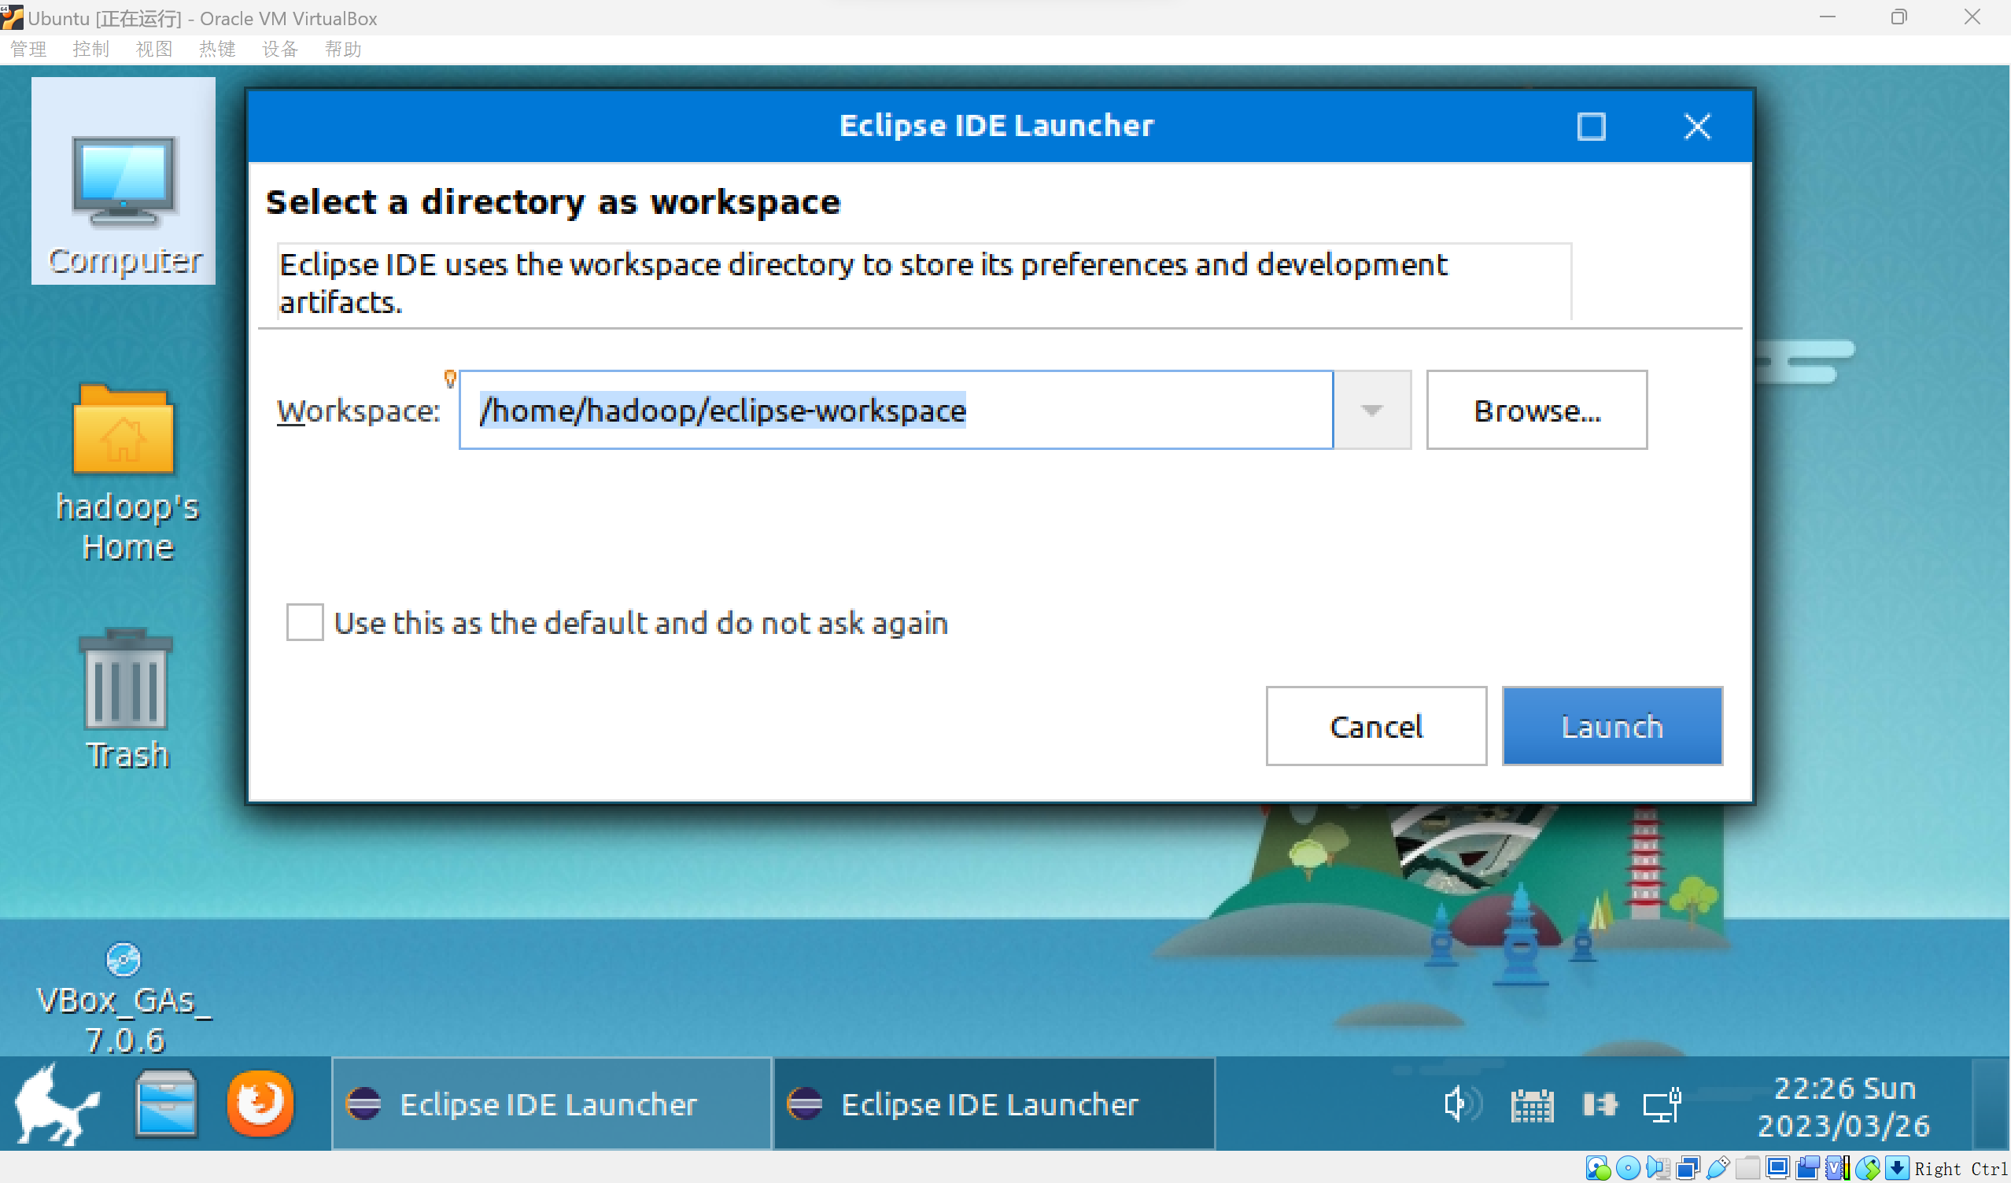

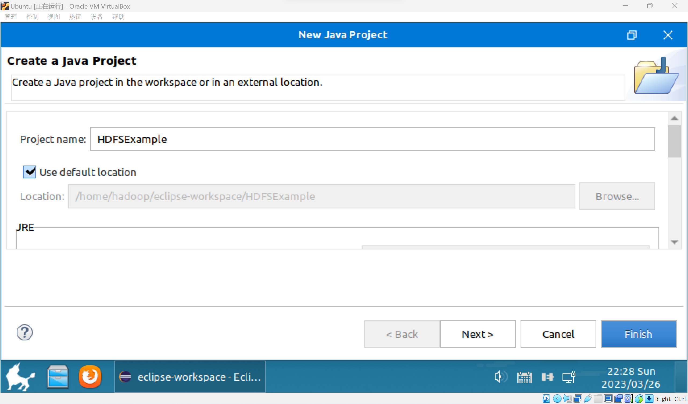

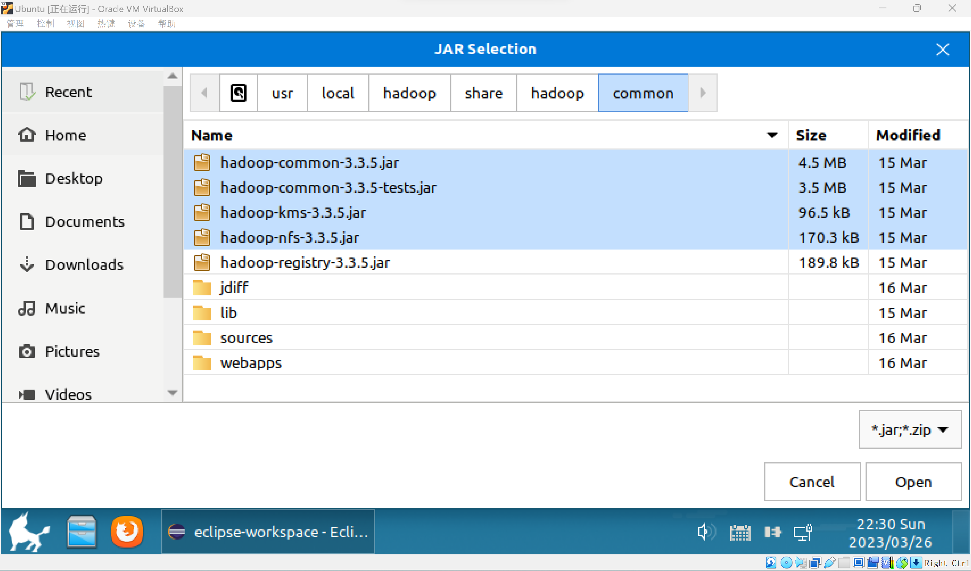

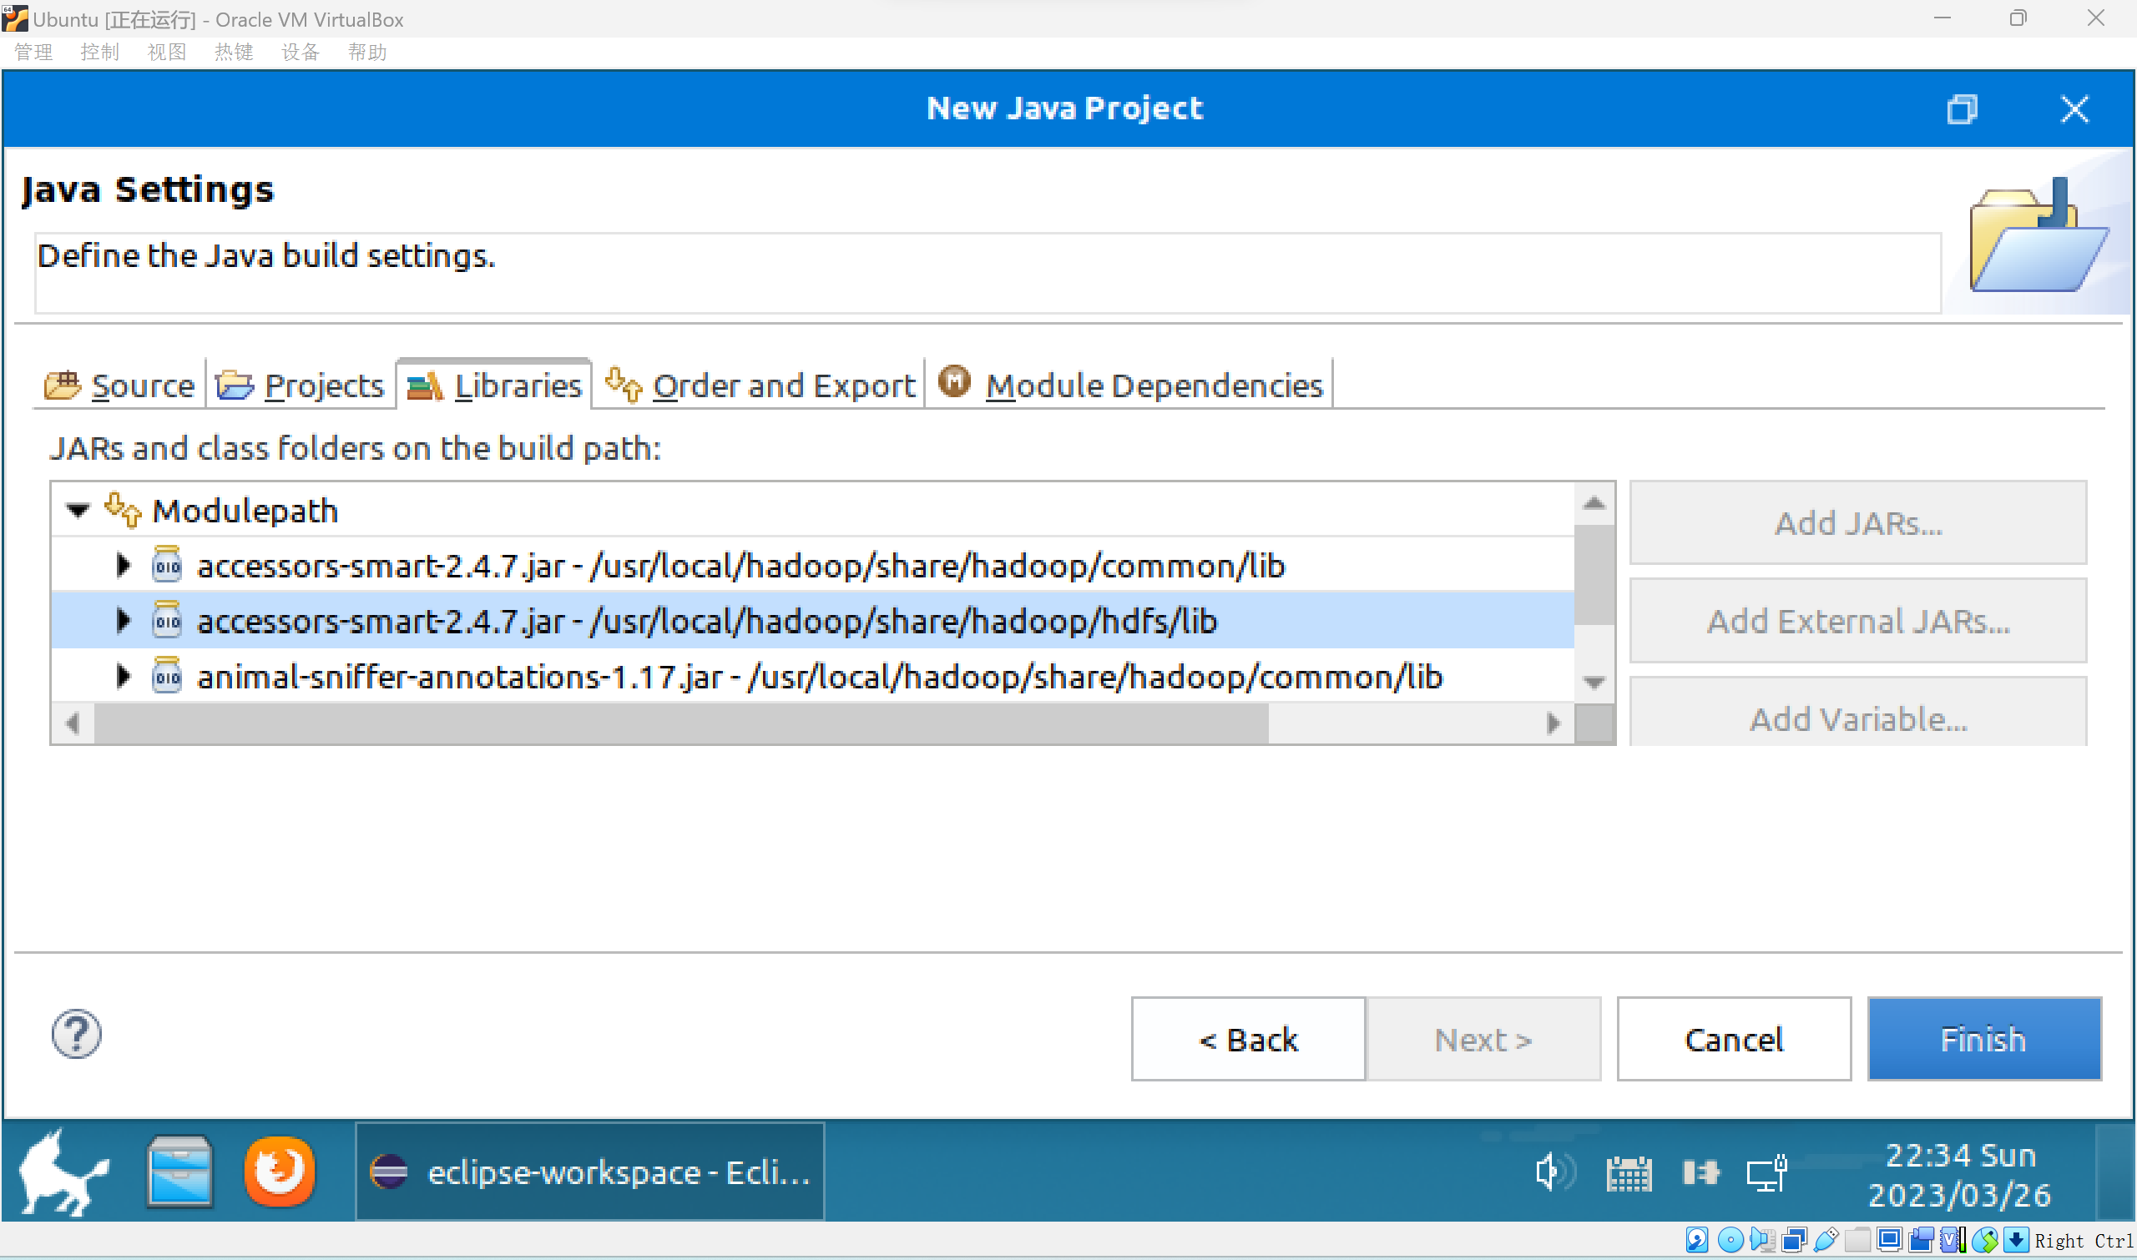

**所有jar包安装完毕。**

**新建类**

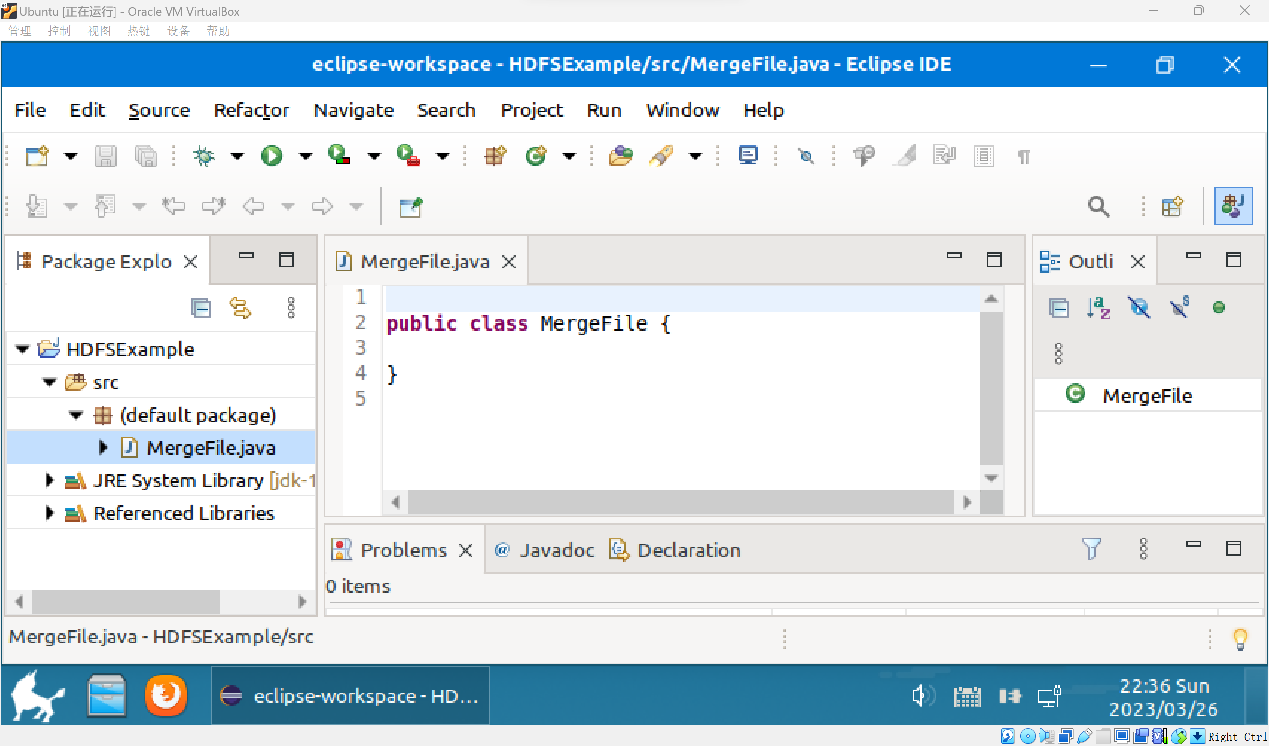

**无报错的创建类**

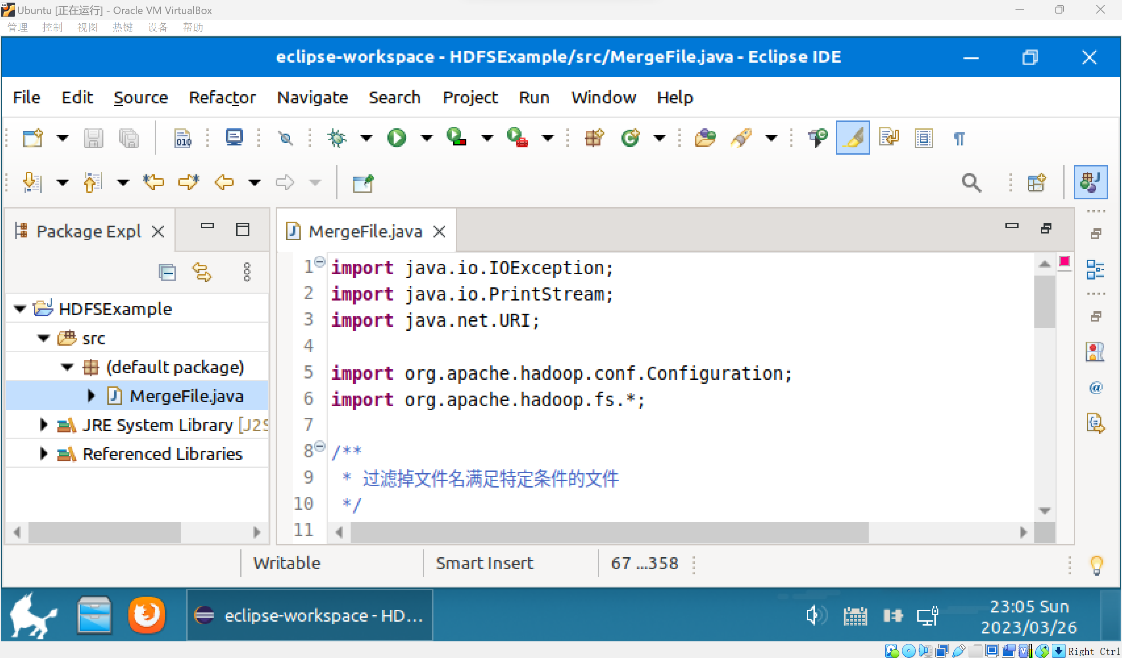

**创建五个需要的文件**

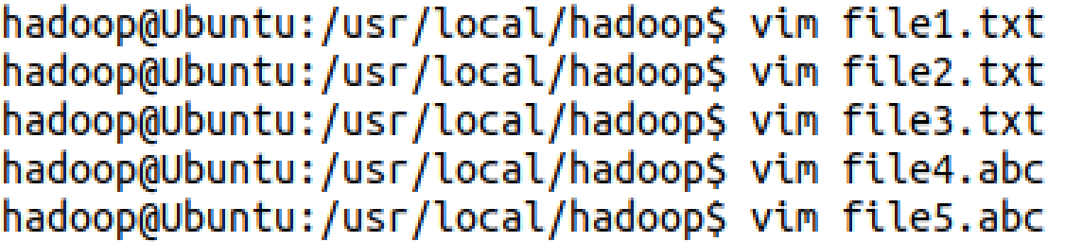

**将5个文件移入hdfs的user/hadoop处**

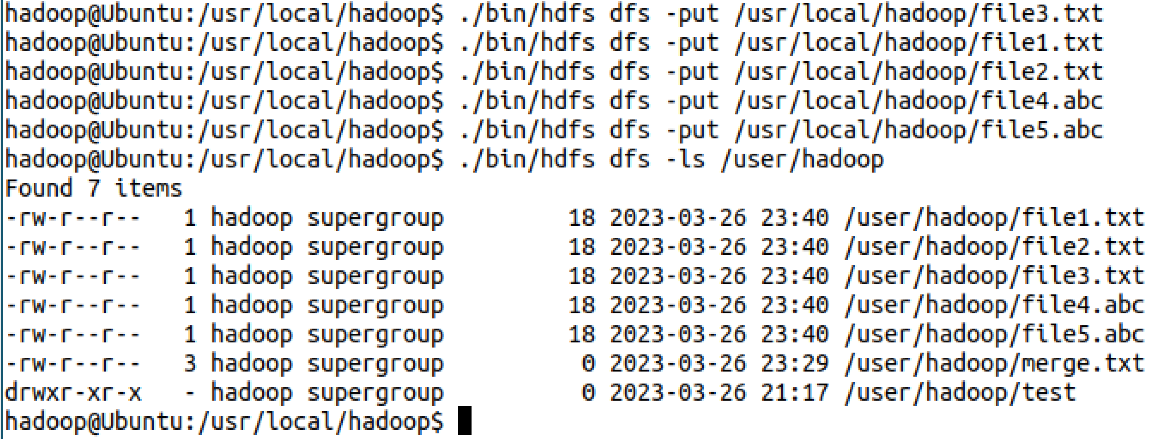

**在运行代码之前必须删除test文件夹，否则不能运行。**

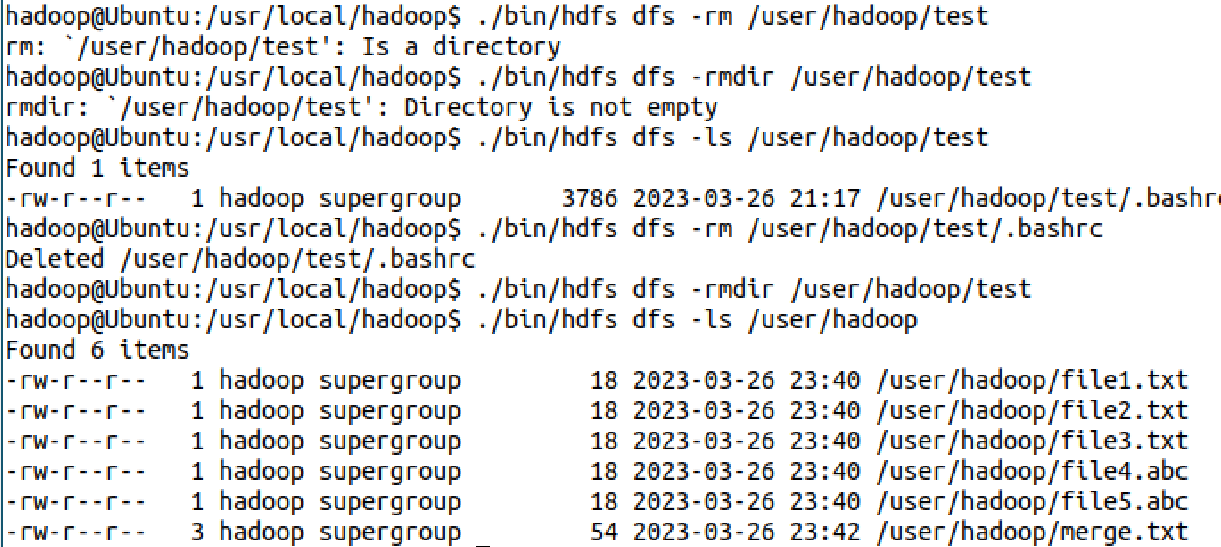

**运行成功**

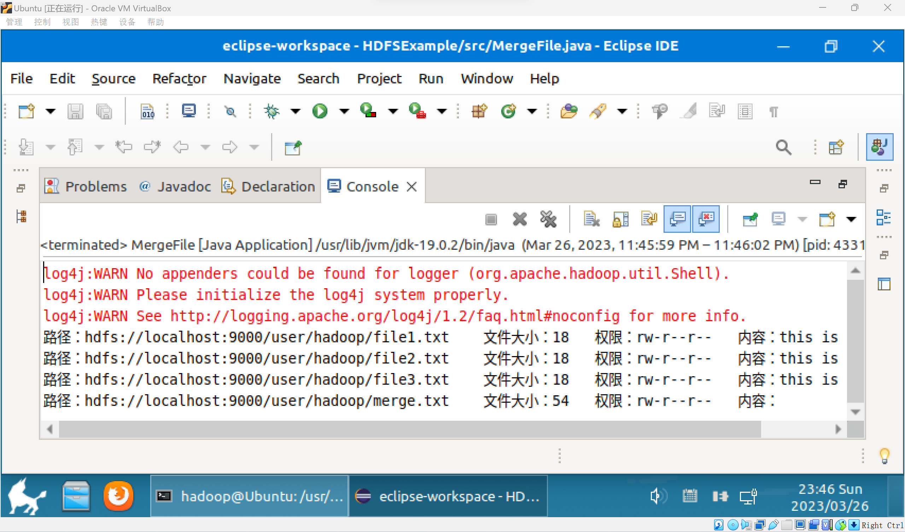

**模型部署**

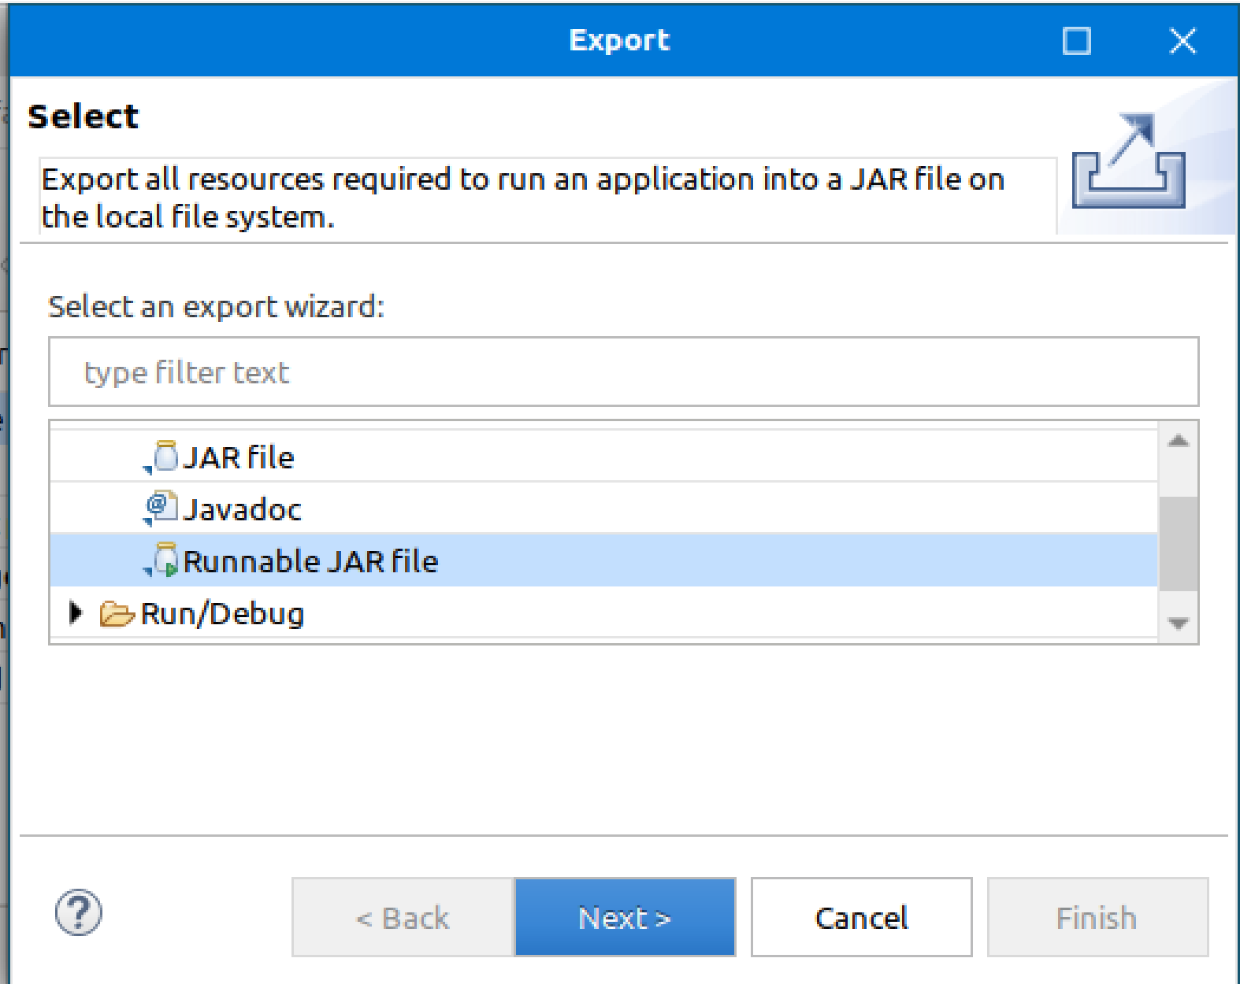

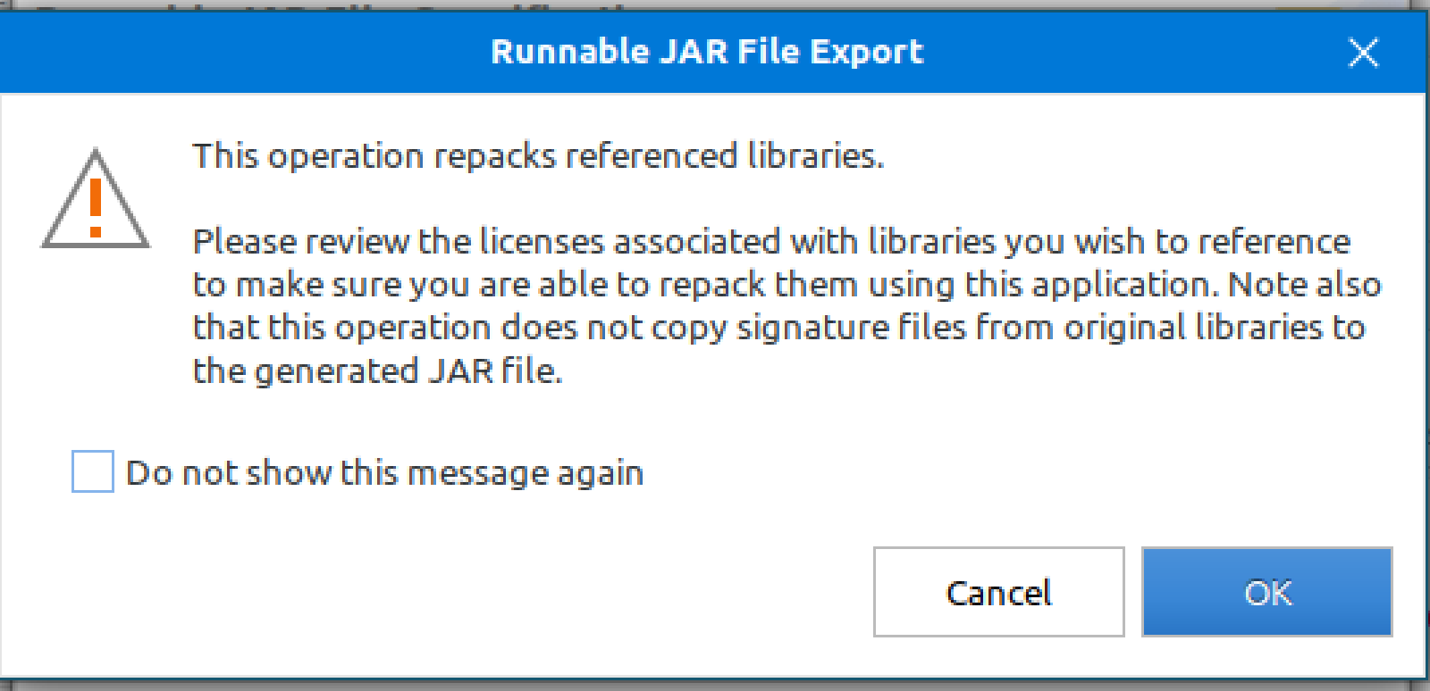

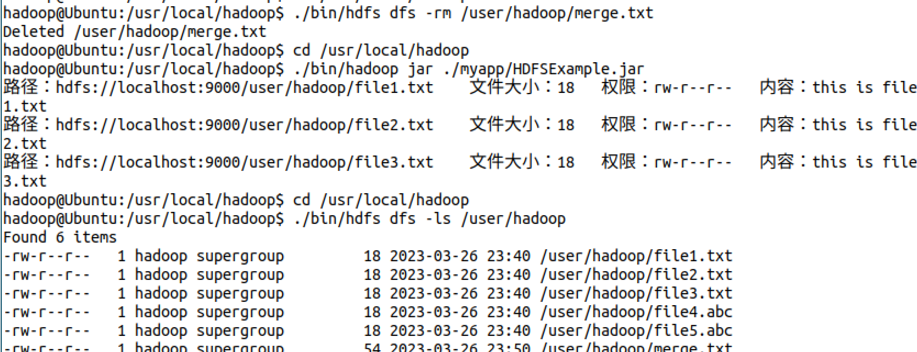

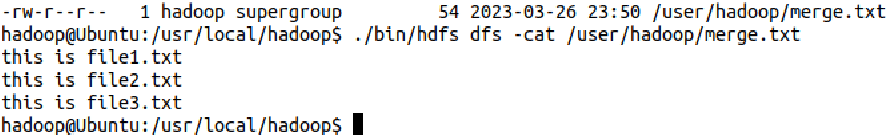

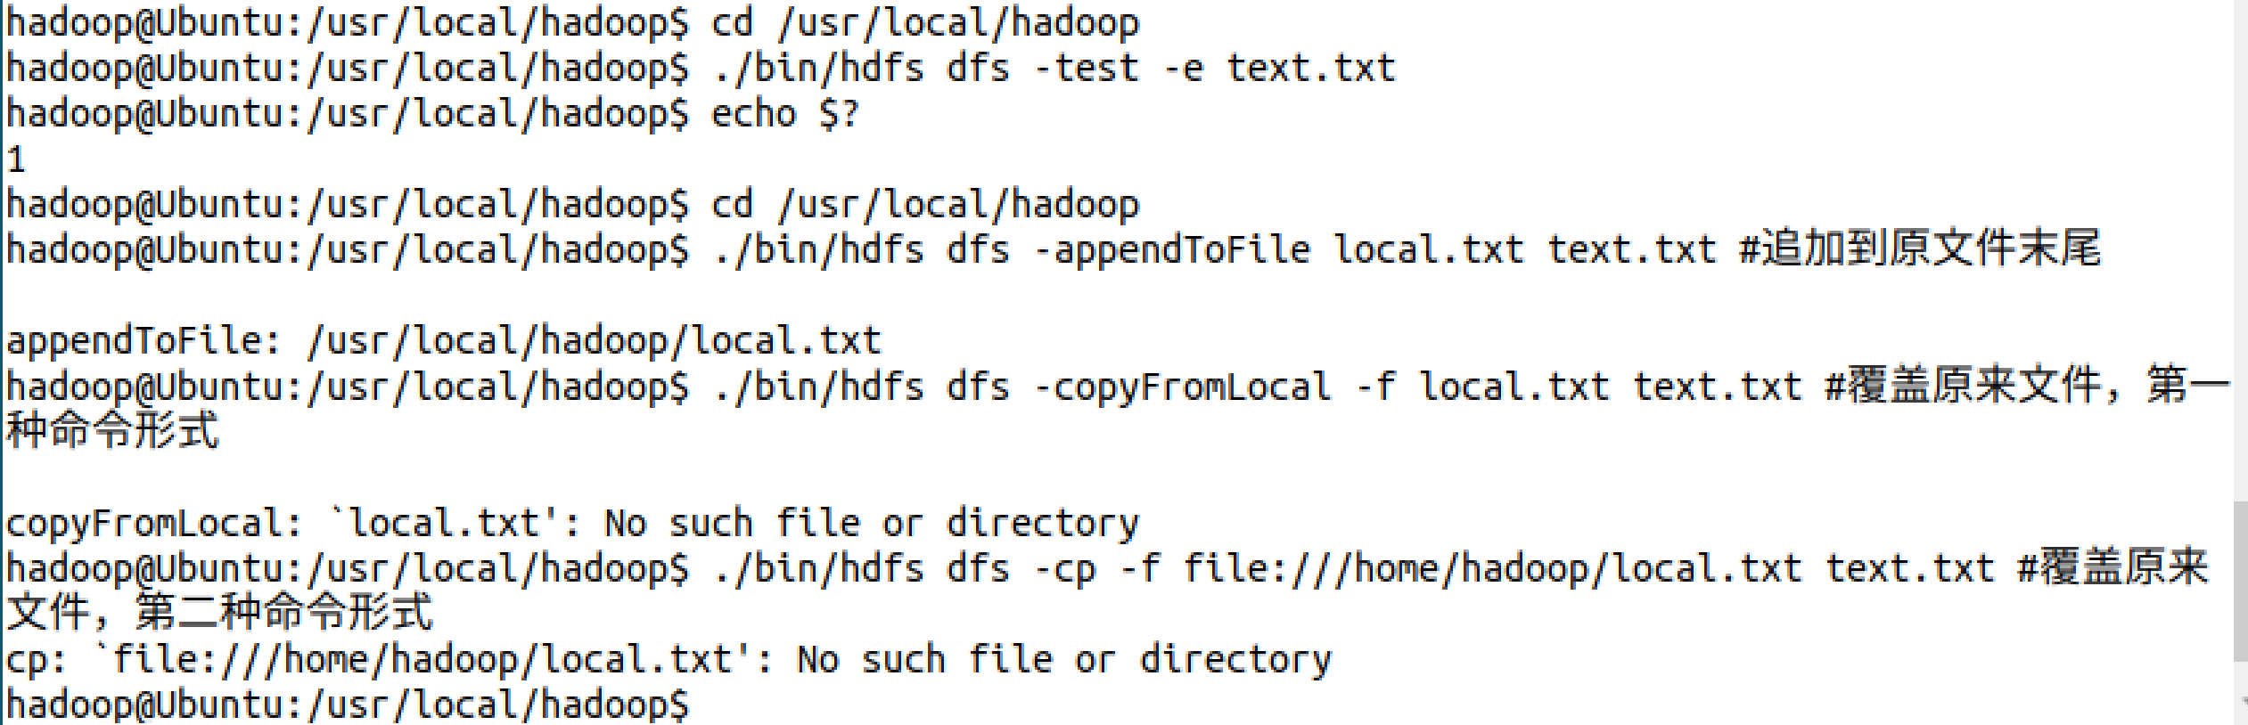

1. **思考讨论题或体会或对改进实验的建议**

可以使用Intellj IDEA作为项目IDE。

1. **实验源代码**

**import org.apache.hadoop.conf.Configuration;**

**import org.apache.hadoop.fs.*;**

**import java.io.*;**

**public class HDFSApi {**

**/\*\***

**\* 判断路径是否存在**

**\*/**

**public static boolean test(Configuration conf, String path) throws IOException {**

**FileSystem fs = FileSystem.get(conf);**

**return fs.exists(new Path(path));**

**}**

**/\*\***

**\* 复制文件到指定路径**

**\* 若路径已存在，则进行覆盖**

**\*/**

**public static void copyFromLocalFile(Configuration conf, String localFilePath, String remoteFilePath) throws IOException {**

**FileSystem fs = FileSystem.get(conf);**

**Path localPath = new Path(localFilePath);**

**Path remotePath = new Path(remoteFilePath);**

**/* fs.copyFromLocalFile 第一个参数表示是否删除源文件，第二个参数表示是否覆盖 */**

**fs.copyFromLocalFile(false, true, localPath, remotePath);**

**fs.close();**

**}**

**/\*\***

**\* 追加文件内容**

**\*/**

**public static void appendToFile(Configuration conf, String localFilePath, String remoteFilePath) throws IOException {**

**FileSystem fs = FileSystem.get(conf);**

**Path remotePath = new Path(remoteFilePath);**

**/* 创建一个文件读入流 */**

**FileInputStream in = new FileInputStream(localFilePath);**

**/* 创建一个文件输出流，输出的内容将追加到文件末尾 */**

**FSDataOutputStream out = fs.append(remotePath);**

**/* 读写文件内容 */**

**byte[] data = new byte[1024];**

**int read = -1;**

**while ( (read = in.read(data)) > 0 ) {**

**out.write(data, 0, read);**

**}**

**out.close();**

**in.close();**

**fs.close();**

**}**

**/\*\***

**\* 主函数**

**\*/**

**public static void main(String[] args) {**

**Configuration conf = new Configuration();**

**conf.set("fs.default.name","hdfs://localhost:9000");**

**String localFilePath = "/home/hadoop/text.txt"; // 本地路径**

**String remoteFilePath = "/user/hadoop/text.txt"; // HDFS路径**

**String choice = "append"; // 若文件存在则追加到文件末尾**

**// String choice = "overwrite"; // 若文件存在则覆盖**

**try {**

**/* 判断文件是否存在 */**

**Boolean fileExists = false;**

**if (HDFSApi.test(conf, remoteFilePath)) {**

**fileExists = true;**

**System.out.println(remoteFilePath + " 已存在.");**

**} else {**

**System.out.println(remoteFilePath + " 不存在.");**

**}**

**/* 进行处理 */**

**if ( !fileExists) { // 文件不存在，则上传**

**HDFSApi.copyFromLocalFile(conf, localFilePath, remoteFilePath);**

**System.out.println(localFilePath + " 已上传至 " + remoteFilePath);**

**} else if ( choice.equals("overwrite") ) { // 选择覆盖**

**HDFSApi.copyFromLocalFile(conf, localFilePath, remoteFilePath);**

**System.out.println(localFilePath + " 已覆盖 " + remoteFilePath);**

**} else if ( choice.equals("append") ) { // 选择追加**

**HDFSApi.appendToFile(conf, localFilePath, remoteFilePath);**

**System.out.println(localFilePath + " 已追加至 " + remoteFilePath);**

**}**

**} catch (Exception e) {**

**e.printStackTrace();**

**}**

**}**

**}**

**cd /usr/local/hadoop**

**./bin/hdfs dfs -test -e text.txt**

**import org.apache.hadoop.conf.Configuration;**

**import org.apache.hadoop.fs.*;**

**import java.io.*;**

**public class HDFSApi {**

**/\*\***

**\* 下载文件到本地**

**\* 判断本地路径是否已存在，若已存在，则自动进行重命名**

**\*/**

**public static void copyToLocal(Configuration conf, String remoteFilePath, String localFilePath) throws IOException {**

**FileSystem fs = FileSystem.get(conf);**

**Path remotePath = new Path(remoteFilePath);**

**File f = new File(localFilePath);**

**/* 如果文件名存在，自动重命名(在文件名后面加上 _0, _1 ...) */**

**if (f.exists()) {**

**System.out.println(localFilePath + " 已存在.");**

**Integer i = 0;**

**while (true) {**

**f = new File(localFilePath + "_" + i.toString());**

**if (!f.exists()) {**

**localFilePath = localFilePath + "_" + i.toString();**

**break;**

**}**

**}**

**System.out.println("将重新命名为: " + localFilePath);**

**}**

**// 下载文件到本地**

**Path localPath = new Path(localFilePath);**

**fs.copyToLocalFile(remotePath, localPath);**

**fs.close();**

**}**

**/\*\***

**\* 主函数**

**\*/**

**public static void main(String[] args) {**

**Configuration conf = new Configuration();**

**conf.set("fs.default.name","hdfs://localhost:9000");**

**String localFilePath = "/home/hadoop/text.txt"; // 本地路径**

**String remoteFilePath = "/user/hadoop/text.txt"; // HDFS路径**

**try {**

**HDFSApi.copyToLocal(conf, remoteFilePath, localFilePath);**

**System.out.println("下载完成");**

**} catch (Exception e) {**

**e.printStackTrace();**

**}**

**}**

**}**

**import org.apache.hadoop.conf.Configuration;**

**import org.apache.hadoop.fs.*;**

**import java.io.*;**

**public class HDFSApi {**

**/\*\***

**\* 读取文件内容**

**\*/**

**public static void cat(Configuration conf, String remoteFilePath) throws IOException {**

**FileSystem fs = FileSystem.get(conf);**

**Path remotePath = new Path(remoteFilePath);**

**FSDataInputStream in = fs.open(remotePath);**

**BufferedReader d = new BufferedReader(new InputStreamReader(in));**

**String line = null;**

**while ( (line = d.readLine()) != null ) {**

**System.out.println(line);**

**}**

**d.close();**

**in.close();**

**fs.close();**

**}**

**/\*\***

**\* 主函数**

**\*/**

**public static void main(String[] args) {**

**Configuration conf = new Configuration();**

**conf.set("fs.default.name","hdfs://localhost:9000");**

**String remoteFilePath = "/user/hadoop/text.txt"; // HDFS路径**

**try {**

**System.out.println("读取文件: " + remoteFilePath);**

**HDFSApi.cat(conf, remoteFilePath);**

**System.out.println("\n读取完成");**

**} catch (Exception e) {**

**e.printStackTrace();**

**}**

**}**

**}**

**import org.apache.hadoop.conf.Configuration;**

**import org.apache.hadoop.fs.*;**

**import java.io.*;**

**import java.text.SimpleDateFormat;**

**public class HDFSApi {**

**/\*\***

**\* 显示指定文件的信息**

**\*/**

**public static void ls(Configuration conf, String remoteFilePath) throws IOException {**

**FileSystem fs = FileSystem.get(conf);**

**Path remotePath = new Path(remoteFilePath);**

**FileStatus[] fileStatuses = fs.listStatus(remotePath);**

**for (FileStatus s : fileStatuses) {**

**System.out.println("路径: " + s.getPath().toString());**

**System.out.println("权限: " + s.getPermission().toString());**

**System.out.println("大小: " + s.getLen());**

**/* 返回的是时间戳,转化为时间日期格式 */**

**Long timeStamp = s.getModificationTime();**

**SimpleDateFormat format = new SimpleDateFormat("yyyy-MM-dd HH:mm:ss");**

**String date = format.format(timeStamp);**

**System.out.println("时间: " + date);**

**}**

**fs.close();**

**}**

**/\*\***

**\* 主函数**

**\*/**

**public static void main(String[] args) {**

**Configuration conf = new Configuration();**

**conf.set("fs.default.name","hdfs://localhost:9000");**

**String remoteFilePath = "/user/hadoop/text.txt"; // HDFS路径**

**try {**

**System.out.println("读取文件信息: " + remoteFilePath);**

**HDFSApi.ls(conf, remoteFilePath);**

**System.out.println("\n读取完成");**

**} catch (Exception e) {**

**e.printStackTrace();**

**}**

**}**

**}**

**import org.apache.hadoop.conf.Configuration;**

**import org.apache.hadoop.fs.*;**

**import java.io.*;**

**import java.text.SimpleDateFormat;**

**public class HDFSApi {**

**/\*\***

**\* 显示指定文件夹下所有文件的信息（递归）**

**\*/**

**public static void lsDir(Configuration conf, String remoteDir) throws IOException {**

**FileSystem fs = FileSystem.get(conf);**

**Path dirPath = new Path(remoteDir);**

**/* 递归获取目录下的所有文件 */**

**RemoteIterator<LocatedFileStatus> remoteIterator = fs.listFiles(dirPath, true);**

**/* 输出每个文件的信息 */**

**while (remoteIterator.hasNext()) {**

**FileStatus s = remoteIterator.next();**

**System.out.println("路径: " + s.getPath().toString());**

**System.out.println("权限: " + s.getPermission().toString());**

**System.out.println("大小: " + s.getLen());**

**/* 返回的是时间戳,转化为时间日期格式 */**

**Long timeStamp = s.getModificationTime();**

**SimpleDateFormat format = new SimpleDateFormat("yyyy-MM-dd HH:mm:ss");**

**String date = format.format(timeStamp);**

**System.out.println("时间: " + date);**

**System.out.println();**

**}**

**fs.close();**

**}**

**/\*\***

**\* 主函数**

**\*/**

**public static void main(String[] args) {**

**Configuration conf = new Configuration();**

**conf.set("fs.default.name","hdfs://localhost:9000");**

**String remoteDir = "/user/hadoop"; // HDFS路径**

**try {**

**System.out.println("(递归)读取目录下所有文件的信息: " + remoteDir);**

**HDFSApi.lsDir(conf, remoteDir);**

**System.out.println("读取完成");**

**} catch (Exception e) {**

**e.printStackTrace();**

**}**

**}**

**}**

**import org.apache.hadoop.conf.Configuration;**

**import org.apache.hadoop.fs.*;**

**import java.io.*;**

**public class HDFSApi {**

**/\*\***

**\* 判断路径是否存在**

**\*/**

**public static boolean test(Configuration conf, String path) throws IOException {**

**FileSystem fs = FileSystem.get(conf);**

**return fs.exists(new Path(path));**

**}**

**/\*\***

**\* 创建目录**

**\*/**

**public static boolean mkdir(Configuration conf, String remoteDir) throws IOException {**

**FileSystem fs = FileSystem.get(conf);**

**Path dirPath = new Path(remoteDir);**

**boolean result = fs.mkdirs(dirPath);**

**fs.close();**

**return result;**

**}**

**/\*\***

**\* 创建文件**

**\*/**

**public static void touchz(Configuration conf, String remoteFilePath) throws IOException {**

**FileSystem fs = FileSystem.get(conf);**

**Path remotePath = new Path(remoteFilePath);**

**FSDataOutputStream outputStream = fs.create(remotePath);**

**outputStream.close();**

**fs.close();**

**}**

**/\*\***

**\* 删除文件**

**\*/**

**public static boolean rm(Configuration conf, String remoteFilePath) throws IOException {**

**FileSystem fs = FileSystem.get(conf);**

**Path remotePath = new Path(remoteFilePath);**

**boolean result = fs.delete(remotePath, false);**

**fs.close();**

**return result;**

**}**

**/\*\***

**\* 主函数**

**\*/**

**public static void main(String[] args) {**

**Configuration conf = new Configuration();**

**conf.set("fs.default.name","hdfs://localhost:9000");**

**String remoteFilePath = "/user/hadoop/input/text.txt"; // HDFS路径**

**String remoteDir = "/user/hadoop/input"; // HDFS路径对应的目录**

**try {**

**/* 判断路径是否存在，存在则删除，否则进行创建 */**

**if ( HDFSApi.test(conf, remoteFilePath) ) {**

**HDFSApi.rm(conf, remoteFilePath); // 删除**

**System.out.println("删除路径: " + remoteFilePath);**

**} else {**

**if ( !HDFSApi.test(conf, remoteDir) ) { // 若目录不存在，则进行创建**

**HDFSApi.mkdir(conf, remoteDir);**

**System.out.println("创建文件夹: " + remoteDir);**

**}**

**HDFSApi.touchz(conf, remoteFilePath);**

**System.out.println("创建路径: " + remoteFilePath);**

**}**

**} catch (Exception e) {**

**e.printStackTrace();**

**}**

**}**

**}**

**import org.apache.hadoop.conf.Configuration;**

**import org.apache.hadoop.fs.*;**

**import java.io.*;**

**public class HDFSApi {**

**/\*\***

**\* 判断路径是否存在**

**\*/**

**public static boolean test(Configuration conf, String path) throws IOException {**

**FileSystem fs = FileSystem.get(conf);**

**return fs.exists(new Path(path));**

**}**

**/\*\***

**\* 判断目录是否为空**

**\* true: 空，false: 非空**

**\*/**

**public static boolean isDirEmpty(Configuration conf, String remoteDir) throws IOException {**

**FileSystem fs = FileSystem.get(conf);**

**Path dirPath = new Path(remoteDir);**

**RemoteIterator<LocatedFileStatus> remoteIterator = fs.listFiles(dirPath, true);**

**return !remoteIterator.hasNext();**

**}**

**/\*\***

**\* 创建目录**

**\*/**

**public static boolean mkdir(Configuration conf, String remoteDir) throws IOException {**

**FileSystem fs = FileSystem.get(conf);**

**Path dirPath = new Path(remoteDir);**

**boolean result = fs.mkdirs(dirPath);**

**fs.close();**

**return result;**

**}**

**/\*\***

**\* 删除目录**

**\*/**

**public static boolean rmDir(Configuration conf, String remoteDir) throws IOException {**

**FileSystem fs = FileSystem.get(conf);**

**Path dirPath = new Path(remoteDir);**

**/* 第二个参数表示是否递归删除所有文件 */**

**boolean result = fs.delete(dirPath, true);**

**fs.close();**

**return result;**

**}**

**/\*\***

**\* 主函数**

**\*/**

**public static void main(String[] args) {**

**Configuration conf = new Configuration();**

**conf.set("fs.default.name","hdfs://localhost:9000");**

**String remoteDir = "/user/hadoop/input"; // HDFS目录**

**Boolean forceDelete = false; // 是否强制删除**

**try {**

**/* 判断目录是否存在，不存在则创建，存在则删除 */**

**if ( !HDFSApi.test(conf, remoteDir) ) {**

**HDFSApi.mkdir(conf, remoteDir); // 创建目录**

**System.out.println("创建目录: " + remoteDir);**

**} else {**

**if ( HDFSApi.isDirEmpty(conf, remoteDir) || forceDelete ) { // 目录为空或强制删除**

**HDFSApi.rmDir(conf, remoteDir);**

**System.out.println("删除目录: " + remoteDir);**

**} else { // 目录不为空**

**System.out.println("目录不为空，不删除: " + remoteDir);**

**}**

**}**

**} catch (Exception e) {**

**e.printStackTrace();**

**}**

**}**

**}**

**import org.apache.hadoop.conf.Configuration;**

**import org.apache.hadoop.fs.*;**

**import java.io.*;**

**public class HDFSApi {**

**/\*\***

**\* 判断路径是否存在**

**\*/**

**public static boolean test(Configuration conf, String path) throws IOException {**

**FileSystem fs = FileSystem.get(conf);**

**return fs.exists(new Path(path));**

**}**

**/\*\***

**\* 追加文本内容**

**\*/**

**public static void appendContentToFile(Configuration conf, String content, String remoteFilePath) throws IOException {**

**FileSystem fs = FileSystem.get(conf);**

**Path remotePath = new Path(remoteFilePath);**

**/* 创建一个文件输出流，输出的内容将追加到文件末尾 */**

**FSDataOutputStream out = fs.append(remotePath);**

**out.write(content.getBytes());**

**out.close();**

**fs.close();**

**}**

**/\*\***

**\* 追加文件内容**

**\*/**

**public static void appendToFile(Configuration conf, String localFilePath, String remoteFilePath) throws IOException {**

**FileSystem fs = FileSystem.get(conf);**

**Path remotePath = new Path(remoteFilePath);**

**/* 创建一个文件读入流 */**

**FileInputStream in = new FileInputStream(localFilePath);**

**/* 创建一个文件输出流，输出的内容将追加到文件末尾 */**

**FSDataOutputStream out = fs.append(remotePath);**

**/* 读写文件内容 */**

**byte[] data = new byte[1024];**

**int read = -1;**

**while ( (read = in.read(data)) > 0 ) {**

**out.write(data, 0, read);**

**}**

**out.close();**

**in.close();**

**fs.close();**

**}**

**/\*\***

**\* 移动文件到本地**

**\* 移动后，删除源文件**

**\*/**

**public static void moveToLocalFile(Configuration conf, String remoteFilePath, String localFilePath) throws IOException {**

**FileSystem fs = FileSystem.get(conf);**

**Path remotePath = new Path(remoteFilePath);**

**Path localPath = new Path(localFilePath);**

**fs.moveToLocalFile(remotePath, localPath);**

**}**

**/\*\***

**\* 创建文件**

**\*/**

**public static void touchz(Configuration conf, String remoteFilePath) throws IOException {**

**FileSystem fs = FileSystem.get(conf);**

**Path remotePath = new Path(remoteFilePath);**

**FSDataOutputStream outputStream = fs.create(remotePath);**

**outputStream.close();**

**fs.close();**

**}**

**/\*\***

**\* 主函数**

**\*/**

**public static void main(String[] args) {**

**Configuration conf = new Configuration();**

**conf.set("fs.default.name","hdfs://localhost:9000");**

**String remoteFilePath = "/user/hadoop/text.txt"; // HDFS文件**

**String content = "新追加的内容\n";**

**String choice = "after"; //追加到文件末尾**

**// String choice = "before"; // 追加到文件开头**

**try {**

**/* 判断文件是否存在 */**

**if ( !HDFSApi.test(conf, remoteFilePath) ) {**

**System.out.println("文件不存在: " + remoteFilePath);**

**} else {**

**if ( choice.equals("after") ) { // 追加在文件末尾**

**HDFSApi.appendContentToFile(conf, content, remoteFilePath);**

**System.out.println("已追加内容到文件末尾" + remoteFilePath);**

**} else if ( choice.equals("before") ) { // 追加到文件开头**

**/* 没有相应的api可以直接操作，因此先把文件移动到本地*/**

**/*创建一个新的HDFS，再按顺序追加内容 */**

**String localTmpPath = "/user/hadoop/tmp.txt";**

**// 移动到本地**

**HDFSApi.moveToLocalFile(conf, remoteFilePath, localTmpPath);**

**// 创建一个新文件**

**HDFSApi.touchz(conf, remoteFilePath);**

**// 先写入新内容**

**HDFSApi.appendContentToFile(conf, content, remoteFilePath);**

**// 再写入原来内容**

**HDFSApi.appendToFile(conf, localTmpPath, remoteFilePath);**

**System.out.println("已追加内容到文件开头: " + remoteFilePath);**

**}**

**}**

**} catch (Exception e) {**

**e.printStackTrace();**

**}**

**}**

**}**

**import org.apache.hadoop.conf.Configuration;**

**import org.apache.hadoop.fs.*;**

**import java.io.*;**

**public class HDFSApi {**

**/\*\***

**\* 删除文件**

**\*/**

**public static boolean rm(Configuration conf, String remoteFilePath) throws IOException {**

**FileSystem fs = FileSystem.get(conf);**

**Path remotePath = new Path(remoteFilePath);**

**boolean result = fs.delete(remotePath, false);**

**fs.close();**

**return result;**

**}**

**/\*\***

**\* 主函数**

**\*/**

**public static void main(String[] args) {**

**Configuration conf = new Configuration();**

**conf.set("fs.default.name","hdfs://localhost:9000");**

**String remoteFilePath = "/user/hadoop/text.txt"; // HDFS文件**

**try {**

**if ( HDFSApi.rm(conf, remoteFilePath) ) {**

**System.out.println("文件删除: " + remoteFilePath);**

**} else {**

**System.out.println("操作失败（文件不存在或删除失败）");**

**}**

**} catch (Exception e) {**

**e.printStackTrace();**

**}**

**}**

**}**

**import org.apache.hadoop.conf.Configuration;**

**import org.apache.hadoop.fs.FSDataInputStream;**

**import org.apache.hadoop.fs.FileSystem;**

**import org.apache.hadoop.fs.Path;**

**import java.io.*;**

**public class MyFSDataInputStream extends FSDataInputStream {**

**public MyFSDataInputStream(InputStream in) {**

**super(in);**

**}**

**/\*\***

**\* 实现按行读取**

**\* 每次读入一个字符，遇到"\n"结束，返回一行内容**

**\*/**

**public static String readline(BufferedReader br) throws IOException {**

**char[] data = new char[1024];**

**int read = -1;**

**int off = 0;**

**// 循环执行时，br 每次会从上一次读取结束的位置继续读取**

**//因此该函数里，off 每次都从0开始**

**while ( (read = br.read(data, off, 1)) != -1 ) {**

**if (String.valueOf(data[off]).equals("\n") ) {**

**off += 1;**

**break;**

**}**

**off += 1;**

**}**

**if (off > 0) {**

**return String.valueOf(data);**

**} else {**

**return null;**

**}**

**}**

**/\*\***

**\* 读取文件内容**

**\*/**

**public static void cat(Configuration conf, String remoteFilePath) throws IOException {**

**FileSystem fs = FileSystem.get(conf);**

**Path remotePath = new Path(remoteFilePath);**

**FSDataInputStream in = fs.open(remotePath);**

**BufferedReader br = new BufferedReader(new InputStreamReader(in));**

**String line = null;**

**while ( (line = MyFSDataInputStream.readline(br)) != null ) {**

**System.out.println(line);**

**}**

**br.close();**

**in.close();**

**fs.close();**

**}**

**/\*\***

**\* 主函数**

**\*/**

**public static void main(String[] args) {**

**Configuration conf = new Configuration();**

**conf.set("fs.default.name","hdfs://localhost:9000");**

**String remoteFilePath = "/user/hadoop/text.txt"; // HDFS路径**

**try {**

**MyFSDataInputStream.cat(conf, remoteFilePath);**

**} catch (Exception e) {**

**e.printStackTrace();**

**}**

**}**

**}**

**import org.apache.hadoop.fs.*;**

**import org.apache.hadoop.io.IOUtils;**

**import java.io.*;**

**import java.net.URL;**

**public class HDFSApi {**

**static{**

**URL.setURLStreamHandlerFactory(new FsUrlStreamHandlerFactory());**

**}**

**/\*\***

**\* 主函数**

**\*/**

**public static void main(String[] args) throws Exception {**

**String remoteFilePath = "hdfs:///user/hadoop/text.txt"; // HDFS文件**

**InputStream in = null;**

**try{**

**/* 通过URL对象打开数据流，从中读取数据 */**

**in = new URL(remoteFilePath).openStream();**

**IOUtils.copyBytes(in,System.out,4096,false);**

**} finally{**

**IOUtils.closeStream(in);**

**}**

**}**

**}**