**Students Selection Strategy Based on Fuzzy**

**Decision Support System**

Student Name:

Student Number:

Date:

1. **Introduction**

This report is mainly about a description of a strategy for automatically selecting students strategy to participate in sports knowledge competitions. In order to be able to control and pick out those students who meet the requirements, it is necessary to establish a strategy model for selecting students. Fuzzy logic control is based on fuzzy set theory, fuzzy language and fuzzy logic control. Fuzzy logic control is usually expressed in the form of "if condition, then result". It is a method of using human knowledge to control the controlled object, and the core is the fuzzy logic controller.

This statement mainly uses Matlab programming language and fuzzy logic control toolbox for modeling calculations. The core content is divided into the following modules:

1. A description of the problems that need to be resolved in the selection of eligible students.
2. Defining the corresponding simple and suitable rules.
3. Modeling of fuzzy control models, including input and output language variables, fuzzy logic control rules, and the selection of membership functions of fuzzy language variables, etc.
4. System evaluation and result display of the model.
5. Work summary and conclusions.
6. **Problem description**

A certain school holds a sports knowledge contest, and a group of students need to be selected to participate in the contest. The selection process is to determine whether a student can pass the selection based on the student's mathematics score and height. There is no clear boundary between good or bad grades and height in the way of artificial selection of students, because it is filled with the strong subjectivity.

In order to ensure fairness, a fuzzy logic control strategy is used to select students. It is supposed that the range of math scores is 0-100, and the math scores are blurred into two levels: bad and good. Meanwhile, the variable range of student heights is 0-10, which is blurred into higher and regular levels. The student pass rates which is set as output the language variable has a range of 0-100, and it is blurred into three levels: higher, lower and regular. In addition, it is necessary to establish fuzzy rules, select appropriate membership functions, and design a reasonable fuzzy inference system. Finally, in order to evaluate the quality of the inference system, several sets of data samples are chosen as test samples to perform the evaluation of the fuzzy control model.

1. **Establishment of fuzzy logic control rules based on problem solving**

The control rule is the core of the fuzzy logic controller, and its correctness directly affects the performance and accuracy of the controller. For the design of fuzzy control rules, the report needs to be resolved in three parts, including choosing a set of words describing input and output variables, defining fuzzy subsets of each fuzzy variable, and establishing control rules for fuzzy logic controllers.

1. Selecting the word sets describing the input and output variables.

The control rules of the fuzzy logic controller are expressed as a set of fuzzy conditional sentences. In the conditional sentences, a collection of some vocabulary describing the state of input and output variables is called a variable word set. In the problem described in this presentation, there are two input variables and one output variable. The input variable names are defined as Mathematics and Height, and the output variable is named Pass. The set of variable state words possessed by Mathematics is good and bad. The variable state word set of Height is higher and regular. The variable state word set of the pass rate is higher, lower and regular.

1. Defining the fuzzy subset of each fuzzy variable

Defining a fuzzy subset is actually to determine the shape of the fuzzy subset membership function curve. Discretizing the determined membership function curve can obtain the membership degree at a finite number of points, which constitutes a corresponding fuzzy subset of fuzzy variables. There are many kinds of membership functions. After many attempts, some more reasonable membership functions has been selected. There are a total of seven membership function curves in this question. Among them, the membership functions possessed by the Mathematical variables are all ‘trapmf’ functions,and the function curves possessed by the Height variables are ‘trimf’

function and ‘trapmf’ function, and the membership function curves possessed by the Pass variables are all ‘trimf’ functions.

1. Defining the fuzzy subset of each fuzzy variable

The control rule of the fuzzy logic controller is based on the strategy of manual control. The manual control strategy is a collection of technical knowledge that is gradually formed by people through learning, experimentation and long-term experience accumulation, and it is stored in the operator's mind. The fuzzy control rules in this report are some conditional statements. As described below:

1. If (Mathmaticas is good) and (Height is higher) then (Pass is higher)

2. If (Mathmaticas is bad) and (Height is higher) then (Pass is lower)

3. If (Height is regular) then (Pass is regular)

1. **Establishment of fuzzy logic controller model**

The report uses Matlab programming language and fuzzy logic control toolbox to establish a calculation model. Firstly, the input variables and output variables of the system must be determined, secondly, the coordinate change range of the input and output variables must be determined, finally, the membership function curve of each variable must be determined. As is shown in Figures below:

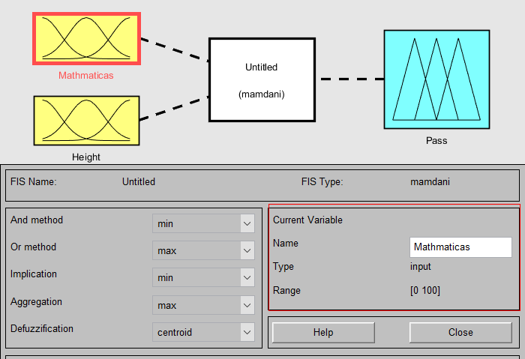 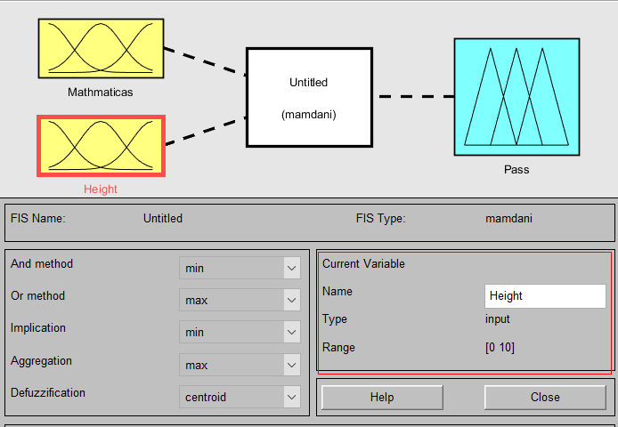

Fig 1 Mathmaticas variable Fig 2 Height variable

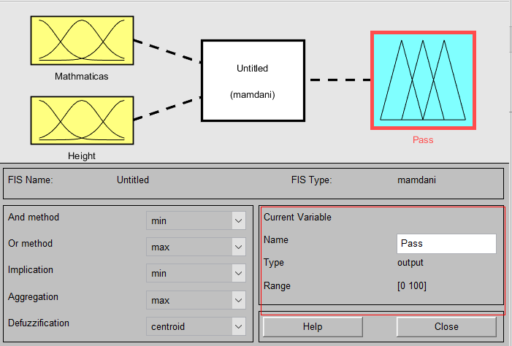

Fig 3 Pass variable

The above figure shows the names of the three variables and their range of change. The range of Mathmaticas is 0-100, the range of Height is 0-10, and the range of output variable Pass is 0-100.

After defining the input and output language variables and the range of change, it is necessary to determine the choice of the membership function.We open the membership function editor, and set the shape of the membership function in the graphical interactive interface. There are many membership function curves, such as ‘pimf’ function, ‘gauss2mf’ function, ‘gbellmf function’, ‘trapmf’ function, ‘trimf’ function, etc. After many experiments, some of the membership functions were selected.

In this report, the ‘trapmf’ function and ‘trimf’ function are selected. Both ‘trapmf’ and ‘trimf’ functions are trapezoidal membership functions, and the function curve is shown in the figure below:

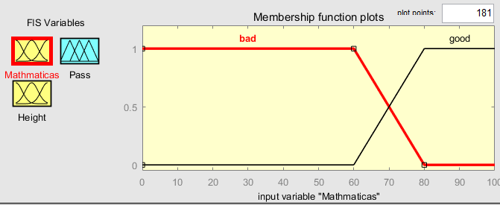

Fig 4 Math MF Curves

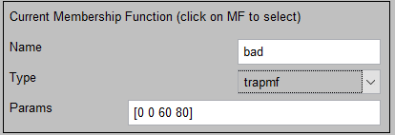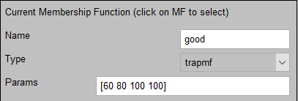

Fig 5 The parameter of bad Fig 6 The parameter of good

The figure 4 shows the membership function curves of Mathmaticas. There are two membership function curves for the good and bad grades, both of which are ‘trapmf’ function curves. The parameter for the bad grade is set to [0 0 60 80], and the parameter for the good grade is set to [60 80 100 100], as is shown in Figures 5 and 6.

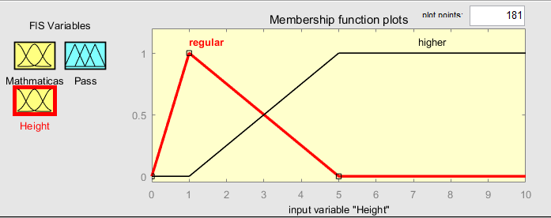

Fig 7 Height MF Curves

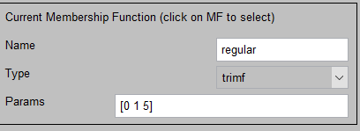 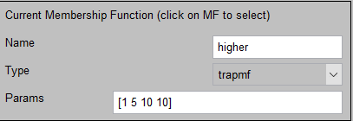

Fig 8 The parameter of regular Fig 9 The parameter of higher

Figure 7 shows the membership function curves of different levels of Height variable, and the range of abscissa is 0-10. The membership function curve of the regular level is the ‘trimf’ function, and the parameter is set to [0 1 5], as is shown in Figure 8. The higher-level membership function curve is the ‘trapmf’ function, and the parameter is set to [1 5 10 10], as is shown in Figure 9.

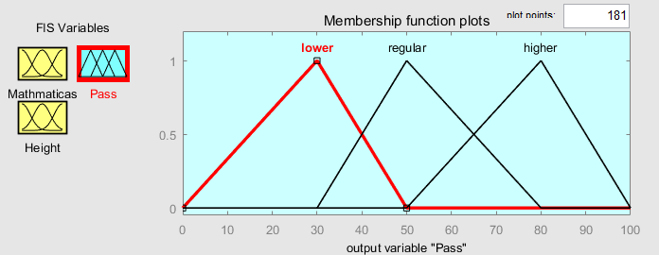

Fig 10 Pass MF Curves

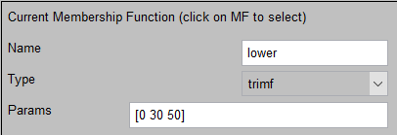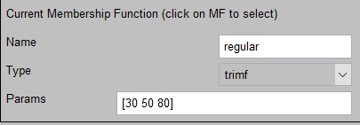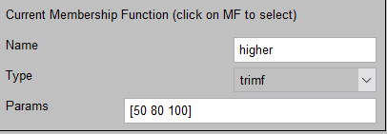

Fig 11 Different parameters about the different levels of Pass

Figure 10 shows the membership function curves of different levels of output variables, all of which are ‘trimf’ function curves, with a range of 0-100. There are three levels of fuzzy level of this variable, namely low level, normal level and high level. Among them, the low level parameter is set to [0 30 50], and the regular level is set to [30 50 80], meanwhile, the high level is set to [50 80 100]. as is shown in Figure 11.

Nextly, we need to define fuzzy control rules. After having opened the fuzzy rule editor, we set all the weight parameters to 1, and set the fuzzy rules in the GUI interface according to the fuzzy logic control rules mentioned above the text, as is shown in the figure below.

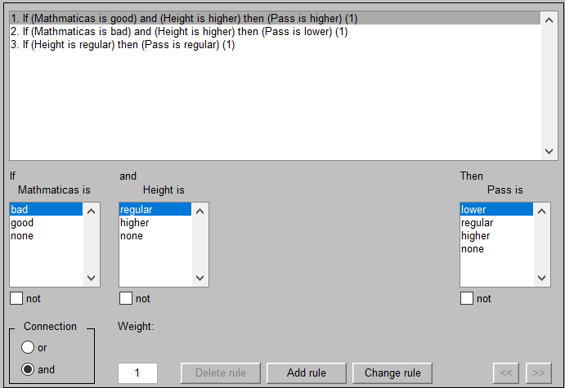

Fig 12 Fuzzy rules

The specific rules are as follows:

1. If (Mathmaticas is good) and (Height is higher) then (Pass is higher)

2. If (Mathmaticas is bad) and (Height is higher) then (Pass is lower)

3. If (Height is regular) then (Pass is regular)

After adding fuzzy logic control rules, we can get the input and output surface diagram of the system, as shown in the following figure:

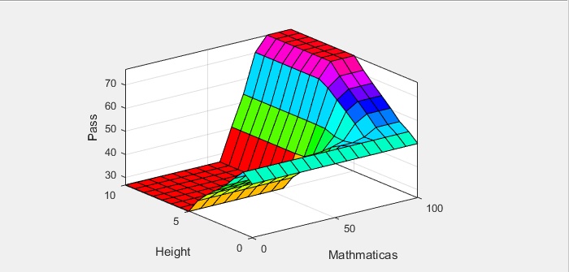

Fig 13 Graph of system response

According to the figure above, as the mathematics score and height increase, the pass rate becomes higher, so the probability of students being selected is greater.

**5. System evaluation and result display of the model**

Several samples were selected to evaluate the inference results of the system. The test samples are shown in the following table:

Table 1 Test samples

|  |  |  |  |
| --- | --- | --- | --- |
| Number | Mathmaticas | Height | Pass |
| 1 | 50 | 1.5 | 56.6979 |
| 2 | 80 | 2 | 45.1905 |
| 3 | 70 | 3 | 51.1905 |
| 4 | 56 | 0.56 | 53.7827 |
| 5 | 62 | 8 | 68.3616 |

As is shown in the table, in the fifth sample, the mathematics score is at a bad level, but the height is at a high level. When the weight parameters are all 1, the pass rate is the highest at this time. In the second sample, the mathematics score is at a good level, and the height is at a regular level, and the pass rate is the lowest at this time. 

Fig 14 Result disply

1. **Work summary and conclusions**

The report mainly aims to select the students who meet the requirements based on the corresponding conditions. This problem is mainly based on fuzzy logic control algorithms, which uses matlab and fuzzy logic control toolbox to establish a fuzzy controller. Meanwhile, we pick out the input and output variables, and select membership functions, and determine fuzzy control rules. Finally, fuzzy control models are established. Besides, we select test samples to evaluate the inference model. Although this is a simple model, it can help us understand the basic principles of fuzzy logic control. In the process of modeling, we also encountered related problems, such as the selection of membership functions or how to determine fuzzy logic control rules, etc. Finally, they have been overcome and resolved. From this experiment, we can get some conclusions:

The correctness of the fuzzy control rules directly affects the performance of the controller, and the number of them is also an important factor to measure the performance of the controller. The choice of membership function is also crucial to the effect of the result. For this problem, when the higher with the mathematics score, and the higher with the height, the output variable Pass can obtain a higher grades, that is the greater probility that the students will be selected.

**Fuzzy Control Rules.**

1. If (Mathmaticas is good) and (Height is higher) then (Pass is higher)

2. If (Mathmaticas is bad) and (Height is higher) then (Pass is lower)

3. If (Height is regular) then (Pass is regular)