**CS2115 2023/2024 Midterm Examination**

**Name: SID:**

**Total points: 100**

**Time: 2 hours**

**Section A (20 points).** *2 points for each question. Only one correct answer for each question.*

1. **B**
2. **A**
3. **A**
4. **C**
5. **A**
6. **C**
7. **A**
8. **C**
9. **A**
10. **C**

**Section B (20 points).** *4 points for each question.* Short-answer questions.

1. 100010010011
2. (A5.C)16
3. (120)8
4. (11010011)2
5. 1 10000110 00001011110000000000000

**Section C (25 points).**

**Q1.(3 points)**

**Answers:**

The K-map for the output D:

(1)

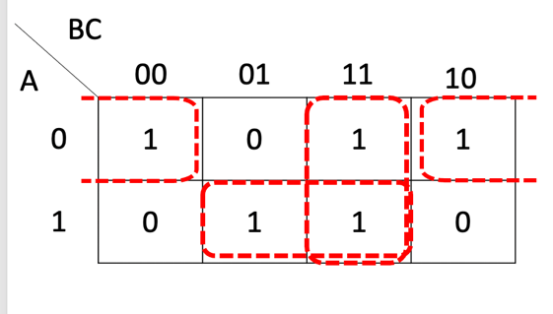

Derived logic expression for D:

Or

(2)

Derived logic expression for D: $\overline{A}\overline{C}+\overline{A}B+AC$

**Q2. (4 points)**

**Answers:**

The K-map for the output F:

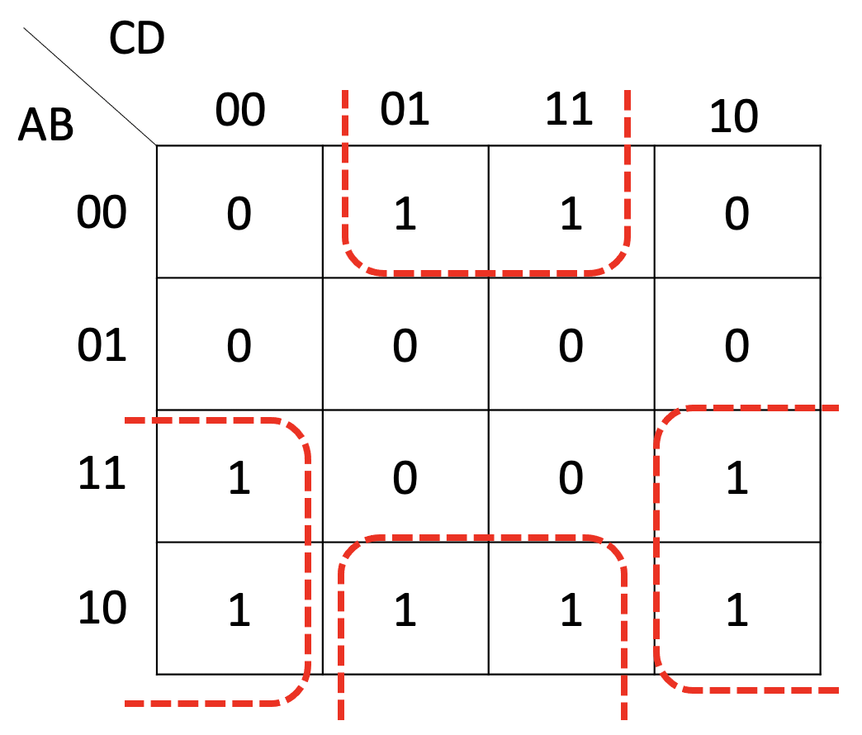

Derived logic expression for F: $\overline{B}D+A\overline{D}$

**Q3.(6 points)**

**Answers:**

|  |  |  |  |  |
| --- | --- | --- | --- | --- |
| **A** | **B** | **C** | **D** | **E** |
| **0** | **0** | **0** | **0** | **1** |
| **0** | **1** | **1** | **0** | **1** |
| **1** | **0** | **0** | **0** | **1** |
| **1** | **1** | **0** | **0** | **0** |

**Q4.(6 points)**

**Answer:**

**Q5.(6 points)**

**Answer:**

G0=A0B0=0

P0=A0⊕B0=1

G1=A1B1=0

P1=A1⊕B1=1

G2=A2B2=0

P2=A2⊕B2=1

C1=G0+P0C0=0+1=1

C2=G1+P1C1=G1+P1G0+P1P0C0=0+0+1=1

C3=G2+P2C2=G2+P2G1+P2P1G0+P2P1P0C0=0+0+0+1=1

S3=A3⊕B3⊕C3= 0 or 1 or 1 = 0

**Section D (35 points).**

Q1: and J-type instructions for jumps and branches in the MIPS instruction set.

**Q2**. **(4 points)**

Answer: R-type instructions are used for arithmetic and logical operations, I-type instructions for immediate values and memory operations,

**Q3**. **(4 points)**

Answer: 1. Load the instruction​

2. Figure out what data to use​

**Q4**. **(9 points)**

Answer: The binary representation is: 000000 01001 01010 01000 00000 100000.

0000 0001 0010 1010 0100 0000 0010 0000.

**Hexadecimal: 0x012A4020**

**Q5. (6 points)**.

Answers:

1. add $t1, $t1, $t2
2. addi $t2, $t2, 1

**Q6. (10 points)**

Answer:

# Load the array address and size

la $a0, myArray # Load the base address of myArray

lw $t0, array size # Load the array size into $t0

# Initialize maxValue to the first element of the array

lw $t1, 0($a0) # Load the first element into $t1

# Loop to find the maximum value

loop:

lw $t2, 0($a0) # Load the current element into $t2

bge $t1, $t2, skip_update

move $t1, $t2 # Update maxValue if the current element is greater

skip_update:

addi $a0, $a0, 4 # Move to the next element

addi $t0, $t0, -1 # Decrement the loop counter

bnez $t0, loop # Continue looping if counter is not zero