**Exercise: Circuits**

1. Given the following logic functions, please construct the logic circuits in Logisim to implement the all the following logic functions (i.e., the share the same set of inputs A and B). The circuits should be simplified as much as possible.



Reference Solution:

After simplification:



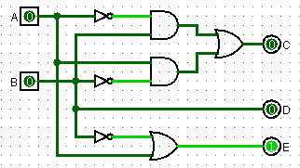

Note: it is also ok to write as C = A XOR B

1. Please build circuits in Logisim according to the following truth table. The circuits should be simplified as much as possible.

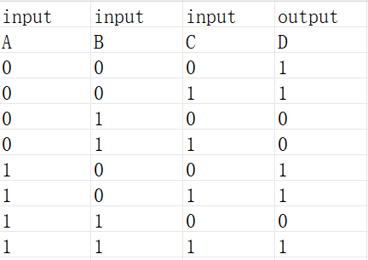

Reference Solution:

1. Sum-of-produce and simplified by binary logic rules



1. Using K-map

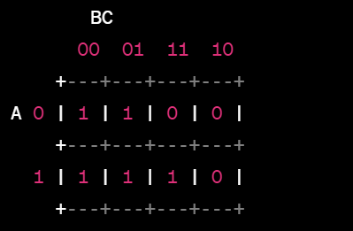

So the derived expression is the same as above

The circuit in Logisim:

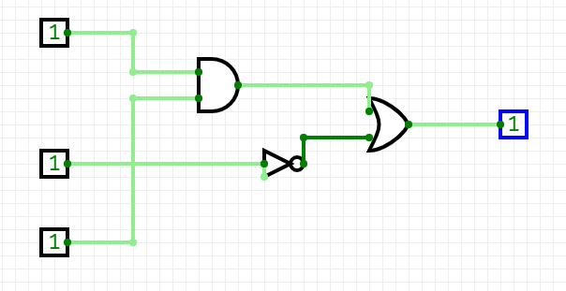

1. Suppose the timing diagram of the input D and clock C of a clocked D flip-flop triggered by raising edges is as follows, please draw the timing diagram of its output Q.

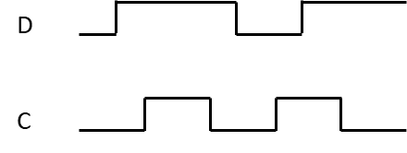

Reference solution:

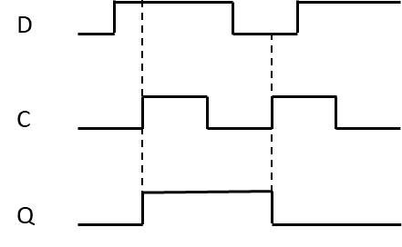

1. Suppose the timing diagram of the input D and clock C of a clocked D flip-flop triggered by falling edges is as follows, please draw the timing diagram of its output Q.

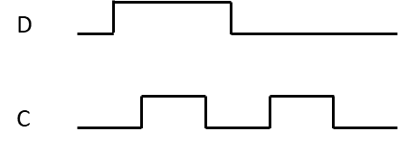

Reference solution:

