Hengyue Liu

4107-2966-75

hengyuel@usc.edu

EE 569 Homework #1

September 20, 2015

### Problem 1: Image Manipulation and Interpolation

1. Image Resizing via Bilinear Interpolation
2. Abstract and Motivation

Bilinear interpolation is a fast way to achieve the resizing of an image. The basic idea is that, if an image is required to stretch larger, the original pixels are relocated to the corresponding locations in the desired image; the blank pixels are interpolated by the nearest four pixels with their distances to the interpolation location as weight values.

1. Approach and Procedures

The core part is changing the coordinates. Suppose the output image is of size N by N with coordinates (x, y), the input image is of n by n with coordinates (row, col), then the stretch ratio will be N/n, and the stretched coordinates will be (row*ratio, col*ratio). Step 1, use this stretched coordinates to evaluate the value of (x, y) based on the formula given in the lecture. Step 2, construct a new image and assign pixel values obtain from step 1.

1. Experimental Results

Shown below are the results for part a).

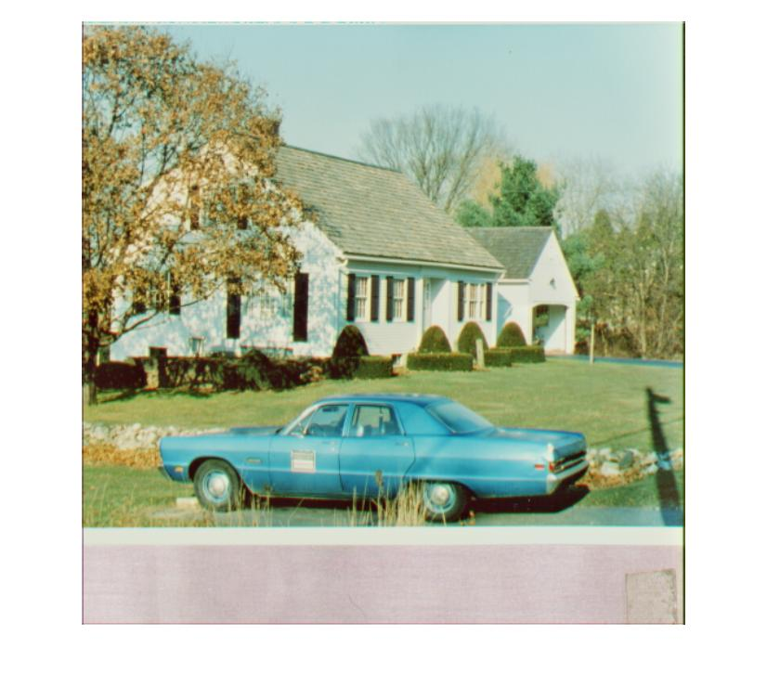

Figure 2 Resized 650*650 image of 'house.raw'

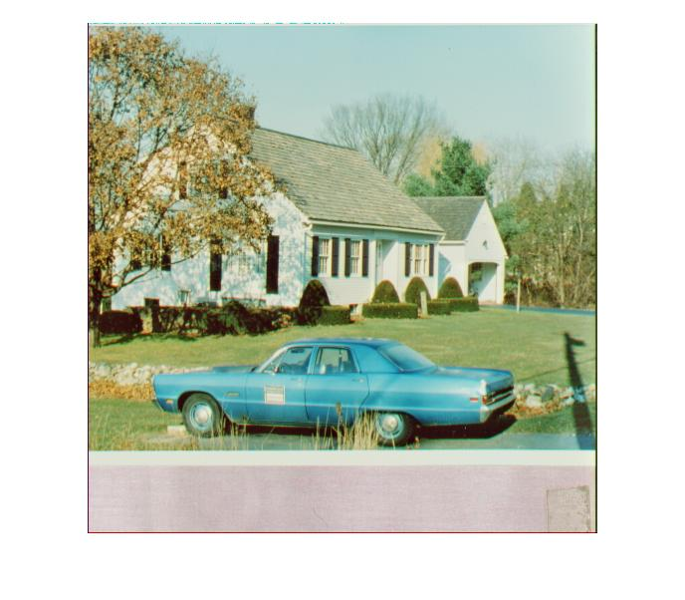

Figure 1 Original image of 'house.raw'

1. Discussion

The four pixels that is used for interpolation actually determine more than 1 interpolated pixel. So the certain area formed by the four pixels contains many interpolated pixels, and they just have different weight values. Note that the interpolated image may be not as clear as original image.

1. Demosaicing of Bayer-patterned Color Image
2. Abstract and Motivation

Since the digital camera sensors are arranged with a pattern called Bayer array, to recover a color RGB image from the picture captured by digital cameras needs to estimate the other two channels at a certain pixel.

1. Approach and Procedures

There are two types of methods, one is bilinear demosaicing, and the other is MHC demosaicing.

1. Experimental Results

Shown below are the results for part b).

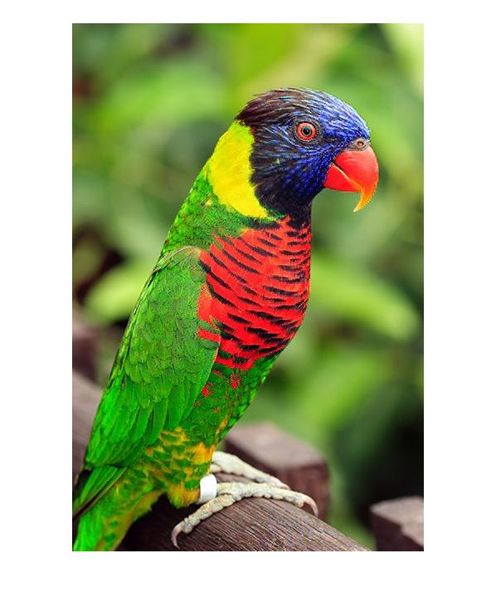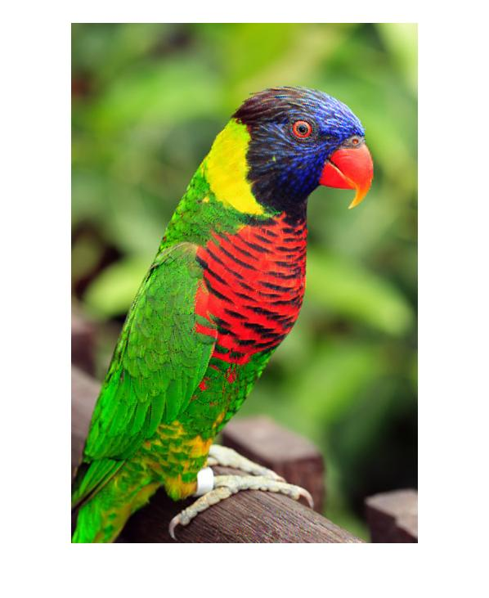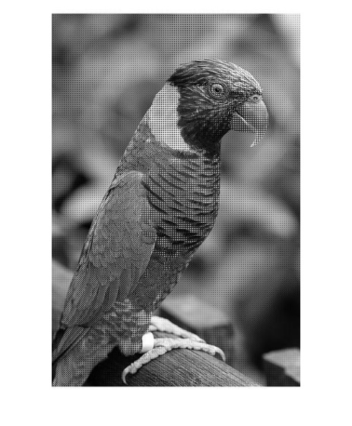

Figure 5 MHC demosaicing image of 'parrot_CFA.raw'

Figure 4 bilinear demosaicing image of 'parrot_CFA.raw'

Figure 3 'parrot_CFA.raw'

1. Discussion

The MHC demosicing approach is better than the bilinear one. It takes more values into consideration, and use 8 masks to estimate the right pixel values.

### Problem 2: Histogram Equalization and Image Filtering

1. Histogram Equalization
2. Abstract and Motivation

Histogram is very important in discussing image processing. To make an image more contrast, the histogram equalization needs to be done.

1. Approach and Procedures

Two ways to conduct the histogram equalization, one is the transfer-function-based histogram equalization method, and the other is the cumulative-probability-based histogram equalization method.

1. Experimental Results

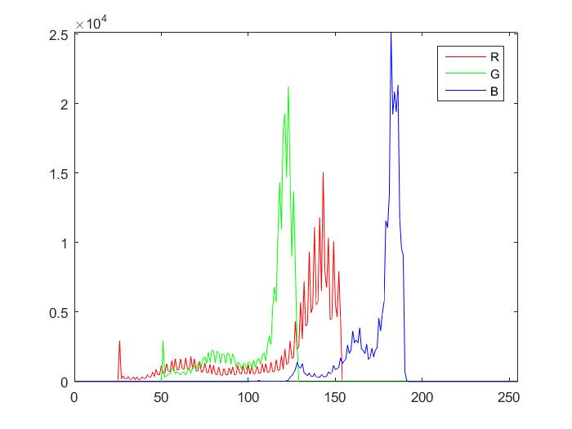Shown below are the results for part 1)

Shown below are the results for part 2)

Figure 6 Histogram of 'jet.raw'

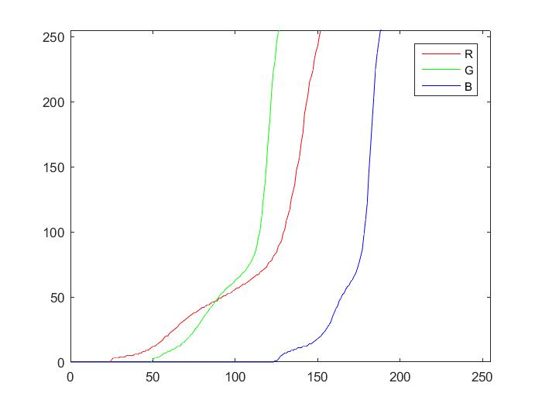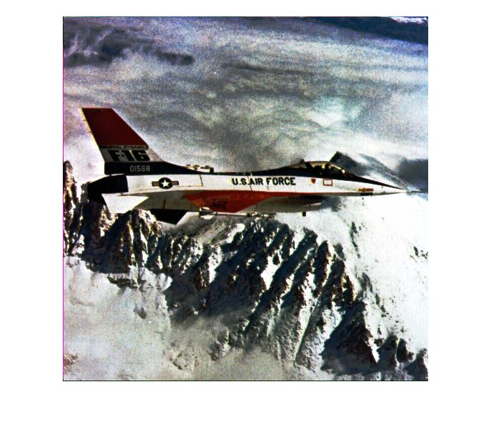

Figure 7 Method A result of 'jet.raw'

Figure 8 Transfer function of Method A for 'jet.raw'

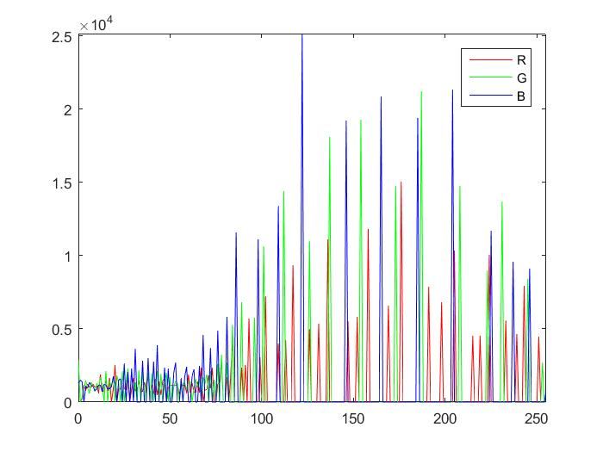Shown below are the results for part 3)

Figure 10 cumulative histogram of Method B enhanced 'jet.raw'

Figure 9 Method B result of 'jet.raw'

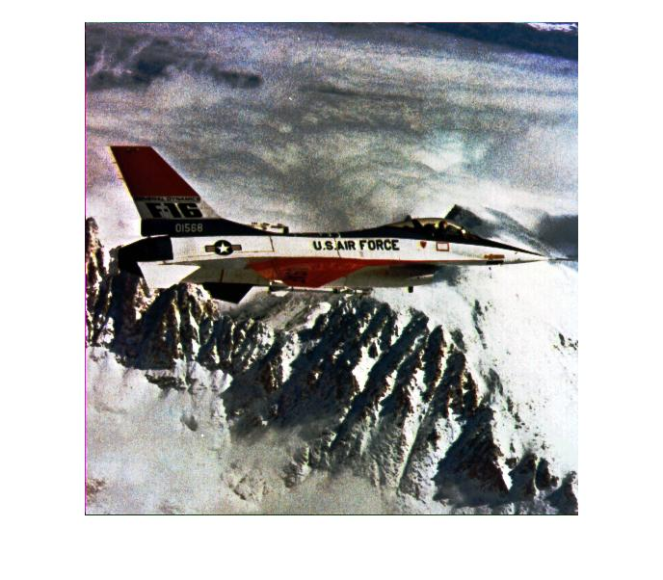

1. Discussion

From my observation, the enhanced images of these two methods are pretty same. But from the histogram, these two are definitely not the same. Both methods achieve the effect of increasing contrast of the image, and the image are much better and realistic than the original one. However, there are some contouring artifacts making the image noisy and blurry, and this is because the distances between neighbor luminance are increased by the method that leads to the discontinuity of luminance values. One way to solve the problem is demosaicing plus noise filtering.

### Problem 3: Noise Removal

1. Abstract and Motivation

There are many types of noise and impulse noise and Gaussian noise are normal ones. Use linear or non-linear filters to filter noise out.

1. Approach and Procedures

Three ways are provided: bilateral filter, guided filter, and BM3D filter.

1. Experimental Results

Shown below are the results for part a)

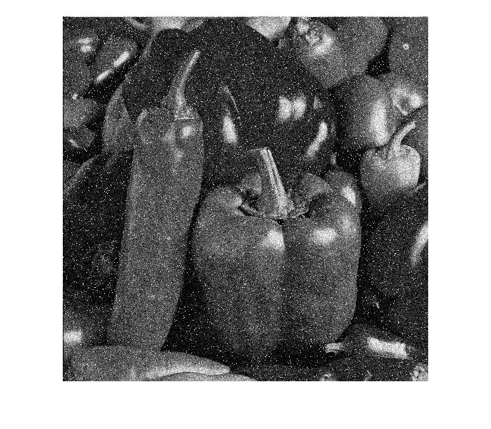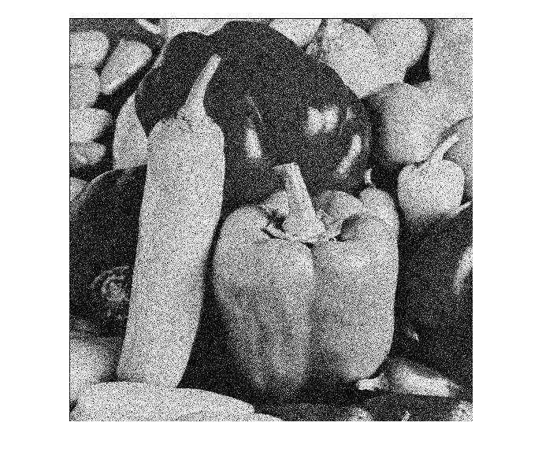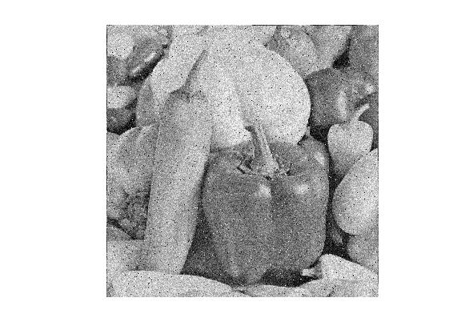

Figure 13 B Channel Noise

Figure 12 G Channel Noise

Figure 11 R Channel Noise

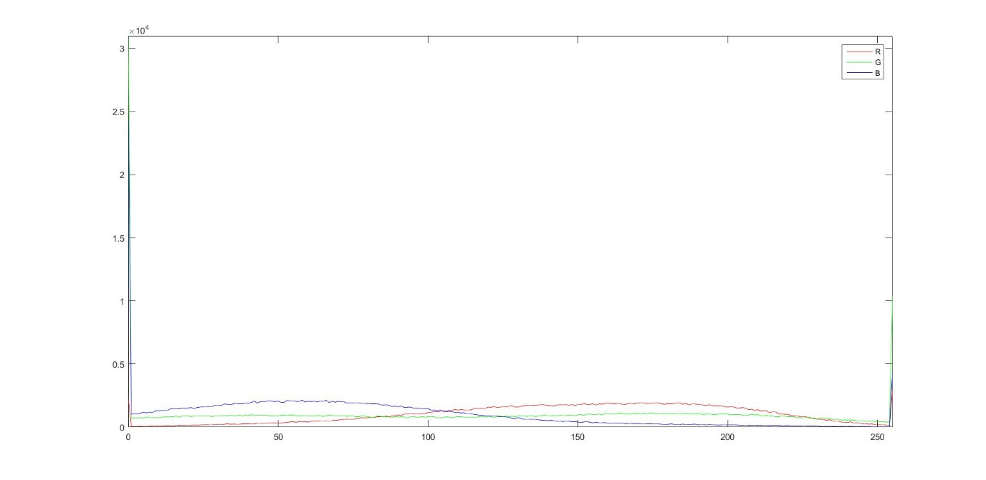

Figure 14 Histogram of peppers_noisy.raw

1. Discussion
2. No. From the histogram of each channel, big impulse can be seen in Blue and Green channels. All Channels have Gaussian additive Noise, Blue and Green Channel has the Impulse Noise.
3. Yes. Because one channel may have only one type of noise. For only one type of noise, if using two filters, it may blur the edges and textures.
4. For Red and Blue channels, perform linear (bilateral) filtering; for Green channel, perform nonlinear (median) filtering.
5. No. The impulse noise need to be removed first, then perform linear filtering. Reason is that impulse noise pixel value is large and extremely different from neighbor pixels. If perform for example Gaussian filtering, the variance and distance value will be influenced dramatically. So, do the non-linear filtering first, then do the linear filtering.

Shortcomings: The Gaussian filter makes the image less noise, but it also make the edges and textures blurry. The bilateral filter takes the advantage of both intensity value distance and pixel distance as weight references, it can decrease the edge effects. However, the image is too smooth that it reduces the reality and resolution.

Better way: Guided filtering and BM3D filtering are good choices.

To Graders, TAs and Professor Jay Kuo,

I am really sorry that my homework 1 is such a mess. I registered this class very late and feel really difficult to catch up in one week. Please forgive my incomplete work and bad report, I have tried my best to finish all the stuff for real. I will do better afterwards, for sure, and try to use C++ and finish bonus questions. Thanks for your patience with my codes and report, I really appreciate it.