Hengyue Liu

4107-2966-75

hengyuel@usc.edu

EE 569 Homework #3

October 25, 2015

### Problem 1: Geometrical Modification

1. Swirl Effect
2. Abstract and Motivation

Swirl Effect is one of many geometrical modification effects which is based on rotation. The difference of swirl compared with rotation is that, how much the pixels are rotated is different. The pixels at the margin of image are rotated by larger angle than the pixels around the center of the image. This process needs the coordinates modification, i.e. change the image coordinates to Cartesian coordinates first, then change to polar coordinates to manipulate pixel locations.

1. Approach and Procedures
2. Read the raw image as image coordinates starting from the left-top pixel.
3. Change the image coordinates to the Cartesian coordinates by shifting the origin to the center of the image.
4. Change the Cartesian coordinates (x, y) to the polar coordinates (r, θ), note that (x, y) can be recovered by x=r*cosθ and y=r*sinθ.
5. Change the angle θ differently, depending on the radius to the origin. By observation, the rotation angle is 3*pi/4*r/R, which R is the largest radius.
6. The recovered Cartesian coordinates (u, v) is fractional, so apply bilinear interpolation. To interpolate, consider the image is swirled back to the original image.
7. Store the swirled image and show the result.
8. Experimental Results

Shown below.

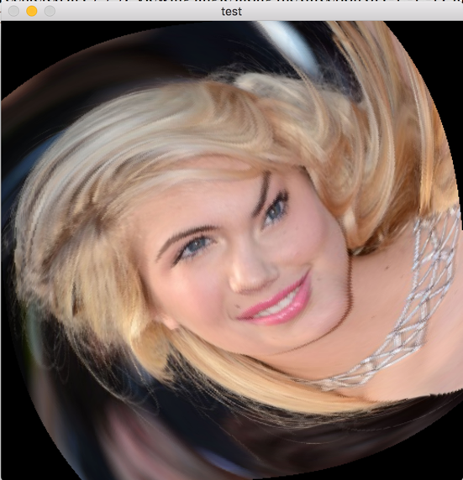

Figure Original 'Kate.raw'

Figure Swirl effect of 'Kate.raw'

1. Discussion

The particular swirl effect provided in the assignment is defined by 3 main factors, rotation center, rotation angle and radius dependency. For this one, the center is image center, and the rotation angle is 3*pi/4 and the angle is influenced by the fraction r/R which R is the largest radius in polar coordinates. One can achieve different swirl effects by modifying these factors.

1. Perspective Transformation & Imaging Geometry
2. Abstract and Motivation

The perspective transformation is basic in computer vision. Suppose there is an object in the world coordinates (a 3D cube in this problem), one needs to capture the scene of the object with a camera. The destination of the transformation is to form an image seen by the camera in image coordinates. This process is achieved by changing the coordinates with rotation & translation matrices and intrinsic matrix of the camera.

1. Approach and Procedures
2. There are 6 images, first put them into a cube in world coordinates; the cube has length 2, and unit length is 0.01 for each pixel.
3. The world homogeneous coordinates (X, Y, Z, 1) is obtained in last step. Generate the extrinsic and intrinsic matrices, then the image coordinates (x, y, 1) is transferred from (X, Y, Z, 1). Note the coordinates obtained is fractional length.
4. Choose a pixel density, change the coordinates based in length into real image coordinates.
5. Show the resulting image.
6. Experimental Results

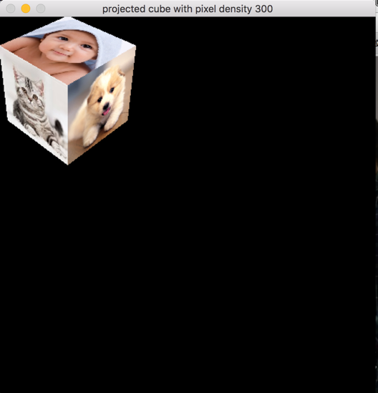Shown below are the results for part b).

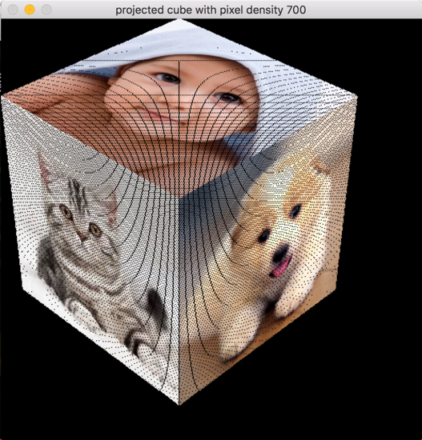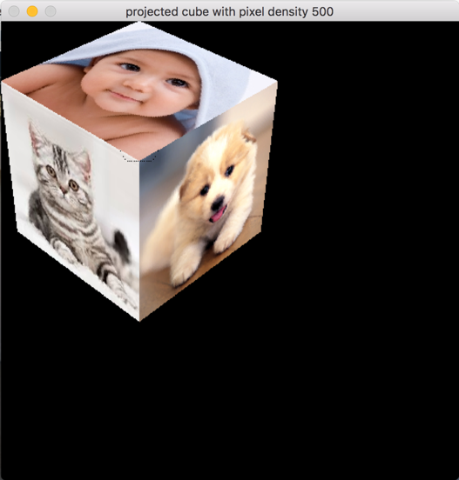

Figure scene with pixel density 300

Figure scene with pixel density 100

Figure 6 scene with pixel density 700

Figure 5 scene with pixel density 500

Below is a part of coordinates and pixel intensity of ‘baby.raw’.

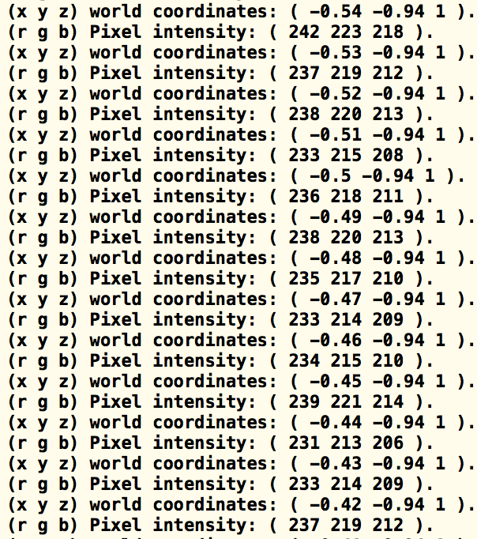

Figure some pixels' world location and intensity value

1. Discussion

4 pixel intensities are chosen for comparison. The results seem acceptable for the images with low pixel intensity like 100 and 300. Imaginably, if the pixel intensity gets smaller, the image size would be smaller too, and to some extend, the image can shrink to one pixel. Figure 5 and 6 are image with large pixel intensity with artifacts created in the images. The black pixels are the places where no pixel is projected. In other words, there are not enough pixels to fill the unit length given. Meanwhile, a pattern can be drawn that dots closer to the camera give more artifacts. Also, the edges of the cube are not well projected and aliased. The aliased edges are caused by low resolution and projection accuracy.

One way to avoid the artifacts and edge aliasing is applying bilinear interpolation. First find a appropriate pixel intensity so that very few or no artifacts can be seen. Then, bilinear interpolate the image to any size one wants. Alternatively, first interpolate the original cube to a large enough one, then project the cube to image plane. And this should be better than the first one.

### Problem 2: Digital Halftoning

1. Dithering
2. Abstract and Motivation

Dithering is useful in printing. If the printer can only print black dots, dithering interleaves the black dots and white space to create more “gray-levels” visually. The goal of dithering is using binary 0 and 1 to represent more levels. In this part, dithering index matrices are utilized which are introduced by Bayer first. The basic 2 by 2 index matrix contains 0, 1, 2 and 3 to represent the likelihood of being printed as black dot. Then, larger index matrices can be generated by the basic 2 by 2 matrix. Threshold the pixel values depending on the thresholds generated by the index matrices.

1. Approach and Procedures
2. Read the raw image as image coordinates starting from the left-top pixel.
3. Change the image coordinates to the Cartesian coordinates by shifting the origin to the center of the image.
4. Change the Cartesian coordinates (x, y) to the polar coordinates (r, θ), note that (x, y) can be recovered by x=r*cosθ and y=r*sinθ.
5. Change the angle θ differently, depending on the radius to the origin. By observation, the rotation angle is 3*pi/4*r/R, which R is the largest radius.
6. The recovered Cartesian coordinates (u, v) is fractional, so apply bilinear interpolation. To interpolate, consider the image is swirled back to the original image.
7. Store the swirled image and show the result.
8. Experimental Results