fix #67164 merge to uxdb_rac_devel

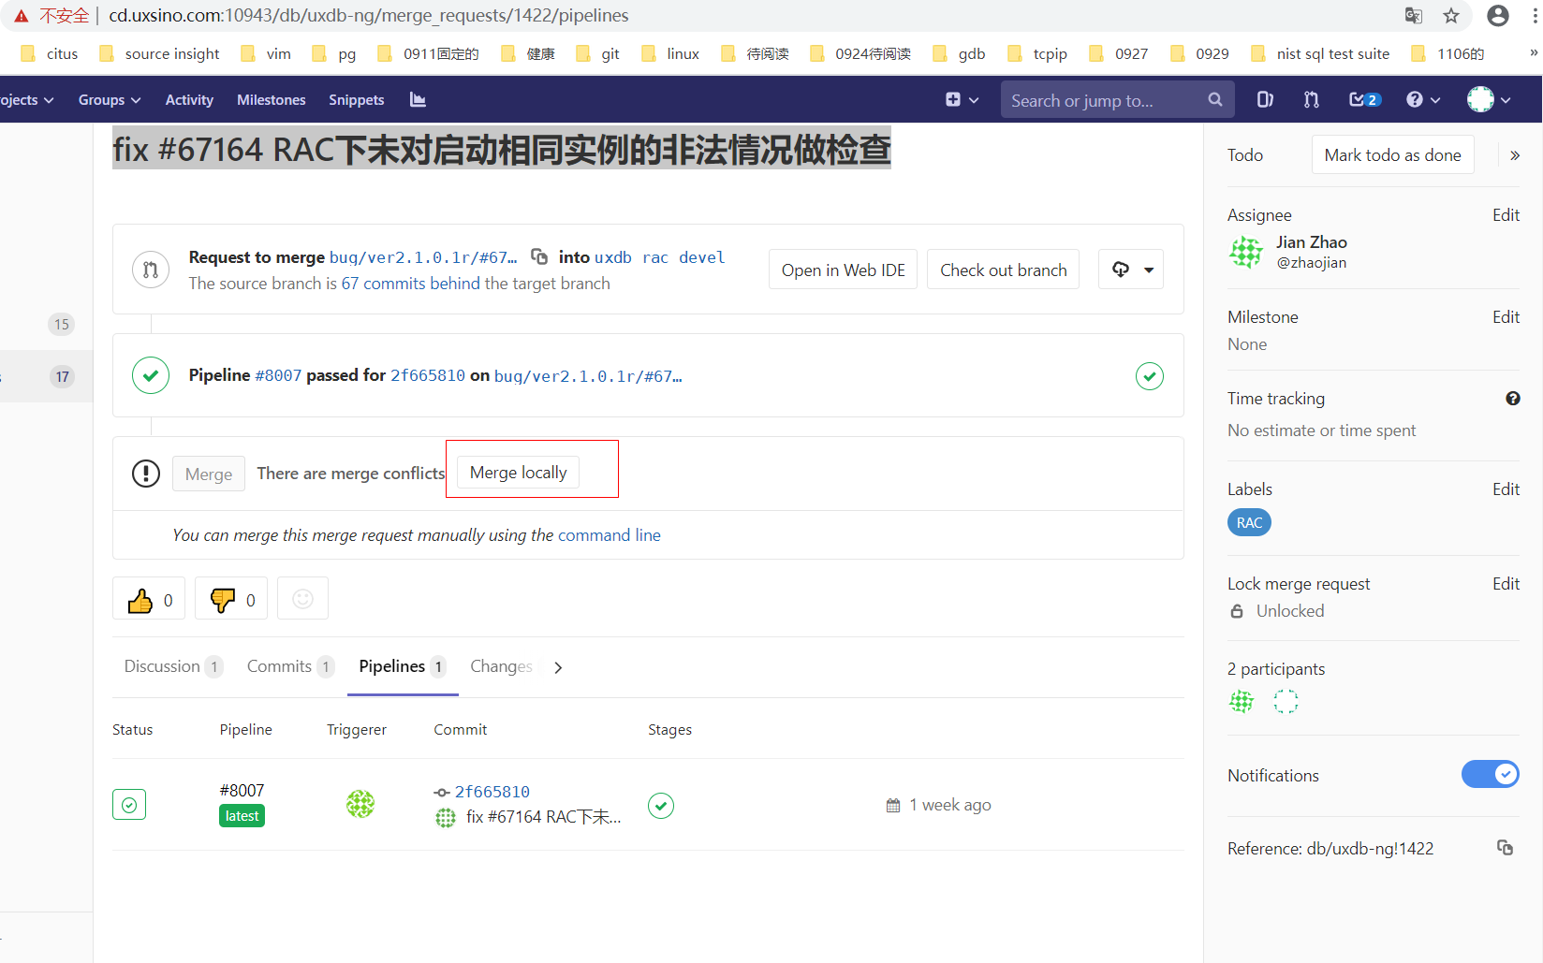

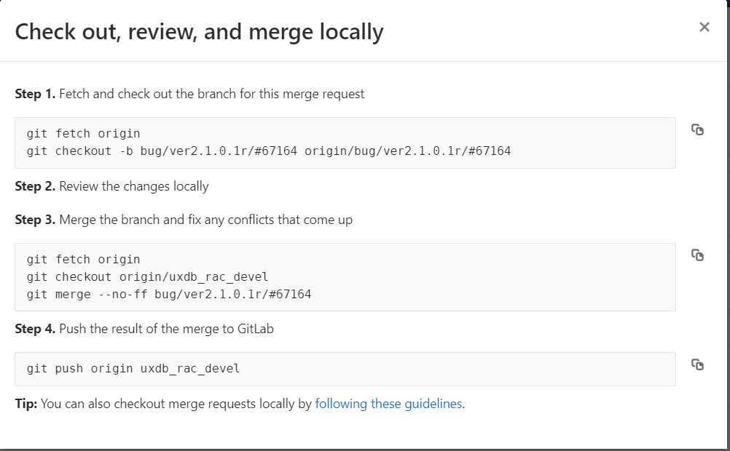

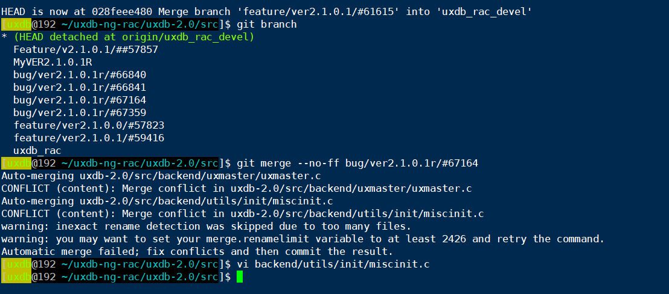

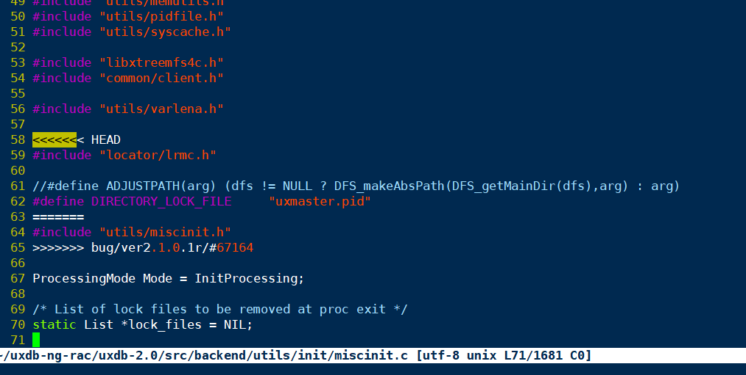

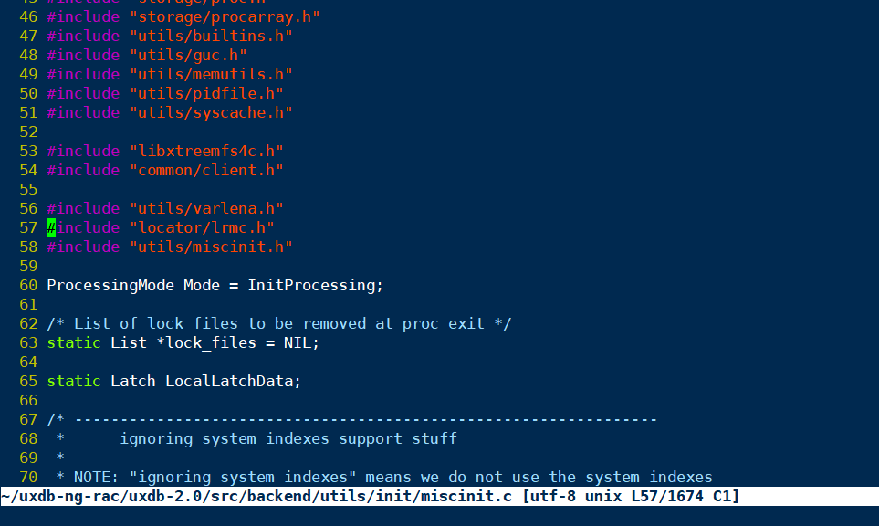

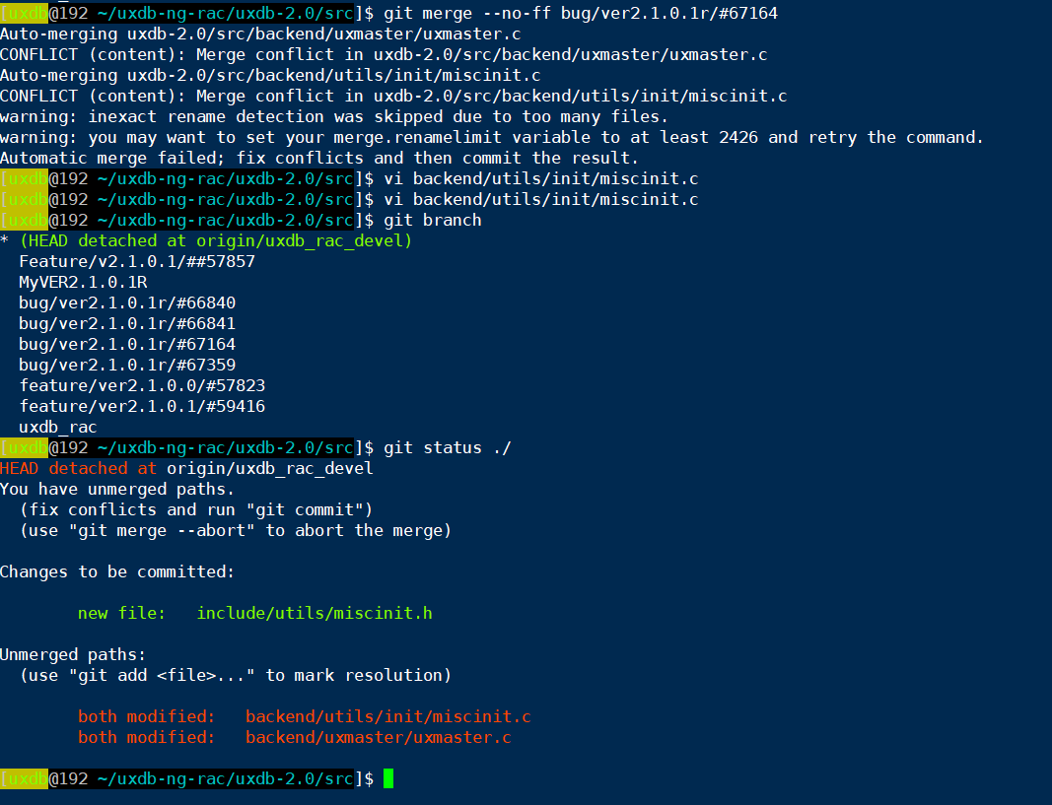

# 刘海峰merge测试

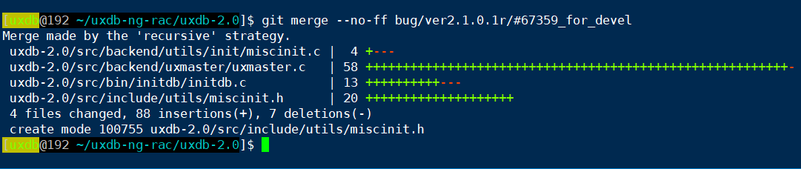

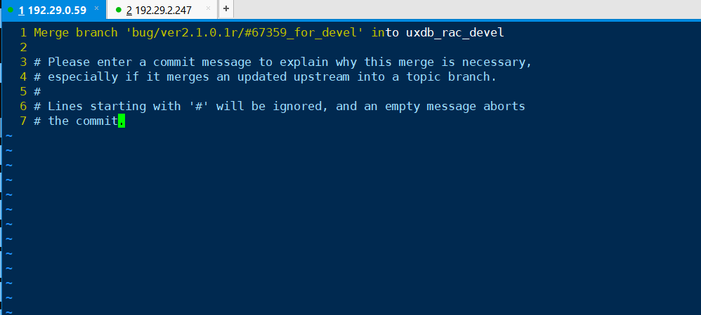

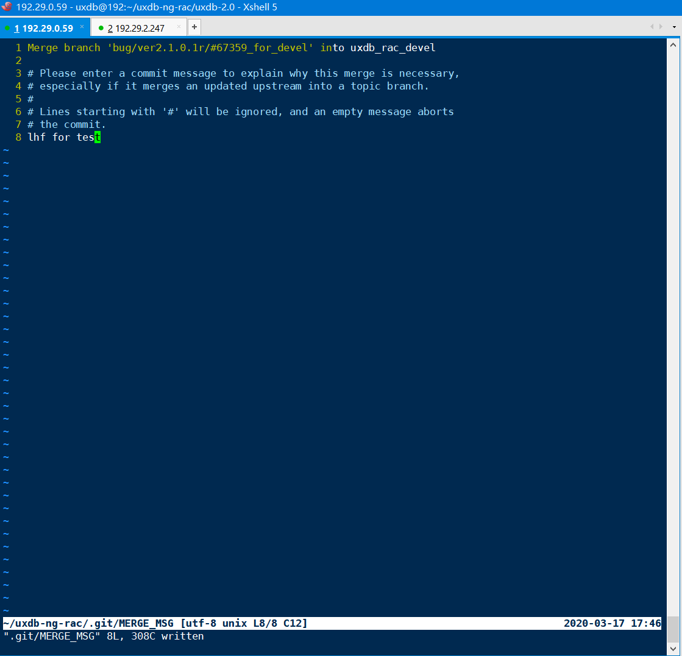



可以看出, 此次merge没有冲突.

merge的内容如下:

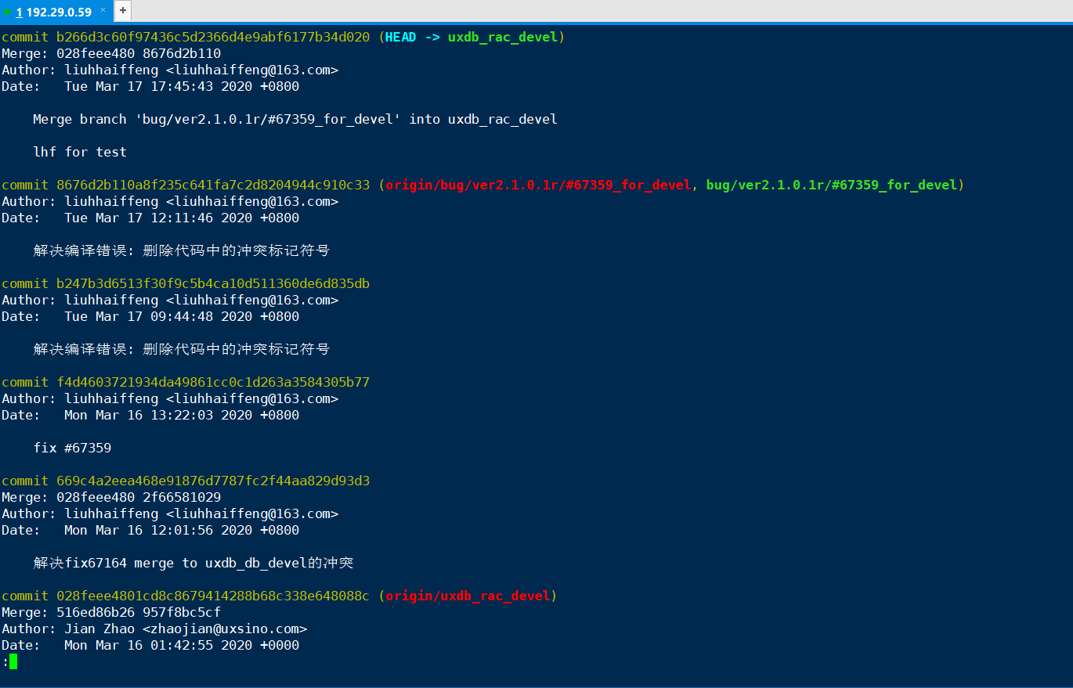

# git使用中的疑惑:

TODO

[uxdb@192 ~/uxdb-ng-rac/uxdb-2.0/src]$ git checkout bug/ver2.1.0.1r/#67359_for_devel

Switched to branch 'bug/ver2.1.0.1r/#67359_for_devel'

Your branch is based on 'origin/bug/ver2.1.0.1r/#6735_for_devel', but the upstream is gone.

(use "git branch --unset-upstream" to fixup)

[uxdb@192 ~/uxdb-ng-rac/uxdb-2.0/src]$

# git rebase演示

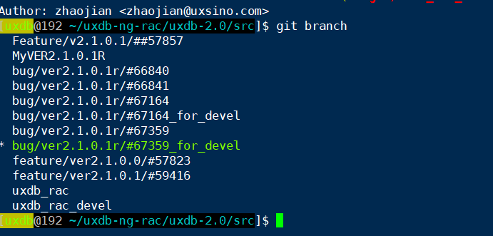

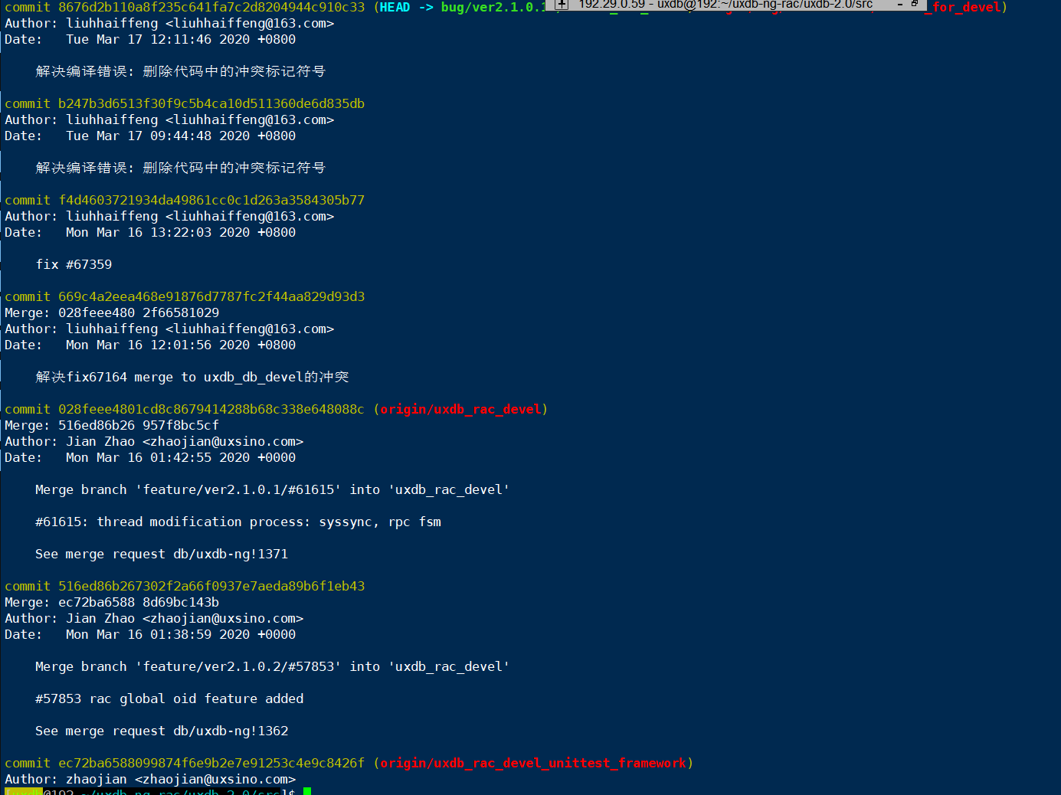

# 什么也没有干, 退出

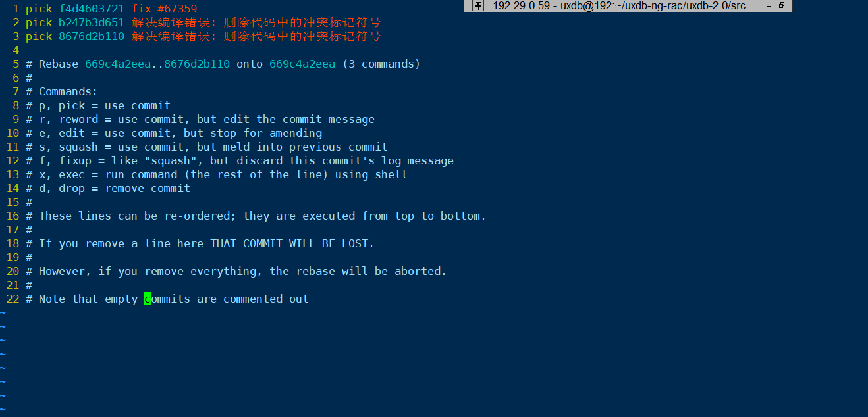

# 可以看出, 没有任何影响, rebase虽然成功了, 但什么也没有干

[uxdb@192 ~/uxdb-ng-rac/uxdb-2.0/src]$ git rebase -i 669c4a2eea

Successfully rebased and updated refs/heads/bug/ver2.1.0.1r/#67359_for_devel.

[uxdb@192 ~/uxdb-ng-rac/uxdb-2.0/src]$ git branch

Feature/v2.1.0.1/##57857

MyVER2.1.0.1R

bug/ver2.1.0.1r/#66840

bug/ver2.1.0.1r/#66841

bug/ver2.1.0.1r/#67164

bug/ver2.1.0.1r/#67164_for_devel

bug/ver2.1.0.1r/#67359

* bug/ver2.1.0.1r/#67359_for_devel

develop

feature/ver2.1.0.0/#57823

feature/ver2.1.0.1/#59416

uxdb_rac

uxdb_rac_devel

[uxdb@192 ~/uxdb-ng-rac/uxdb-2.0/src]$ git log

commit 8676d2b110a8f235c641fa7c2d8204944c910c33 (HEAD -> bug/ver2.1.0.1r/#67359_for_devel, origin/bug/ver2.1.0.1r/#67359_for_devel, develop)

Author: liuhhaiffeng <liuhhaiffeng@163.com>

Date: Tue Mar 17 12:11:46 2020 +0800

解决编译错误: 删除代码中的冲突标记符号

commit b247b3d6513f30f9c5b4ca10d511360de6d835db

Author: liuhhaiffeng <liuhhaiffeng@163.com>

Date: Tue Mar 17 09:44:48 2020 +0800

解决编译错误: 删除代码中的冲突标记符号

commit f4d4603721934da49861cc0c1d263a3584305b77

Author: liuhhaiffeng <liuhhaiffeng@163.com>

Date: Mon Mar 16 13:22:03 2020 +0800

fix #67359

commit 669c4a2eea468e91876d7787fc2f44aa829d93d3

Merge: 028feee480 2f66581029

Author: liuhhaiffeng <liuhhaiffeng@163.com>

Date: Mon Mar 16 12:01:56 2020 +0800

解决fix67164 merge to uxdb_db_devel的冲突

commit 028feee4801cd8c8679414288b68c338e648088c (origin/uxdb_rac_devel)

Merge: 516ed86b26 957f8bc5cf

Author: Jian Zhao <zhaojian@uxsino.com>

Date: Mon Mar 16 01:42:55 2020 +0000

Merge branch 'feature/ver2.1.0.1/#61615' into 'uxdb_rac_devel'

#61615: thread modification process: syssync, rpc fsm

See merge request db/uxdb-ng!1371

commit 516ed86b267302f2a66f0937e7aeda89b6f1eb43

Merge: ec72ba6588 8d69bc143b

Author: Jian Zhao <zhaojian@uxsino.com>

Date: Mon Mar 16 01:38:59 2020 +0000

Merge branch 'feature/ver2.1.0.2/#57853' into 'uxdb_rac_devel'

#57853 rac global oid feature added

See merge request db/uxdb-ng!1362

# rebase 修改

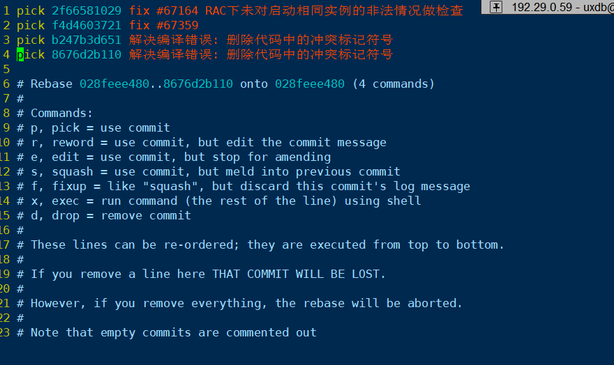

pick 2f66581029 fix #67164 RAC下未对启动相同实例的非法情况做检查

pick f4d4603721 fix #67359

pick b247b3d651 解决编译错误: 删除代码中的冲突标记符号

pick 8676d2b110 解决编译错误: 删除代码中的冲突标记符号

# Rebase 028feee480..8676d2b110 onto 028feee480 (4 commands)

#

# Commands:

# p, pick = use commit

# r, reword = use commit, but edit the commit message

# e, edit = use commit, but stop for amending

# s, squash = use commit, but meld into previous commit

# f, fixup = like "squash", but discard this commit's log message

# x, exec = run command (the rest of the line) using shell

# d, drop = remove commit

#

# These lines can be re-ordered; they are executed from top to bottom.

#

# If you remove a line here THAT COMMIT WILL BE LOST.

#

# However, if you remove everything, the rebase will be aborted.

#

# Note that empty commits are commented out

# 修改

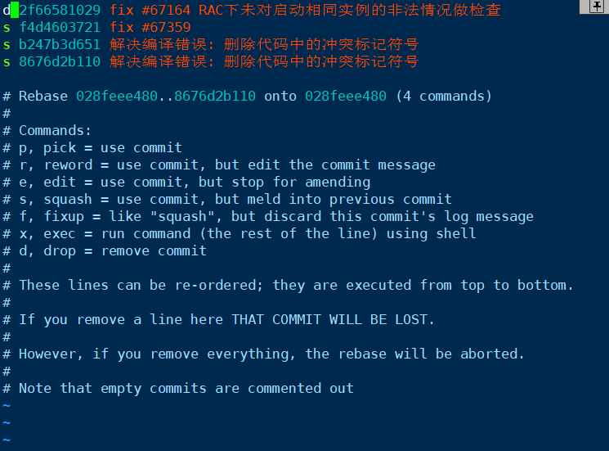

# 失败

