Energy Aware Multi-hop Multi-path Hierarchical (EAMMH) Routing Protocol in Wireless Sensor Networks

Savan Kiran
Computer science department
M.S Ramaiah Institute of Technology
Bengaluru
savankiran@gmail.com
Raja Nahusha Varsha
Computer science department
M.S Ramaiah Institute of Technology
Bengaluru
nahusharaj@gmail.com

Shivanand Khobanna
Computer science department
M.S Ramaiah Institute of Technology
Bengaluru
shivanandkhobanna@yahoo.com
Seira Ann George
Computer science department
M.S Ramaiah Institute of Technology
Bengaluru
Seiraann123@gmail.com

Abstract— A wireless sensor network (WSN) consists of low cost, low power, small in size and multifunctional sensor nodes. Routing protocols in WSNs emphasize on data dissemination, limited battery power and bandwidth constraints in order to facilitate efficient working of the network, thereby increasing the lifetime of the network. Routing protocols in WSNs are also application specific which has led to the development of a variety of protocols. Based on the underlying network structure, routing techniques can be classified into three categories: data-centric, hierarchical and location based routing. WSN has a design trade-off between energy and communication overhead which forms the nerve center of the routing techniques. In this paper, we present an energy aware multi-hop multi-path hierarchical routing protocol (EAMMH). EAMMH protocol organizes the sensor nodes into clusters and forms a multi-hop intra-cluster network. It further establishes multiple paths from each sensor node to the cluster head and provides an energy aware heuristic function to choose the appropriate path.

Keywords- wireless Wireless Sensor Networks, Routing Protocols, Energy Efficient Protocols, Multiple path, Multi-hop.

Introduction
This Recent technological advancements in micro electronics and wireless communication technologies have enabled manufacturing of small, low cost, battery operated and multi-functional sensor nodes[1,2,3,4,5]. These sensor nodes measure ambient condition in the surrounding environment that can be processed to reveal the characteristics of the phenomena occurring at the location where the sensor nodes are deployed. A large number of these sensor nodes are either placed carefully or randomly deployed over a geographical area and networked through wireless links to form a WSN. Each sensor node in WSN is capable of communicating with each other and the base station (BS) for the purpose of data integration and dissemination. WSN are used mainly in military, civilian and for industrial applications. WSNs applications in the military field include battlefield surveillance, intrusion detection, target field and imaging. However, WSN are now being used in many civilian application areas too, including environment and habitat monitoring, health applications, home automation and traffic control.
WSN have unique characteristics such as denser level of node deployment, higher unreliability of sensor nodes and severe energy, computation and storage constraints which present many challenges in the development and application of WSN. Research has been made to explore and find solutions for various design architecture and application issues and significant advancement has been made in the development and deployment of WSNs. WSN typically contains hundreds or thousands of sensor nodes which allows for sensing over larger geographical regions with greater accuracy. Usually the sensor nodes are deployed randomly over geographical location and these nodes communicate with each other to form a network. Each node has three basic components [6] as shown in figure 1[7]:
- Sensing unit
- Processing unit
- Transmission unit
The node senses the data from the environment, processes it and sends it to the base station. These nodes can either route the data to the base station (BS) or to other sensor nodes such that the data eventually reaches the base station. In most applications, sensor nodes suffer from limited energy supply and communication bandwidth. These nodes are powered by irreplaceable batteries and hence network lifetime depends on the battery consumption[8]. Innovative techniques are developed to efficiently use the limited energy and bandwidth resource to maximize the lifetime of the network. It creates the need for routing protocols to be highly adaptive and resource aware.
According to the first order radio energy model as shown in figure 2, energy consumed in transmitting a message[9,10] is given by:
1
where, k is the length of the message, d is the transmission distance between the transmitter and the receiver, E_{elec} is the electronic energy, is the transmitter amplifier and ∂ is the path loss component.
Also, the energy consumed in message reception[9,10] is given by,
2
Based on the first order radio energy model, it can be inferred that, with the reduction in size and number of messages being exchanged, energy consumption can be reduced. Routing techniques use this approach to maximize the network lifetime. In this paper, we present an energy aware multi-hop multi-path hierarchical routing protocol (EAMMH). The major objective of this paper is to extend the network lifetime by using energy efficient and energy aware routing techniques in a cluster-based hierarchical network topology. During cluster formation, a probabilistic approach is followed in selecting the cluster heads and the load is distributed by rotating the cluster heads periodically. Using multi-hop intra-cluster approach significantly increases the cluster size thus facilitating in forming lesser number of clusters and further increasing the scalability of the network. By using a fixed bound size for clusters, the sensor nodes can be homogenously distributed among clusters. By adopting the multi-path approach, we can alleviate the problem of the exhaustion of nodes along the minimal path. Hence the existence of alternate paths induces robustness to failure. At the cross-roads of choosing the paths, appropriate path is selected by means of an energy aware heuristic function.
The contributions of this paper are the following:
- Introduces a new model of maximizing the network lifetime of the network, where multi-hop multiple paths are used for transmitting data from the sensor node to the base station.
- Design the heuristic function to choose the appropriate path.
2. RELATED WORK
The main task of a sensor network is to forward the sensing data gathered by sensor nodes to the base station. One simple approach to the fulfilment of this task is direct data transmission. In this case, each node in the network directly sends sensing data to the base station. However, if the base station is remote from the sensor node, the node will soon die due to excessive energy consumption for delivering data. To solve this problem, some algorithms aimed at saving energy have been proposed [3-7].
Heinzelman et al. [3] proposed an alternative clustering-based algorithm, called LEACH (Low- Energy Adaptive Clustering Hierarchy). It assumes that there exists a unique base station outside the sensor network and all the sensor nodes can communicate with this base station directly. In order to save energy, LEACH only chooses a fraction p of all sensor nodes to serve as cluster heads, where p is a design parameter that must be determined before deployment. The rest sensor nodes join the proper clusters according to the signal strength from cluster heads. In order to share the energy load, its operation is divided into rounds which can guarantee the cluster head rotate in each round. In each round, after cluster formation phase, the cluster heads aggregate the data received from their cluster members and send the aggregated data to the base station by single hop communication, so it can sharply reduce the data needed to be transmitted to the base station.
S. Lindsey et al. proposed a hierarchical based routing algorithm, called PEGASIS [4]. These authors noticed that for a node, within a range of some distance, the energy consumed for receiving or sending circuits is higher than that consumed for amplifying circuits. In order to reduce the energy consumption of sensor nodes, PEGASIS uses the GREED algorithm to form all the sensor nodes in the system into a chain. According to its simulation results, the performance of PEGASIS is better than LEACH, especially when the distance between sensor network and sink node is far large.
R. Krishnan, D. Starobinski proposed an Efficient Clustering algorithm for Self-Organizing Wireless Sensor Networks. They noticed that self-organization of wireless sensor networks, which involves network decomposition into connected clusters is a challenging task because of the limited bandwidth and energy resources available in these networks. To overcome these challenges, they present a novel approach for message-efficient clustering, in which nodes allocate local growth budgets to neighbours. This approach significantly reduces the number of messages exchanged and allows the cluster to grow based on local decisions rather than involving the initiator at each round.

Ming Liu 1,*, Jiannong Cao 2, Guihai Chen 3 and Xiaomin Wang proposed a distributed and energy efficient protocol, called EAP for data gathering in wireless sensor networks. In EAP, a node with a high ratio of residual energy to the average residual energy of all the neighbor nodes in its cluster range will have a large probability to become the cluster head. This can better handle heterogeneous energy circumstances than existing clustering algorithms which elect the cluster head only based on a node’s own residual energy. After the cluster formation phase, EAP constructs a spanning tree over the set of cluster heads. Only the root node of this tree can communicate with the sink node by single-hop communication. EAP also utilizes a simple but efficient approach to solve the area coverage problem. With the increase in node density, this approach can guarantee that the network lifetime will be linear with the number of deployed nodes, which significantly outperforms the previous works designed for data gathering application.

Yang Jing, Xu Mai, Xu Jinfu, Xu Baoguo , Hong Lu proposed that multipath routing uses multiple paths to transmit data, which can achieve both load balancing and fault tolerance. A cluster-based multipath delivery scheme, called CMDS is introduced which uses cluster and multipath to improve the capability of load balance, and thus prolonging the network lifetime. Firstly, CMDS organizes the nodes into clusters so that nodes communicate information only with cluster heads and cluster heads take the task of data aggregation. Then, cluster heads transmit information to base station (sink) along multiple paths. When cluster heads or intermediate nodes choose the next hop node for forwarding data, they will use some parameters, such as the residual energy and the number of hops to sink among the neighbors, that are helpful to distribute traffic among all nodes.

There are two different multipath routings between source node and sink node. One is disjoint multipath routing, where the alternative paths do not intersect each other. The other is braided multipath routing, where there are typically no completely disjoint paths. In, Ganesan et al. presented a disjoint multipath routing based on local information, which is a distributed algorithm and can achieve load balancing. This algorithm uses a primary route to transmit data. Only when the primary route fails, the alternative route can be used. However, this algorithm is not attractive for the network lifetime. In, a meshed multipath routing with efficient strategy has been described. Such an algorithm can achieve a better throughout than the traditional multipath algorithms. However, this approach requires nodes to be equipped with GPS (Global Positioning System), which increases the cost of node.

Abbreviations and Acronyms
Wireless Sensor Network (WSN): A sensor network is a group of specialized transducers with a communications infrastructure intended to monitor and record conditions at diverse locations. Commonly monitored parameters are temperature, humidity, pressure, wind direction and speed, illumination intensity, vibration intensity, sound intensity, power-line voltage, chemical concentrations, pollutant levels and vital body functions.
Sensor node: It is also known as a mote (chiefly in North America), is a node in a wireless sensor network that is capable of performing some processing, gathering sensory information and communicating with other connected nodes in the network. A mote is a node but a node cannot always be a mote.
Base Station (BS): A fixed station in a wireless sensor network, used for communicating with sensors. A base station is what links sensors to a wireless carrier's network.A base station provides local coverage for a wireless network. The area of coverage may be many miles or just a few city blocks. The coverage can be in all directions, or the antennas may be aimed only in one direction.
Cluster: In a wireless sensor network, cluster is a group of sensor nodes in which one node will act as a cluster head, and remaining nodes will act as member nodes.The groups either may be overlapped or may be non-overlapped.
Cluster Head (CH): In a wireless sensor network, cluster head is sensor node which is capable of data aggregation and dissemination of data to BS.
Mobile Ad-hoc Network (MANET): MANET is a collection of mobile autonomous nodes that communicate with each other by forming a multi hop radio network and maintaining connectivity in a decentralized manner.
Time Division Multiple Access (TDMA): It is a channel access method for shared medium networks. It allows several users to share the same frequency channel by dividing the signal into different time slots. The users transmit in rapid succession, one after the other, each using its own time slot. This allows multiple stations to share the same transmission medium (e.g. radio frequency channel) while using only a part of its channel capacity
LEACH -Low Energy Adaptive Clustering Hierarchy
PEGASIS- Power Efficient GAthering in Sensor Information System

3. NETWORK MODEL
Data gathering application is a typical application in wireless sensor networks. This paper aims at the study of the problems that involve this kind of application. In this section, we will make some assumptions about the network model before problem statement.
This paper assumes that N sensor nodes are randomly scattered in a two-dimensional square field A, and the sensor network has the following properties:
- This network is a static densely deployed network.
- The nodes are immobile.
- There exists only one base station, which is deployed at a fixed place outside A.
- The battery used in the sensor node is irreplaceable.
- Sensor nodes are location-unaware, i.e. a sensor node cannot get its location information through other mechanism such as GPS or position algorithms.
- The radio power can be controlled, i.e., a node can vary its transmission power depending on the distance to the receiver [5].

The first four properties are typical assumptions about wireless sensor networks. These assumptions are widely adopted by most previous works, such as [3 - 6]. For a sensor node, there are three kinds of methods to get its location information i.e. GPS, directional antenna and position algorithms. However, obtaining location information with a hardware device such as GPS or directional antennae will cause an increase in the cost of a sensor node, and position algorithms that need to exchange a large quantity of messages to compute the node’s location information will also result in high energy consumption. As a result, the energy cost and system complexity involved in obtaining geography information may compromise the effectiveness of the proposed solutions as a whole. For this reason, the fifth assumption is reasonable. The sixth assumption mainly deals with the definition of different power levels for intra-cluster and inter-cluster communications. In this way, the node energy consumption can be remarkably reduced so as to further prolong sensor network lifetime. In this paper, for simplicity, we assume the power level is continuous.
Despite the tremendous potentials and its numerous advantages namely distributed localized computing, communication in which failure of one part of the network does not affect the operation in other part of the network, longer area coverage, extreme environment area monitoring, WSNs pose various challenges to research community.
Furthermore, the hop distance strategy in Wireless Sensor Networks (WSNs) has a major impact on energy consumption of each sensor node. Long-hop routing minimizes reception cost. However, a substantial power demand is incurred for long distance transmission. Since the transceiver is the major source of power consumption in the node, optimizing the routing for hop length can extend significantly the lifetime of the network.
The major flaw of LEACH routing protocol is concerned with the one-to-one connection between the cluster head and the participating sensor nodes in the cluster. It prevents the growth of the cluster size, thus reducing the scalability of the protocol. This yearns’ us to use multi-hop rather than a single-hop intra-cluster network.
Longer network operation creates a scenario where the minimal multi-hop path gets overused causing the nodes to be ephemeral. The failure of intermediate routing nodes leads to expensive communication between the other nodes along the path.

In order to solve the problems mentioned above, we present a novel hierarchical clustering scheme EAMMH which can meet all the requirements listed previously. In the next section, we will describe the EAMMH algorithm in details.
4. Energy Aware Multi-hop Multi-path Hierarchical (EAMMH) Routing Protocol:
The operation of the EAMMH protocol is broken up into rounds where each round begins with a set-up phase, when the clusters are organized, followed by a steady-state phase, when data transfers to the base station occur.

4.1 Set-up phase:
Initially, after the node deployment the neighbour discovery takes place. This can be done using many methods like: k-of-n approach, ping, beacon messaging. After the neighbour discovery, when cluster are being created, each node decides whether or not to become a cluster-head for the current round. This decision is similar to the method used in LEACH[8]. The operation of LEACH is broken up into rounds where each round begins with a setup phase, followed by a steady state phase.
The set up phase follows the following sequence
- CH selection: Every round begins with a CH selection each node in the network decides whether to become the CH for the current round or not. Depending on the required percentage of cluster heads for the network and the number of times the node has been a cluster head. For any node n, the threshold equation for CH selection is given by,
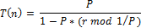
if n € G
0 , otherwise
where, P is the desired percentage of CH, r is the current round and G is the set of nodes that have not been CH in the last 1/P rounds. Every node in G chooses a random number between 0 and 1 and if the number is less than the threshold value, it is selected as the CH for the current round.
- Cluster Formation: Each node that has elected itself as a cluster-head for the current round broadcasts an ADV message to its one hop neighbor with the following information:
- Budget allocated to the neighbor (B).
- Minimum number of hops to reach cluster head through it ( h_{min} ).
- Average energy of the path (E_{avg} ).
- Traffic information through that node (t).
During the cluster formation every node that comes under a cluster consumes one spot from the budget assigned to it. Similarly, they divide the rest of the budget allotted to them among their one hop neighbours randomly[xxx][persistent algorithm].
The neighbouring node receives a number of ADV messages from its one hop neighbours. If it is the first adv message the neighbouring node has received then the neighbour is added as the minimal path and heuristic value is calculated, else the neighbour is added to the alternative path list and the heuristic value is calculated. Finally the receiving neighbour sends back an acknowledgement message to the cluster head and broadcasts the advertising message to its one hop neighbour. This process is continued till the budget exhausts, as shown in figure 2
G F
.
.
.
.
.
.
.
.
.
.
.
.
2
L
D
E
I
H
1 B
C 2 A 2 1
K
Figure 2.
Where, = alternative path,
Consider an example shown in figure 2, where the node A initially broadcasts a ADV message to its one hop neighbours B,C,D and E and randomly allocates budget 2,2,2 and 2 respectively. Than the node B broadcasts a ADV message to its one hop neighbours as it has only one budget which less than the number of one hop neighbours it randomly allocates the budget ‘1’ to the node G and the nodes F and C added to the alternative path list. Similarly this process is carried out in all the sub-trees till the budget exhausts and simultaneously the routing table at each node is updated with following information’s.
4.2 Data transmission phase:
Once the clusters are created and sensor nodes are allotted time slots for data transmission to begin. Assuming nodes always have data to send, they send it during their allocated transmission time to the cluster head.
- When a node receives the data from its neighbours it aggregates it with its own data. During forwarding the aggregated data, it has to choose a path from different entries in the routing table. It uses a heuristic function to choose a path give by:

h = K E _{avg}
h_{min} * t

where: K= constant, E_{avg} = Average energy of the current path, h_{min} = minimum hop count in current path, t = traffic in the current path.

The path with highest heuristic value is chosen. If this path’s E_{min}> threshold, it is chosen. Else the path with the next highest heuristic value is chosen, where
E_{min} = E_{avg} /const.
The const may be any integer value like 10.
- If no node in the routing table has E_{min} greater than threshold energy, it picks the node with highest minimum energy.

Comparison of EAMMH test result with LEACH test result:
LEACH protocol operation starts with the cluster head selection at 0.1s and cluster formation starts at 0.2s. To comply with the EAMMH operation of rounds, the nodes start transmitting data only after 0.4s. Since the one-hop transmission range of the node is 50m only, any transmission over distance greater than 50m requires extra energy.

Extra loss of Energy = ( ( 4 * pi * d * f ) / c ) ² * 0.5 * 10⁻⁴ (5)
= (( ( ( 4* 3.142 * 2.4 * 10⁹ ) / ( 3 * 10⁸) ) ² )* 0.5 * 10⁻⁴ )* d²

Total Energy required = Energy for 50m + Extra loss of Energy * Energy for 50m
= 0.001597 + Extra loss of Energy * 0.001597

The Energy status of each node at the end of each round for the LEACH operation is shown in fig

EAMMH protocol starts with neighbor discovery at time 0.0s (upon node deployment) followed by cluster heads selection at time 0.1s. The cluster formation starts at 0.2s and the data flows from 0.4s. Each round lasts for 5s and the path parameters are updated every 1s.

The Energy status of each node at the end of each round for the LEACH operation is shown in fig. The simulation results for 8 rounds of operation is given below. The x-axis represents the nodes and y-axis represents the energy level of the node. As shown in the results, the nodes that become the cluster head will lose energy at a rate faster than other nodes.

Inspite of cluster head's faster rate of energy depletion, after the completion of 8 rounds, the minimum energy of the node is 8J, whereas in LEACH operation, a few of the nodes die at the end of 8 rounds.

Also, the load is well balanced in EAMMH implementation. But in LEACH implementation, the CH suffers a lot and huge amount of energy depletes in 1 round which results in the death of the node in the subsequent rounds.

Y axis - Energy
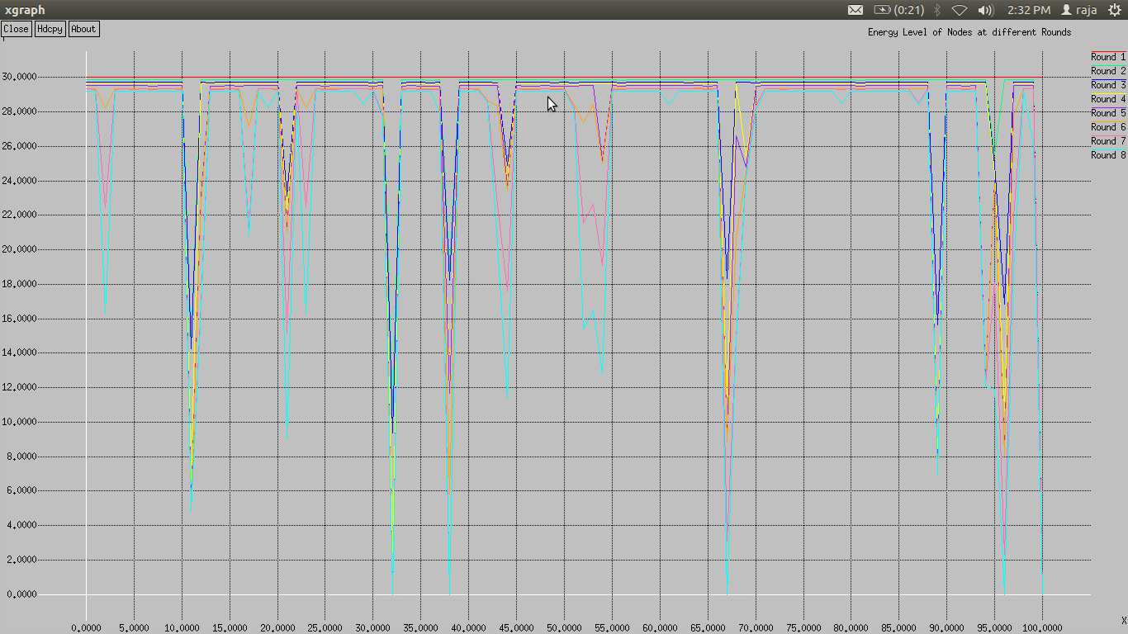
X axis - Nodes

Figure – simulation result of LEACH protocol taken for 8 rounds
Y axis - Energy

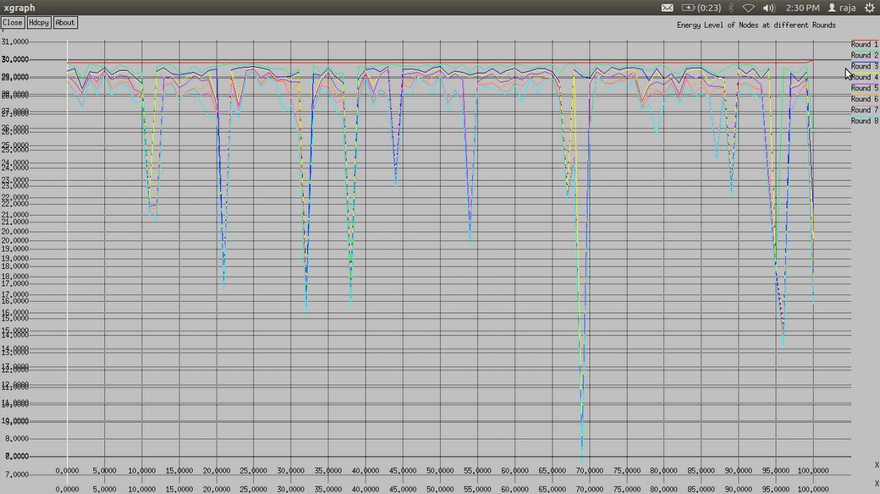

X axis - Nodes
Figure -- simulation result of EAMMH protocol taken for 8 rounds

4.4 Periodic Updates:
In the beginning of each round, the information which includes E_{avg,} t and E_{min} is forwarded to all the nodes throughout the cluster. As the network starts operating, each node’s energy starts draining out and so does E_{avg} and E_{min} with a varying t. This information is reliable only for a certain amount of time and hence the changed values needs to be advertised to the other nodes in the cluster.

As the nodes receive the periodic updates from their neighbouring nodes, new heuristic values are calculated at each node and the routing tables gets updated. Thus, they are dynamic as there are no constant values.

7. CONCLUSION:

WSNs have discovered a wide range of applications in the recent era. Growing demand for WSN has accelerated the research and development of routing protocols used in WSNs. In this paper we present EAMMH, a novel energy efficient data gathering protocol, where clustering is based on the allocating growth budget to neighbours, multi-hop, multi-path. Unlike the persistent algorithm our algorithm will use the minimal path recursively, which will lead to decrease the network lifetime. Our algorithm chooses the alternative based on heuristic function value (routing table information). EAMMH protocol organizes the sensor nodes into clusters and forms a multi-hop intra-cluster network. In addition it further establishes multiple paths from each sensor node to the cluster head and provides an energy aware heuristic function to choose the appropriate path.

REFERENCES

[1] I. F. Akyildiz et al,( March 2002), “Wireless sensor networks: a survey”, Computer Networks, V Vol. 38, pp. 393-422.
[2] K. Sohrabi, et al, (October 2000) "Protocols for self-organization of a wireless sensor network,” I IEEE Personal Communications, Vol. 7, No. 5, pp. 16-27.
[3] R. Min, et al., (January 2001), “Low Power Wireless Sensor Networks,” Internation Conference o o on VLSI Design, Bangalore, India.
[4] J.M. Rabaey, et al., ( July 2000), "PicoRadio supports ad hoc ultra low power wireless e networking," IEEE Computer, Vol. 33, pp. 42-48.
[5] R. H. Katz, J. M. Kahn and K. S. J. Pister, ( August 1999), “Mobile Networking for Smart Dust,” 5th Annual ACM/IEEE International Conference on Mobile Computing and Networking (MobiCom’99), Seattle, WA.
[6] I.F.Akyildiz,W.Su, Y.Sankarasubramaniam,E.Cayirci, (Dec 2002), “Wireless Sensor Networks:A survey”, Elsevier science B.V.
[7] Shio Kumar Singh, M P Singh and D K Singh, (August 2010), “A Survey of Energy-Efficient Hierarchical Cluster-Based Routing in wireless Sensor Network,” Int J. of Advanced Networking and Applications Volume:02, Issue:02, Pages:570-580.
[8] W. Heinzelman, A. Chandrakasan and H. Balakrishnan, (Jan 2000), “Energy-Efficient Communication Protocol for Wireless Microsensor Networks,” Proc. 33rd Hawaii Int’l. Conf. Sys. Sci.
[9] Zuniga, M. Z.; Krishnamachari, B. (2002), "Integrating Future Large-Scale Wireless Sensor Networks with the Internet," - Department of Electrical Engineering, UNiversity of Southern California.
[10] Alonso, J., Dunkels, A., Voigt. T, ( March 2004), “Bounds on the energy consumption of routings in wireless sensor nodes” WiOpt'04: Modeling and Optimization in Mobile, Ad Hoc and Wireless Networks,” Cambridge, UK.

