测试情况

测试库表：qc_push

测试工具：JMeter

JMeter可通过设置线程组来模拟真实用户对DB服务器做压力测试。使用JMeter进行数据库测试的过程。创建测试计划，模拟并发用户发送SQL请求到数据库。测试数据库。

性能测试的目标是找到数据库的性能瓶颈。通过线程和连接数来构造测试场景，完成对数据库的测试。

DB状况：

DB最大连接数：max_connections=151

缓存池：innodb_buffer_pool_size=8388608

Redo日志文件：innodb_log_file_size=50331648

查询缓存：query_cache_size=59999232

join_buffer_size=262144

sort_buffer_size=262144

1. 循环样本：1000；线程：1；连接数：150；数据量<100

测试结果：< 100ms 正常

|  |  |  |  |  |  |  |
| --- | --- | --- | --- | --- | --- | --- |
| Label | # Samples | Average | Median | 90% Line | 95% Line |  |
| JDBC Request | 1000 | 42 | 20 | 22 | 24 |  |
| 总体 | 1000 | 42 | 20 | 22 | 24 |  |
| 99% Line | Min | Max | Error % | Throughput | Received KB/sec | Sent KB/sec |
| 27 | 20 | 21102 | 0.00% | 23.70848 | 0.25 | 0 |
| 27 | 20 | 21102 | 0.00% | 23.70848 | 0.25 | 0 |

图例如下：

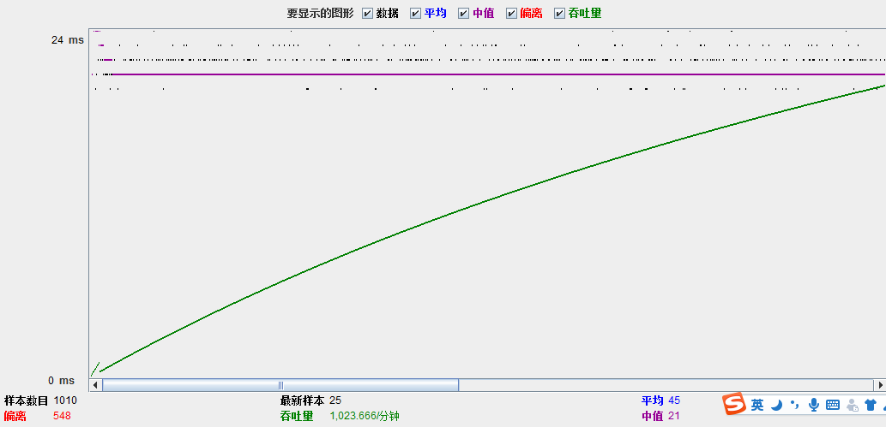

1. 循环样本：5000；线程：5；连接数：150；数据量<100

测试结果：< 100ms 正常

|  |  |  |  |  |  |  |
| --- | --- | --- | --- | --- | --- | --- |
| Label | # Samples | Average | Median | 90% Line | 95% Line |  |
| JDBC Request | 5000 | 56 | 21 | 23 | 24 |  |
| 总体 | 5000 | 56 | 21 | 23 | 24 |  |
| 99% Line | Min | Max | Error % | Throughput | Received KB/sec | Sent KB/sec |
| 30 | 19 | 36063 | 0.00% | 86.04519 | 0.92 | 0 |
| 30 | 19 | 36063 | 0.00% | 86.04519 | 0.92 | 0 |

图例如下：

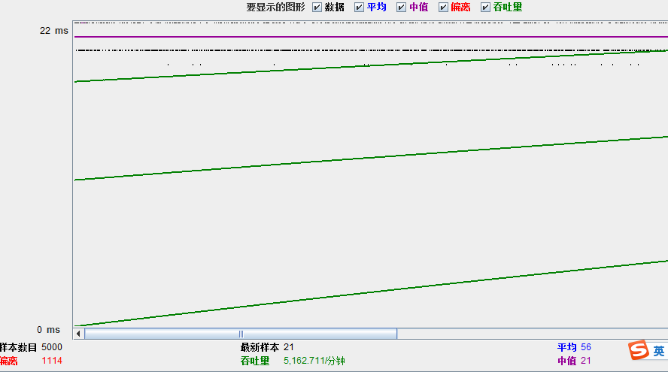

1. 循环样本：7223；线程：5；连接数：150；数据量>100000

测试结果：>5000ms 响应时间较长

|  |  |  |  |  |  |  |
| --- | --- | --- | --- | --- | --- | --- |
| Label | # Samples | Average | Median | 90% Line | 95% Line |  |
| JDBC Request | 7233 | 3190 | 2925 | 4053 | 4378 |  |
| 总体 | 7233 | 3190 | 2925 | 4053 | 4378 |  |
| 99% Line | Min | Max | Error % | Throughput | Received KB/sec | Sent KB/sec |
| 5213 | 1344 | 64630 | 0.00% | 2.8584 | 2.44 | 0 |
| 5213 | 1344 | 64630 | 0.00% | 2.8584 | 2.44 | 0 |

图例如下：

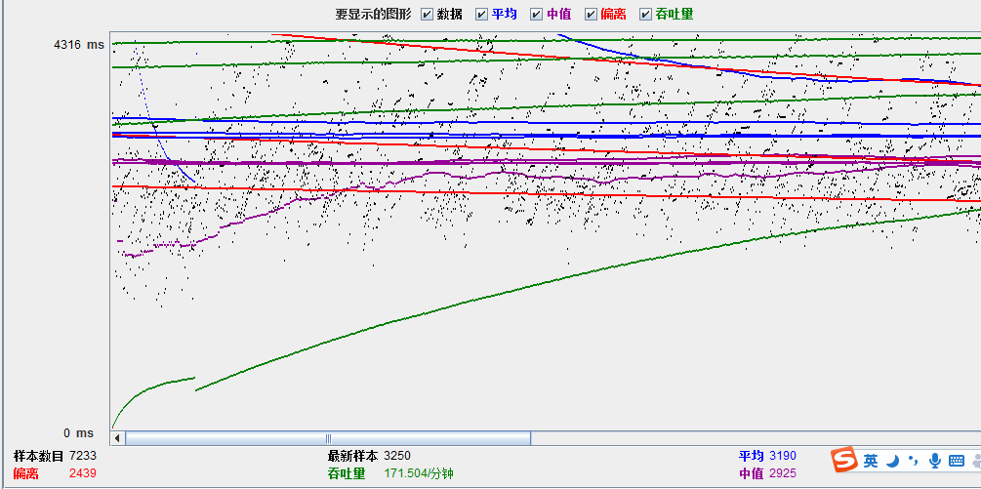

1. 循环样本：130；线程：5；连接数：150；数据量>1000000

测试结果：>250000ms 超时

|  |  |  |  |  |  |  |
| --- | --- | --- | --- | --- | --- | --- |
| Label | # Samples | Average | Median | 90% Line | 95% Line |  |
| JDBC Request | 131 | 46030 | 26112 | 30129 | 288515 |  |
| 总体 | 131 | 46030 | 26112 | 30129 | 288515 |  |
| 99% Line | Min | Max | Error % | Throughput | Received KB/sec | Sent KB/sec |
| 289718 | 23114 | 289920 | 0.76% | 0.21691 | 0 | 0 |
| 289718 | 23114 | 289920 | 0.76% | 0.21691 | 0 | 0 |

图例如下：

