学号：031502209姓名：陈翔 学院：数学与计算机科学学院 专业：计算机 班级：2班
《Linux 操作系统设计实践》实验五
实验环境：ubuntu 16.0.4 lts
实验内容：有简单功能的图形界面程序，点击按钮后一次会生成一个100以内的加法算式。

代码：
#include <gtk/gtk.h>
#include <stdlib.h>
gint count=1;
char s1[20], s2[20], s3[20], s4[100];
//interger to string
void get(char *s, long long t){
int len=0;
do{
s[len++]=t%10+'0';
t/=10;
}while(t!=0);
s[len]=0;
for(int l=0, r=len-1; l<r; l++, r--){
char tmp=s[l];
s[l]=s[r];
s[r]=tmp;
}
}
//s4=s1+s2+s3
void gs4(char *s1, char *s2, char *s3, char *s4){
int len=0;
for(int i=0; s1[i]; i++)
s4[len++]=s1[i];
s4[len++]='+';
for(int i=0; s2[i]; i++)
s4[len++]=s2[i];
s4[len++]='=';
for(int i=0; s3[i]; i++)
s4[len++]=s3[i];
s4[len]=0;
}
GtkWidget *label;
void on_button_clicked (GtkWidget *button,gpointer userdata)
{
int a=rand()%100, b=rand()%100;
long long c=(long long)a+b;
get(s1, a);
get(s2, b);
get(s3, c);
gs4(s1, s2, s3, s4);
gtk_label_set_text(GTK_LABEL(label), s4);
}
int main ( int argc , char* argv[])
{
GtkWidget *box;
GtkWidget *window;
GtkWidget *button;
//initial window
gtk_init(&argc,&argv);
window = gtk_window_new(GTK_WINDOW_TOPLEVEL);
g_signal_connect(G_OBJECT(window),"destroy",G_CALLBACK(gtk_main_quit),NULL);
gtk_window_set_title(GTK_WINDOW(window),"Random");
gtk_window_set_default_size(GTK_WINDOW(window),1000,750);
gtk_window_set_position(GTK_WINDOW(window),GTK_WIN_POS_CENTER);
gtk_container_set_border_width(GTK_CONTAINER(window),20);
//initial container
box=gtk_vbox_new(FALSE, 0);
gtk_container_add(GTK_CONTAINER(window), box);
//initial label and button
label=gtk_label_new("yoo");
button = gtk_button_new_with_label("Generate");
//add label and button to container
gtk_box_pack_start(GTK_BOX(box), label, TRUE, TRUE, 3);
gtk_box_pack_start(GTK_BOX(box), button, TRUE, TRUE, 3);
//click button
g_signal_connect(G_OBJECT(button),"clicked",G_CALLBACK(on_button_clicked),(gpointer)count);
gtk_widget_show_all(window);
gtk_main();
return FALSE;
}
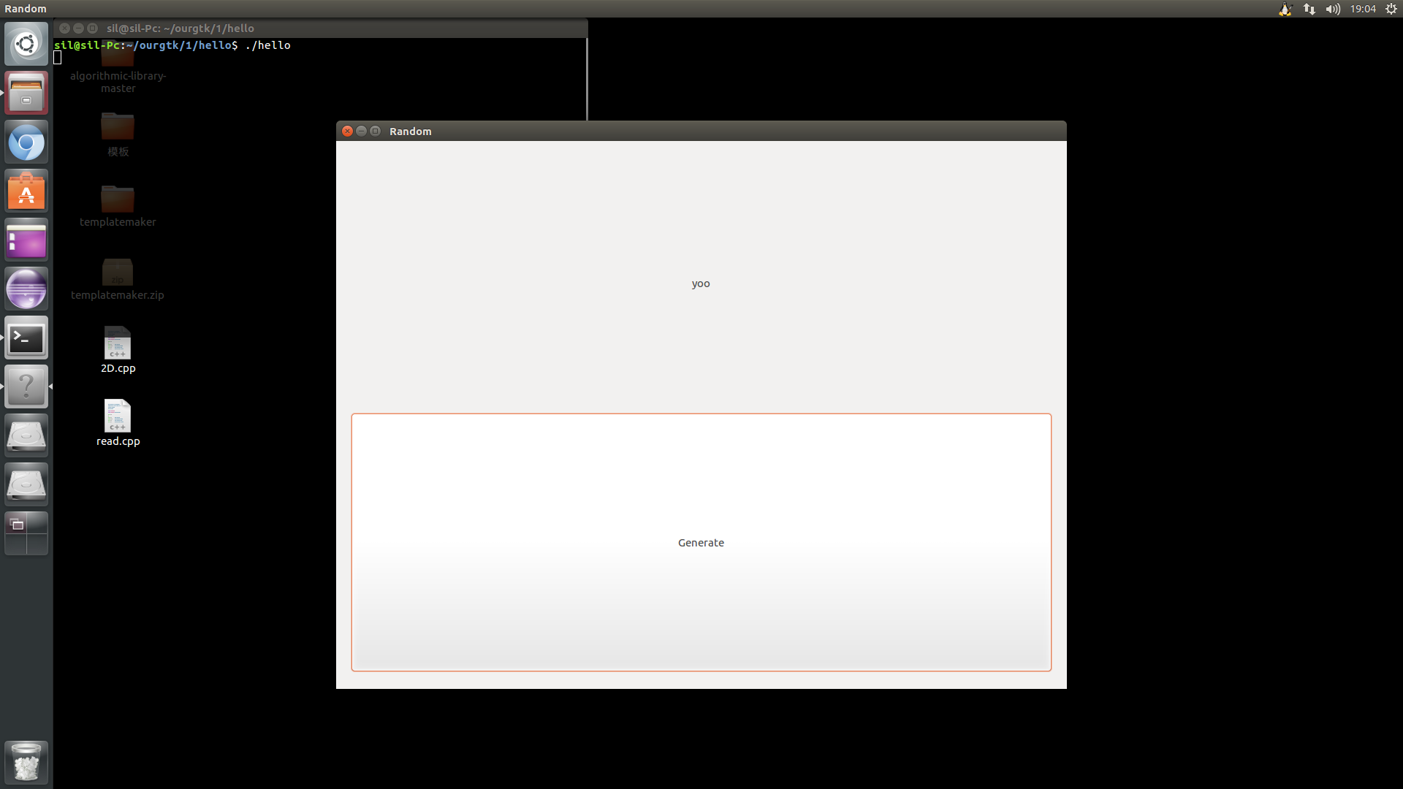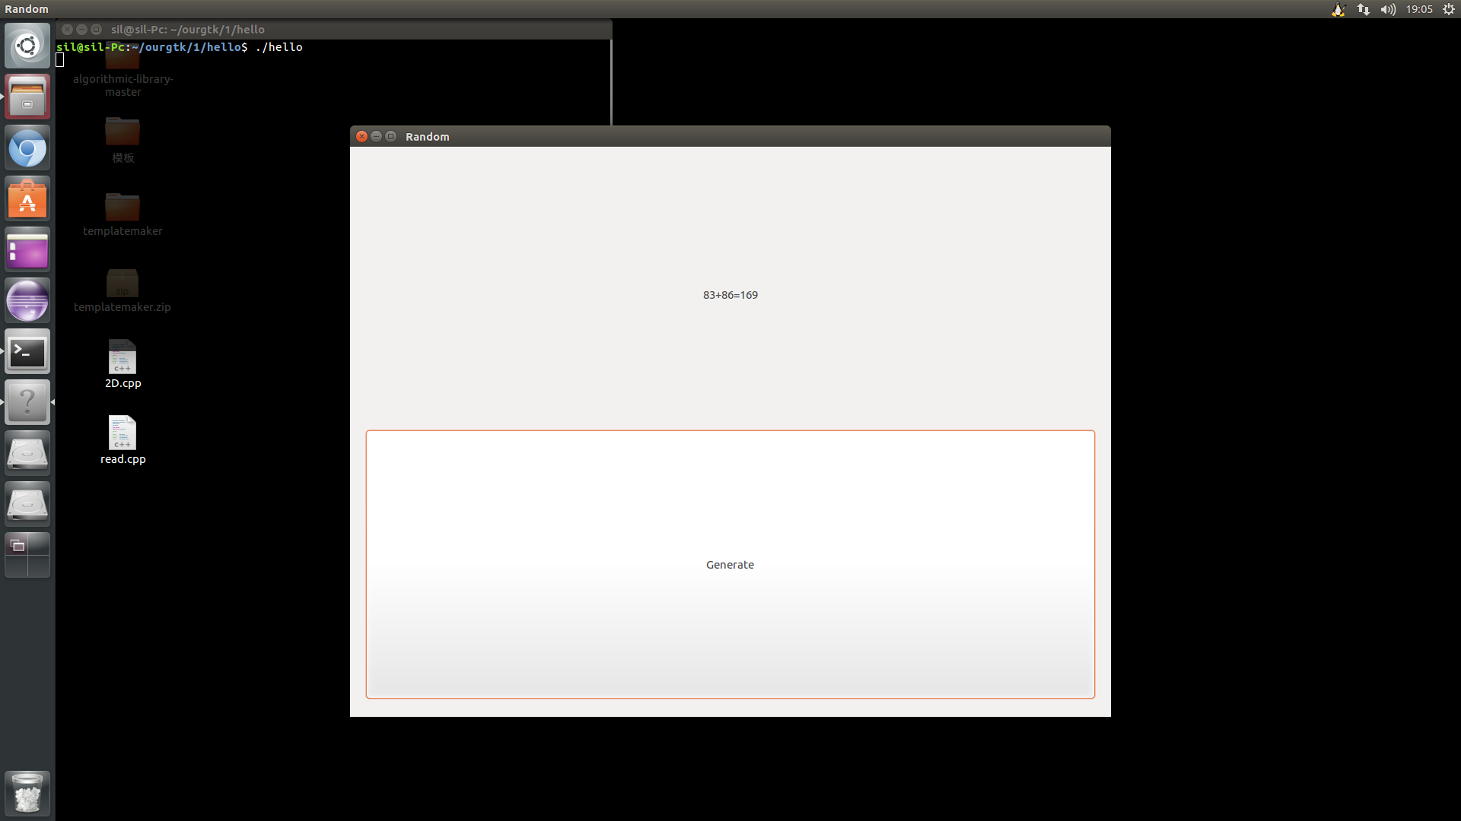

心得体会：学习了linux图形界面编程基本知识，掌握了gtk的使用方法。

