

《Linux操作系统设计实践》
实验报告

学号： 031502209
姓名： 陈翔
年级： 2015
学院： 数计学院
专业： 计算机系

实验时间：2017－2018学年第一学期

目录
《Linux 操作系统设计实践》实验一：进程管理 1
《Linux 操作系统设计实践》实验二：进程通信 5
《Linux 操作系统设计实践》实验三：网络编程 10
《Linux 操作系统设计实践》实验四：文件操作 17
《Linux 操作系统设计实践》实验五：图形界面 19
《Linux 操作系统设计实践》实验六：综合应用 22

《Linux 操作系统设计实践》实验一：进程管理
学号：031502209姓名：陈翔 学院：数学与计算机科学学院 专业：计算机 班级：2班
实验内容：
运行代码：
#include <stdio.h>
#include <stdlib.h>
#include <unistd.h>
#include <signal.h>
#include <sys/wait.h>

int father_process_waiting_flag = 1; //父进程等待标志
int child_process_id = 0; //子进程ID

void father_process_wait() //父进程等待
{
while(father_process_waiting_flag) {
printf("Father Process Waiting\n");
sleep(1);
}
}

void child_process_wait() //子进程等待
{
while(1) {
printf("Child Process Waiting\n");
sleep(2);
}
}

void father_process_stop() //父进程中止
{
if(child_process_id) { //若子进程仍在运行，则中止子进程
kill(child_process_id, SIGUSR1); //父进程发送用户信号给子进程
wait(0); //等待子进程执行退出
printf("Child Process Exited\n");
child_process_id = 0;
} else { //若子进程不存在，则父进程退出
printf("Father Process Exiting\n");
father_process_waiting_flag = 0;
}
}

void child_process_stop() //子进程中止
{
printf("Child Process Exiting\n");
exit(0);
}

int main()
{
child_process_id = fork();
if(child_process_id < 0) { //fork失败时的处理
perror("");
exit(child_process_id);
}
if(child_process_id) { //父进程分支
signal(SIGINT, father_process_stop); //绑定键盘^C信号到对应程序
father_process_wait(); //进入循环等待
} else { //子进程分支
signal(SIGINT, SIG_IGN); //忽略键盘^C信号
signal(SIGUSR1, child_process_stop); //绑定用户信号到对应程序
child_process_wait(); //进入循环等待
}
return 0;
}
运行结果：
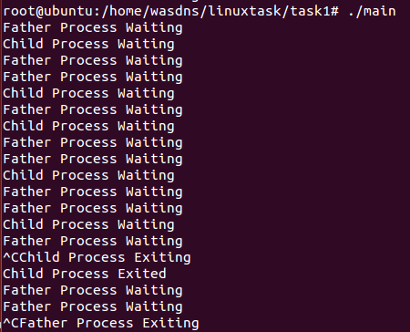
实验总结：
利用fork()函数，创建父子进程，同时利用signal()函数对SIGINT信号进行管控，使得子进程存在时中止字进程，若子进程不存在则中止父进程。
kill()用于父进程发送用户信号SIGUSR1给子进程，子进程以此执行中止函数。

《Linux 操作系统设计实践》实验二：进程通信
学号：031502209姓名：陈翔 学院：数学与计算机科学学院 专业：计算机 班级：2班
实验环境：Ubuntu 14.04.5 LTS
实验内容：
运行代码：
umsg.h 利用共享内存和信号量的封装来实现类消息队列的功能
#ifndef __UMSG_H__
#define __UMSG_H__

#include <sys/shm.h>
#include <sys/sem.h>
#include <sys/types.h>
#include <sys/ipc.h>
#include <string.h>

#define LETTERNUM 8
#define LETTERSIZE 300
#define INT_MAX 2147483647

struct mailbox {
long type[LETTERNUM];
char text[LETTERNUM][LETTERSIZE];
};

struct letter {
long type;
char text[LETTERSIZE];
};

struct msgid {
int semid;
int shmid;
struct mailbox* mcont;
};

union semun {
int val;
struct semid_ds *buf;
unsigned short *arry;
};

extern struct msgid umsgget(key_t ukey, int umsgflg) {
struct msgid ret = { -1, -1, NULL};
union semun rec;
ret.semid = semget(ukey, 3, umsgflg);

if (ret.semid == -1) return ret;
ret.shmid = shmget(ukey, sizeof(struct mailbox), umsgflg);

if (ret.shmid == -1) {
semctl(ret.semid, 0, IPC_RMID, NULL);
semctl(ret.semid, 1, IPC_RMID, NULL);
semctl(ret.semid, 2, IPC_RMID, NULL);
ret.semid = -1;
return ret;
}

void *gshm = shmat(ret.shmid, NULL, 0);

if (gshm == (void*) - 1) {
semctl(ret.semid, 0, IPC_RMID, NULL);
semctl(ret.semid, 1, IPC_RMID, NULL);
semctl(ret.semid, 2, IPC_RMID, NULL);
shmctl(ret.shmid, IPC_RMID, NULL);
ret.semid = -1;
ret.shmid = -1;
return ret;
}

rec.val = LETTERNUM;
semctl(ret.semid, 0, SETVAL, rec);
rec.val = 0;
semctl(ret.semid, 1, SETVAL, rec);
rec.val = 1;
semctl(ret.semid, 2, SETVAL, rec);
ret.mcont = (struct mailbox*) gshm;

for (int i = 0; i < LETTERNUM; ++i)
ret.mcont->type[i] = -1;

return ret;
}

extern int umsgctl(struct msgid mid, int cmd) {
if (cmd != IPC_RMID) return -1;

int flag;
flag = semctl(mid.semid, 0, cmd, NULL);

if (flag == -1) return -1;
flag = shmctl(mid.shmid, cmd, NULL);

return flag;
}

extern int umsgsnd(struct msgid mid, const struct letter * scont) {
int semstat, i;
struct sembuf sp = {0, -1, IPC_NOWAIT};
struct sembuf rv = {1, +1, IPC_NOWAIT};
struct sembuf mp = {2, -1, IPC_NOWAIT};
struct sembuf mv = {2, +1, IPC_NOWAIT};

semstat = semop(mid.semid, &sp, 1);
if (semstat == -1)return -1;
semstat = semop(mid.semid, &mp, 1);
if (semstat == -1)return -1;

for (i = 0; i < LETTERNUM; ++i) {
if(mid.mcont->type[i] == -1)break;
}

if (i == LETTERNUM)return -1;

mid.mcont->type[i] = scont->type;
strcpy(mid.mcont->text[i], scont->text);
semstat = semop(mid.semid, &mv, 1);

if (semstat == -1)return -1;
semstat = semop(mid.semid, &rv, 1);

return semstat;
}

extern int umsgrcv(struct msgid mid, struct letter * scont) {
int semstat, i, min = INT_MAX, mini;
struct sembuf rp = {1, -1, IPC_NOWAIT};
struct sembuf sv = {0, +1, IPC_NOWAIT};
struct sembuf mp = {2, -1, IPC_NOWAIT};
struct sembuf mv = {2, +1, IPC_NOWAIT};

semstat = semop(mid.semid, &rp, 1);
if(semstat == -1) return -1;
semstat = semop(mid.semid, &mp, 1);
if(semstat == -1) return -1;

for (i = 0, mini = -1; i < LETTERNUM; ++i) {
if ((mid.mcont->type[i] > 0) && (min > mid.mcont->type[i])) {
mini = i;
min = mid.mcont->type[i];
}
}
if (mini == -1) return -1;

scont->type = mid.mcont->type[mini];
strcpy(scont->text, mid.mcont->text[mini]);
mid.mcont->type[mini] = -1;
semstat = semop(mid.semid, &mv, 1);

if (semstat == -1)return -1;
semstat = semop(mid.semid, &sv, 1);

return semstat;
}

#endif
C2uCTL.c 同时包含发送和接收的通信程序，在开始运行时手动输入KEY来建立相互的连接。

#define _XOPEN_SOURCE 1

#include <stdio.h>
#include <stdlib.h>
#include <unistd.h>
#include <time.h>
#include <errno.h>
#include <string.h>

#include <sys/types.h>
#include <sys/ipc.h>

#include "umsg.h"

int main(int argc, char *argv[])
{
struct msgid msg_id1, msg_id2;
int key1, key2, flag;
char inpt[5];
struct letter send, recv;
printf("LOCAL KEY:");
scanf("%d", &key1);
msg_id1 = umsgget(key1, IPC_CREAT | 0600);
printf("REMOTE KEY:");
scanf("%d", &key2);
msg_id2 = umsgget(key2, IPC_CREAT | 0600);
printf("MSGID1A:%d,MSGID2A:%d\n", msg_id1.semid, msg_id2.semid);
printf("MSGID1B:%d,MSGID2B:%d\n", msg_id1.shmid, msg_id2.shmid);
printf("OPERATE (H:HELP E:EXIT)\n");
for(int loop = 1; inpt[0] != 'E'; ++loop) {
printf("INPUT :");
scanf("%s", inpt);
switch(inpt[0]) {
case 'S':case 's':
send.type = loop;
scanf("%s", send.text);
flag = umsgsnd(msg_id2, &send);
if(flag != -1)printf("SEND#%05ld %-32s [ O K ]\n", send.type, send.text);
else printf("SEND#%05ld %-32s [ FAILED ]\n", send.type, send.text);
break;
case 'R':case 'r':
flag = umsgrcv(msg_id1, &recv);
if(flag != -1)printf("RECV#%05ld %-32s [ O K ]\n", recv.type, recv.text);
else printf("RECV#ERROR %-32s [ FAILED ]\n", " ");
break;
case 'E':case 'e':
inpt[0] = 'E';
break;
default:
printf("S:Send R:Receive E:Exit\n");
}
}
umsgctl(msg_id1, IPC_RMID);
umsgctl(msg_id2, IPC_RMID);
return EXIT_SUCCESS;
}
运行结果：
预留空间为每个进程各8封信，当空间满时发送失败，须等待对方接收才能继续发送。
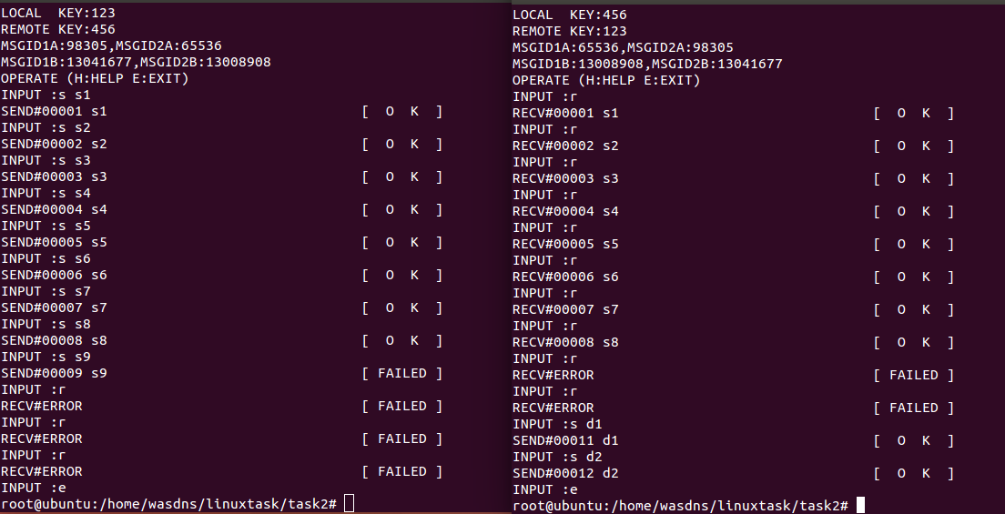
实验总结：
利用信号量和共享内存实现通信较为复杂，可以参考消息队列的函数所实现的功能来编写。

《Linux 操作系统设计实践》实验三：网络编程
学号：031502209姓名：陈翔 学院：数学与计算机科学学院 专业：计算机 班级：2班
实验环境：Ubuntu 14.04.5 LTS
实验内容：
运行代码：
E3GOBANG.c 主程序，用以连接和收发数据，并处理下棋事件
#include <stdio.h>
#include <sys/socket.h>
#include <unistd.h>
#include <netinet/in.h>
#include <arpa/inet.h>
#include "GOBANG.h"
#define PORT 16923
int main()
{
char inputbuf[100];
char recbuf[100];

int final = 0;
int over = 0;
int player = 1;
int x, y;

int role = 0;
int server_sockfd, client_sockfd;
struct sockaddr_in server_addr = {0};
struct sockaddr_in client_addr = {0};
int client_sockaddr_len;
int optval = 1;
do {
printf("(L)isten , (C)onnect or (E)xit:");
scanf("%s", inputbuf);
switch(inputbuf[0]) {
case 'L':case 'l':
server_sockfd = socket(AF_INET, SOCK_STREAM, 0); //服务器建立套接字
if(server_sockfd == -1) {
perror("");
return 1;
}
if((setsockopt(server_sockfd, SOL_SOCKET, SO_REUSEADDR, &optval, sizeof(optval))) == -1) { //设置套接字选项
perror("Setsockopt Error");
return 1;
}
server_addr.sin_family = AF_INET;
server_addr.sin_addr.s_addr = htonl(INADDR_ANY);
server_addr.sin_port = htons(PORT);
if(bind(server_sockfd, (struct sockaddr *) &server_addr, sizeof(server_addr)) == -1) { //套接字绑定
perror("Bind Error");
return 1;
}
if(listen(server_sockfd, 5) == -1) { //进行客户端监听
perror("Listen Error");
return 1;
}
printf("Waiting client...\n");
client_sockaddr_len = sizeof(client_addr);
client_sockfd = accept(server_sockfd, (struct sockaddr *) &client_addr, (socklen_t *__restrict) &client_sockaddr_len); //等待客户端连接
if(client_sockfd == -1) {
perror("");
return 1;
}
role = 1; //设定服务器对应玩家角色
break;
case 'C':case 'c':
printf("Server address:");
scanf("%s", inputbuf);
client_sockfd = socket(AF_INET, SOCK_STREAM, 0); //客户端建立套接字
if(client_sockfd == -1) {
perror("");
return 1;
}
client_addr.sin_family = AF_INET;
client_addr.sin_port = htons(PORT);
client_addr.sin_addr.s_addr = inet_addr(inputbuf); //根据手动输入地址进行连接
if(client_addr.sin_addr.s_addr == -1) {
printf("Address is invalid");
return 1;
}
server_sockfd = connect(client_sockfd, (struct sockaddr *)(&client_addr), sizeof(client_addr)); //连接服务器
if(server_sockfd == -1) {
perror("Connect failed");
return 1;
}
role = 2; //设定服务器对应玩家角色
break;
case 'E':case 'e':
return 0;
default:
role = 0;
}
} while(!role);

do {
printtable(); //打印棋盘
if(player == role) { //当前与对应端一致
do {
printf("Player %s (INPUT:Ln or (Q)uit):", tablechar[player]);
scanf("%s", inputbuf);
ipttoop(inputbuf, &x, &y, &over);
} while((!over) && (x < 0 || y < 0));
send(client_sockfd, inputbuf, sizeof(inputbuf), 0); //发送己方指令
} else { //
printf("Waiting Player %s ...\n", tablechar[player]);
recv(client_sockfd, recbuf, sizeof(recbuf), 0); //接收对方指令
ipttoop(recbuf, &x, &y, &over);
}
if(over)break;
if(set(x, y, player)) { //放置棋子
printf("Set Error!\n");//放置失败
} else {
player = 3 - player; //放置成功，切换玩家
}
final = check(); //检测游戏是否结束
} while(!final && !over);
if(!over) {
printtable();
switch(final) { //游戏结果
case 1:
printf("Player () WIN!\n");
break;
case 2:
printf("Player >< WIN!\n");
break;
case 3:
printf("DRAW!\n");
break;
default:
printf("ERROR");
}
}
close(server_sockfd);
close(client_sockfd);
return 0;
}
GOBANG..h 五子棋头文件，内含棋盘、落子、判断胜负等函数。

#ifndef _GOBANG_H_
#define _GOBANG_H_
#include <stdlib.h>
int table[15][15] = {0}; //棋盘
const char tablechar[][3] = {" ", "()", "><"}; //棋盘图案
int lastx, lasty, count = 0;
void printtable() //打印棋盘
{
int i, j;
printf(" A B C D E F G H I J K L M N O\n");
for(i = 0; i < 15; ++i) {
if(i)printf(" --+--+--+--+--+--+--+--+--+--+--+--+--+--+--\n");
printf("%2d ", i + 1);
for(j = 0; j < 15; ++j) {
if(j)printf("|");
printf("%s", tablechar[table[i][j]]);
}
printf("\n");
}
}

int set(int x, int y, int c) //放置棋子
{
if(x >= 15)return 1;
if(y >= 15)return 1;
if(table[y][x])return 1;
else table[y][x] = c;
lastx = x;
lasty = y;
++count;
return 0;
}

const int wayx[8] = { -1, +1, -1, +1, -1, +1, +0, +0};
const int wayy[8] = { -1, +1, +1, -1, +0, +0, -1, +1};

int check() //检测胜利
{
if(count == 15 * 15)return 3;
int i, j, x, y, d;
int c = table[lasty][lastx];
for(i = 0; i < 8 ; ++i) {
x = lastx;
y = lasty;
for(j = 0; j < 4; ++j) {
x += wayx[i];
y += wayy[i];
if(x < 0 || x >= 15)break;
if(y < 0 || y >= 15)break;
if(table[y][x] != c)break;
}
if((i&1)==0)d=j;
else {
d+=j+1;
if(d >= 5)return c;
}
}
return 0;
}

void ipttoop(char *ipt, int *x, int *y, int *over) //将字符指令转为操作
{
char buf[3] = {0};
int tx, ty;
tx = ipt[0] - 'A';
if(tx > ('Z' - 'A'))tx = ipt[0] - 'a';
if(tx == ('Q' - 'A'))*over = 1;
if(tx > ('O' - 'A'))tx = -1;
if(tx < 0)tx = -1;
buf[0] = ipt[1];
buf[1] = ipt[2];
buf[3] = 0;
ty = atoi(buf) - 1;
if(ty >= 15)ty = -1;
*x = tx;
*y = ty;
}

#endif
运行结果：
与远程服务器建立的五子棋游戏。
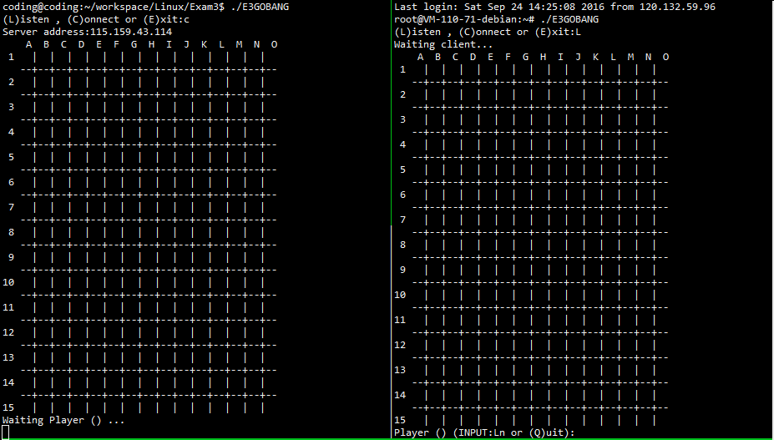
相互落子，并让对方收到结果。
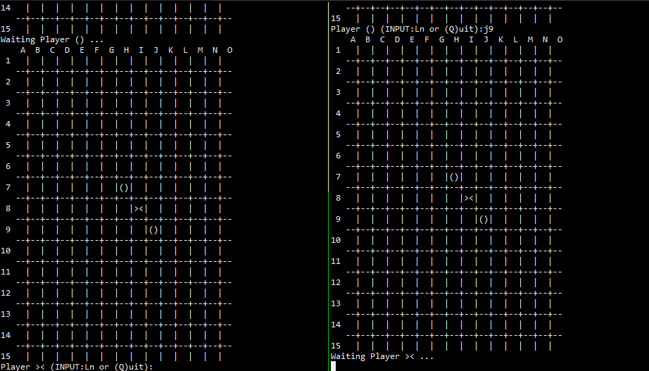
游戏结束，某方胜利，同时连接中断。
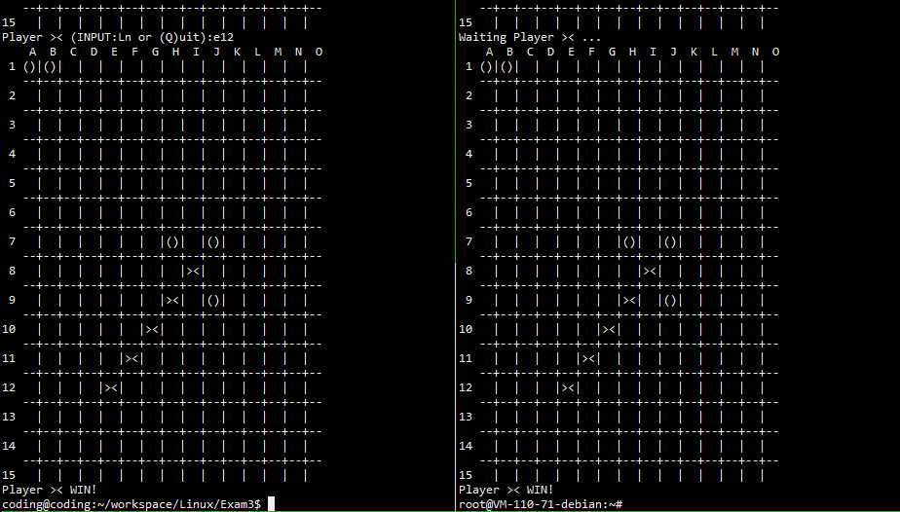

实验总结：
之前编写的代码会导致一次游戏后连接不上，经检查是服务器端bind进行绑定失败，之后利用setsockopt函数设定套接字类型，使得连接中断后下次连接能够正常。
游戏虽用类似S/C机制进行连接，但对局的相关计算仍由服务器与客户机自行处理，网络仅发送对方所下位置。

《Linux 操作系统设计实践》实验四：文件操作
学号：031502209姓名：陈翔 学院：数学与计算机科学学院 专业：计算机 班级：2班
实验环境：Ubuntu 14.04.5 LTS
实验内容：
运行代码：
#include <sys/types.h>
#include <sys/stat.h>
#include <fcntl.h>
#include <unistd.h>
#include <stdio.h>
#include <string.h>
#include <stdlib.h>

#define FLAGS O_WRONLY | O_CREAT | O_TRUNC

int main() {
char buf1[] = {"Hello "};
char buf2[] = {"World!"};
int fd = 0, count = 0;
const char *path = "test";

if ((fd = open(path, FLAGS, 0600)) == -1) {
printf("Open file failed!\n");
exit(1);
}
count = strlen(buf1);
if (write(fd, buf1, count) != count) {
printf("Write file failed!\n");
exit(1);
}

system("cat test");
printf("\n");

if (lseek(fd, 10, SEEK_SET)==-1) {
printf("lseek failed!\n");
exit(1);
}
count = strlen(buf2);

if (write(fd,buf2,count)!=count) {
printf("write file failed!\n");
exit(1);
}

system("cat test");
printf("\n");

return 0;
}
运行结果：
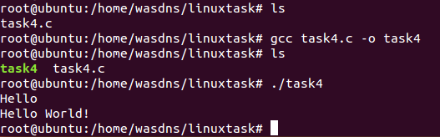
实验总结：
本次实验实现是简单的，参考课件，通过对文件读写等操作很容易实现实验目的，如果要结合第二次和第三次实验的话，只用把他们之间联系起来，比如当server读入数据时，同时将数据存入文件中去，client就可以从文件中直接读取数据。这里就没写了 如果需要代码的话，参考下实验二和实验三的代码，再加上实验四（也就是上面的代码），往输入输出的代码中增加文件的操作，实现保存信息的发送接收，道理是一样的。

《Linux 操作系统设计实践》实验五：图形界面
学号：031502209姓名：陈翔 学院：数学与计算机科学学院 专业：计算机 班级：2班
实验环境：Ubuntu 14.04.5 LTS
实验内容：
#include <gtk/gtk.h>
#include <stdlib.h>

int count = 1;
char s1[20], s2[20], s3[20], s4[100];

// interger to string
void get(char *s, long long t) {
int len = 0;

do {
s[len++] = t%10+'0';
t /= 10;
} while(t != 0);

s[len] = 0;
for (int l = 0, r = len-1; l < r; l++, r--) {
char tmp = s[l];
s[l] = s[r];
s[r] = tmp;
}
}

// s4 = s1+s2+s3
void gs4(char *s1, char *s2, char *s3, char *s4) {
int len = 0;
for (int i = 0; s1[i]; i++)
s4[len++] = s1[i];
s4[len++] = '+';

for (int i = 0; s2[i]; i++)
s4[len++] = s2[i];
s4[len++] = '=';

for (int i = 0; s3[i]; i++)
s4[len++] = s3[i];
s4[len] = 0;
}

GtkWidget *label;

void on_button_clicked (GtkWidget *button, gpointer userdata) {
int a = rand()%100, b = rand()%100;
long long c = (long long)a+b;

get(s1, a);
get(s2, b);
get(s3, c);
gs4(s1, s2, s3, s4);
gtk_label_set_text(GTK_LABEL(label), s4);
}

int main (int argc , char* argv[]) {
GtkWidget *box;
GtkWidget *window;
GtkWidget *button;

// initial the window
gtk_init(&argc, &argv);
window = gtk_window_new(GTK_WINDOW_TOPLEVEL);
g_signal_connect(G_OBJECT(window), "destroy", G_CALLBACK(gtk_main_quit), NULL);
gtk_window_set_title(GTK_WINDOW(window), "Random");
gtk_window_set_default_size(GTK_WINDOW(window), 1000, 750);
gtk_window_set_position(GTK_WINDOW(window), GTK_WIN_POS_CENTER);
gtk_container_set_border_width(GTK_CONTAINER(window), 20);

// initial the container
box = gtk_vbox_new(FALSE, 0);
gtk_container_add(GTK_CONTAINER(window), box);

// initial the label and button
label = gtk_label_new("yoo");
button = gtk_button_new_with_label("Generate");

// add the label and button to the container
gtk_box_pack_start(GTK_BOX(box), label, TRUE, TRUE, 3);
gtk_box_pack_start(GTK_BOX(box), button, TRUE, TRUE, 3);

// click the button
g_signal_connect(G_OBJECT(button), "clicked", G_CALLBACK(on_button_clicked), (gpointer)count);
gtk_widget_show_all(window);

gtk_main();

return FALSE;
}
运行结果：
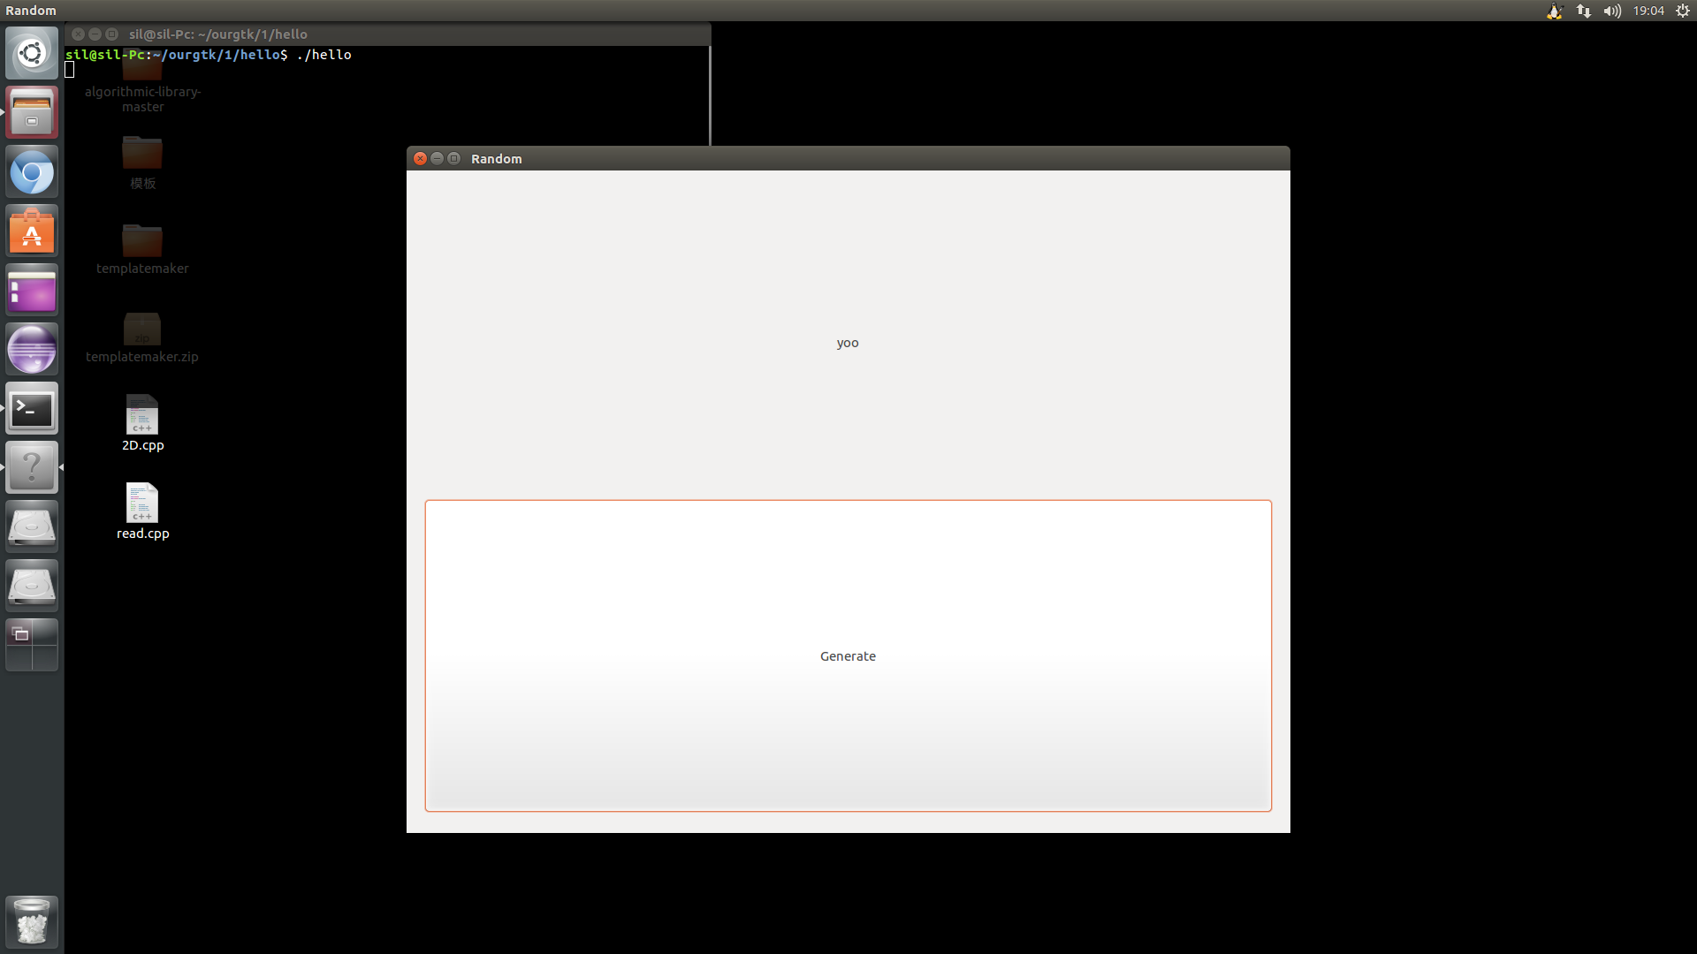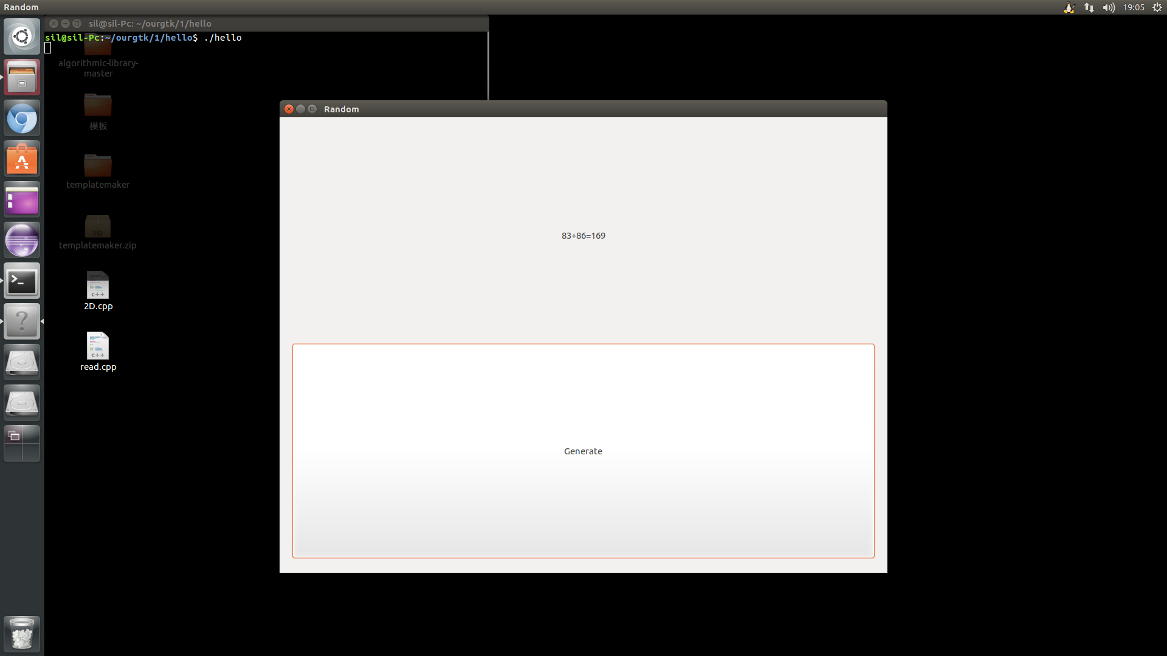
心得体会：学习了linux图形界面编程基本知识，掌握了gtk的使用方法。

《Linux 操作系统设计实践》实验六：综合应用
学号：031502209姓名：陈翔 学院：数学与计算机科学学院 专业：计算机 班级：2班
实验环境：Ubuntu 14.04.5 LTS

程序运行演示说明
程序包含client.c server,c
编译运行：
将所有文件置于统一文件夹下，使用
gcc server.c -lpthread –o server
gcc client.c –lpthread –o client
进行编译。

主要界面截图：
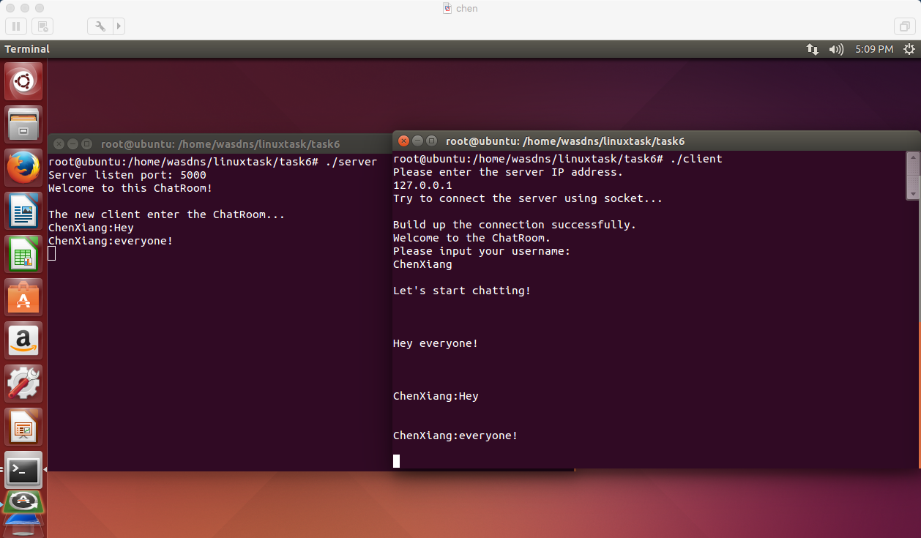

实验结果总结
本实验将实验代码进行细分，将代码分为多个模块分工合作，最后再进行数据和函数的对接。

编程工作总结
程序的编写是非常劳累的，虽然有先前实验的积累和经验，但需要有一个完整的规划，一点细小的偏差就容易导致实现效果与预想大不相同。各个模块之间的联系也是需要非常仔细处理的事情。这次实验也在代码组织和管理上给我上了很好的一课。

源程序代码
client.c
/* gcc client.c -o client -lpthread */
#include <stdlib.h>
#include <stdio.h>
#include <string.h>
#include <errno.h>
#include <netdb.h>
#include <sys/types.h>
#include <netinet/in.h>
#include <sys/socket.h>
#include <sys/wait.h>
#include <unistd.h>
#include <pthread.h>
#define TRUE 1
#define PORT 5000

int quit = 0;

void *get_server(void* sockfd) {
char buf[1024];
int rev;

if (((int)sockfd) < 0)
printf("\nCannot get the server information.\n");
else {
printf("\n\007\n");
for (;;) {
if (!quit) {
if ((rev = recv((int)sockfd, buf, 1024, 0)) > 0)
printf("\n\007%s\n", buf);

if (rev == 0) {
printf("\nThe server ends up the connection.\n");
quit = 1;
continue;
}
printf("\n");
} else {
close((int)sockfd);
break;
}
}
return(NULL);
}
}

int main() {
int connfd,snd,slenth;

struct sockaddr_in server;
struct hostent *hp;

char honame[20], msg2[1024], msg1[1024], cln[102], qstr[] = {"Quit"};

pthread_t tid;

printf("Please enter the server IP address.\n");
scanf("%s*", honame);
printf("Try to connect the server using socket...\n");

if ((connfd = socket(AF_INET, SOCK_STREAM, 0)) < 0)
printf("Error: Cannot create the socket.\n");

if ((hp = gethostbyname(honame)) == NULL) {
printf("Error: Cannot get the server IP address\n");
exit(1);
} else printf(" \n");

memcpy(&server.sin_addr, hp->h_addr, hp->h_length);

server.sin_family = AF_INET;
server.sin_port = htons(PORT);

if (connect(connfd, (struct sockaddr*)&server, sizeof(server)) < 0) {
printf("Error: Cannot connect to the server.\n");
exit(1);
}

printf("Build up the connection successfully.\n");
printf("Welcome to the ChatRoom.\n");

printf("Please input your username:\n");

scanf("%s",msg1);

slenth = strlen(msg1);
msg1[slenth] = ':';
msg1[slenth+1] = '\0';

strcpy(cln, msg1);
pthread_create(&tid, NULL, &get_server, (void*)connfd);

printf("\nLet's start chatting!\n");

while (TRUE) {
printf("\n");
scanf("%s", msg2);

if (strcmp(msg2, qstr) == 0) {
close(connfd);
quit = 1;
} else {
strcat(msg1, msg2);
snd = send(connfd, msg1, strlen(msg1)+1, 0);
strcpy(msg1, cln);

if (snd < 0) printf("\n \n");
}
}

return 0;
}
server.c:
/* gcc server.c -o server -lpthread */
#include <stdlib.h>
#include <stdio.h>
#include <string.h>
#include <errno.h>
#include <netdb.h>
#include <sys/types.h>
#include <netinet/in.h>
#include <sys/socket.h>
#include <sys/wait.h>
#include <unistd.h>
#include <pthread.h>

#define MAXLINE 1000
#define LISTENQ 20
#define PORT 5000
#define MAXFD 20

FILE *fp;
int i, maxi = -1;
int client[MAXFD];

void *get_client(void *sockfd) {
char buf[MAXLINE];
int rev;
if ((int)sockfd < 0) printf("\nThe new client cannot enter the ChatRoom\n");
else {
printf("\nThe new client enter the ChatRoom...\n");
do {
memset(buf, 0, sizeof(buf));

if ((rev = recv((int)sockfd, buf, 1024, 0)) < 0)
printf("\nCannot read the user information.\n");

if (rev == 0)
printf("\nThe user ends up the connection.\n");
else {
printf("%s\n", buf);
for(i = 0;i <= maxi; i++)
send(client[i],buf,strlen(buf)+1,0);
fputs(buf,fp);
}
} while (rev != 0);
fclose(fp);
}

close((int)sockfd);
return(NULL);
}

int main() {
int connfd,listenfd,sockfd;

socklen_t length;

fp = fopen("student.txt","w");

struct sockaddr_in server;
struct sockaddr tcpaddr;
pthread_t tid;

listenfd = socket(AF_INET,SOCK_STREAM,0);

if (listenfd < 0) {
printf("Error: Cannot build up the socket.\n");
exit(1);
}

memset(&server, 0, sizeof(server));
server.sin_family = AF_INET;
server.sin_port = htons(PORT);
server.sin_addr.s_addr = htonl(INADDR_ANY);

if (bind(listenfd, (struct sockaddr*)&server, sizeof(server))<0) {
printf("Error: Cannot bind the socket.\n");
exit(1);
}
length = sizeof(server);

if (getsockname(listenfd,(struct sockaddr*)&server,&length)<0) {
printf("Error: Cannot get the server listen port.\n");
exit(1);
}

for(i = 0; i < MAXFD; i++) {
client[i] = -1; //initialize the client column
}

listen(listenfd, LISTENQ);
printf("Server listen port: %d\n", ntohs(server.sin_port));
printf("Welcome to this ChatRoom!\n");

for (;;) {
connfd = accept(listenfd, &tcpaddr, &length);
for (i = 0; i < MAXFD; i++) {
if (client[i] < 0) {
client[i] = connfd;
break;
}
}

if (i == MAXFD-1) {
printf("The user number has exceeded the threshold.\n");
exit(0);
}

if (i > maxi) maxi = i;
pthread_create(&tid, NULL, &get_client, (void*)connfd);
}
return 0;
}

