Introduction to ITWS

Quiz 2: March 29, 2021

Place your name on the top of this document in the header

Enter your answers directly into this document (unless instructed otherwise)

All answers should be in be in Your Own Words, and use proper grammar

There are 5 questions on this test. Make sure you complete them all.

Make sure your answers use an alternative font and/or color – (not black or red)

Save this document as *yourName*-*yourRCSID-*S21Quiz2.docx

Create a readme file and discuss any relevant information about the lab, include at least; your GitHub id and Discord handle.

Place all quiz specific documents including this one under your iit folder in a folder named

quiz2

When finished with the quiz, zip your iit folder into a file named

*yourName*-*yourRCSID-*S21Quiz2.zip

Commit your changes as instructed below and push to GitHub

Submit it to LMS

NOTE: You are not to discuss this quiz with anyone. You are not to reference old (previous semester) submissions for ‘help’ or guidance. You may not solicit or receive help online or in-person. You may reference online resources, and you may use the notes from this class, but all work must be your own and you must figure out the solutions on your own.

ALSO NOTE: This quiz is due at 11:59PM on the date shown on LMS. From 11:59-12:09:59 it will be accepted as late with a -30% penalty. At 12:10 it will NOT be accepted, and you will get a 0. Please submit your quiz on time.

1. GIT (10 points)
   1. Create a private repo on Github for your iit directory including all your content for this class thus far, including the quiz2 folder
   2. Make sure your repo and your local folder are synced and match
   3. Make sure you have a descriptive readme that is visible in the main area for the repo
   4. Invite Varad and me to collaborate: Varad’s id is varad0119, and my id is rplotka
   5. At the end of this quiz, all your work in your iit directory (including your quiz answers) should be pushed to your repo – make sure it is private.
2. Technology (coding): (35 points)
   1. You will be making changes to your website
   2. Create an issue indicating that Quiz 2 is taking place
   3. Check out a branch from your iit repo, and name it quiz2

You should make stages/commits to this branch – DO NOT merge it back into the master/main until you are finished with the quiz

* 1. jQuery/jQueryUI
     1. Modify your menu to use jQueryUI widgets (Menu, Tabs, etc)
     2. Add 1 new interaction (your choice)
     3. Add 1 additional widget (your choice)
     4. Add 2 effects (your choice)

accordion for lab selection

tabs for home menu

Slider+progressbar for lab navigation

Shake for a button that’s already selected

Use fold to show/hide a menu for lab navigation

Make the menu that pops up resizeable

*(You may need to modify your design to accommodate the above. Be creative – use this opportunity to jazz up your site)*

* 1. Using external fonts from Google – make sure your Header and Menu and Footer use one unique font, and your text uses another.
  2. Make sure you give a detailed description of your design choices, why you made them and how you went about implementing them. Be descriptive.
  3. When done, merge your changes back
  4. Close the issue with a detailed comment
  5. Make sure your readme is descriptive and styled (nothing too crazy, but not just text)

1. Technology (description) (15 points): Web Development
   1. Based on the discussions in class, what is a namespace and what does it mean for us. Explain in detail, and in your own words, and provide 2 examples from class discussions/labs.

A namespace is

* 1. Explain, in your own words, exactly how your solution to the validation in Lab 5 worked. Include a reasoning for your logic and include the code snippet here in Menlo font.

I had a Boolean called isValid that I set to true by default, and I would check the value of each text field. If the area had something that was not blank/the placeholder text when the user pressed submit, the function would check to see if isValid is true or false. If it is true, it will set it to false, set the variable error’s value to “You must enter a first name/last name/etc. \n”, and focus on the said field. If isValid is already false, then instead of overwriting error’s previous value, it would concatenate “You must enter a first name/last name/etc. \n” to the error message. The function would do this with every text field in the form, and at the end it would call an alert with the value of error. Lastly, I would return false at the end because otherwise clicking on the button would redirect the page to a blank page which I did not want to do.

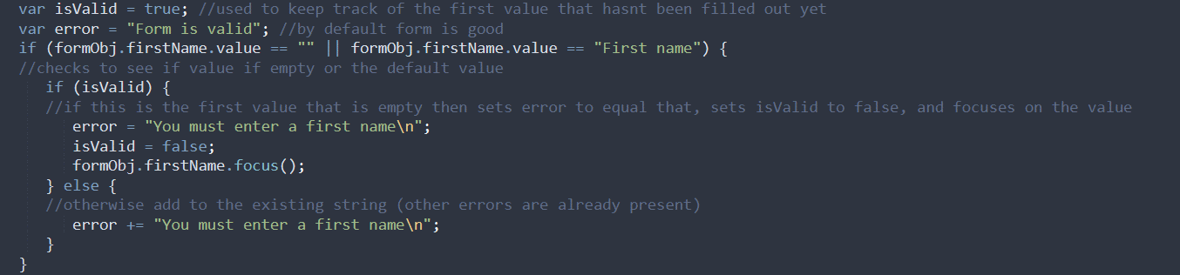

var isValid = true; //used to keep track of the first value that hasnt been filled out yet

var error = "Form is valid"; //by default form is good

if (formObj.firstName.value == "" || formObj.firstName.value == "First name") {

//checks to see if value if empty or the default value

if (isValid) {

//if this is the first value that is empty then sets error to equal that, sets isValid to false, and focuses on the value

error = "You must enter a first name\n";

isValid = false;

formObj.firstName.focus();

} else {

//otherwise add to the existing string (other errors are already present)

error += "You must enter a first name\n";

}

}

* 1. What is the difference between an application layer protocol, a Transport layer protocol and a Link layer protocol? Give 3 example of each.

Transport layer protocols is what actually transports the stuff while the application layer more like it contains the information’s but it also it specifies the shared communication proconsuls used by host in the communication method

Transport layer examples – tcp/udp/dccp

Link layer protocols - Ethernet, Category 5 cables, USB

HCI - Website mockups (20 points) (deck and video are online on LMS in week 9)

* 1. Explain, in your own words, per the inclass lecture, what is a paper prototype

A paper prototype is a way to communicate ideas in the initial stages of development of a product. It does not require the user to create an actual mockup, just what it should look like and therefore requires less energy and resources than something like a proper mockup.

* 1. Using Balsamiq, create a prototype of your website. Include the files in a subfolder of yor quiz2 folder named quiz2HCI

I created the mockup before question 2 where I added modifications to my website with jQuery. The future planned next steps is what I will add with jQuery

* 1. In your prototype, add the current functionality and add future planned next steps. Make sure they phases are indicates clearly in your mockups

1. Web Science (20 points)
   1. Explain, in your own words: What is a URI? How does it relate to a URL? How do they help make ‘the Web’? Name 3 examples from class in your answer. (use complete sentences and your own words)

A URI is an acronym for Uniform Resource Identifier and is used to identify where a resource is on the web. They identify a specific resource, and compared to a URL, they do not specify how to access the resource – a URI would be [www.ietf.org/rfc/rfc2396.txt](http://www.ietf.org/rfc/rfc2396.txt) while the URL would be <http://www.ietf.org/rfc/rfc2396.txt>. Another example of URI vs URL would be the URI being [example@example.com](mailto:example@example.com), while the URL being <mailto:example@example.com>. URLs URIs help make “the Web”

By having URLs and URIs link to each other, they enable users to access otherwise isolated resources, giving “the Web” its namesake – without URLs and URIs, someone would have to input the specific address of the specific resource they want to access and not be able to traverse through the internet as well as they can with the system that is “the Web”.

* 1. Social Problem
     1. Using references from the in-class lecture, identify a social problem and propose an engineered solution. What could you do to offer a solution?

(In your response, identify how to measure, analyze evaluate and iterate. In other words, How might you analyze and visualize information to help make your case? )

Who should govern the web – how should it be regulated?

Solution:

Measure

Analyze

Evaluate

Iterate