Jason Liu

Max Spero

Cloak and Dagger: Designing a Lying AI Agent

For our CS 221 project, we decided to explore a state-based model in the space of game playing. We settled on Coup, a card game for 2-5 players. The goal of this game is to eliminate other players’ influences while keeping one’s own a mystery. Tactics involve gathering information, amassing wealth, deceiving other players, and calling out other players’ bluffs. Each choice has its own pair of risks and rewards involved. At its core, the strategy to winning the game will involve lying, at least for humans. We were curious to see what a near-optimal strategy from a computer’s perspective would be.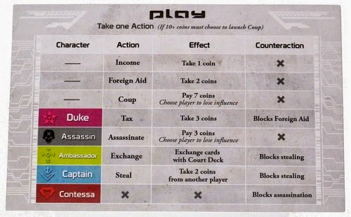

We have played this game over a hundred times this year, and what we have found is that after we all learned the game, nobody ever won solely by telling the truth. A good human player in coup does not rely on the luck of the draw to get good characters; instead, she bluffs her way to victory and relies on the fact that no one player has enough information to call her out on her lies. It would be very interesting to make an AI that does the same.

Our input is the ability to simulate a game of Coup between bots, each with their own strategy. Our output is the decision process, including the amount of lying, for each bot. Our evaluation metric is the win distribution for each bot. An example of input would be four other simulated bots with preprogrammed policies, simulating a game. Output would be our bots’ win distributions

A baseline is a bot that only tells the truth. From a list of available actions, it chooses one and continues. An oracle is a bot that knows all information in the game and can lie and call bluffs accordingly. The gap is that an oracle can always beat the baseline. It can lie for the optimal situation, knowing what the baseline’s cards are.

There are many challenges associated with this project. These include, but are certainly not limited to- simulating a game, training a bot meaningfully, associating value with lying, figuring out the minimum representation of a state. In addition, it currently seems that the optimal strategy is EXTREMELY context based. A further challenge is simulating the risk of being called out on a bluff.

Of the 221 projects from last year, a good proportion were related to game playing. However, these games were usually 2048 (and some Catan), and involved no deception- in fact, very few were adverserial. We were also unable to find other projects related to Coup. So in this respect, we feel that our project is unique.

All in all, we feel that we have found a very interesting project and we are excited to put our skills to the test.