Taiwanese Food in San Francisco Bay Area

## Introduction

When it comes to food, the **San Francisco Bay Area** is known for the wide variety and amazing quality it offers not only on traditional American food but also exotic/international cuisine. Taiwanese food, for example, is one of the most popular categories. This analysis will focus on the distribution of highest-rated Taiwanese restaurants in the Bay Area.

As a fan for **Taiwanese food** **in the SF Bay Area**, I am very excited to present you the map of the of highest-rated Taiwanese restaurants and explore which cities offer the best quality Taiwanese food within driving distance.

## Data Source & Tools

* Data Source

The Foursquare API location data (source: <https://foursquare.com/>) is utilized to analyze the ratings and density of distribution of Taiwanese restaurants in the SF Bay Area. Using **Redwood City** (a city located approximately at the center of the SF Bay Area) as the centroid, I pulled data for all Taiwanese restaurants within **100km from Redwood City**.

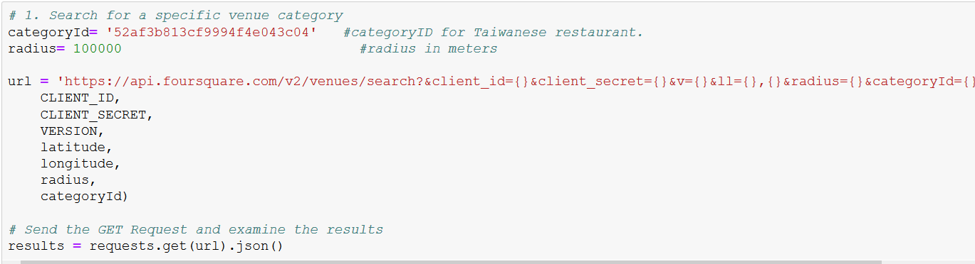

* Tools
  + A **json** file was created to capture Foursquare API data
  + **Python folium library and Leaflet Map** to visualize geographic details of the restaurant distribution

## Data Clean-up & Exploration

Using Foursquare API data, 30 restaurants across Bay Area were captured (see below example on the first five rows of the data) with 25 locational attributes including venue ID, address, latitude/longitude location, postal code, etc.

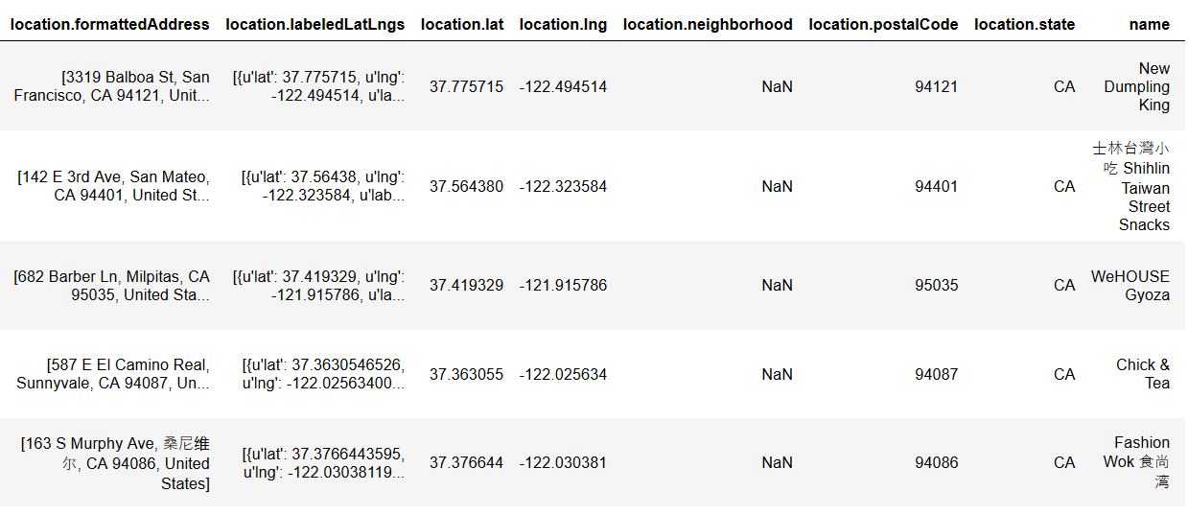

Once the list of restaurant ID’s is available, the rating of individual restaurants are called by another Foursquare API command and merged with current restaurant details. Note that not all restaurants have ratings available, possibly due to recent openings or a lack of valid reviews.

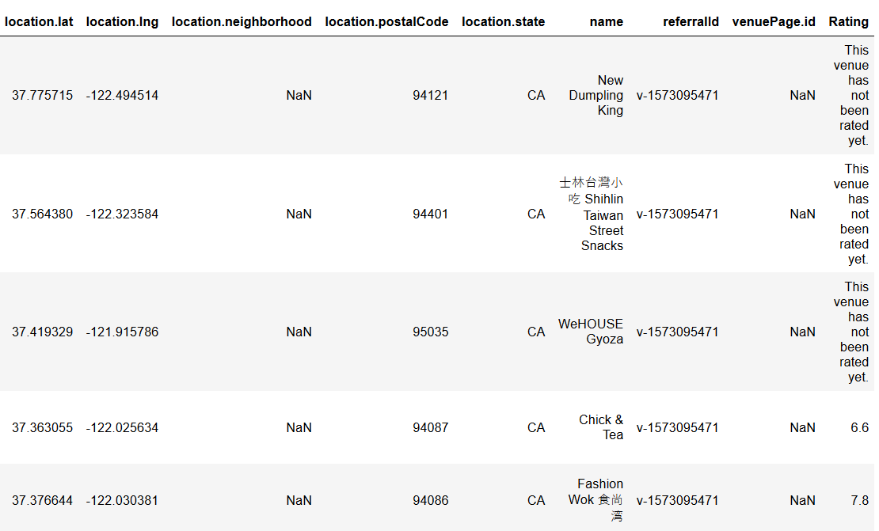

Now that the data is ready, let’s map out the Taiwanese restaurants in Bay Area! For simplicity, restaurants currently without ratings are removed from the analysis with 22 restaurants remained. As shown below, most restaurants are located in the South Bay with a few in San Francisco, Oakland and the Easy Bay Area.

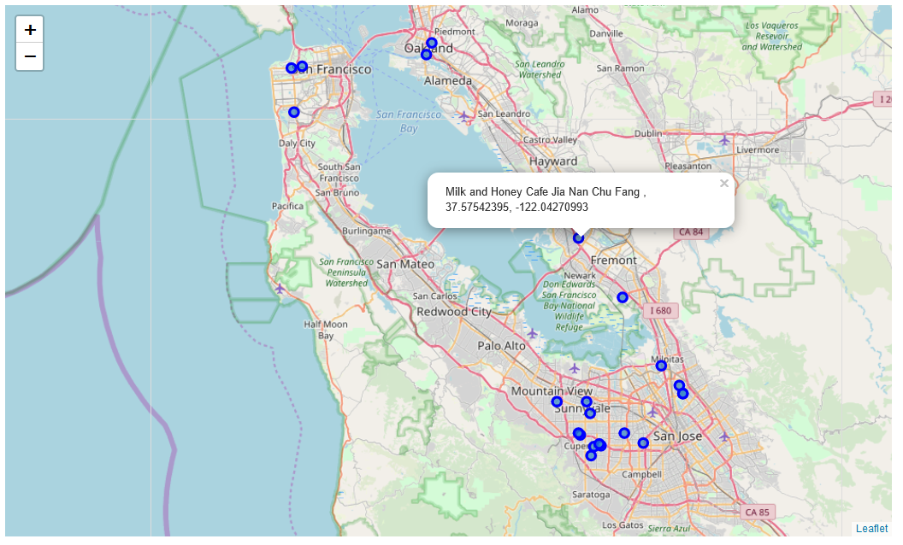

By plotting a histogram of ratings of all restaurants, you can see:

* The bar with the highest number of restaurants has ratings between 8.0 - 8.5 out of the 10-point scale.
* The ratings range from 5.3 to 8.4, where the distribution is skewed to the left, i.e. most Taiwanese restaurants are highly rated.

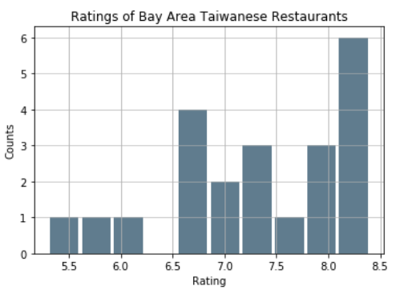 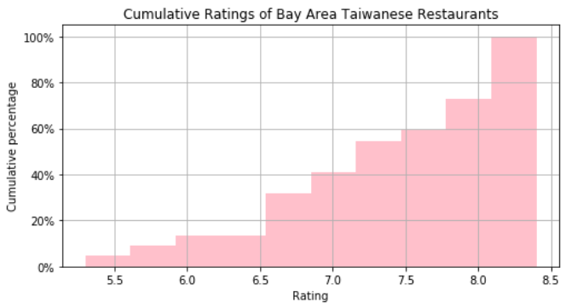

To deep dive on the differences between cities, here’s a boxplot with the distribution of restaurant ratings for all cities in the SF Bay Area that have Taiwanese restaurants -

* There is a minimal number of restaurant data available from Foursquare in Milpitas and Mountain View.
* Fremont restaurants have the highest ratings but there are very few options.
* Cupertino has the widest range of ratings. Comparing Cupertino and San Francisco, despite of having the same medium score, the distribution of ratings in Cupertino is much wider, i.e. with the expectation of visiting a restaurant of medium score of 7.4, one is more likely to get surprises exploring restauratns in Cupertino than in San Francisco.

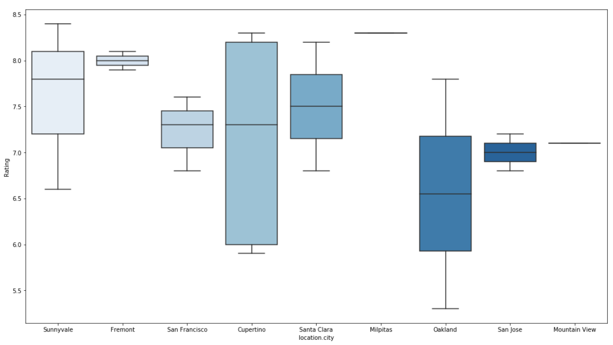

## Conclusion & Lessons Learned

Overall, Taiwanese restaurants are high-rated generally and located mostly in the South Bay, San Francisco City, Oakland and the Easy Bay Area. Given the data available, **Sunnyvale and Fremont** are two of the Bay Area cities that offer the best options of highly-rated Taiwanese restaurants. Here are some interesting lessons learned:

* Due to Foursquare API supporting data in multiple languages and many of the Taiwanese restaurants’ information is in Mandarin, *unicode* was helpful in standardizing all data to English. And even after applying *unicode*, one restaurant that had the city stated as “Sang Ni Wei Er” which actually means “Sunnyvale.” Such differences may not be obvious nor systematic and requires manul corrections.
* There are quite a few Taiwanese restaurants that I know exist but didn’t show up in the database pull, potentially due to:
  + Lack of valid reviews to create ratings
  + Incorrect classification due to the variety of food provided that some end up being categorized as Japanaese/Chinese food while they actually provide mostly Taiwanese cuisine.
  + New restaurants that just recently opened and have not had time to create directory listings and receive ratings.