HW2实验报告

计24 李心成 2012012057

**实验三 基于傅里叶级数的信号分解**

rect.m

%yo为矩形脉冲信号

%y为其傅里叶级数, mse为均方误差

% h为脉高，w为脉宽，n为项数

function [y, yo, mse] = rect(h, w, n, x)

T = 2 * w; %周期

yo = h * rectpuls(x, w);

y = h * w / T;

for k = 1:n

y = y + ((2 * h * w * sin(k * pi * w / T) / (k * pi)) * cos(k * 2 * pi * x / T));

end

mse = norm(y - yo);

fig.m

x = -1:0.01:1;

[y1, yo, m1] = rect(1, 1, 10, x);

[y2, yo, m2] = rect(1, 1, 100, x);

[y3, yo, m3] = rect(1, 1, 1000, x);

[y4, yo, m4] = rect(1, 1, 10000, x);

figure(1);

plot(x, y1, '-y', x, y2, '--m', x, y3, ':c', x, y4, '-.r', x, yo, 'k');

m = zeros([1,1000]);

for k = 1:1000

[y, yo, m(k)] = rect(1, 1, k, x);

end

x2 = 1:1000;

figure(2);

plot(x2, m);

运行结果

下图中黑色为原始矩形脉冲信号，其余为余弦项数不同的傅里叶近似信号。近似信号的波形相比原始脉冲信号不够平滑，有很多波动与毛刺。而且波动与毛刺随着余弦项数的增加而显著减少。

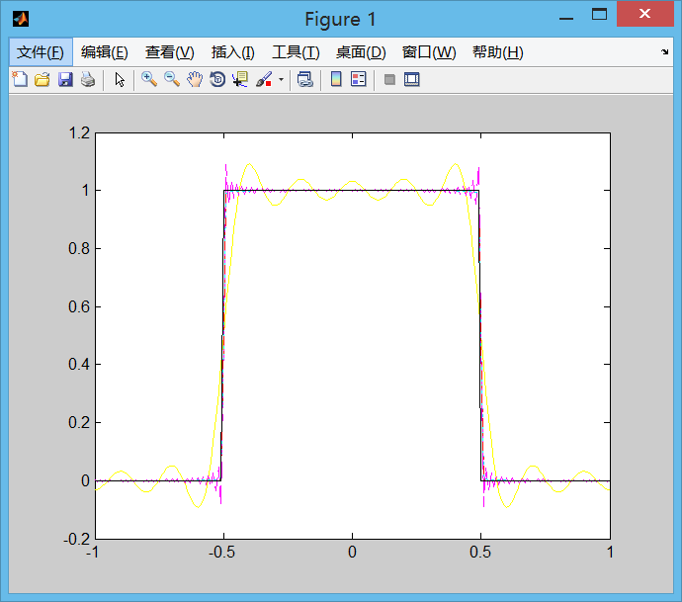

Figure 1

下图为均方误差随着余弦项数的变化曲线。可以很明显的看出，随着余弦项数的增加，均方误差递减，且递减的趋势也递减。

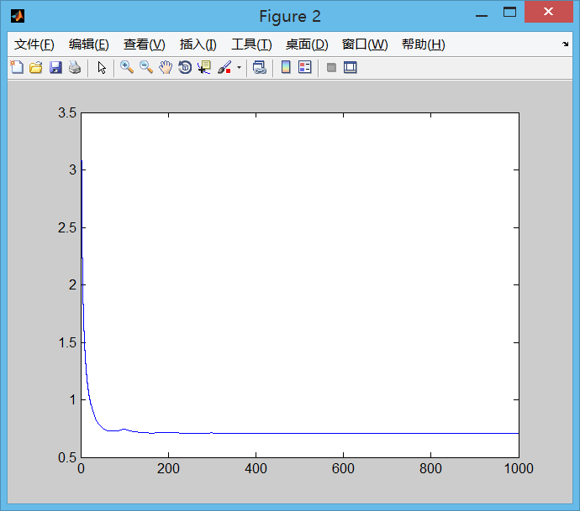

Figure 2

**实验四 双音频按键识别**

1. 编码规则

|  |  |  |  |  |
| --- | --- | --- | --- | --- |
| **DTMF keypad frequencies (with sound clips)** | | | | |
|  | **1209 Hz** | **1336 Hz** | **1477 Hz** | **1633 Hz** |
| **697 Hz** | [1](http://upload.wikimedia.org/wikipedia/commons/b/bf/Dtmf1.ogg) | [2](http://upload.wikimedia.org/wikipedia/commons/7/7d/Dtmf2.ogg) | [3](http://upload.wikimedia.org/wikipedia/commons/2/28/Dtmf3.ogg) | [A](http://upload.wikimedia.org/wikipedia/commons/d/d5/DtmfA.ogg) |
| **770 Hz** | [4](http://upload.wikimedia.org/wikipedia/commons/9/9f/Dtmf4.ogg) | [5](http://upload.wikimedia.org/wikipedia/commons/1/1c/Dtmf5.ogg) | [6](http://upload.wikimedia.org/wikipedia/commons/7/7b/Dtmf6.ogg) | [B](http://upload.wikimedia.org/wikipedia/commons/5/5a/DtmfB.ogg) |
| **852 Hz** | [7](http://upload.wikimedia.org/wikipedia/commons/9/9f/Dtmf7.ogg) | [8](http://upload.wikimedia.org/wikipedia/commons/f/f7/Dtmf8.ogg) | [9](http://upload.wikimedia.org/wikipedia/commons/5/59/Dtmf9.ogg) | [C](http://upload.wikimedia.org/wikipedia/commons/9/96/DtmfC.ogg) |
| **941 Hz** | [*](http://upload.wikimedia.org/wikipedia/commons/e/e7/DtmfStar.ogg) | [0](http://upload.wikimedia.org/wikipedia/commons/2/2d/Dtmf0.ogg) | [#](http://upload.wikimedia.org/wikipedia/commons/c/c4/Dtmf-.ogg) | [D](http://upload.wikimedia.org/wikipedia/commons/9/99/DtmfD.ogg) |

1. DTMF声音生成

dial.m

%产生DTMF信号

function y = dial(keyNames)

fs = 8000;

dtmf.keys = ...

['1','2','3','A';

'4','5','6','B';

'7','8','9','C';

'*','0','#','D'];

dtmf.col = ones(4,1)*[1209,1336,1477,1633];

dtmf.row = [697;770;852;941]*ones(1,4);

dur = 0.25;

t = 0:1/fs:dur;

y = 0;

for i = 1:length(keyNames)

keyName = keyNames(i);

if (keyName~='1' && keyName~='2' && keyName~='3' && keyName~='A' && keyName~='4' && keyName~='5' && keyName~='6' && keyName~='B' && keyName~='7' && keyName~='8' && keyName~='9' && keyName~='C' && keyName~='#' && keyName~='0' && keyName~='*' && keyName~='D')

continue

end;

[r,c] = find(dtmf.keys==keyName);

tone = sin(2*pi*dtmf.row(r,c)*t) + sin(2*pi*dtmf.col(r,c)*t);

y = [y,zeros(1,0.05*fs),tone];

end

soundsc(y,8000);

test.m

y = dial('123456789');

实际听起来和手机的声音很像。

3.识别按键录音

readDial.m

%读入DTMF音频识别内容

%频率8000

function res = readDial(filename)

audio = audioread(filename);

y = abs(fft(audio,2048));

p = y.*y /10000;

row = find(p(1:250) == max(p(1:250)));

col = 300+find(p(300:380) == max(p(300:380)));

if (row < 180)

row = 1;

elseif (row < 200)

row = 2;

elseif (row < 220)

row = 3;

else

row = 4;

end

if (col < 320)

col = 1;

elseif (col < 340)

col = 2;

else

col = 3;

end

keys = ...

['1','2','3','A';

'4','5','6','B';

'7','8','9','C';

'*','0','#','D'];

res = keys(row,col);

end

test.m

res = [];

for i = 0:9

res = [res,readDial(['dtmf-',num2str(i),'.wav'])];

end

disp(res);

算法先读入音频文件，然后用快速傅里叶转换算法得到频谱，然后算出功率向量，找到最匹配的按键音。

采用了10个分别为0,1,2,3,4,5,6,7,8,9的DTMF音频文件，识别结果为#,1,3,3,4,6,6,7,9,9，识别率为60%。