八、1.

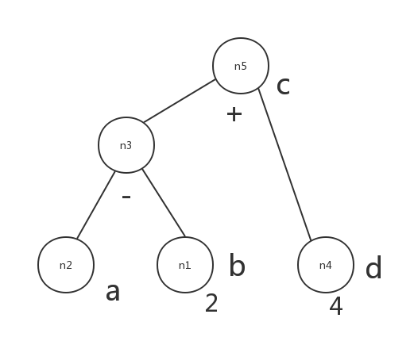（n2下面添一个 $a_{0}$ 比较好~）

2.

|  |  |  |  |  |
| --- | --- | --- | --- | --- |
| 基本块 | LiveUse | Def | LiveOut | LiveIn |
| B1 | Φ | {a} | {a} | Φ |
| B2 | {a} | {b,c,d,e} | {a,c,d} | {a} |
| B3 | {a,d} | Φ | {a,c,d} | {a,c,d} |
| B4 | {a,c} | {e} | {a} | {a,c} |

3. a, b, d

4.{(6), (7)}

九、Lecture10

6

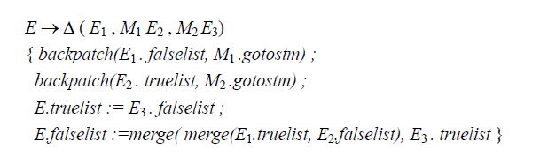

9(b) 好像最后一个应该是G .beginlist := merge(S.nextlist, N . nextlist) ;

