# 上机题第六题实验报告

王伟任 计33 2013011333

1. **题目要求及分析**

**第六章上机题3**： 对物理实验中所得数据分别用公式 $y=a+bt+ct^{2}$ 和指数函数 $y=ae^{bt}$ 作曲线拟合，比较上述两条拟合曲线哪条更好。

由于用法方程法作曲线拟合只能用多项式函数拟合，不能直接用指数函数拟合，因此需要将指数函数做一次变型将其转化为多项式函数，方法是两边取自然对数，变为 $\ln{y}=\ln{a}+bt$ 的多项式形式。

1. **实验结果及分析**

用公式 $y=a+bt+ct^{2}$ 进行拟合的结果为：

a = -45.2942307692; b = 94.1942921784; c = -6.1268261151。

误差的2-范数为22.0137732933。

结果保存在out1.txt中。

用指数函数 $y=ae^{bt}$ 进行拟合的结果为：

a = 67.3937925785; b = 0.2389834379。

误差的2-范数为218.9097098003。

结果保存在out2.txt中。

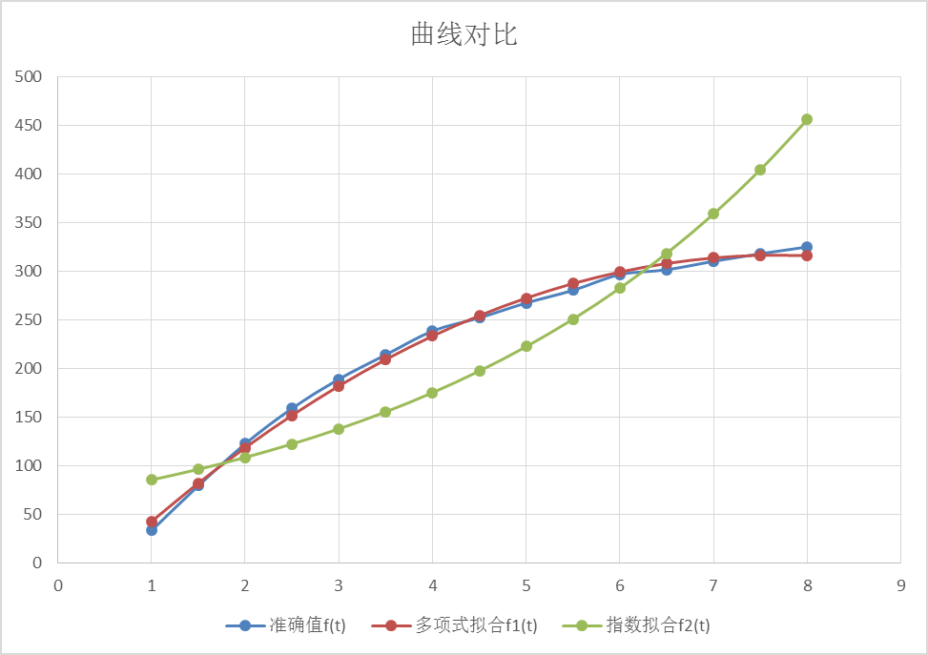

将表格函数，多项式函数，指数函数三条曲线绘制在同一张图中，可以很明显看出，用多项式函数作曲线拟合的效果更好，与表格函数的差距更小一些。用指数函数拟合效果较差，而且虽然指数函数拟合的曲线也是单调递增的，但是斜率却是增大的趋势，而原函数的斜率趋势是减小的。

1. **实验代码**

采用C++语言实现。

用公式 $y=a+bt+ct^{2}$ 进行拟合：

**#include <cstdio>**

**#include <cmath>**

**int n = 15;**

**int w = 3;**

**double** create(double* t){**

**double** ans = new double*[n];**

**for (int i = 0; i < n; i++){**

**ans[i] = new double[w];**

**for (int j = 0; j < w; j++){**

**ans[i][j] = 1.0;**

**for (int kk = 0; kk < j; kk++)**

**ans[i][j] *= t[i];**

**}**

**}**

**return ans;**

**}**

**double* multiply1(double** A, double* f){**

**double* ans = new double[w];**

**for (int i = 0; i < w; i++){**

**ans[i] = 0;**

**for (int j = 0; j < n; j++)**

**ans[i] += A[j][i] * f[j];**

**}**

**return ans;**

**}**

**double** multiply2(double** A){**

**double** ans = new double*[w];**

**for (int i = 0; i < w; i++){**

**ans[i] = new double[w];**

**for (int j = 0; j < w; j++){**

**ans[i][j] = 0.0;**

**for (int k = 0; k < n; k++)**

**ans[i][j] += A[k][i] * A[k][j];**

**}**

**}**

**return ans;**

**}**

**double** Cholesky(double** G){**

**double** L = new double*[w];**

**for (int i = 0; i < w; i++)**

**L[i] = new double[w];**

**for (int i = 0; i < w; i++)**

**for (int j = i + 1; j < w; j++)**

**L[i][j] = 0;**

**L[0][0] = sqrt(G[0][0]);**

**for (int i = 1; i < w; i++)**

**L[i][0] = G[i][0] / L[0][0];**

**for (int j = 1; j < w; j++){**

**double ss = 0.0;**

**for (int i = 0; i < j; i++)**

**ss += L[j][i] * L[j][i];**

**L[j][j] = sqrt(G[j][j] - ss);**

**for (int i = j + 1; i < w; i++){**

**double s = 0.0;**

**for (int ii = 0; ii < j; ii++)**

**s += L[i][ii] * L[j][ii];**

**L[i][j] = (G[i][j] - s) / L[j][j];**

**}**

**}**

**return L;**

**}**

**double* solve(double** L, double* b){**

**double* y = new double[w];**

**for (int i = 0; i < w; i++){**

**y[i] = b[i] / L[i][i];**

**for (int j = 0; j < i; j++)**

**y[i] = y[i] - y[j] * L[i][j] / L[i][i];**

**}**

**return y;**

**}**

**double* solve2(double** L, double* y){**

**double* x = new double[w];**

**for (int i = w - 1; i >= 0; i--){**

**x[i] = y[i] / L[i][i];**

**for (int j = i + 1; j < w; j++)**

**x[i] = x[i] - x[j] * L[j][i] / L[i][i];**

**}**

**return x;**

**}**

**int main(){**

**FILE* fp = fopen("test.txt", "r");**

**double* t = new double[n];**

**double* f = new double[n];**

**for (int i = 0; i < n; i++)**

**fscanf(fp, "%lf", &t[i]), fgetc(fp);**

**for (int i = 0; i < n; i++)**

**fscanf(fp, "%lf", &f[i]), fgetc(fp);**

**fclose(fp);**

**double** A = create(t);**

**double* b = multiply1(A, f);**

**double** G = multiply2(A);**

**double** L = Cholesky(G);**

**double* y = solve(L, b);**

**double* x = solve2(L, y);**

**fp = fopen("out1.txt", "w");**

**for (int i = 0; i < w; i++){**

**if (i == 0) fprintf(fp, "a = ");**

**if (i == 1) fprintf(fp, "b = ");**

**if (i == 2) fprintf(fp, "c = ");**

**fprintf(fp, "%.10f;\t", x[i]);**

**}**

**fprintf(fp, "\n");**

**fprintf(fp, "wu cha 2-norm = ");**

**double* delta = new double[n];**

**for (int i = 0; i < n; i++){**

**delta[i] = 0;**

**for (int j = 0; j < w; j++)**

**delta[i] += A[i][j] * x[j];**

**}**

**double norm = 0;**

**for (int i = 0; i < n; i++)**

**norm += (delta[i] - f[i]) * (delta[i] - f[i]);**

**norm = sqrt(norm);**

**fprintf(fp, "%.10f\n", norm);**

**fclose(fp);**

**delete[] t;**

**delete[] f;**

**delete[] b;**

**delete[] y;**

**delete[] x;**

**delete[] delta;**

**for (int i = 0; i < w; i++)**

**delete[] G[i], delete[] L[i];**

**delete[] G;**

**delete[] L;**

**for (int i = 0; i < n; i++)**

**delete[] A[i];**

**delete[] A;**

**return 0;**

**}**

用指数函数 $y=ae^{bt}$ 进行拟合：

**#include <cstdio>**

**#include <cmath>**

**int n = 15;**

**int w = 2;**

**double** create(double* t){**

**double** ans = new double*[n];**

**for (int i = 0; i < n; i++){**

**ans[i] = new double[w];**

**for (int j = 0; j < w; j++){**

**ans[i][j] = 1.0;**

**for (int kk = 0; kk < j; kk++)**

**ans[i][j] *= t[i];**

**}**

**}**

**return ans;**

**}**

**double* multiply1(double** A, double* f){**

**double* ans = new double[w];**

**for (int i = 0; i < w; i++){**

**ans[i] = 0;**

**for (int j = 0; j < n; j++)**

**ans[i] += A[j][i] * f[j];**

**}**

**return ans;**

**}**

**double** multiply2(double** A){**

**double** ans = new double*[w];**

**for (int i = 0; i < w; i++){**

**ans[i] = new double[w];**

**for (int j = 0; j < w; j++){**

**ans[i][j] = 0.0;**

**for (int k = 0; k < n; k++)**

**ans[i][j] += A[k][i] * A[k][j];**

**}**

**}**

**return ans;**

**}**

**double** Cholesky(double** G){**

**double** L = new double*[w];**

**for (int i = 0; i < w; i++)**

**L[i] = new double[w];**

**for (int i = 0; i < w; i++)**

**for (int j = i + 1; j < w; j++)**

**L[i][j] = 0;**

**L[0][0] = sqrt(G[0][0]);**

**for (int i = 1; i < w; i++)**

**L[i][0] = G[i][0] / L[0][0];**

**for (int j = 1; j < w; j++){**

**double ss = 0.0;**

**for (int i = 0; i < j; i++)**

**ss += L[j][i] * L[j][i];**

**L[j][j] = sqrt(G[j][j] - ss);**

**for (int i = j + 1; i < w; i++){**

**double s = 0.0;**

**for (int ii = 0; ii < j; ii++)**

**s += L[i][ii] * L[j][ii];**

**L[i][j] = (G[i][j] - s) / L[j][j];**

**}**

**}**

**return L;**

**}**

**double* solve(double** L, double* b){**

**double* y = new double[w];**

**for (int i = 0; i < w; i++){**

**y[i] = b[i] / L[i][i];**

**for (int j = 0; j < i; j++)**

**y[i] = y[i] - y[j] * L[i][j] / L[i][i];**

**}**

**return y;**

**}**

**double* solve2(double** L, double* y){**

**double* x = new double[w];**

**for (int i = w - 1; i >= 0; i--){**

**x[i] = y[i] / L[i][i];**

**for (int j = i + 1; j < w; j++)**

**x[i] = x[i] - x[j] * L[j][i] / L[i][i];**

**}**

**return x;**

**}**

**int main(){**

**FILE* fp = fopen("test.txt", "r");**

**double* t = new double[n];**

**double* f = new double[n];**

**for (int i = 0; i < n; i++){**

**fscanf(fp, "%lf", &t[i]);**

**fgetc(fp);**

**}**

**for (int i = 0; i < n; i++){**

**fscanf(fp, "%lf", &f[i]);**

**fgetc(fp);**

**f[i] = log(f[i]);**

**}**

**fclose(fp);**

**double** A = create(t);**

**double* b = multiply1(A, f);**

**double** G = multiply2(A);**

**double** L = Cholesky(G);**

**double* y = solve(L, b);**

**double* x = solve2(L, y);**

**fp = fopen("out2.txt", "w");**

**fprintf(fp, "a = %.10f;\t", exp(x[0]));**

**fprintf(fp, "b = %.10f;\n", x[1]);**

**fprintf(fp, "wu cha 2-norm = ");**

**double* delta = new double[n];**

**for (int i = 0; i < n; i++){**

**delta[i] = 0;**

**for (int j = 0; j < w; j++)**

**delta[i] += A[i][j] * x[j];**

**delta[i] = exp(delta[i]);**

**}**

**double norm = 0;**

**for (int i = 0; i < n; i++){**

**f[i] = exp(f[i]);**

**norm += (delta[i] - f[i]) * (delta[i] - f[i]);**

**}**

**norm = sqrt(norm);**

**fprintf(fp, "%.10f\n", norm);**

**fclose(fp);**

**delete[] t;**

**delete[] f;**

**delete[] b;**

**delete[] y;**

**delete[] x;**

**delete[] delta;**

**for (int i = 0; i < w; i++)**

**delete[] G[i], delete[] L[i];**

**delete[] G;**

**delete[] L;**

**for (int i = 0; i < n; i++)**

**delete[] A[i];**

**delete[] A;**

**return 0;**

**}**