NetHack LLM-agent: observation & harness experiments
A 9B open model plays NetHack on a fixed set of game seeds with a fixed per-game turn budget. “Descend” means the agent reached the second dungeon level — our current success objective.

Base evaluation
The baseline agent is shown the on-screen map and issues low-level moves one step at a time. In this setup it explores reasonably but almost never makes progress toward the goal: it circles the starting room, retraces the same steps, and eventually starves or dies on the first level — it descended in 0 of 4 games.
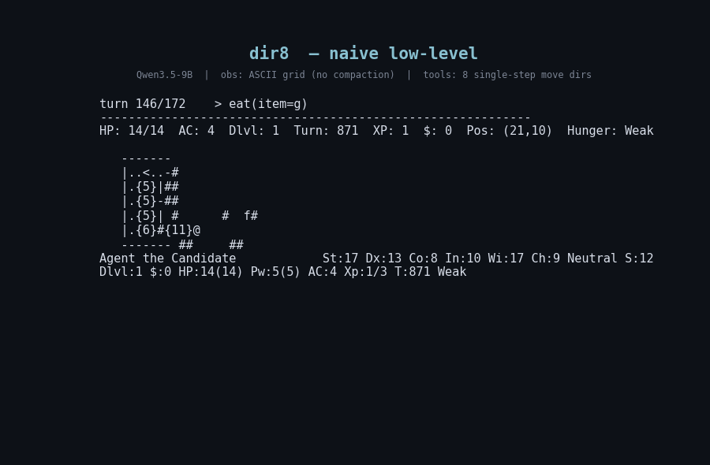
Low-level movement: the agent explores but does not descend.
When we instead give the agent higher-level actions (e.g. “explore,” “go to the stairs,” “descend”) rather than individual moves, behavior changes sharply: it reached the second level in 2 of 4 games — the only configuration that descended at all — versus 0 of 4 for the baseline. The gain is all-or-nothing (the agent either solves a game quickly or wanders until the turn budget runs out), so the rate still needs a larger run to confirm.
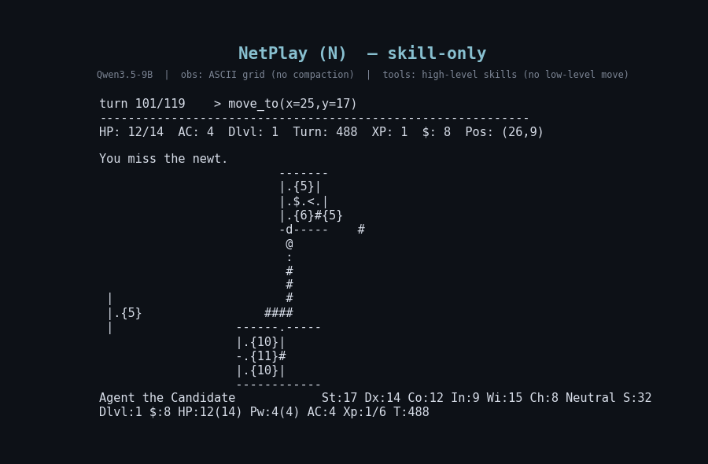
Higher-level actions: the only setup that descended.

Reducing the observation size, and the overall picture
A separate question is whether compressing the observation (a smaller, condensed view of the screen) costs us anything. It does not: the compressed and full-size views produce essentially the same outcomes, so compression is a cost saving, not a capability change — useful because it cuts the tokens per turn substantially. Putting all the comparisons together: the visual map is essential (replacing it with a text-only description of the scene collapses the agent’s ability to play); the action interface is the one real capability lever; observation compression is free on the capability axis; and an explicit on-screen reminder to find and use the stairs did not help — spelling out the goal did not change exploration. The single reliable improvement to descent came from an automatic “unstick” mechanism that intervenes when the agent stalls in place.
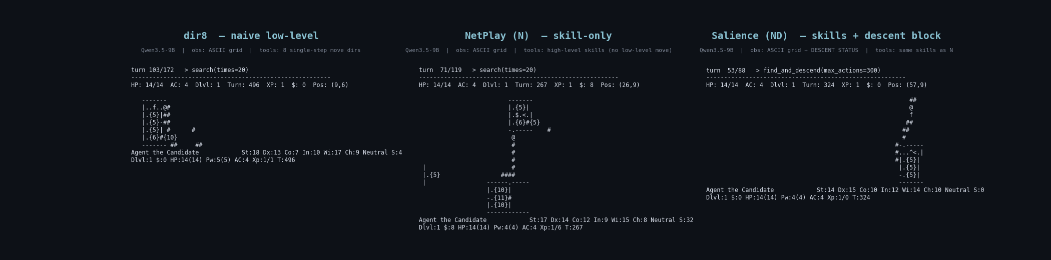
Side-by-side, same game: low-level moves (left), high-level skills (middle), skills + stair reminder (right).

What we have not reached, and the blockers
We still do not have reliable descent — the agent reaches the second level only occasionally and on favorable games, and we have not pushed past it to deeper levels. Notably, scaling up the observation (showing the complete, uncompressed screen every turn) did not help and in fact made play worse, because the larger input crowds out the agent’s attention. The blockers are:
- Exploration strategy — the agent does not systematically search the level to reveal the downward staircase, the proximate cause of nearly every failure.
- Survival — games that drag on end in starvation or death before the agent finds the stairs.
- More observation is not the answer — capability is gated by how the agent acts and explores, not by how much of the screen it sees.

The high-level action interface (NetPlay-style)
The configuration that unlocked descent replaces single-keypress movement with a small set of skills — each one a scripted routine that can carry out many game steps from a single decision, so the model reasons in terms of intent (“explore,” “go downstairs”) rather than individual moves. This follows the NetPlay approach (Jeurissen et al., 2024). The baseline, by contrast, exposes only the eight compass-direction moves, one step per decision. The skills available to the agent:
- Move & explore: autoexplore (walk unseen corridors until something noteworthy appears), move_to (path to a tile), find_and_descend (locate the down-stairs and go down in one call), descend, search (for hidden passages/doors), kick (force a stuck door).
- Fight & survive: attack, engrave_elbereth (protective ward), pray (emergency divine aid), eat, quaff (drink a potion), read (a scroll).
- Items: pickup (take what is on the current tile).
- Memory & knowledge: add_note (record a fact), pin_objective (keep the current goal in view), recall (retrieve earlier notes), wiki_lookup / wiki_search (query an offline NetHack knowledge base).
The descent-focused variants narrow this set toward navigation (dropping item/knowledge skills that proved to be turn sinks) and, in one variant, add the persistent stair note — which, as noted above, did not change behavior.

Animated versions
Google Docs shows these as still images only (it does not animate GIFs). The animated clips autoplay in Discord, Slack, a browser, Google Drive’s preview, or Google Slides. Files: videos/seed24_dir8_COMPACTED.gif, videos/seed24_netplayN_COMPACTED.gif, videos/seed24_salienceND_COMPACTED.gif, videos/seed24_3panel_COMPACTED.gif.

