实验条件：音频振荡器激励信号峰峰值为**2V**，频率为**4K**

* **保存零点残余电压时的波形图**，并用手动模式，**cursor光标模式**进行读数测量，此电压为**V残余p-p= 。**

Table 1 静态性能测试数据记录（注意：相位差可记录同相，反相，零点附近不用记）

|  |  |  |  |  |  |  |  |  |  |  |  |
| --- | --- | --- | --- | --- | --- | --- | --- | --- | --- | --- | --- |
| **X (mm)** | **5.0** | **4.5** | **4** | **3.5** | **3.0** | **2.5** | **2.0** | **1.5** | **1.0** | **0.5** | **0** |
| **VO(p-p)** |  |  |  |  |  |  |  |  |  |  |  |
| **相位差** |  |  |  |  |  |  |  |  |  |  |  |
| **V电压表** |  |  |  |  |  |  |  |  |  |  |  |
| **X (mm)** | **0** | **-0.5** | **-1.0** | **-1.5** | **-2.0** | **-2.5** | **-3.0** | **-3.5** | **-4.0** | **-4.5** | **-5.0** |
| **VO(p-p)** |  |  |  |  |  |  |  |  |  |  |  |
| **相位差** |  |  |  |  |  |  |  |  |  |  |  |
| V电压表 |  |  |  |  |  |  |  |  |  |  |  |

波形图记录：位移为正、位移为负各一幅图。**作出V-X线。测试完成后，将磁芯位移回到零点。**

* 零点残余电压补偿



图零点残余电压参考接线图

* **保存零点残余电压时的波形图**，并用手动模式，**cursor光标模式**进行读数测量，记录此时差动变换器2输出电压为V零点p-p = 。
* V'残余p-p=V零点p-p/K= ，K为差动放大器II的放大倍数（通过以下电路图进行计算）。并与上面未经补偿的残余电压**V残余p-p**进行比较。

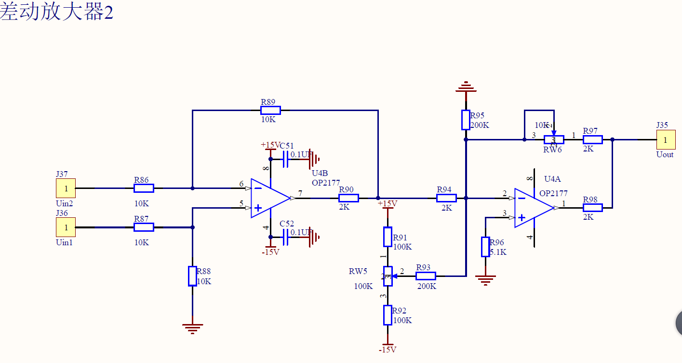



* 相敏检波器倍数调节为**1倍**
* 电桥模块**Rw1、Rw2**，差动变换器II模块**Gain、Zero均保持不变**
* **CH1接音频振荡器器0°输出端，CH2接相敏检波器Uout输出端**（在高频段进行电路参数调整）。用手按住振动平台（让传感器产生一个大位移），仔细**调节移相器**的旋钮，使示波器CH2波形为一个接近**全波整流**
* Table 2 静态位移测试数据记录

|  |  |  |  |  |  |  |  |  |  |  |  |
| --- | --- | --- | --- | --- | --- | --- | --- | --- | --- | --- | --- |
| **X (mm)** | **5.0** | **4.5** | **4** | **3.5** | **3.0** | **2.5** | **2.0** | **1.5** | **1.0** | **0.5** | **0** |
| **Vave（V）** |  |  |  |  |  |  |  |  |  |  |  |
| **V电压表（V）** |  |  |  |  |  |  |  |  |  |  |  |
| **X (mm)** | **0** | **-0.5** | **-1.0** | **-1.5** | **-2.0** | **-2.5** | **-3.0** | **-3.5** | **-4.0** | **-4.5** | **-5.0** |
| **Vave（V）** |  |  |  |  |  |  |  |  |  |  |  |
| **V电压表（V）** |  |  |  |  |  |  |  |  |  |  |  |

|  |  |  |  |  |  |  |  |  |  |  |  |  |  |
| --- | --- | --- | --- | --- | --- | --- | --- | --- | --- | --- | --- | --- | --- |
| f(Hz) |  |  |  |  |  |  |  |  |  |  |  |  |  |
| Vp-p(V) |  |  |  |  |  |  |  |  |  |  |  |  |  |



直流激励电压表读数

|  |  |  |  |  |  |  |  |  |  |  |  |
| --- | --- | --- | --- | --- | --- | --- | --- | --- | --- | --- | --- |
| X（mm） | -2.5 | -2.25 | -2 | -1.75 | -1.5 | -1.25 | -1 | -0.75 | -0.5 | -0.25 | 0 |
| V（mv） |  |  |  |  |  |  |  |  |  |  |  |
| X（mm） | 0 | 0.25 | 0.5 | 0.75 | 1 | 1.25 | 1.5 | 1.75 | 2 | 2.25 | 2.5 |
| V（mv） |  |  |  |  |  |  |  |  |  |  |  |

1. 直流激励，先找空间零位，然后电桥调零。再把位移往下2.5mm，然后每次往上0.25mm进行测量
2. 交流激励时霍尔式传感器的位移特性



表交流激励电压表读数

|  |  |  |  |  |  |  |  |  |  |  |  |
| --- | --- | --- | --- | --- | --- | --- | --- | --- | --- | --- | --- |
| X（mm） | -2.5 | -2.25 | -2 | -1.75 | -1.5 | -1.25 | -1 | -0.75 | -0.5 | -0.25 | 0 |
| V（mv） |  |  |  |  |  |  |  |  |  |  |  |
| X（mm） | 0 | 0.25 | 0.5 | 0.75 | 1 | 1.25 | 1.5 | 1.75 | 2 | 2.25 | 2.5 |
| V（mv） |  |  |  |  |  |  |  |  |  |  |  |

|  |  |  |  |  |  |  |  |  |  |  |  |  |
| --- | --- | --- | --- | --- | --- | --- | --- | --- | --- | --- | --- | --- |
| f(Hz) |  |  |  |  |  |  |  |  |  |  |  |  |
| Vp-p(V) |  |  |  |  |  |  |  |  |  |  |  |  |