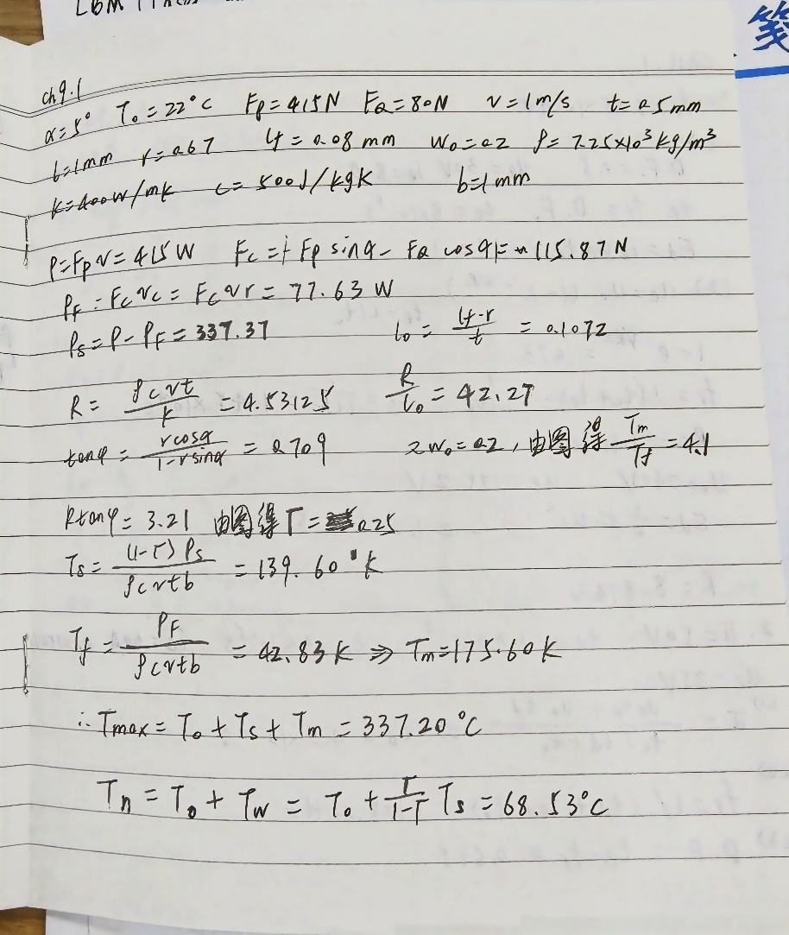

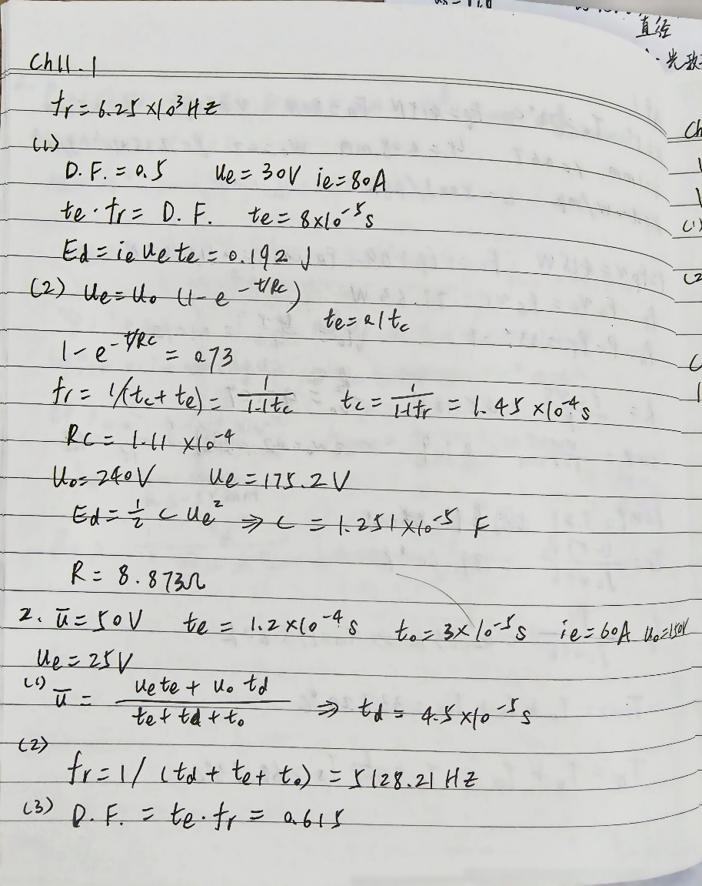

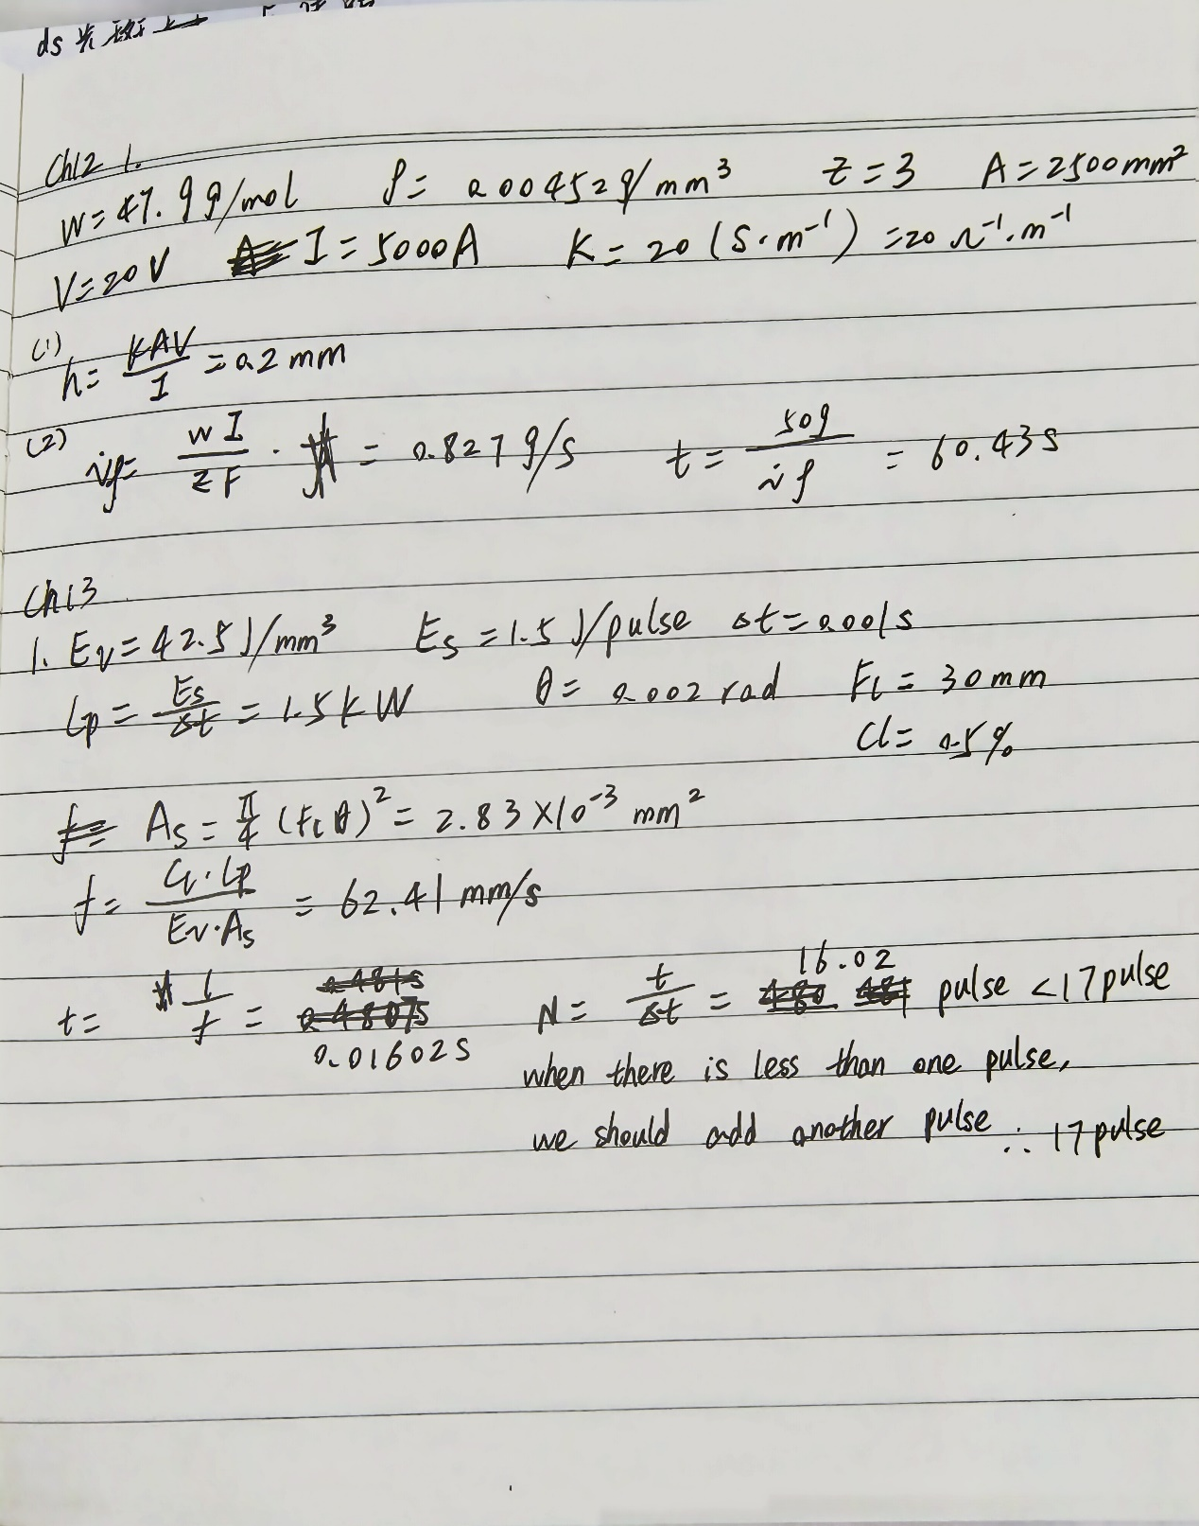

Ch13

2. List the material removal mechanisms, advantages and disadvantages of EDM, ECM, CHM, LBM, and EBM.

EDM：

advantages：1.Hardness is not a key factor (good for hard, difficult-to machine

materials)2.Low cutting force and no burr3.Precision and complication shape

disadvantages：1.Electrically conductive material – Electrical insulators may work but slow MRR, Slow – MRR is low (except for the hollow electrode drilling)2.Electrode wear will cause Inaccuracy of the part and dull edges in cavity3. Recast layer and heat affected zone (HAZ) - a thin, hard recast layer and HAZ under machined surfaces, which may not good for further manufacturing

ECM:

advantages：1.Less residual and thermal stress2. Low mechanical force3. Low tool wear4. No burr (can debur difficult-to-access areas)

disadvantages：1.Slow2. High tooling costs3. Safety hazard due to high electrical current4. Only for electrically conductive material5. Electrolyte disposal – an environmental issues6.costing too much money

LBM:

advantages：1.Laser beam can be branched to different workstations working at the same time.2. Capable for micro features in difficult-to-machine and refractory materials.3. Control the beam characteristics to adapt to a specific machining duty.

disadvantages：1.Equipment cost2. Unsafe for eye3. Limited dimensional and form accuracy4. Surface heat affected zone (HAZ)5. Blind holes of precise depth are difficult6. Laser produces tapered holes.7. Low energy efficiency (η = 1%)

EBM:

advantages：1. Machining any material independent of its mechanical properties2. Micromachining economically at higher speeds than that of EDM and ECM – Drilling of fine holes is possible at high rates (up to 4000 holes/s)3. Maintaining high accuracy and repeatability of ±0.1 mm for position and ±5% of the diameter of the drilled hole4. No difficulty with acute angles5. Producing good finish6. Providing a high degree of automation and productivity

disadvantages：1.High capital cost of equipment2. Time loss for evacuating the machining vacuum chamber3. Presence of a thin recast layer and heat affected zone4. Necessity for auxiliary backing material

3. Compare EDM and ECM in terms of the polarity of the workpiece, level of voltage and current, the electrical conductivity of the electrolyte, and the machined surface quality. (8 points)

the polarity of the workpiece: EDM uses conductive workpiece materials, usually metals, and requires a pair of electrodes to generate discharge. ECM is suitable for both conductive and non-conductive workpieces as the machining process is achieved through electrochemical reactions without the need for electrical sparks.

level of voltage and current: EDM typically employs high-frequency pulse power with voltage ranging from 80V to 200V and current ranging from 3A to 100A, depending on the conductivity of the work material. ECM generally uses direct current power with voltage ranging from 5V to 30V. However, the current is relatively high, typically between 50A and 40000A.

the electrical conductivity of the electrolyte: EDM does not require electrolyte. ECM requires the use of electrolyte as a medium, and the electrolyte must have sufficient electrical conductivity to provide the necessary current during the machining process.

the machined surface quality: For EDM, when the electrode wears, it can cause inaccuracy of the part and dull edges in cavity, and EDM itself can cause recast layers and heat affected zone. ECM generally provides better surface quality, with machined surfaces usually being smooth, having no significant heat-affected zone, and minimal residual stress.