Ch 1: Introduction

1. Machining process for the three key components of the harmonic drive, which is used extensively in robotics and machines. Three key parts of the harmonic drive are – Part A: circular spline (fixed), Part B: flex spline (attached to output shaft, not shown), and Part C: wave generator (attached to input shaft, not shown). Describe the machine processes to create the 2D features shown in the drawing below for Parts A, B and C. Note: Do NOT discuss the machining of 3D real parts in the class video. The design and manufacturing of the durable harmonic drive are challenging and only a few companies in the world can make this product. (15 points)

  

Solution :

A: Lathe turning a section of the tube. Grinding the outside and inside and then broaching the internal ring gear profile.

B: Lathe turning a section of the tube. Grinding the outside and inside and then grinding the external ring gear profile.

C: Lathe cutting a ring of the rod. Lathe cutting and then external can grinding.

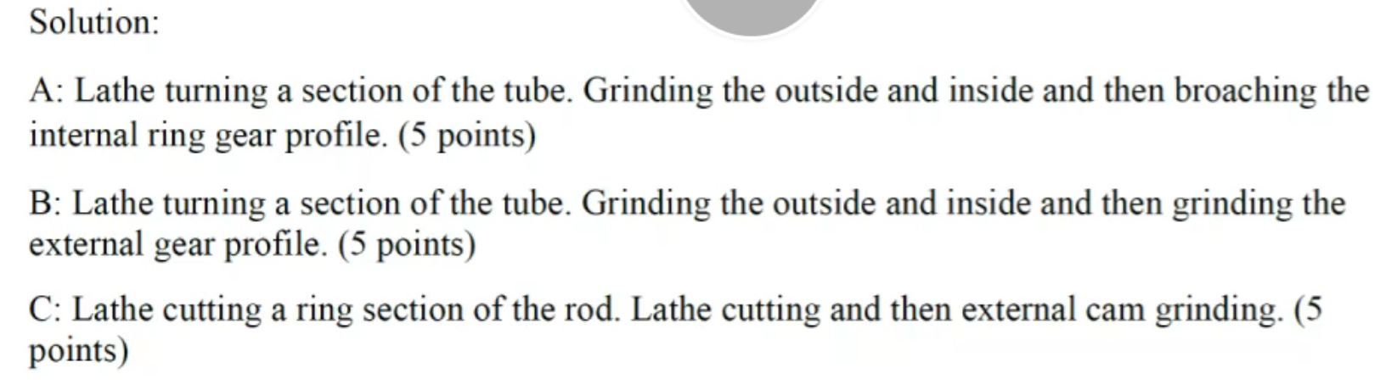

2. What are the machining processes to produce the centrifugal compressor impeller/wheel of a turbocharger? What is the design feature to allow high material removal rate to create the propeller blade? (5 points)

Solution: the frank milling(end milling) of the blade is used.



Ch 2: Singe point cutting

1. These telescope mirrors are not flat. How to create the precise shape on these mirror surfaces (NOT the hexagon shape)? (4 points)

Solution: single point diamond turning with fast tool servo.



Ch 3: Multiple point cutting

4. How to make the drill with the spiral holes for cutting fluid delivery? The tool material is tungsten carbide in cobalt matrix. (4 points)

Solution: put line or wire in place when forming(extrusion) the tool before the cutting edges are ground .



2. Explain the following specification of a grinding wheel (21 points)

39C60-IVK

10 X 1-1/2 X 1-1/4

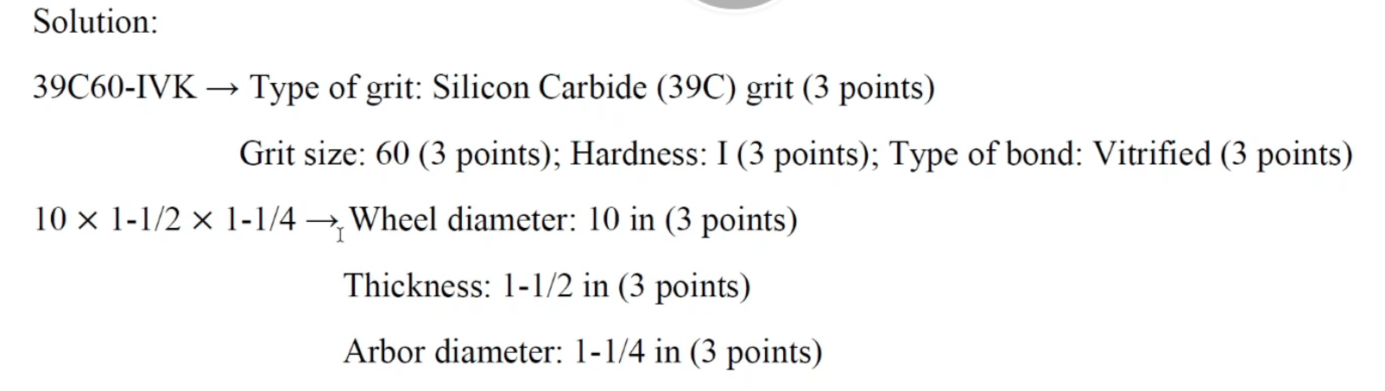

2. List the material removal mechanisms, advantages and disadvantages of EDM, ECM, CHM, LBM, and EBM. (15 points)

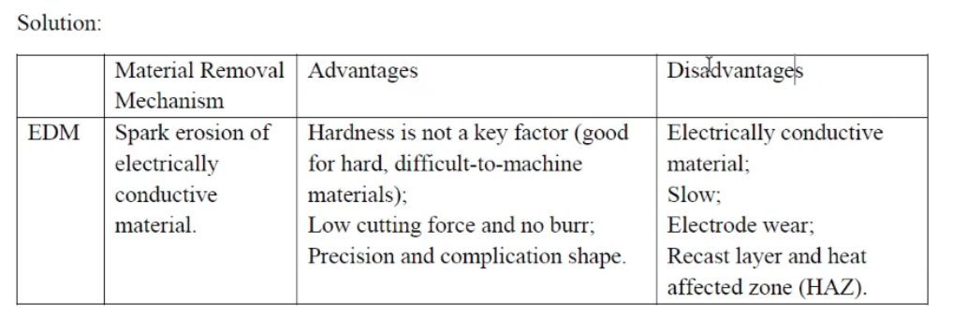

3. Compare EDM and ECM in terms of the polarity of the workpiece, level of voltage and current, the electrical conductivity of the electrolyte, and the machined surface quality. (8 points)

