2.

public class Money {  
 public static void main(String[] args) {  
 int cock, hen, chick;  
 for(chick = 0; chick < 100; chick += 3) {  
 for(cock = 0; cock < 20; cock++) {  
 hen = 100 - cock - chick;  
 if(hen < 0)  
 return;  
 if((5\*cock + 3\*hen +chick/3) == 100) {  
 System.*out*.print("公鸡: "+cock);  
 System.*out*.print(" 母鸡: "+hen);  
 System.*out*.print(" 小鸡: "+chick+"\n");  
 }  
 }  
 }  
 }  
}

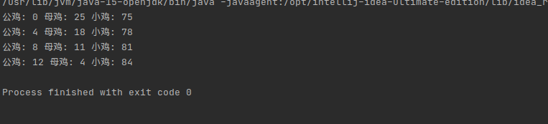

3.

public class Box {  
 public static void main(String[] args) {  
 int red, yellow, black, white;  
 for(red = 1; red <=4; red++) {  
 for(yellow = 1; yellow <=4; yellow++) {  
 for(black = 1; black <= 4; black++) {  
 for(white = 1; white <= 4; white++) {  
 int[] sum = {red, yellow, black, white}; // 判断互不相等  
 int flag = 0;  
 for(int i = 0; i < 4; i++) {  
 for(int j = i+1; j < 4; j++) {  
 if(sum[i] == sum [j])  
 flag = 1;  
 }  
 }  
 if(flag == 0) {  
 if((black == 1 ^ yellow == 2) && (black == 2 ^ white == 3) && (red == 2 ^ white == 4)) {  
 System.*out*.println("red in: "+red);  
 System.*out*.println("yellow in: "+yellow);  
 System.*out*.println("black in: "+black);  
 System.*out*.println("white in: "+white);  
 return;  
 }  
 }  
 }  
 }  
 }  
 }  
 }  
}

