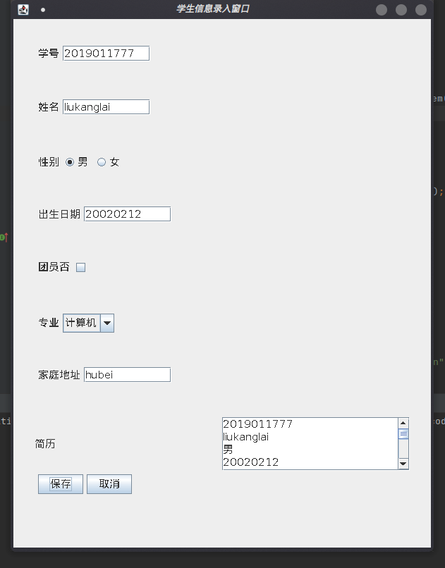1.

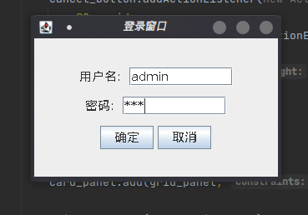

import javax.swing.*;  
import java.awt.*;  
import java.awt.event.ActionEvent;  
import java.awt.event.ActionListener;  
  
*/\*\**  
 *\** ***@author*** *liukanglai*  
 *\** ***@date*** *4/28/21 - 1:38 PM*  
 *\*/*  
  
// 一个面板不能同时被两个面板使用？？？  
  
public class LoginWindows {  
 public static void main(String[] args) {  
 JFrame win = new JFrame("登录窗口");  
  
 win.setSize(300, 200);  
 win.setLocationRelativeTo(null);  
 win.setDefaultCloseOperation(WindowConstants.*EXIT_ON_CLOSE*);  
  
 CardLayout cLayout = new CardLayout(30, 30);  
 JPanel card_panel = new JPanel(cLayout);  
  
 *addCard1*(card_panel, cLayout, win);  
 *addCard2*(card_panel, cLayout, win);  
  
 cLayout.show(card_panel, "Log in");  
  
 win.setContentPane(card_panel);  
 win.setVisible(true);  
 }  
  
 static void addCard1(JPanel card_panel, CardLayout cLayout, JFrame win) {  
 JPanel grid_panel = new JPanel(new GridLayout(3, 3));  
  
 JPanel name_panel = new JPanel(new FlowLayout());  
 JLabel name = new JLabel("用户名: ");  
 name.setFont(new Font(null, Font.*PLAIN*, 15));  
 JTextField nameField = new JTextField(8);  
 nameField.setFont(new Font(null, Font.*PLAIN*, 15));  
 name_panel.add(name);  
 name_panel.add(nameField);  
  
 JPanel password_panel = new JPanel(new FlowLayout());  
 JLabel password = new JLabel("密码: ");  
 password.setFont(new Font(null, Font.*PLAIN*, 15));  
 JPasswordField passwordField = new JPasswordField(8);  
 passwordField.setFont(new Font(null, Font.*PLAIN*, 15));  
 passwordField.setEchoChar('*');  
 password_panel.add(password);  
 password_panel.add(passwordField);  
  
 JPanel options_panel = new JPanel(new FlowLayout());  
 JButton yes_button = new JButton("确定");  
 yes_button.setFont(new Font(null, Font.*PLAIN*, 15));  
 yes_button.addActionListener(new ActionListener() {  
 @Override  
 public void actionPerformed(ActionEvent e) {  
 String name = nameField.getText();  
 String password = new String(passwordField.getPassword());  
 if(name.equals("admin") && password.equals("123")) {  
 cLayout.next(card_panel);  
 win.setSize(600, 800);  
 win.setTitle("学生信息录入窗口");  
 }  
 else {  
 JOptionPane.*showMessageDialog*(null, "用户名或密码错误！！！");  
 }  
 }  
 });  
 JButton cancel_button = new JButton("取消");  
 cancel_button.setFont(new Font(null, Font.*PLAIN*, 15));  
 cancel_button.addActionListener(new ActionListener() {  
 @Override  
 public void actionPerformed(ActionEvent actionEvent) {  
 System.*exit*(0);  
 }  
 });  
 options_panel.add(yes_button);  
 options_panel.add(cancel_button);  
  
 card_panel.add(grid_panel, "Log in");  
  
 grid_panel.add(name_panel);  
 grid_panel.add(password_panel);  
 grid_panel.add(options_panel);  
 }  
  
 static void addCard2(JPanel card_panel, CardLayout cLayout, JFrame win) {  
 JPanel grid_panel = new JPanel(new GridLayout(9, 1));  
  
 JPanel student_id_panel = new JPanel(new FlowLayout(FlowLayout.*LEFT*));  
 JLabel id = new JLabel("学号");  
 id.setFont(new Font(null, Font.*PLAIN*, 15));  
 JTextField idField = new JTextField(8);  
 idField.setFont(new Font(null, Font.*PLAIN*, 15));  
 student_id_panel.add(id);  
 student_id_panel.add(idField);  
  
 JPanel name_panel = new JPanel(new FlowLayout(FlowLayout.*LEFT*));  
 JLabel name = new JLabel("姓名");  
 name.setFont(new Font(null, Font.*PLAIN*, 15));  
 JTextField nameField = new JTextField(8);  
 nameField.setFont(new Font(null, Font.*PLAIN*, 15));  
 name_panel.add(name);  
 name_panel.add(nameField);  
  
 JPanel gender_panel = new JPanel(new FlowLayout(FlowLayout.*LEFT*));  
 JLabel gender = new JLabel("性别");  
 gender.setFont(new Font(null, Font.*PLAIN*, 15));  
 ButtonGroup genderButton = new ButtonGroup();  
 JRadioButton genderButton0 = new JRadioButton("男");  
 genderButton0.setFont(new Font(null, Font.*PLAIN*, 15));  
 JRadioButton genderButton1 = new JRadioButton("女");  
 genderButton1.setFont(new Font(null, Font.*PLAIN*, 15));  
 genderButton.add(genderButton0);  
 genderButton.add(genderButton1);  
 genderButton0.setSelected(true);  
 gender_panel.add(gender);  
 gender_panel.add(genderButton0);  
 gender_panel.add(genderButton1);  
  
 JPanel birthday_panel = new JPanel(new FlowLayout(FlowLayout.*LEFT*));  
 JLabel birthday = new JLabel("出生日期");  
 birthday.setFont(new Font(null, Font.*PLAIN*, 15));  
 JTextField birthdayField = new JTextField(8);  
 birthdayField.setFont(new Font(null, Font.*PLAIN*, 15));  
 birthday_panel.add(birthday);  
 birthday_panel.add(birthdayField);  
  
 JPanel tuanyuan_panel = new JPanel(new FlowLayout(FlowLayout.*LEFT*));  
 JLabel tuanyuan = new JLabel("团员否");  
 tuanyuan.setFont(new Font(null, Font.*PLAIN*, 15));  
 JCheckBox tuanyuanButton = new JCheckBox();  
 tuanyuanButton.setFont(new Font(null, Font.*PLAIN*, 15));  
 tuanyuan_panel.add(tuanyuan);  
 tuanyuan_panel.add(tuanyuanButton);  
  
 JPanel profession_panel = new JPanel(new FlowLayout(FlowLayout.*LEFT*));  
 JLabel profession = new JLabel("专业");  
 profession.setFont(new Font(null, Font.*PLAIN*, 15));  
 String[] professionList = new String[]{"计算机","数学","物理","哲学","其他"};  
 JComboBox professionButton = new JComboBox(professionList);  
 professionButton.setFont(new Font(null, Font.*PLAIN*,15));  
 profession_panel.add(profession);  
 profession_panel.add(professionButton);  
  
 JPanel address_panel = new JPanel(new FlowLayout(FlowLayout.*LEFT*));  
 JLabel address = new JLabel("家庭地址");  
 address.setFont(new Font(null, Font.*PLAIN*, 15));  
 JTextField addressField = new JTextField(8);  
 addressField.setFont(new Font(null, Font.*PLAIN*, 15));  
 address_panel.add(address);  
 address_panel.add(addressField);  
  
 //JPanel resume_panel = new JPanel(new FlowLayout(FlowLayout.LEFT));  
 JPanel resume_panel = new JPanel(new GridLayout());  
 JLabel resume = new JLabel("简历");  
 resume.setFont(new Font(null, Font.*PLAIN*, 15));  
 JTextArea resumeText = new JTextArea(20, 30);  
 resumeText.setFont(new Font(null, Font.*PLAIN*, 15));  
 resumeText.setLineWrap(true);  
 JScrollPane textPane = new JScrollPane(resumeText);  
 resume_panel.add(resume);  
 resume_panel.add(textPane);  
  
 JPanel options_panel = new JPanel(new FlowLayout(FlowLayout.*LEFT*));  
 JButton yes_button = new JButton("保存");  
 yes_button.setFont(new Font(null, Font.*PLAIN*, 15));  
 yes_button.addActionListener(new ActionListener() {  
 @Override  
 public void actionPerformed(ActionEvent e) {  
 resumeText.append(idField.getText()+'\n');  
 resumeText.append(nameField.getText()+'\n');  
 if(genderButton0.isSelected()) {  
 resumeText.append("男\n");  
 }  
 else {  
 resumeText.append("女\n");  
 }  
 resumeText.append(birthdayField.getText()+'\n');  
 if(tuanyuanButton.isSelected()) {  
 resumeText.append("不是团员\n");  
 }  
 else {  
 resumeText.append("是团员\n");  
 }  
 resumeText.append((String)professionButton.getSelectedItem()+'\n');  
 resumeText.append(addressField.getText()+'\n');  
 }  
 });  
 options_panel.add(yes_button);  
 JButton cancel_button = new JButton("取消");  
 cancel_button.setFont(new Font(null, Font.*PLAIN*, 15));  
 cancel_button.addActionListener(new ActionListener() {  
 @Override  
 public void actionPerformed(ActionEvent actionEvent) {  
 cLayout.first(card_panel);  
 win.setSize(300,200);  
 win.setTitle("登录窗口");  
 }  
 });  
 options_panel.add(cancel_button);  
  
 card_panel.add(grid_panel, "the student's information");  
  
 grid_panel.add(student_id_panel);  
 grid_panel.add(name_panel);  
 grid_panel.add(gender_panel);  
 grid_panel.add(birthday_panel);  
 grid_panel.add(tuanyuan_panel);  
 grid_panel.add(profession_panel);  
 grid_panel.add(address_panel);  
 grid_panel.add(resume_panel);  
 grid_panel.add(options_panel);  
  
 }  
}

2.

import javax.swing.*;  
import java.applet.Applet;  
import java.awt.Image;  
import java.awt.*;  
import java.awt.event.ActionEvent;  
import java.awt.event.ActionListener;  
  
*/\*\**  
 *\** ***@author*** *liukanglai*  
 *\** ***@date*** *5/2/21 - 5:45 PM*  
 *\*/*  
public class RecommendStudents extends Applet {  
 public static void main(String[] args) {  
 JFrame win = new JFrame("班级推优");  
 win.setSize(500, 600);  
 win.setLocationRelativeTo(null);  
 win.setDefaultCloseOperation(WindowConstants.*EXIT_ON_CLOSE*);  
  
 JPanel panel = new JPanel(new BorderLayout());  
 Font font = new Font(null, Font.*PLAIN*, 15);  
  
 JPanel nPanel = new JPanel(new FlowLayout());  
 JLabel num = new JLabel("投票人数");  
 int[] votes_num = new int[]{0};  
 num.setFont(font);  
 JTextField numText = new JTextField(8);  
 JLabel maxVote = new JLabel("最高票");  
 int[] max_vote = new int[]{0};  
 maxVote.setFont(font);  
 JTextField maxVoteText = new JTextField(8);  
 panel.add(nPanel, BorderLayout.*NORTH*);  
 nPanel.add(num);  
 nPanel.add(numText);  
 nPanel.add(maxVote);  
 nPanel.add(maxVoteText);  
  
 JPanel ePanel = new JPanel(new GridLayout(6, 1));  
 JLabel votes = new JLabel("票数");  
 votes.setFont(font);  
 int[] votesNum = new int[]{0, 0, 0, 0, 0};  
 JLabel votes0 = new JLabel(votesNum[0]+"票");  
 votes0.setFont(font);  
 JLabel votes1 = new JLabel(votesNum[1]+"票");  
 votes1.setFont(font);  
 JLabel votes2 = new JLabel(votesNum[2]+"票");  
 votes2.setFont(font);  
 JLabel votes3 = new JLabel(votesNum[3]+"票");  
 votes3.setFont(font);  
 JLabel votes4 = new JLabel(votesNum[4]+"票");  
 votes4.setFont(font);  
 panel.add(ePanel, BorderLayout.*EAST*);  
 ePanel.add(votes);  
 ePanel.add(votes0);  
 ePanel.add(votes1);  
 ePanel.add(votes2);  
 ePanel.add(votes3);  
 ePanel.add(votes4);  
  
 JPanel wPanel = new JPanel(new GridLayout(6, 1));  
 JLabel candidate = new JLabel("候选人");  
 candidate.setFont(font);  
  
 JPanel wPanel0 = new JPanel(new FlowLayout(FlowLayout.*LEFT*));  
 JLabel candidate0 = new JLabel();  
 ImageIcon image0 = new ImageIcon("/home/liukanglai/Code/IdeaProjects/demo/src/me/T6/4682.jpg");  
 Image img0 = image0.getImage();// 获得此图标的Image  
 img0 = img0.getScaledInstance(60, 70, Image.*SCALE_AREA_AVERAGING*);// 将image压缩后得到压缩后的img  
 image0.setImage(img0);// 将图标设置为压缩后的图像  
 candidate0.setIcon(image0);  
 JCheckBox duanBtn = new JCheckBox("段同学");  
 duanBtn.setFont(font);  
 wPanel0.add(candidate0);  
 wPanel0.add(duanBtn);  
  
 JPanel wPanel1 = new JPanel(new FlowLayout(FlowLayout.*LEFT*));  
 JLabel candidate1 = new JLabel();  
 ImageIcon image1 = new ImageIcon("/home/liukanglai/Code/IdeaProjects/demo/src/me/T6/26366.jpg");  
 Image img1 = image1.getImage();  
 img1 = img1.getScaledInstance(60, 70, Image.*SCALE_AREA_AVERAGING*);  
 image1.setImage(img1);  
 candidate1.setIcon(image1);  
 JCheckBox gaoBtn = new JCheckBox("高同学");  
 gaoBtn.setFont(font);  
 wPanel1.add(candidate1);  
 wPanel1.add(gaoBtn);  
  
  
 JPanel wPanel2 = new JPanel(new FlowLayout(FlowLayout.*LEFT*));  
 JLabel candidate2 = new JLabel();  
 ImageIcon image2 = new ImageIcon("/home/liukanglai/Code/IdeaProjects/demo/src/me/T6/0439.jpg");  
 Image img2 = image2.getImage();  
 img2 = img2.getScaledInstance(60, 70, Image.*SCALE_AREA_AVERAGING*);  
 image2.setImage(img2);  
 candidate2.setIcon(image2);  
 JCheckBox zhuBtn = new JCheckBox("朱同学");  
 zhuBtn.setFont(font);  
 wPanel2.add(candidate2);  
 wPanel2.add(zhuBtn);  
  
 JPanel wPanel3 = new JPanel(new FlowLayout(FlowLayout.*LEFT*));  
 JLabel candidate3 = new JLabel();  
 ImageIcon image3 = new ImageIcon("/home/liukanglai/Code/IdeaProjects/demo/src/me/T6/8788.png");  
 Image img3 = image3.getImage();  
 img3 = img3.getScaledInstance(60, 70, Image.*SCALE_AREA_AVERAGING*);  
 image3.setImage(img3);  
 candidate3.setIcon(image3);  
 JCheckBox liuBtn = new JCheckBox("刘同学");  
 liuBtn.setFont(font);  
 wPanel3.add(candidate3);  
 wPanel3.add(liuBtn);  
  
 JPanel wPanel4 = new JPanel(new FlowLayout(FlowLayout.*LEFT*));  
 JLabel candidate4 = new JLabel();  
 ImageIcon image4 = new ImageIcon("/home/liukanglai/Code/IdeaProjects/demo/src/me/T6/30312.png");  
 Image img4 = image4.getImage();  
 img4 = img4.getScaledInstance(60, 70, Image.*SCALE_AREA_AVERAGING*);  
 image4.setImage(img4);  
 candidate4.setIcon(image4);  
 JCheckBox liBtn = new JCheckBox("李同学");  
 liBtn.setFont(font);  
 wPanel4.add(candidate4);  
 wPanel4.add(liBtn);  
  
 panel.add(wPanel, BorderLayout.*WEST*);  
 wPanel.add(candidate);  
 wPanel.add(wPanel0);  
 wPanel.add(wPanel1);  
 wPanel.add(wPanel2);  
 wPanel.add(wPanel3);  
 wPanel.add(wPanel4);  
  
  
  
 JPanel sPanel = new JPanel(new FlowLayout());  
 JButton vote = new JButton("投票");  
 vote.setFont(font);  
 vote.addActionListener(new ActionListener() {  
 @Override  
 public void actionPerformed(ActionEvent actionEvent) {  
 votes_num[0]++;  
 if (duanBtn.isSelected()) {  
 votesNum[0]++;  
 duanBtn.setSelected(false);  
 votes0.setText(votesNum[0] + "票");  
 }  
 if (gaoBtn.isSelected()) {  
 votesNum[1]++;  
 gaoBtn.setSelected(false);  
 votes1.setText(votesNum[1] + "票");  
 }  
 if (zhuBtn.isSelected()) {  
 votesNum[2]++;  
 zhuBtn.setSelected(false);  
 votes2.setText(votesNum[2] + "票");  
 }  
 if (liuBtn.isSelected()) {  
 votesNum[3]++;  
 liuBtn.setSelected(false);  
 votes3.setText(votesNum[3] + "票");  
 }  
 if (liBtn.isSelected()) {  
 votesNum[4]++;  
 liBtn.setSelected(false);  
 votes4.setText(votesNum[4] + "票");  
 }  
 for (int i = 0; i < 5; i++) {  
 max_vote[0] = max_vote[0] < votesNum[i] ? votesNum[i] : max_vote[0];  
 }  
 numText.setText(String.*valueOf*(votes_num[0]));  
 maxVoteText.setText(String.*valueOf*(max_vote[0]));  
 MyPanel cPanel = new MyPanel(win, votesNum);  
 panel.add(cPanel, BorderLayout.*CENTER*);  
 }  
 });  
 JButton cancel = new JButton("取消");  
 cancel.setFont(font);  
 panel.add(sPanel, BorderLayout.*SOUTH*);  
 sPanel.add(vote);  
 sPanel.add(cancel);  
  
 win.setContentPane(panel);  
 win.setVisible(true);  
 }  
 public static class MyPanel extends JPanel {  
  
 JFrame frame;  
 int[] votesNum = new int[5];  
  
 public MyPanel(JFrame frame, int[] votesNum) {  
 this.frame = frame;  
 System.*arraycopy*(votesNum, 0, this.votesNum, 0, 5);  
 }  
 @Override  
 protected void paintComponent(Graphics g) {  
 super.paintComponent(g);  
 // 重新调用 Graphics 的绘制方法绘制时将自动擦除旧的内容  
 g.setColor(Color.*red*);  
 for (int i = 0; i < 5; i++) {  
 //填充矩形：一票长度设置为5：  
 g.fillRect(20, 150 + i * 70, votesNum[i] * 5, 35);  
 }  
 }  
 }  
}

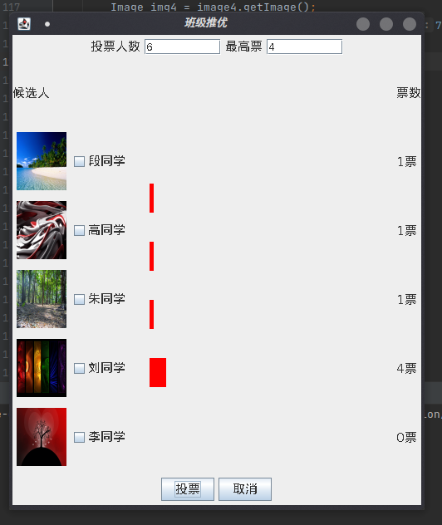

3.

import javax.swing.*;  
import java.awt.*;  
import java.awt.event.KeyAdapter;  
import java.awt.event.KeyEvent;  
  
*/\*\**  
 *\** ***@author*** *liukanglai*  
 *\** ***@date*** *5/3/21 - 8:29 PM*  
 *\*/*  
public class BattleOfTanks {  
 public static void main(String[] args) {  
 JFrame win = new JFrame("坦克大战游戏");  
 win.setSize(400, 650);  
 win.setLocationRelativeTo(null);  
 win.setDefaultCloseOperation(3);  
  
 JPanel panel = new JPanel(new BorderLayout());  
  
 JPanel nPanel = new JPanel(new FlowLayout());  
 ImageIcon image = new ImageIcon("/home/liukanglai/Downloads/坦克素材/steels.gif");  
 JLabel[] label0 = new JLabel[15];  
 for(int i = 0; i < 15; i++) {  
 label0[i] = new JLabel(image);  
 nPanel.add(label0[i]);  
 }  
 panel.add(nPanel, BorderLayout.*NORTH*);  
  
 JPanel sPanel = new JPanel(new FlowLayout());  
 JLabel[] label1 = new JLabel[15];  
 for(int i = 0; i < 15; i++) {  
 label1[i] = new JLabel(image);  
 sPanel.add(label1[i]);  
 }  
 panel.add(sPanel, BorderLayout.*SOUTH*);  
  
 JPanel wPanel = new JPanel(new GridLayout(15, 1));  
 JLabel[] label2 = new JLabel[15];  
 for(int i = 0; i < 15; i++) {  
 label2[i] = new JLabel(image);  
 wPanel.add(label2[i]);  
 }  
 panel.add(wPanel, BorderLayout.*WEST*);  
  
 JPanel ePanel = new JPanel(new GridLayout(15,1));  
 JLabel[] label3 = new JLabel[15];  
 for(int i = 0; i < 15; i++) {  
 label3[i] = new JLabel(image);  
 ePanel.add(label3[i]);  
 }  
 panel.add(ePanel, BorderLayout.*EAST*);  
  
 JPanel cPanel = new JPanel(null);  
 JLabel tank = new JLabel (new ImageIcon("/home/liukanglai/Downloads/坦克素材/p1tankD.gif"));  
 JLabel enemy = new JLabel(new ImageIcon("/home/liukanglai/Downloads/坦克素材/enemy2U.gif"));  
 int[] location = new int[]{20, 20};  
 tank.setBounds(location[0], location[1], 60, 60);  
 enemy.setBounds(200, 200, 60, 60);  
 cPanel.add(tank);  
 cPanel.add(enemy);  
 panel.add(cPanel, BorderLayout.*CENTER*);  
  
 win.addKeyListener(new KeyAdapter() {  
 @Override  
 public void keyPressed(KeyEvent e) {  
 super.keyPressed(e);  
 switch (e.getKeyCode()) {  
 case KeyEvent.*VK_LEFT*:  
 location[0]--;  
 tank.setBounds(location[0], location[1], 60, 60);  
 break;  
 case KeyEvent.*VK_UP*:  
 location[1]--;  
 tank.setBounds(location[0], location[1], 60, 60);  
 break;  
 case KeyEvent.*VK_RIGHT*:  
 location[0]++;  
 tank.setBounds(location[0], location[1], 60, 60);  
 break;  
 case KeyEvent.*VK_DOWN*:  
 location[1]++;  
 tank.setBounds(location[0], location[1], 60, 60);  
 break;  
 default:  
 break;  
 }  
 }  
 });  
  
 win.setContentPane(panel);  
 win.setVisible(true);  
 }  
}

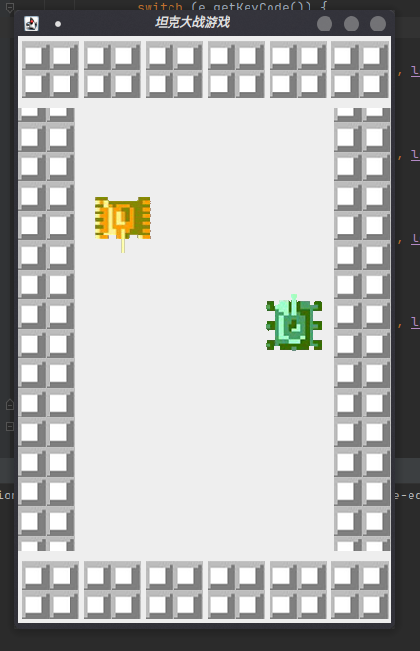

4.

import javax.sound.sampled.AudioInputStream;  
import javax.sound.sampled.AudioSystem;  
import javax.sound.sampled.Clip;  
import javax.swing.*;  
import java.awt.*;  
import java.awt.event.ActionEvent;  
import java.awt.event.ActionListener;  
import java.io.File;  
  
*/\*\**  
 *\** ***@author*** *liukanglai*  
 *\** ***@date*** *5/4/21 - 1:54 PM*  
 *\*/*  
public class PlayPiano {  
 public static void main(String[] args) {  
 JFrame win = new JFrame("弹钢琴");  
 win.setSize(420, 240);  
 win.setLocationRelativeTo(null);  
 win.setDefaultCloseOperation(3);  
  
 JPanel panel = new JPanel(null);  
 ImageIcon image = new ImageIcon("/home/liukanglai/Downloads/钢琴素材/keyBoard.jpg");  
 JLabel piano = new JLabel(image);  
 piano.setBounds(0, -150, 400, 500);  
 panel.add(piano);  
 JButton[] buttons = new JButton[13];  
 for(int i = 0; i < 13; i++) {  
 buttons[i] = new JButton(String.*valueOf*((char)('a'+i)));  
 buttons[i].setBounds(30*i, 10, 30, 150);  
 panel.add(buttons[i]);  
 }  
 int[] flag = new int[]{0};  
 for(int i = 0; i < 13; i++) {  
 int color0 = (int)(Math.*random*()*255);  
 int color1 = (int)(Math.*random*()*255);  
 int color2 = (int)(Math.*random*()*255);  
 flag[0]++;  
 File file = new File("/home/liukanglai/Downloads/钢琴素材/"+flag[0]+".wav");  
 buttons[i].setBackground(new Color(color0, color1, color2));  
 buttons[i].addActionListener(new ActionListener() {  
 @Override  
 public void actionPerformed(ActionEvent actionEvent) {  
 try {  
 AudioInputStream audioInputStream = AudioSystem.*getAudioInputStream*(file.getAbsoluteFile());  
 Clip clip = AudioSystem.*getClip*();  
 clip.open(audioInputStream);  
 clip.start();  
 } catch (Exception ex) {  
 System.*out*.println("Error with playing sound.");  
 ex.printStackTrace();  
 }  
 }  
 });  
 }  
 win.setContentPane(panel);  
 win.setVisible(true);  
 }  
}

