1.  
import javax.swing.*;  
import java.awt.*;  
import java.awt.event.ActionEvent;  
import java.awt.event.ActionListener;  
import java.io.FileNotFoundException;  
import java.io.FileReader;  
import java.io.FileWriter;  
import java.io.IOException;  
  
*/\*\**  
 *\** ***@author*** *liukanglai*  
 *\** ***@date*** *5/15/21 - 11:21 AM*  
 *\*/*  
  
public class LoginWindowsPlus {  
 public static void main(String[] args) {  
 JFrame win = new JFrame("学生信息录入窗口");  
  
 win.setSize(600, 800);  
 win.setLocationRelativeTo(null);  
 win.setDefaultCloseOperation(WindowConstants.*EXIT_ON_CLOSE*);  
  
 CardLayout cLayout = new CardLayout(30, 30);  
 JPanel card_panel = new JPanel(cLayout);  
  
 *addCard2*(card_panel, cLayout, win);  
  
  
 win.setContentPane(card_panel);  
 win.setVisible(true);  
 }  
 static void addCard2 (JPanel card_panel, CardLayout cLayout, JFrame win) {  
 JPanel grid_panel = new JPanel(new GridLayout(9, 1));  
  
 JPanel student_id_panel = new JPanel(new FlowLayout(FlowLayout.*LEFT*));  
 JLabel id = new JLabel("学号");  
 id.setFont(new Font(null, Font.*PLAIN*, 15));  
 JTextField idField = new JTextField(8);  
 idField.setFont(new Font(null, Font.*PLAIN*, 15));  
 JButton idButton = new JButton("查询");  
 idButton.setFont(new Font(null, Font.*PLAIN*, 15));  
  
 student_id_panel.add(id);  
 student_id_panel.add(idField);  
 student_id_panel.add(idButton);  
  
 JPanel name_panel = new JPanel(new FlowLayout(FlowLayout.*LEFT*));  
 JLabel name = new JLabel("姓名");  
 name.setFont(new Font(null, Font.*PLAIN*, 15));  
 JTextField nameField = new JTextField(8);  
 nameField.setFont(new Font(null, Font.*PLAIN*, 15));  
 name_panel.add(name);  
 name_panel.add(nameField);  
  
 JPanel gender_panel = new JPanel(new FlowLayout(FlowLayout.*LEFT*));  
 JLabel gender = new JLabel("性别");  
 gender.setFont(new Font(null, Font.*PLAIN*, 15));  
 ButtonGroup genderButton = new ButtonGroup();  
 JRadioButton genderButton0 = new JRadioButton("男");  
 genderButton0.setFont(new Font(null, Font.*PLAIN*, 15));  
 JRadioButton genderButton1 = new JRadioButton("女");  
 genderButton1.setFont(new Font(null, Font.*PLAIN*, 15));  
 genderButton.add(genderButton0);  
 genderButton.add(genderButton1);  
 genderButton0.setSelected(true);  
 gender_panel.add(gender);  
 gender_panel.add(genderButton0);  
 gender_panel.add(genderButton1);  
  
 JPanel birthday_panel = new JPanel(new FlowLayout(FlowLayout.*LEFT*));  
 JLabel birthday = new JLabel("出生日期");  
 birthday.setFont(new Font(null, Font.*PLAIN*, 15));  
 JTextField birthdayField = new JTextField(8);  
 birthdayField.setFont(new Font(null, Font.*PLAIN*, 15));  
 birthday_panel.add(birthday);  
 birthday_panel.add(birthdayField);  
  
 JPanel tuanyuan_panel = new JPanel(new FlowLayout(FlowLayout.*LEFT*));  
 JLabel tuanyuan = new JLabel("团员否");  
 tuanyuan.setFont(new Font(null, Font.*PLAIN*, 15));  
 JCheckBox tuanyuanButton = new JCheckBox();  
 tuanyuanButton.setFont(new Font(null, Font.*PLAIN*, 15));  
 tuanyuan_panel.add(tuanyuan);  
 tuanyuan_panel.add(tuanyuanButton);  
  
 JPanel profession_panel = new JPanel(new FlowLayout(FlowLayout.*LEFT*));  
 JLabel profession = new JLabel("专业");  
 profession.setFont(new Font(null, Font.*PLAIN*, 15));  
 String[] professionList = new String[]{"计算机", "数学", "物理", "哲学", "其他"};  
 JComboBox professionButton = new JComboBox(professionList);  
 professionButton.setFont(new Font(null, Font.*PLAIN*, 15));  
 profession_panel.add(profession);  
 profession_panel.add(professionButton);  
  
 JPanel address_panel = new JPanel(new FlowLayout(FlowLayout.*LEFT*));  
 JLabel address = new JLabel("家庭地址");  
 address.setFont(new Font(null, Font.*PLAIN*, 15));  
 JTextField addressField = new JTextField(8);  
 addressField.setFont(new Font(null, Font.*PLAIN*, 15));  
 address_panel.add(address);  
 address_panel.add(addressField);  
  
 //JPanel resume_panel = new JPanel(new FlowLayout(FlowLayout.LEFT));  
 JPanel resume_panel = new JPanel(new GridLayout());  
 JLabel resume = new JLabel("简历");  
 resume.setFont(new Font(null, Font.*PLAIN*, 15));  
 JTextArea resumeText = new JTextArea(20, 30);  
 resumeText.setFont(new Font(null, Font.*PLAIN*, 15));  
 resumeText.setLineWrap(true);  
 JScrollPane textPane = new JScrollPane(resumeText);  
 resume_panel.add(resume);  
 resume_panel.add(textPane);  
  
 JPanel options_panel = new JPanel(new FlowLayout(FlowLayout.*LEFT*));  
 JButton yes_button = new JButton("保存");  
 yes_button.setFont(new Font(null, Font.*PLAIN*, 15));  
 yes_button.addActionListener(new ActionListener() {  
 @Override  
 public void actionPerformed(ActionEvent e) {  
 resumeText.setText("");  
 resumeText.append(idField.getText() + '\n');  
 resumeText.append(nameField.getText() + '\n');  
 if (genderButton0.isSelected()) {  
 resumeText.append("男\n");  
 } else {  
 resumeText.append("女\n");  
 }  
 resumeText.append(birthdayField.getText() + '\n');  
 if (tuanyuanButton.isSelected()) {  
 resumeText.append("不是团员\n");  
 } else {  
 resumeText.append("是团员\n");  
 }  
 resumeText.append((String) professionButton.getSelectedItem() + '\n');  
 resumeText.append(addressField.getText() + '\n');  
 FileWriter studentInfo = null;  
 try {  
 studentInfo = new FileWriter(idField.getText() + ".txt");  
 studentInfo.write(resumeText.getText());  
 } catch (IOException ioException) {  
 ioException.printStackTrace();  
 } finally {  
 if(studentInfo != null) {  
 try {  
 studentInfo.close();  
 } catch (IOException ioException) {  
 ioException.printStackTrace();  
 }  
 }  
 }  
 }  
 });  
 options_panel.add(yes_button);  
 JButton read_button = new JButton("读取");  
 read_button.setFont(new Font(null, Font.*PLAIN*, 15));  
 read_button.addActionListener(new ActionListener() {  
 @Override  
 public void actionPerformed(ActionEvent e) {  
 resumeText.setText("");  
 resumeText.append(idField.getText() + '\n');  
 resumeText.append(nameField.getText() + '\n');  
 if (genderButton0.isSelected()) {  
 resumeText.append("男\n");  
 } else {  
 resumeText.append("女\n");  
 }  
 resumeText.append(birthdayField.getText() + '\n');  
 if (tuanyuanButton.isSelected()) {  
 resumeText.append("不是团员\n");  
 } else {  
 resumeText.append("是团员\n");  
 }  
 resumeText.append((String) professionButton.getSelectedItem() + '\n');  
 resumeText.append(addressField.getText() + '\n');  
 }  
 });  
 idButton.addActionListener(new ActionListener() {  
 @Override  
 public void actionPerformed(ActionEvent actionEvent) {  
 resumeText.setText("");  
 FileReader studentInfo = null;  
 try {  
 studentInfo = new FileReader(idField.getText() + ".txt");  
 char[] info = new char[5];  
 int length;  
 while((length = studentInfo.read(info)) != -1) {  
 String infoString = new String(info, 0, length);  
 resumeText.append(infoString);  
 }  
 } catch (IOException e) {  
 e.printStackTrace();  
 } finally {  
 if(studentInfo != null) {  
 try {  
 studentInfo.close();  
 } catch (IOException e) {  
 e.printStackTrace();  
 }  
 }  
 }  
 }  
 });  
 options_panel.add(read_button);  
  
 card_panel.add(grid_panel);  
  
 grid_panel.add(student_id_panel);  
 grid_panel.add(name_panel);  
 grid_panel.add(gender_panel);  
 grid_panel.add(birthday_panel);  
 grid_panel.add(tuanyuan_panel);  
 grid_panel.add(profession_panel);  
 grid_panel.add(address_panel);  
 grid_panel.add(resume_panel);  
 grid_panel.add(options_panel);  
 }  
}

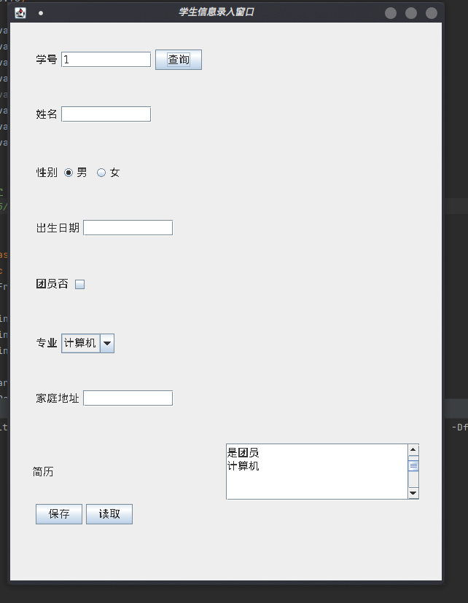

2.  
import java.io.*;  
import java.net.MalformedURLException;  
import java.net.URL;  
  
*/\*\**  
 *\** ***@author*** *liukanglai*  
 *\** ***@date*** *5/15/21 - 3:06 PM*  
 *\*/*  
public class FetchUrl {  
 public static void main(String[] args) {  
 URL url = null;  
 FileWriter fi = null;  
 InputStreamReader urli = null;  
 BufferedReader urlr = null;  
 try {  
 url = new URL("https://www.cup.edu.cn/jwc/jxjs/Ttrends/e3da1a3f369d4b47a0e020edbeb6f87f.htm");  
 fi = new FileWriter("url.txt");  
 urli = new InputStreamReader(url.openStream());  
 urlr = new BufferedReader(urli);  
 String read;  
 while ((read = urlr.readLine()) != null) {  
 fi.write(read + "\n");  
 }  
 } catch (IOException e) {  
 e.printStackTrace();  
 } finally {  
 try {  
 urlr.close();  
 } catch (IOException e) {  
 e.printStackTrace();  
 }  
 try {  
 fi.close();  
 } catch (IOException e) {  
 e.printStackTrace();  
 }  
 }  
 try {  
 urli.close();  
 } catch (IOException e) {  
 e.printStackTrace();  
 }  
 }  
}

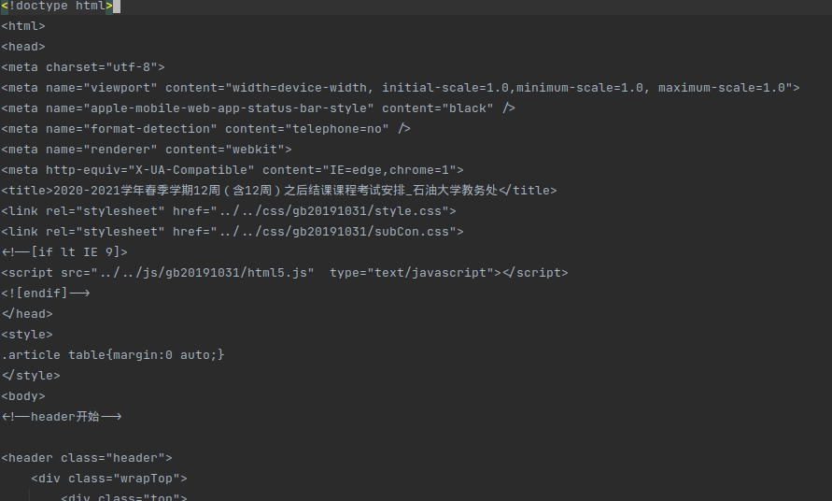

3.

Server:

import javax.swing.*;  
import java.awt.*;  
import java.awt.event.ActionEvent;  
import java.awt.event.ActionListener;  
import java.io.DataInputStream;  
import java.io.DataOutput;  
import java.io.DataOutputStream;  
import java.io.IOException;  
import java.net.ServerSocket;  
import java.net.Socket;  
  
*/\*\**  
 *\** ***@author*** *liukanglai*  
 *\** ***@date*** *5/22/21 - 9:36 AM*  
 *\*/*  
public class ChatServer {  
 public static void main(String[] args) {  
 JFrame frame = new JFrame("Server Chat");  
 frame.setLocation(500, 500);  
 frame.setSize(400, 450);  
 frame.setDefaultCloseOperation(3);  
  
 JPanel chat_panel = new JPanel(new FlowLayout());  
 Font font = new Font(null, Font.*PLAIN*, 15);  
 JTextArea chatInfo = new JTextArea(20, 25);  
 chatInfo.setFont(font);  
 chatInfo.setEditable(false);  
 chatInfo.setLineWrap(true);  
 JTextField putInfo = new JTextField(16);  
 putInfo.setFont(font);  
 JButton put = new JButton("发送");  
 put.setFont(font);  
 chat_panel.add(chatInfo);  
 chat_panel.add(putInfo);  
 chat_panel.add(put);  
 frame.setContentPane(chat_panel);  
 frame.setVisible(true);  
  
 try {  
 ServerSocket s_socket = new ServerSocket(2000);  
 Socket socket = s_socket.accept();  
 DataInputStream in = new DataInputStream(socket.getInputStream());  
 DataOutputStream out = new DataOutputStream(socket.getOutputStream());  
 out.writeUTF("我是服务器");  
 String get_client = in.readUTF();  
 chatInfo.append("服务器收到客户端：" + get_client + "\n");  
 put.addActionListener(new ActionListener() {  
 @Override  
 public void actionPerformed(ActionEvent actionEvent) {  
 try {  
 chatInfo.append("服务端：" + putInfo.getText() + "\n");  
 out.writeUTF(putInfo.getText());  
 } catch (IOException e) {  
 e.printStackTrace();  
 }  
 }  
 });  
 while(true) {  
 get_client = in.readUTF();  
 chatInfo.append("客户端：" + get_client + "\n");  
 }  
 } catch (IOException e) {  
 e.printStackTrace();  
 }  
  
 }  
}

Client:

import javax.swing.*;  
import java.awt.*;  
import java.awt.event.ActionEvent;  
import java.awt.event.ActionListener;  
import java.io.*;  
import java.net.DatagramPacket;  
import java.net.Socket;  
  
*/\*\**  
 *\** ***@author*** *liukanglai*  
 *\** ***@date*** *5/15/21 - 3:08 PM*  
 *\*/*  
public class ChatClient {  
 public static void main(String[] args) {  
 JFrame frame = new JFrame("Client Chat");  
 frame.setLocation(20, 20);  
 frame.setSize(400, 450);  
 frame.setDefaultCloseOperation(3);  
  
 JPanel chat_panel = new JPanel(new FlowLayout());  
 Font font = new Font(null, Font.*PLAIN*, 15);  
 JTextArea chatInfo = new JTextArea(20, 25);  
 chatInfo.setFont(font);  
 chatInfo.setEditable(false);  
 chatInfo.setLineWrap(true);  
 JTextField putInfo = new JTextField(16);  
 putInfo.setFont(font);  
 JButton put = new JButton("发送");  
 put.setFont(font);  
 chat_panel.add(chatInfo);  
 chat_panel.add(putInfo);  
 chat_panel.add(put);  
  
 frame.setContentPane(chat_panel);  
 frame.setVisible(true);  
 try {  
 Socket socket = new Socket("127.0.0.1", 2000);  
 DataInputStream in = new DataInputStream(socket.getInputStream());  
 DataOutputStream out = new DataOutputStream(socket.getOutputStream());  
 out.writeUTF("我是客户机");  
 String get_server = in.readUTF();  
 chatInfo.append("客户端收到服务端："+get_server + "\n");  
 put.addActionListener(new ActionListener() {  
 @Override  
 public void actionPerformed(ActionEvent actionEvent) {  
 try {  
 chatInfo.append("客户端：" + putInfo.getText() + "\n");  
 out.writeUTF(putInfo.getText());  
 } catch (IOException e) {  
 e.printStackTrace();  
 }  
 }  
 });  
 while(true) {  
 get_server = in.readUTF();  
 chatInfo.append("服务端：" + get_server + "\n");  
 }  
 } catch (IOException e) {  
 e.printStackTrace();  
 }  
  
 }  
}

