1. 6个验证节点+4个非验证节点
2. 普通模式

|  |  |  |  |  |  |  |  |  |  |  |
| --- | --- | --- | --- | --- | --- | --- | --- | --- | --- | --- |
| 发送  速率 | 时间 | 节点数 | 连接数 | Memsize | poolsize | 最大  TPS | 平均TPS | 总时间 | 总交易数量 | 情况 |
| 2000 | 60 | 1 | 1 | 10000B | 100MB | 3016 | 1309 | 55.6 | 72763 |  |
|  |  |  |  |  |  |  |  |  |  |  |
|  |  |  |  |  |  |  |  |  |  |  |

1. 主从模式

|  |  |  |  |  |  |  |  |  |  |  |  |
| --- | --- | --- | --- | --- | --- | --- | --- | --- | --- | --- | --- |
| 发送  速率 | 时间 | 节点数 | 连接数 | Memsize | poolsize | 最大  TPS | 平均TPS | 总时间 | 总交易数量 | 情况 | 发送  速率 |
| 2000 | 100 | 2 | 1 | 20000 | 100MB |  |  |  |  |  |  |
|  |  |  |  |  |  |  |  |  |  |  |  |
|  |  |  |  |  |  |  |  |  |  |  |  |
|  |  |  |  |  |  |  |  |  |  |  |  |

1. 6个节点

|  |  |  |  |  |  |  |  |  |  |  |
| --- | --- | --- | --- | --- | --- | --- | --- | --- | --- | --- |
| 发送  速率 | 时间 | 节点数 | 连接数 | Memsize | poolsize | 最大  TPS | 平均TPS | 总时间 | 总交易数量 | 情况 |
| 2000 | 60 | 1 | 1 | 10000 | 400000 | 3232 | 2095 | 42 | 88000 |  |
| 2000 | 60 | 1 | 2 | 10000 | 400000 | 3343 | 2649 | 27 | 74000 |  |
| 2000 | 60 | 1 | 2 | 20000 | 400000 | 3472 | 2196 | 52 | 116000 |  |
| 3000 | 60 | 1 | 2 | 20000 | 400000 | 3761 | 1312 | 45 | 59683 |  |
| 2000 | 60 | 1 | 2 | 20000 | 100MB | 3245 | 1696 | 40 | 68000 |  |
| 2000 | 600 | 1 | 2 | 20000 | 100MB |  |  |  |  |  |

华为云服务器4个节点

|  |  |  |  |  |  |  |  |  |  |  |
| --- | --- | --- | --- | --- | --- | --- | --- | --- | --- | --- |
| 发送  速率 | 时间 | 节点数 | 连接数 | Memsize | poolsize | 最大  TPS | 平均TPS | 总时间 | 总交易数量 | 情况 |
| 2000 | 60 | 1 | 2 | 50000 | 800000 | 9080 | 7774 | 13. | 104181 |  |
| 2000 | 60 | 1 | 2 | 50000 | 100000 | 9404 | 8524 | 22 | 188000 |  |
| 2000 | 60 | 1 | 2 | 200000 | 400000 | 8461 | 5238 | 8 | 45710 |  |
| 4000 | 60 | 1 | 2 | 40000 | 80000 | 6858 | 830 | 51 | 42657 | 01 |
| 4000 | 60 | 1 | 2 | 40000 | 800000 |  |  |  |  | 01 |
| 2000 | 60 | 1 | 2 | 40000 | 200000 |  |  |  |  | 01 |
| 2000 | 60 | 1 | 2 | 30000 | 400000 | 9172 | 5920 | 11 | 68230 |  |
| 2000 | 60 | 1 | 2 | 20000 | 400000 | 8676 | 6524 | 29 | 191056 |  |
| 2000 | 100 | 1 | 1 | 20000 | 800000 | 6469 | 4928 | 40 | 198000 |  |
| 4000 | 100 | 1 | 1 | 20000 | 800000 | 8877 | 6977 | 44 | 312684 |  |
| 6000 | 100 | 1 | 1 | 20000 | 800000 | 8908 | 7203 | 42 | 307684 |  |
| 1500 | 60 | 1 | 2 | 200000 | 400000 | 8196 | 5750 | 30 | 177000 | 正常 |
| 3000 | 60 | 1 | 2 | 200000 | 400000 | 6455 | 812 | 53 | 43447 |  |
| 2000 | 60 | 1 | 2 | 200000 | 400000 | 9837 | 5352 | 10 | 57807 |  |

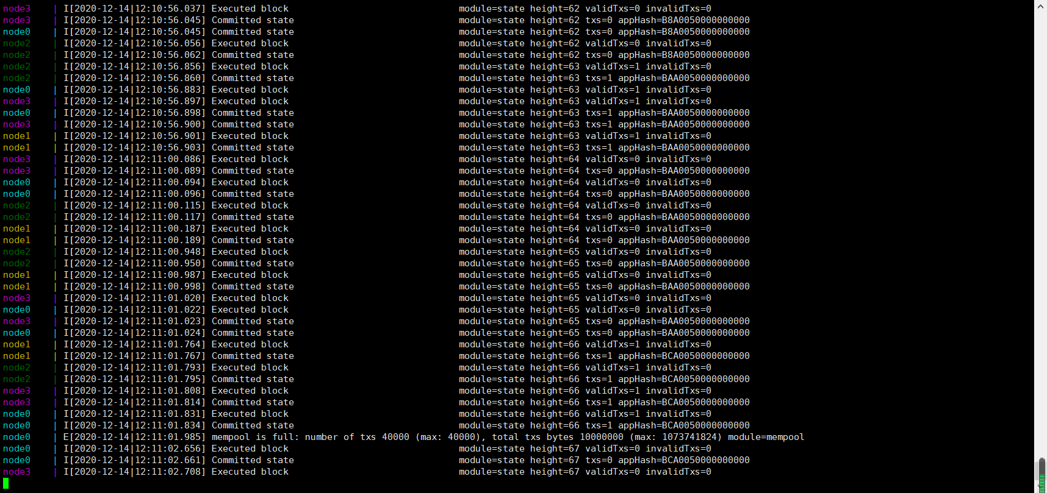

中间出现很多0

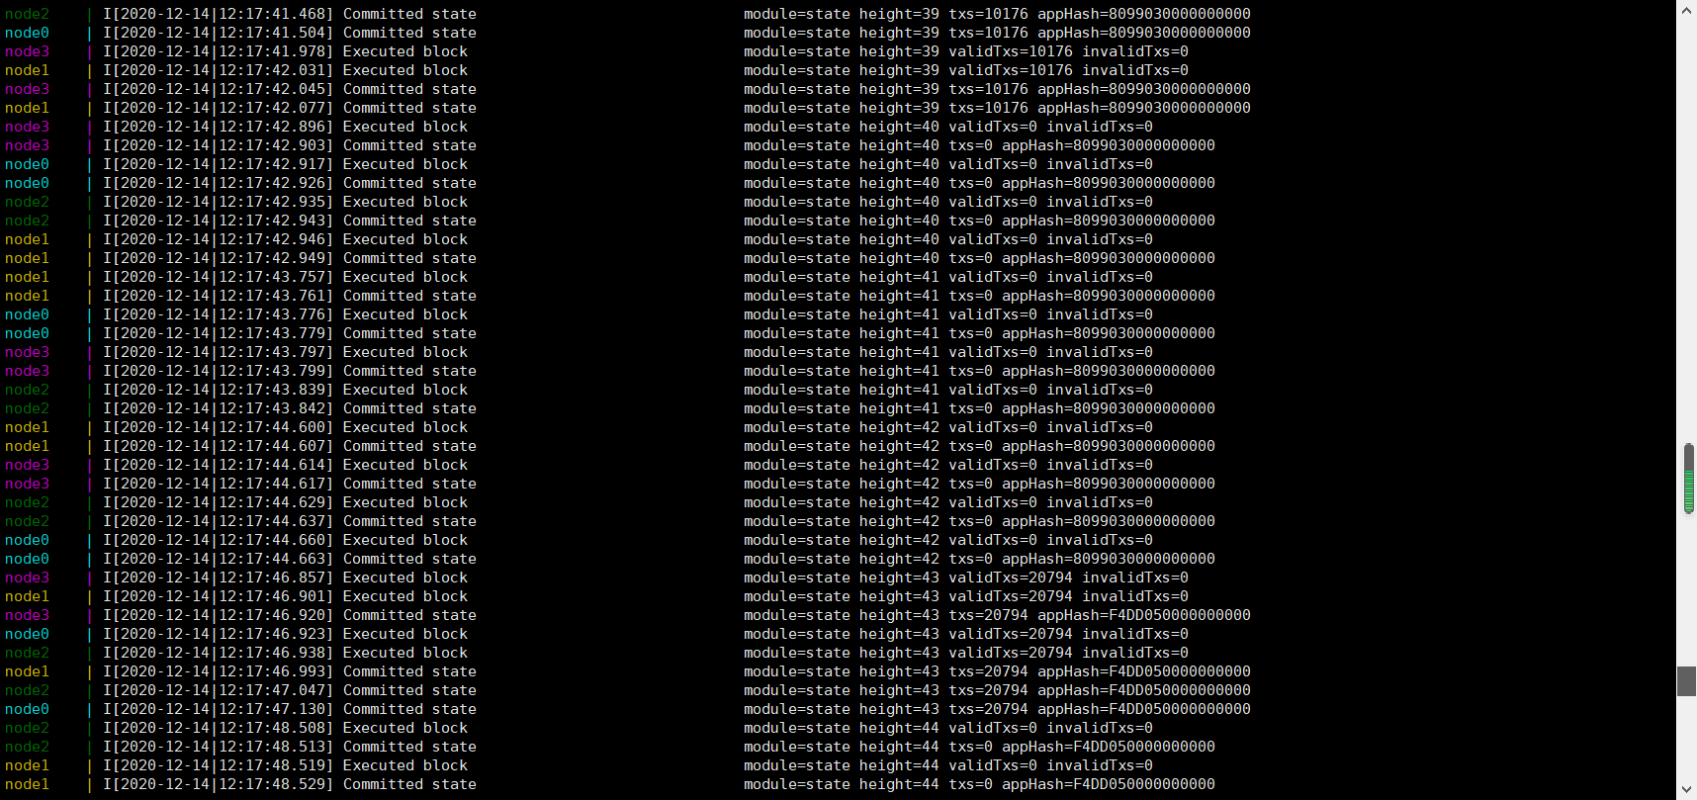

云服务器5个节点

|  |  |  |  |  |  |  |  |  |  |  |  |
| --- | --- | --- | --- | --- | --- | --- | --- | --- | --- | --- | --- |
| 发送  速率 | 时间 | 节点数 | 连接数 | size | Memsize | poolsize | 最大  TPS | 平均TPS | 总时间 | 总交易数量 | 情况 |
|  |  |  |  |  |  |  |  |  |  |  |  |
| 2000 | 60 | 1 | 2 | 250 | 50000 | 400000 | 6058 | 2869 | 35 | 102077 |  |
| 2000 | 60 | 1 | 2 | 250 | 200000 | 400000 |  |  |  | i/o |  |
| 2000 | 60 | 1 | 2 | 250 | 50000 | 400000 |  |  |  |  |  |
| 2000 | 60 | 1 | 2 | 100 | 30000 | 500000 | 9216 | 4252 | 22 | 96682 |  |
| 2000 | 60 | 1 | 2 | 100 | 30000 | 500000 | 9428 | 6829 | 23 | 163495 |  |
| 2000 | 60 | 1 | 2 | 100 | 30000 | 500000 | 9765 | 6373 | 21 | 135728 |  |