4个节点：

|  |  |  |  |  |  |  |  |
| --- | --- | --- | --- | --- | --- | --- | --- |
| 发送交易速率 | 持续  时间(s) | 大小  (B) | Mempool  size | mempool  cach e_size | 平均TPS | 最大TPS | 总处理交易 |
| 3000 | 10 | 250 | 10000 | 20000 | 1251.271 | 1454.898 | 16000 |
| 5000 | 10 | 250 | 10000 | 20000 | 1933.247 | 2920.085 | 37215 |
| 8000 | 10 | 250 | 10000 | 20000 | 1315.876 | 2551.834 | 20000 |
| 10000 | 10 | 250 | 10000 | 20000 | 2910.784 | 2915.452 | 20000 |
| 3000 | 10 | 250 | 40000 | 80000 | 865.301 | 2524.190 | 27000 |
| 5000 | 10 | 250 | 40000 | 80000 | 2031.766 | 2216.312 | 14903 |
| 8000 | 10 | 250 | 40000 | 80000 | 1667.319 | 2192.982 | 11076 |
| 10000 | 10 | 250 | 40000 | 80000 | 2007.495 | 2152.389 | 15000 |

当内存池和缓存大小分别设置为100000、200000时，在进行tm-load-test测试时会直接退出，信息如下：

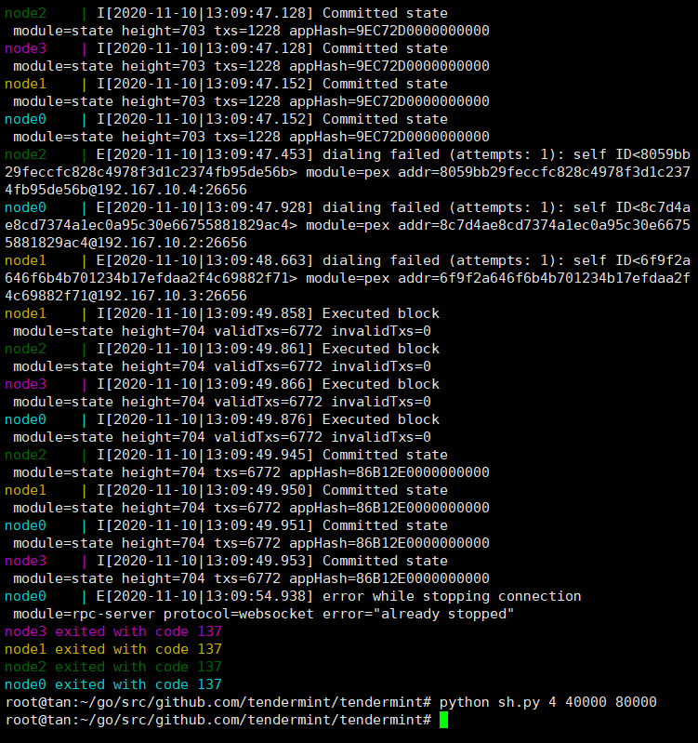

华为云服务器（4个节点）：

|  |  |  |  |  |  |  |  |
| --- | --- | --- | --- | --- | --- | --- | --- |
| 发送交易速率 | 持续时间(s) | 大小(B) | Mempool_size | mempool.cach e_size | 平均TPS | 最大TPS | 总处理交易 |
| 10000 | 10 | 250 | 100000 | 200000 | 8072 | 8383 | 90000 |
| 10500 | 10 | 250 | 100000 | 200000 | 6021 | 6773 | 94500 |
| 10800 | 10 | 250 | 100000 | 200000 | 5518 | 8330 | 97200 |
| 11000 | 10 | 250 | 100000 | 200000 | 5691 | 6273 | 99000 |
| 10500 | 10 | 250 | 80000 | 160000 | 5723 | 7004 | 94500 |
| 10500 | 10 | 250 | 150000 | 300000 | 4167 | 8275 | 94500 |
|  |  |  |  |  |  |  |  |
|  |  |  |  |  |  |  |  |