Equant Works User Guide
(2026)
Preface: Product Overview
Equant Works is a next-generation document management platform focusing on content enhancement and engineering workflows. Unlike traditional office software, Equant Works is designed to complement existing tools while providing specialized depth for industry scenarios. It features built-in construction estimation templates designed to significantly improve calculation efficiency.

Key Features：
1. Unified Resource Explorer: View folders and documents simultaneously for quick access. Toggle between "Detail" and "Compact" modes to inspect document attributes easily.
2. Tabbed Multi-View Interface: Supports Split-View (Side-by-Side or Stacked) for easy cross-referencing and comparison.
3. Lightweight Document Engine: Built-in viewers for Office, PDF, DWG, and image files with basic editing capabilities. It also supports embedding MS Office, LibreOffice, and AutoCAD for full editing.
4. Auto-Backup & Recovery: Automatic document backup with version history and restore points.
5. Custom Properties (Metadata): Define custom attributes for folders/nodes to facilitate fast searching. These properties can serve as variables within documents—updating a property value in the panel automatically updates the referenced text in the document.
6. Formula Auditing: Dynamically analyze cell references and dependencies. Trace which formulas reference a specific cell for complete data transparency.
7. Column-Level Formula Automation: Pre-set formulas for entire columns. Formulas are automatically generated when editing, eliminating the need for manual copy-pasting.
8. Automated Subtotals: Built-in logic for sectional statistics, tailored for construction cost estimation workflows.
9. CAD/PDF Data Linkage: Extract quantity data directly from .dwg or .pdf drawings into spreadsheets. Modifying the drawing entity automatically updates the spreadsheet. Includes bi-directional tracing to locate drawing entities from spreadsheet data.
10、Built-in Estimation Templates: Includes standard templates such as Takeoff Sheets and Bill of Quantities (BOQ) for rapid project setup.

I. Basic Functions（Free version）
1．Interface Overview
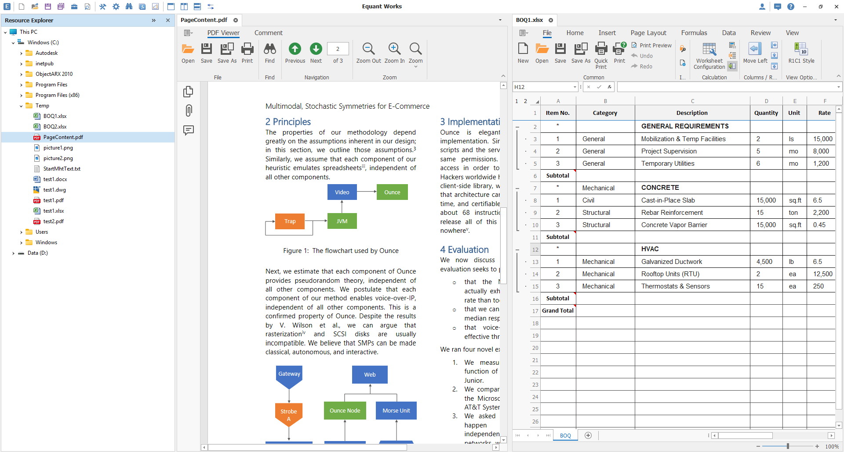
The main toolbar is located at the top to maximize workspace. Standard functions are on the left, while system buttons (Account, Help) are on the right.

2．General Options
Click the Options button() to open the preferences dialog：
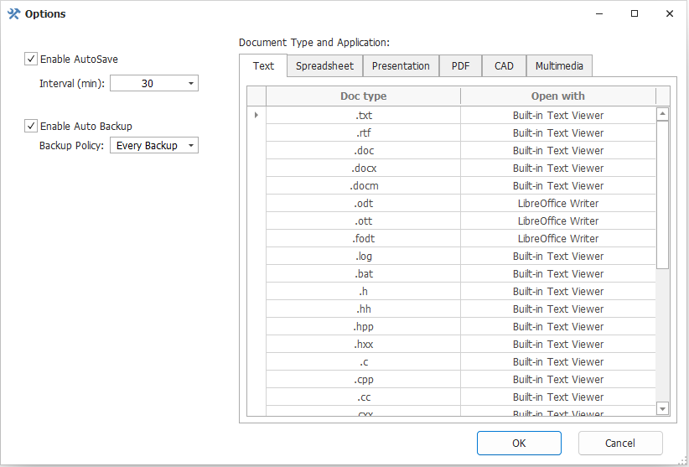
AutoSave: Toggle automatic saving and set the interval (in minutes).
Default Applications: In the right-hand tab, configure which application opens specific file types.
Built-in Viewer: Lightweight, no third-party software required (supports Office, PDF, CAD).
External App: You can also set specific files to open with external apps via the "Open with" context menu in the Resource Explorer.

3．Resource Explorer
The panel defaults to "This PC", showing all drives and folders. The default is the compact mode.
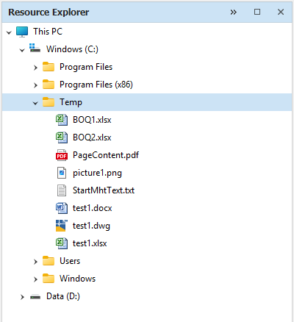

View Modes: Click to switch to details mode or to return to compact mode.
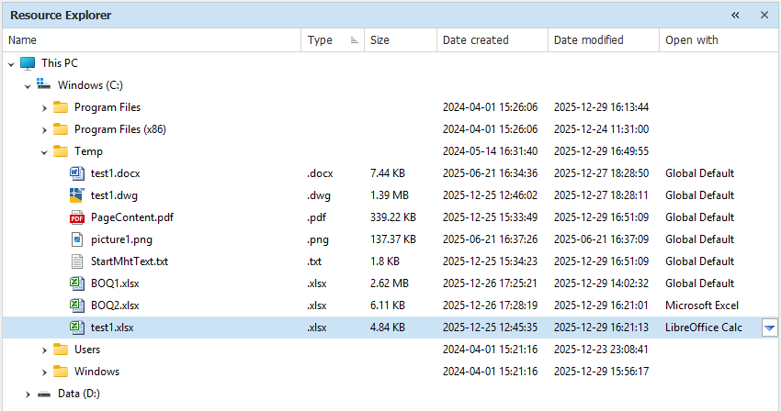
Context Menu: Right-click a file for options like "Show in Explorer" or "Properties." Hold Ctrl + Right-click to access the native Windows system menu.

4．Document Viewing & Layouts
Double-click a file or select "Open Document" to view. Manage multiple documents with the following layout controls:
Side-by-Side View(): Arranges documents vertically (left/right).
Stacked View(): Arranges documents horizontally (top/bottom).
Reset Layout(): Returns to the default tabbed view.
Swap Panes(): Swaps the position of the document groups.
Note: The software remembers your last reading position.

5．Custom Properties (Metadata)
5.1 Editing custom attributes
Access the panel via the Properties button().
Hierarchy: Properties under "Parent Node" are inherited from the folder structure. Properties under "Current Node" apply only to the selected file.
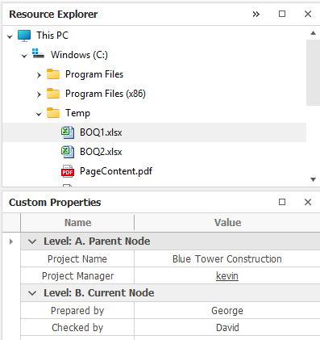

5.2 Application of custom attributes
A、Search: Use properties as search filters.
B、Variables (Pro): Inject properties into Word/Excel documents as variables. Changing the value in the panel updates the document content instantly.
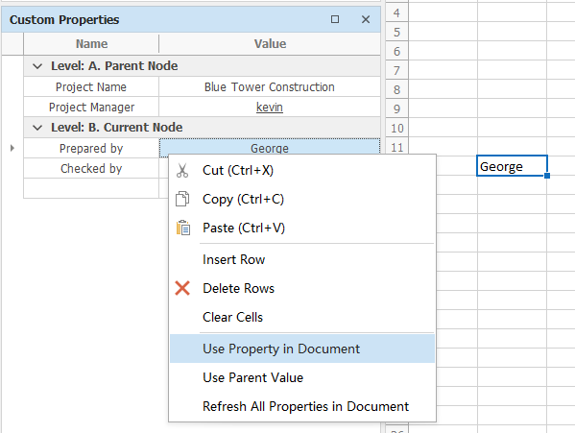

6．Backup & Recovery
Click the Backup History button ()to view saved versions. Select a timestamp and click "Restore" to revert to that version.
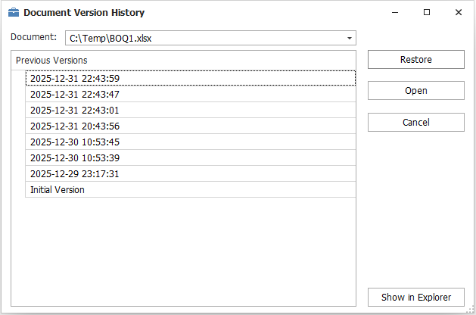

7．Search
Click the Search button to open the search panel.
Folder: Search by Current Folder/ Root Folder.
File Type: Types of documents to search.
Search in: Which attributes of a document are searched, such as the document name and custom attributes, The default is to search the entire text.
Keywords: Supports standard text or Regular Expressions (Regex).

The following is an example of search results; double-click to open the document:
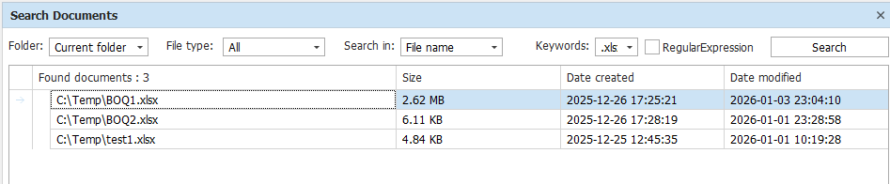

8．Formula Analysis
Click the Formula Analysis button()to open the Analysis pane. The software will automatically display the formula's reference data. If there are nested references, the analysis panel will display the relevant references hierarchically.

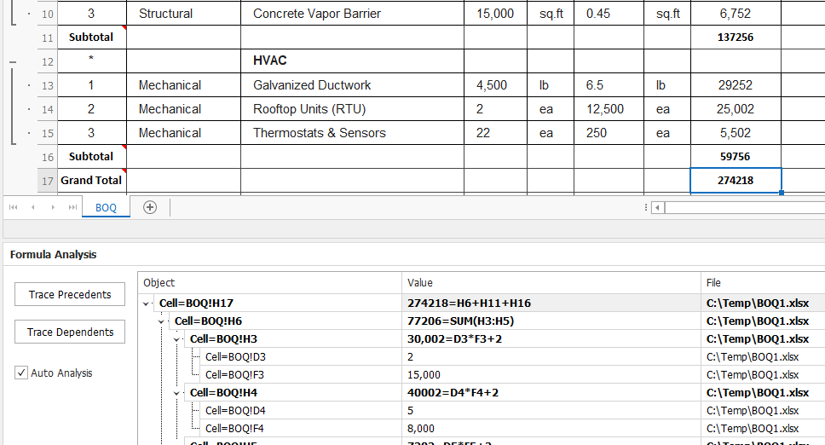

Trace Precedents: Shows which cells the current formula refers to (supports nested levels).
Trace Dependents: Shows which other formulas reference the selected cell.
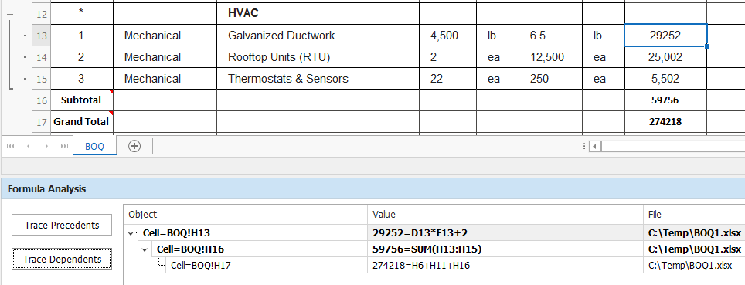
Navigation: Clicking a node in the analysis pane jumps directly to that cell.

II. Advanced Functions（Professional version）
1．New Project:Click the New button(). A "Project" corresponds to a physical folder on your drive. You can then right-click on the node in the resource panel to create a new subfolder or document.
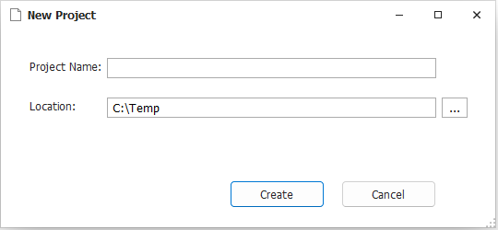

2．Open Project:Click Open button ().
You can select any folder to open as a project. 'This PC' is equivalent to a special project.
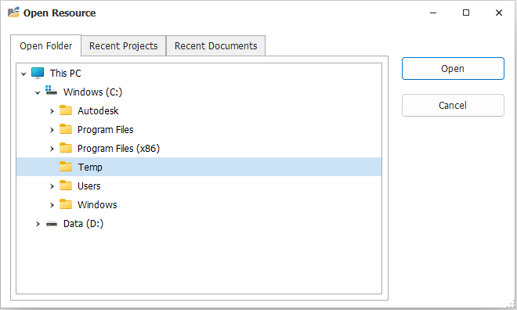
3．Creating Documents & Templates
Right-click in the Resource Explorer to select New Folder or New Document.
Blank Document: Creates an empty file.
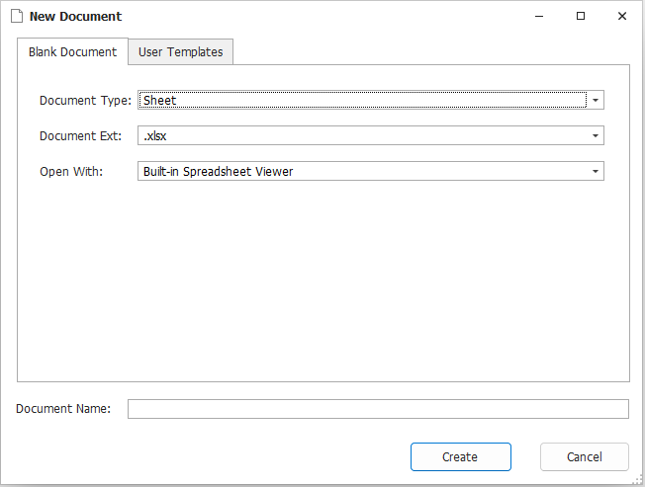
User Templates: Choose from pre-loaded construction templates (e.g., General Takeoff.xlsx, BOQ.xlsx).
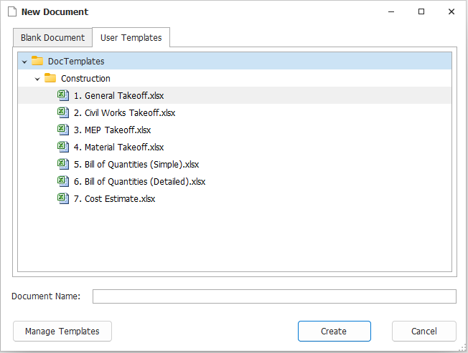
Click "Manage Templates" to add your own standard forms.
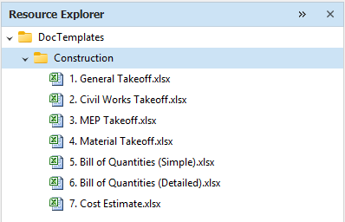

4．Spreadsheet Configuration (Smart Columns)
Go to Ribbon -> File -> Worksheet Configuration.
Data Validation Tab: Define dropdown lists for specific columns (e.g., Units: m, m², kg, ton).
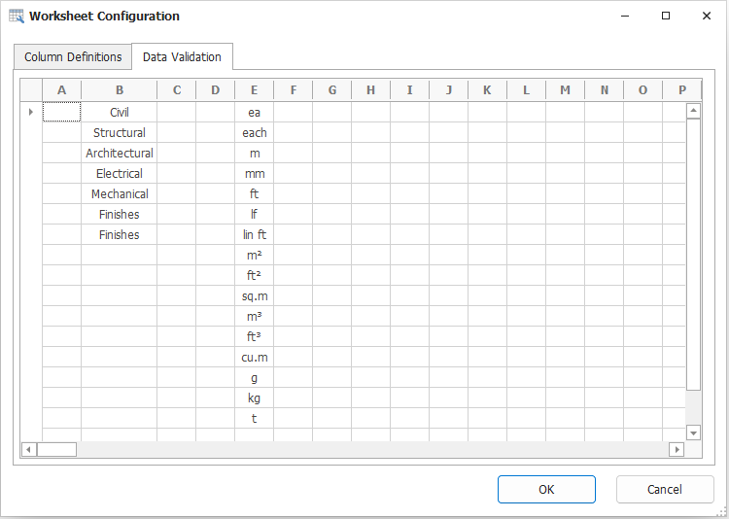

Column Definitions Tab: Set up calculation logic.
Visible / Total: Toggle column visibility or enable automatic sub-totaling.

Formula: Define the back-end formula using column letters (e.g., =D*F+2). When you enter data in the sheet, the formula is applied automatically to that row, ensuring consistency and reducing errors.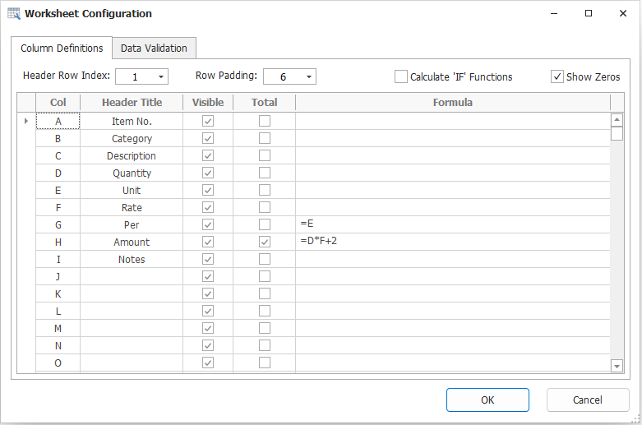

The software will automatically generate the formula for the current row based on the formula settings in the background. This method achieves formula standardization (by pre-setting a template table) and avoids the errors that can easily occur when manually copying formulas. 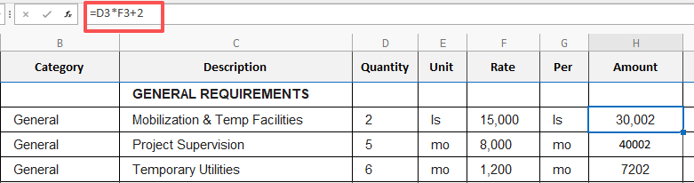

5．Grouping & Totals
Define Section: Enter an asterisk * in the first column to mark a section header row.

Generate Totals:
Method A: Right-click a row -> Set as Subtotal Row. This will generate a summary formula for that row.
Method B: Ribbon -> File -> Update Totals to batch-calculate all section summaries.
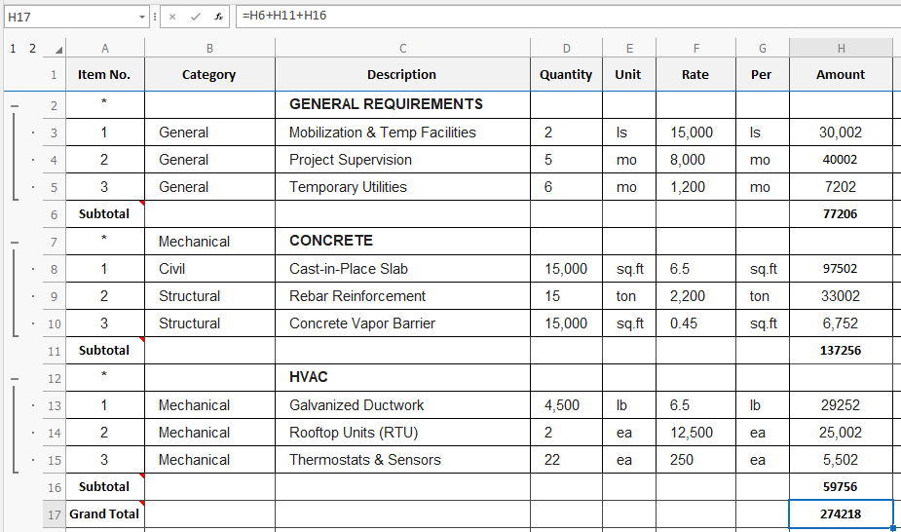

6．CAD Takeoff & Measurement
The built-in CAD Viewer includes a specialized Calculation Toolbar for engineering takeoff. It supports both .dwg and vector .pdf files.
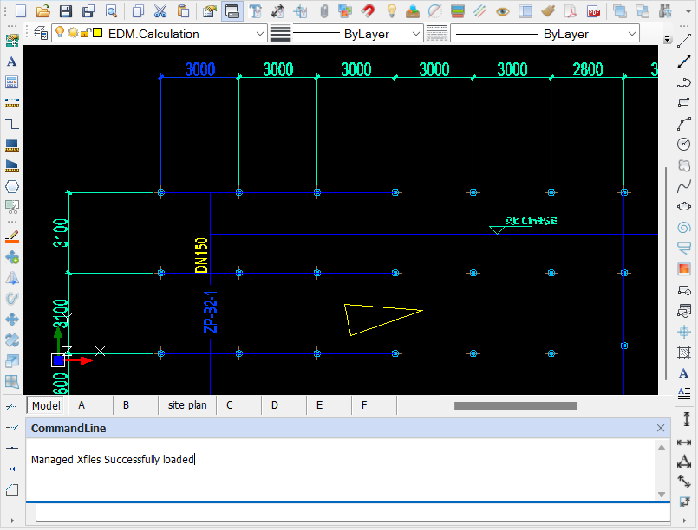

For drawings in .pdf format, right-click on the document node and select the menu->Open With-》Built-in CAD Viewer
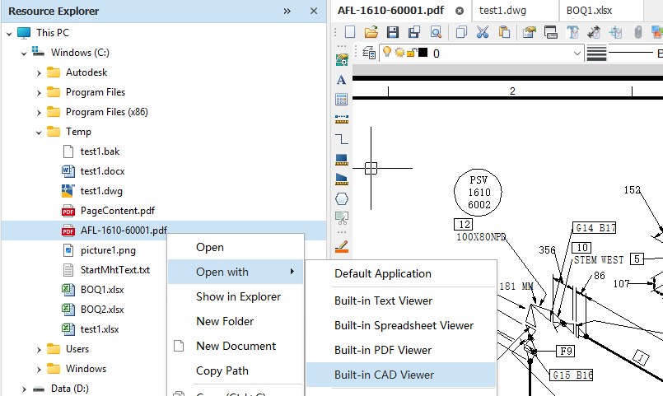

6.1 Calculation Settings
Click the Settings button()to configure:
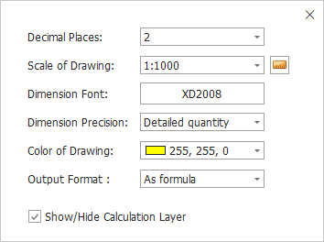
Scale: Set the drawing scale (e.g., 1:100, 1:1000).
Output Format: Choose whether extracted data enters the spreadsheet as a static value or a formula.

6.2 Extract Text
Click to select text labels on the drawing (e.g., "DN150") and send them to the adjacent spreadsheet cell. 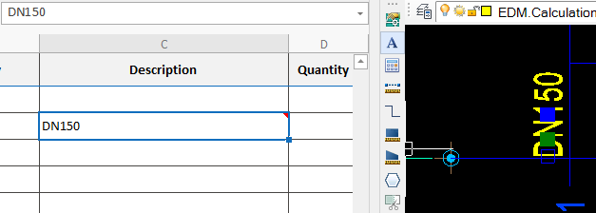

6.3 Count Items
Click to tally selected entities.

6.4 Distance Takeoff (Line/Polyline)
Manual: Click to draw/trace lines; the length is calculated upon completion.
Auto: Click to batch-extract lengths from selected existing lines.

6.5 Area Takeoff
Manual: Click or to define a polygon area.
Auto: Click to extract the area of a selected closed shape (e.g., a hatch or polygon).

6.6 Capture Snapshot
Click to screenshot a detail and paste it into the adjacent document.

7．Entity Auditing (Bi-directional Linking)
Click the Trace Entity button ，Select a spreadsheet cell containing CAD data. The panel will list the linked entity ID.
Clicking the entity ID automatically zooms and pans the CAD view to highlight the specific entity, facilitating audit trails.
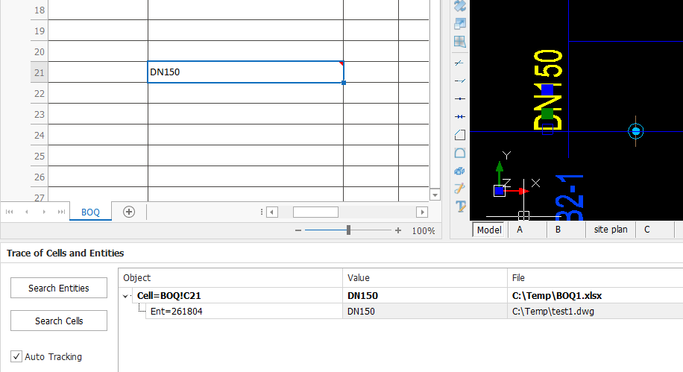

8．AI Assistant
Right-click within any Text, Spreadsheet, or PDF document and select AI Assistant., You can then enter the AI ​​interactive interface.
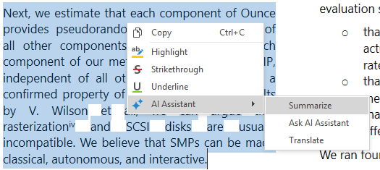

For example, clicking "Summarize" will bring up a summary window.
