Sustainable House

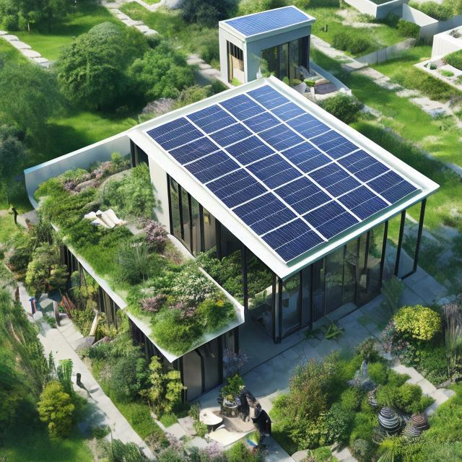

Table of Contents
1. Abstract 2
2. Introduction 2
3. Process of development 2
4. Conclusion and discussion 8
5. Appendix: 9

1. Abstract
This report will discuss the overall developing process of our chosen BIM project----Sustainable house, with explanation of Dynamo codes and related information of parametric modelling. The reason of determination of the designed project and possible methods to reduce the manual errors also included. BIM has many advantages but there are still some possible limitations, which will be highlighted in this report. In general, parametric modeling has a good future prospect, supporting people to complete complex and repetitive tasks.

2. Introduction
Since the industrial revolutions, people’s lives have been highly dependent on fossil fuels as the source of energy. The demand for energy is leading to several problems, including increasing concentration of greenhouse gases, causing climate change happening around the globe. As people’s lives get better, the population increases, more lands are occupied by buildings, leading to many adverse effects of unsustainable development. In addition, oil reserves continue to decrease. The rise of the sea level, glacial melting, and energy crisis remind us to use other environmentally friendly energy for sustainable development.
We think if we can combine nature and human development together, making our life more sustainable, it may bring more advantages to both humans and other creatures. Thus, under this circumstance, we developed the idea of a "Sustainable House".
In our journey to promote sustainability and reduce environmental impact, we thoroughly explored different building designs and strategies to make buildings more energy-efficient and reduce carbon emissions. Through rigorous research and analysis, we dug into innovative methods and technologies promoting sustainable living. This involved studying the integration of renewable energy sources such as solar panels, implementing roof gardens in unused roof spaces, and putting transparent solar panels in windows to maximise energy generation while maintaining aesthetics. Additionally, we focused on utilising advanced insulating materials to minimize heat loss and improve thermal comfort, alongside the adoption of a newly developed sewage treatment system to ensure efficient waste management and resource conservation. Through teamwork and considering every aspect of our design, our vision turned into a model. This model not only shows the architectural structure but also the strategic approach to implementing sustainable technologies. By using Revit and Dynamo, we meticulously executed and showcased the functionality and benefits of each component, encouraging a sustainable society for generations to come.

3. Process of development
Overall, the house is divided into 3 main sections during the development: walls, roofs and specific components such as doors and windows. With the advantages of parametric modelling using Dynamo, the house can vary in size and shape.
By using the architectural properties of AutoCAD Revit, designers can model a house from the floor plane to a detailed 3D design that can be built.
3.1 Wall
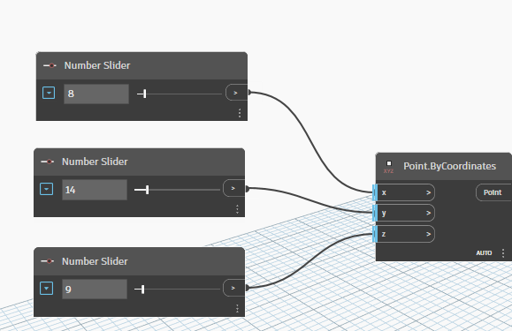
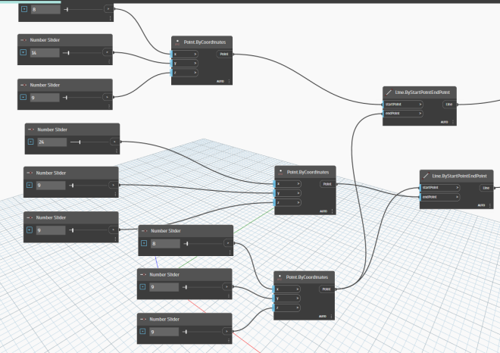
Figure1. creating coordinates for walls and joined them together to form basic lines
Multiple walls are built to form the house's structure within the Dynamo environment. Each wall is created by specifying its starting point which is done by using "Point.ByCoordinates" node. These nodes can be joined together form lines, which can form a basic floor plane for the house.

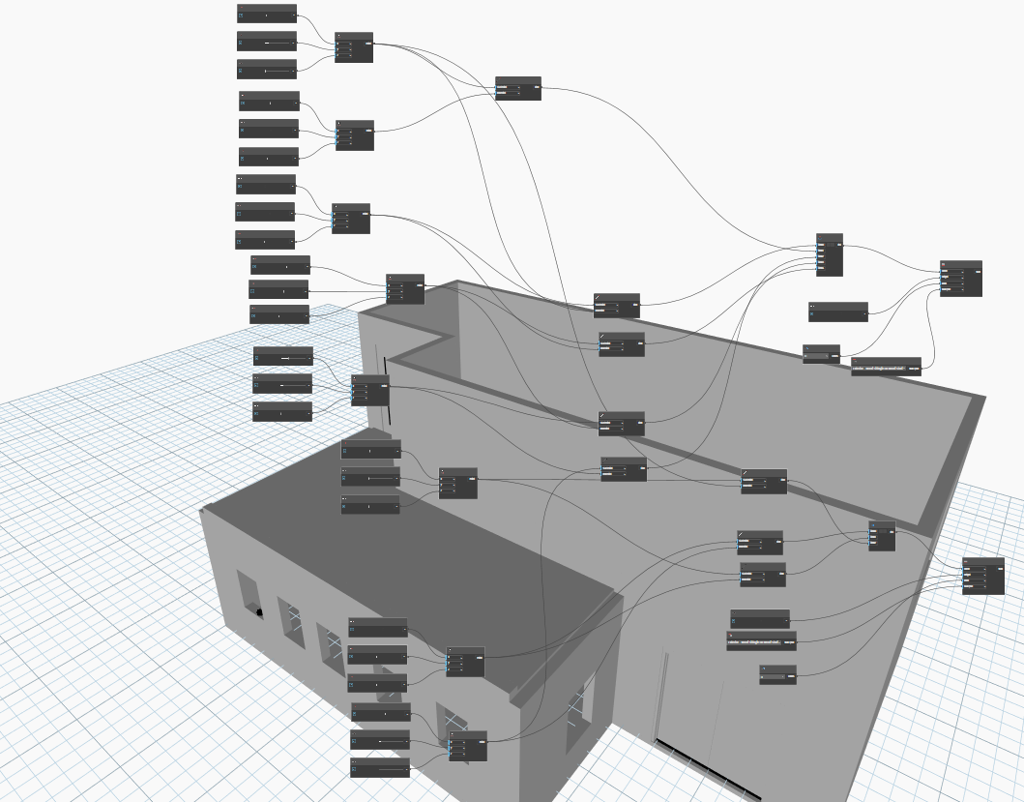
Figure2. Join lines together with list and use WallByCurveandHeight
Subsequently, parameters defining the wall's characteristics, including length, height, thickness, and other properties, are determined using a combination of “Number” nodes and “Number Slider”. The ”WallByCurveandHeight” is used to create walls with functions of chosen levels, adjust height and types.

.

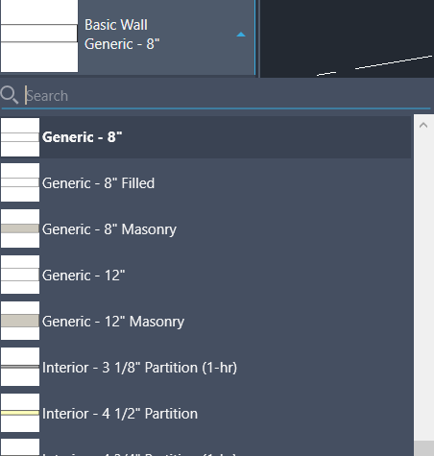
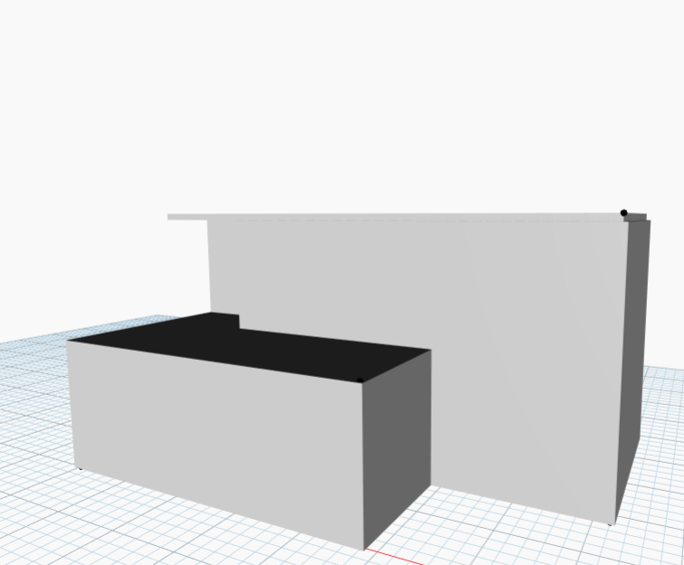
Figure3. different wall types in Revit Dynamo. Additionally, nodes such as "Level" and "WallType" are used to specify the appropriate level and wall type to be utilized. This approachis used to create walls.

3.2 Adding components
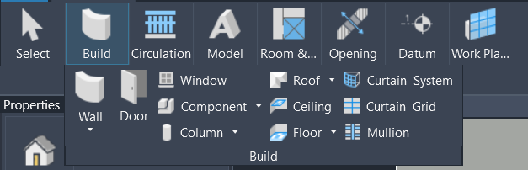
Figure4. Component panels in Revit.
After creating walls, components such as windows and doors are added into them using Dynamo nodes. To add doors and windows, nodes are employed to select the wall where the component will be placed and its precise location. The "AllElementsOfCategory" node is utilized to specify the category from the Revit model, while the "Categories" node is used to pinpoint the specific component type. Then, the "Element.Geometry" node extracts the geometric representation of the chosen element from the Revit model. This process ensures the seamless addition of components to walls in the Revit environment

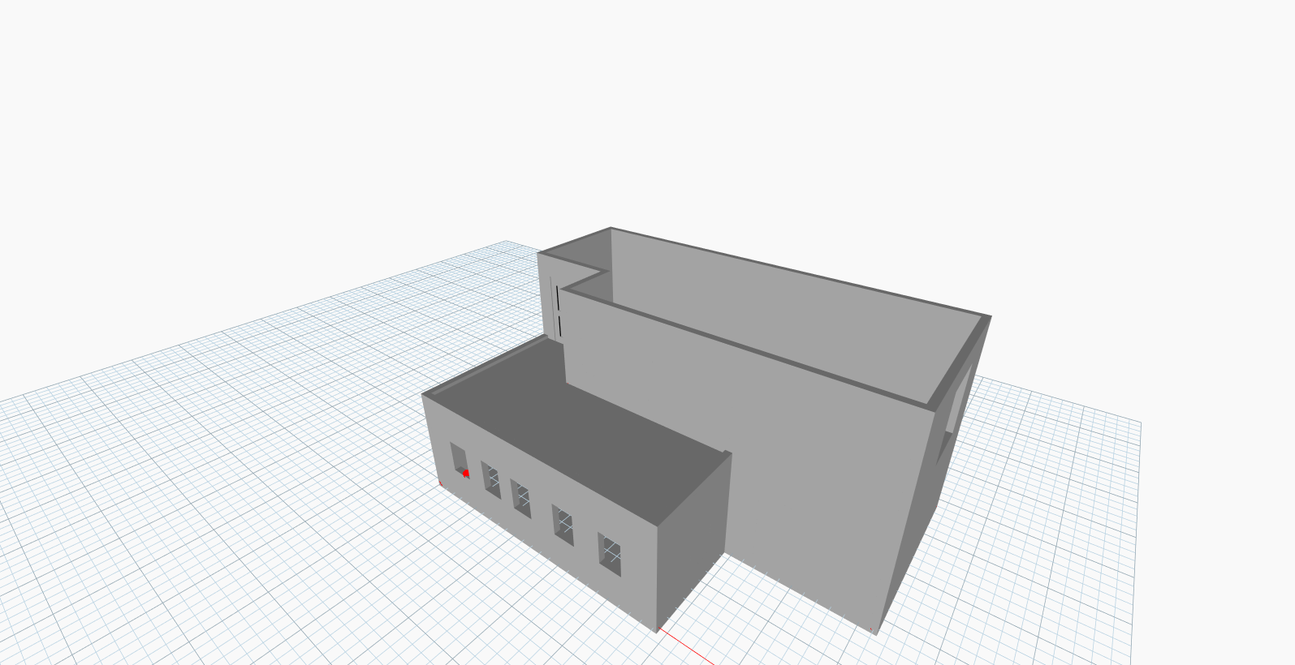Figure5. Model after addition of components.
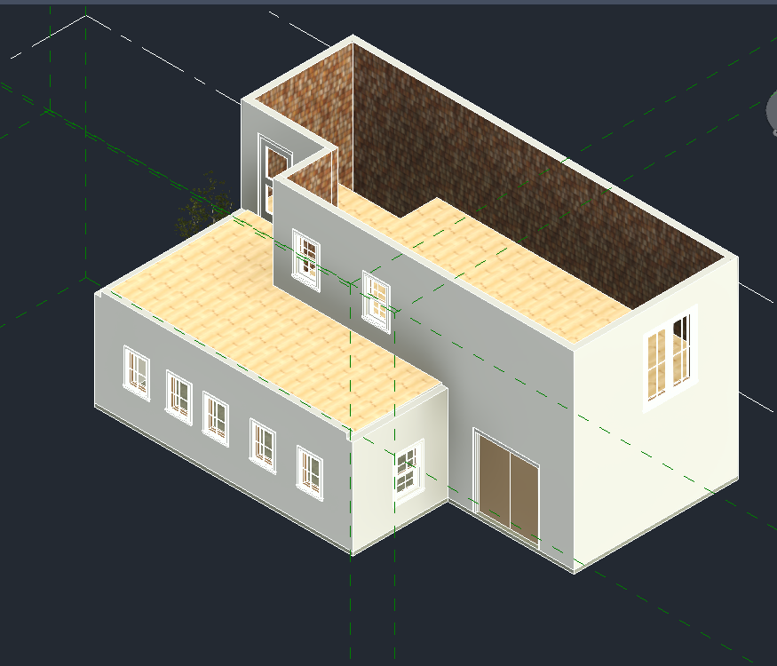
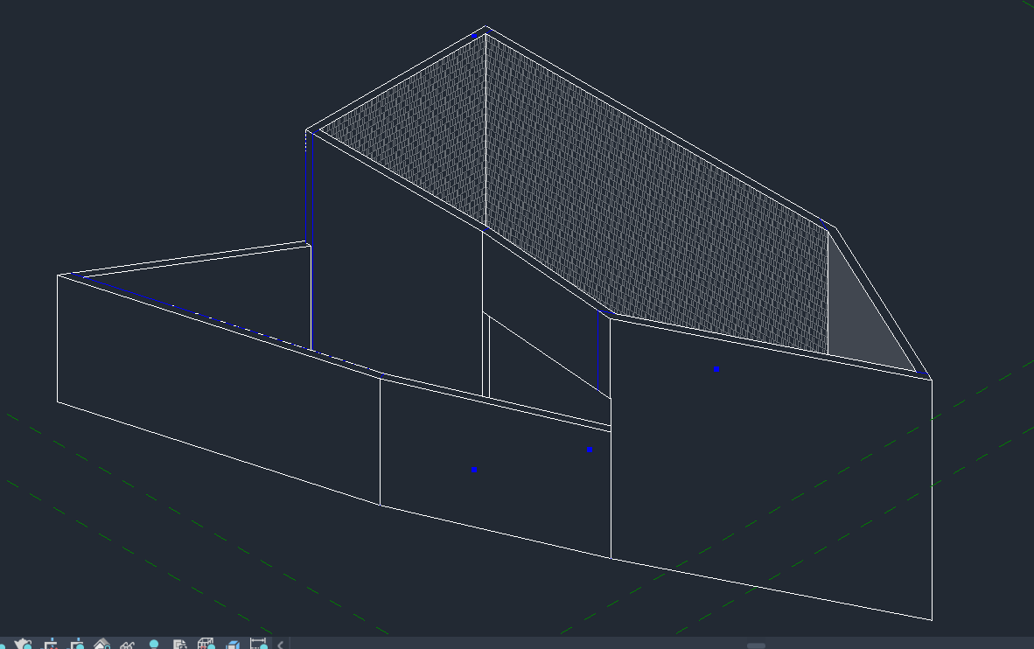
Figure 6 & 7 Complete model of the project in Revit.

3.3 Roof
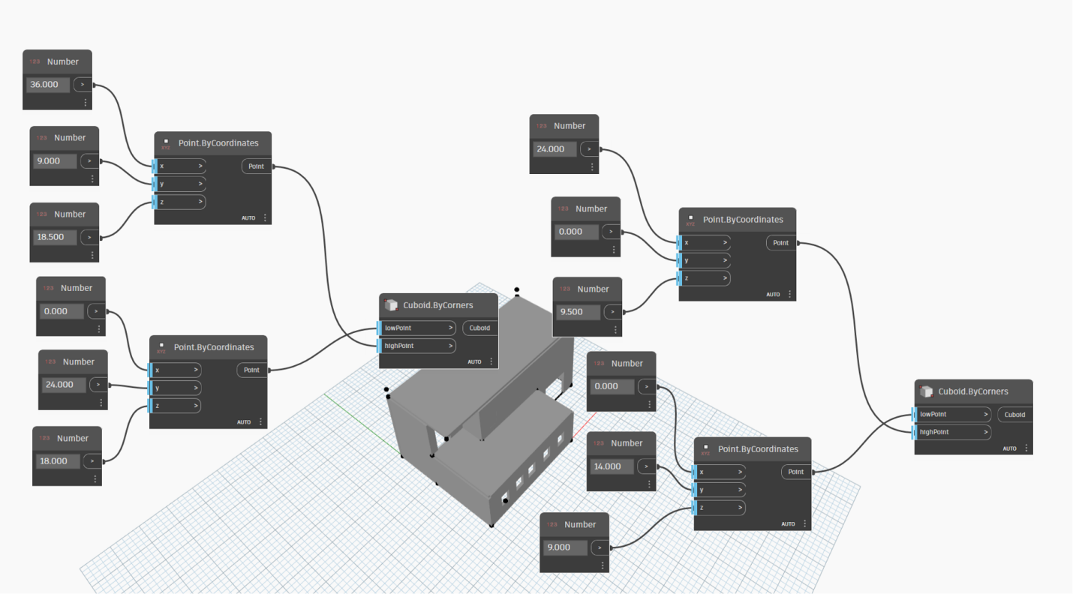Figure8. creating simple roofs in Revit Dynamo.
In the process of designing a roof in Dynamo, several nodes are used to define its characteristics and structure. Number nodes are used for parameters such as the pitch, slope, or height of the roof, allowing for precise adjustments to meet design requirements. Additionally, the "Point.ByCoordinates" nodes are used to create points representing the corners or key points of the roof outline, defining its shape and dimensions. To establish the basic framework of the roof, the "Cuboid.ByCorners" nodes are used, enabling the creation of an initial roof structure.
3.4 Parametric modeling
To achieve the goal of parametric modeling, the constructure should be modified easily by changing the size. The “Number Slider” is used to change the coordinates of the points. Then the length, width and height of walls, floors and roofs can all be varied due to the change of the base points. Slide the button and houses of different sizes can be created (As seen in the appendix, we build 4 different models). Finally, the goal is accomplished.
3.5 Model in Dynamo
Since the code in Dynamo can only let the model be shown in Revit, some specific functions can be used to let the model be shown in the Dynamo file. The “All element of Category”, “Element.Geometry”and “Categories” are used for showing up the model in Dynamo. Different components can be chosen to be shown, creating advantages for designers to perform parametric modelling.
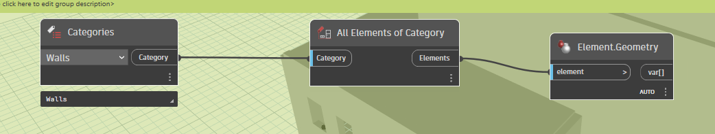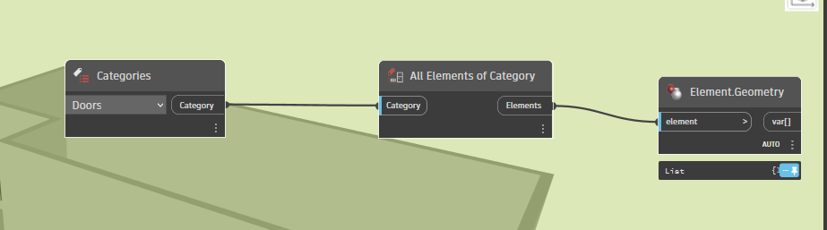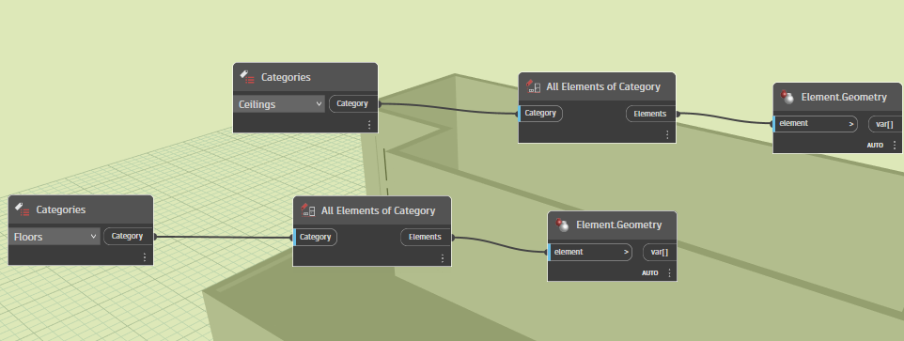Figure 9,10,11. Codes for the model in Dynamo
3.6 Methods to reduce human errors
The nodes in the dynamo are difficult to control. By testing different numbers and adjusting the position of coordinates, the location of coordinates can be determined, reducing the source of errors. Adding components sometimes may create errors, which should be tested several times.

4. Conclusion and discussion
BIM, Building Information Modelling, involves creating data about a building throughout the process of making the structure.(Azhar et al.,2015) Using BIM speeds up the design and construction process using three-dimensional building modelling software. For example, BIM is used in the dynamo to create the coordinates of some points and then use these points to build lines, walls or roofs.
The technique of parametric modelling is often used in the BIM process. Parametric modelling is used by interpreting objects with the help of dimensions, angles, materials, etc. and by creating relationships between parameters and elements, which can determine how a change to one parameter can affect the other parameters. This technique leaves no room for human error. Even a tiny mistake may result in complete disorder of the whole design. This is because of the property of parametric modeling. Every structure is based on the points confirmed at the beginning of the design. If the coordinates of the points have problems, then the consequent steps will go wrong.
In general, parametric modelling can increase the work efficiency and accuracy of the project, allowing people to construct complex models effectively. In the past people needed to do shield measurement to certain the size of the building. However, with parametric modeling, it can be done simply by using software on the computer. It also provides automation and optimization to facilitate project development. There are “wall, roof, window" functions in the parametric modeling software. These elements can be easily built by using these functions. However, everything has two sides. Parametric modeling requires people to spend more time mastering technical skills about how to use the software, which needs a period of systematic studying. What’s more, the system may also create potential errors. Due to the low fault tolerance, a small mistake will lead to huge disaster and is hard to find out. Moreover, the limitation in flexibility can lead to an unsuccessful product, resulting in a faulty design.
In the future, parametric modelling can be more beneficial than ever. With the rapid development of technology, there will be more functions in parametric modeling which can be easily used. After designing the external building, the detailed internal structure can be also designed. By using it, we can quantify the architecture's size and details, which will undoubtedly benefit the consequent construction. (Barlish & Sullivan,2012) On the construction site, AI can understand the file easily and it contains every data it needs to build a building. Efficiency can be improved. It can have a significant impact on reality. When we get there, not only can we design a simple building but also draw a blueprint for a city or even a country. The drain system and traffic system can all be designed by parametric modeling, which will speed up the development of the world.

5. Appendix:

5.1 Citations
Azhar, S., Khalfan, M., & Maqsood, T. (2015). Building information modelling (BIM): Now and beyond. Construction Economics and Building, 12(4), 15-28. https://doi.org/10.5130/ajceb.v12i4.3032

Barlish, K., & Sullivan, K. (2012). How to measure the benefits of BIM — A case study approach. Automation in Construction, 24, 149-159. https://doi.org/10.1016/j.autcon.2012.02.008

5.2 Final models
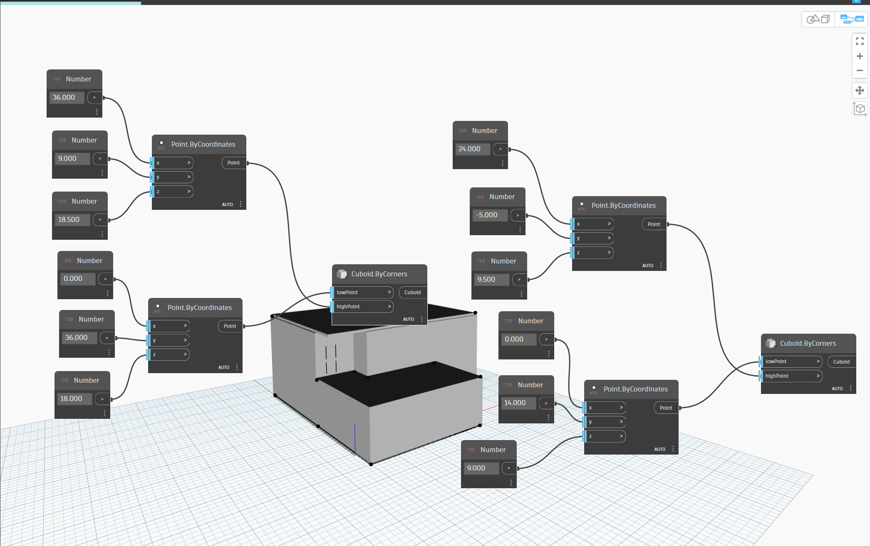
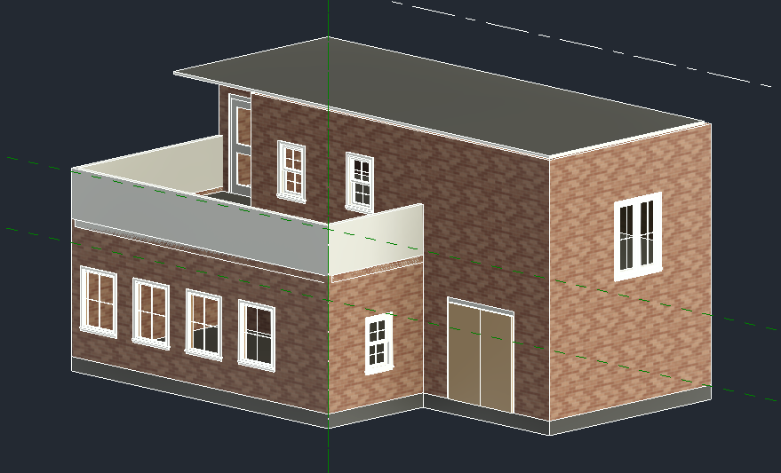

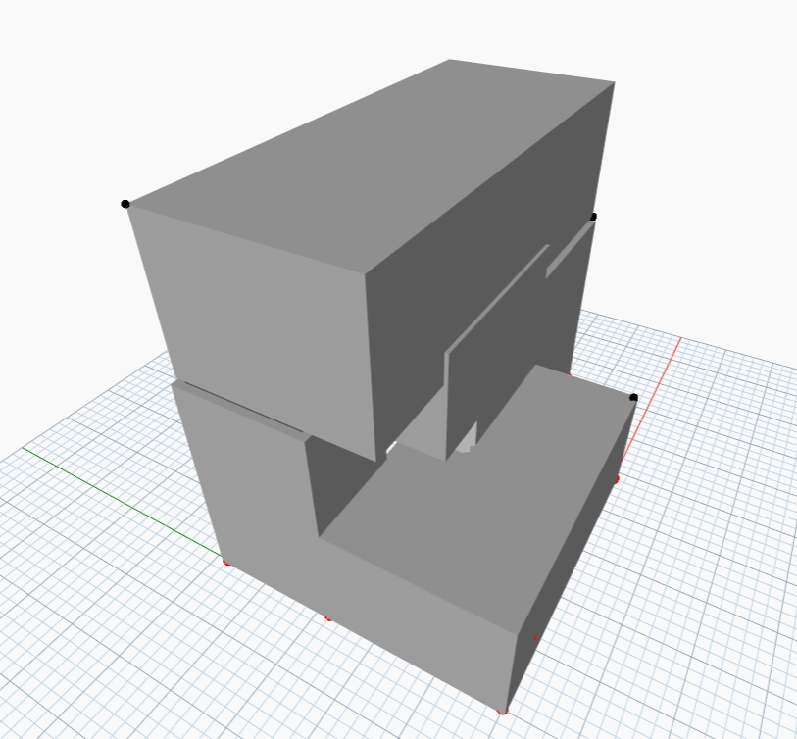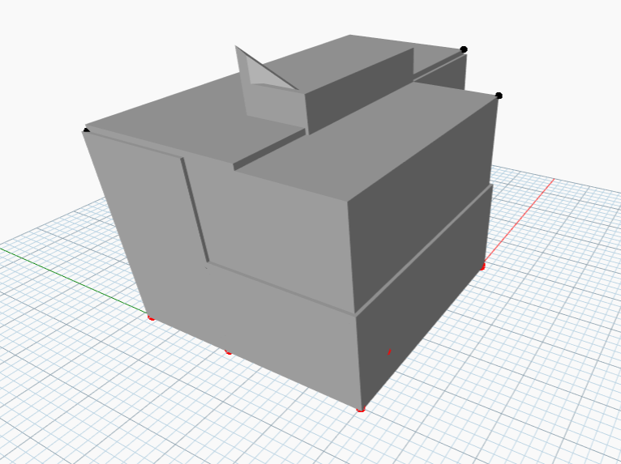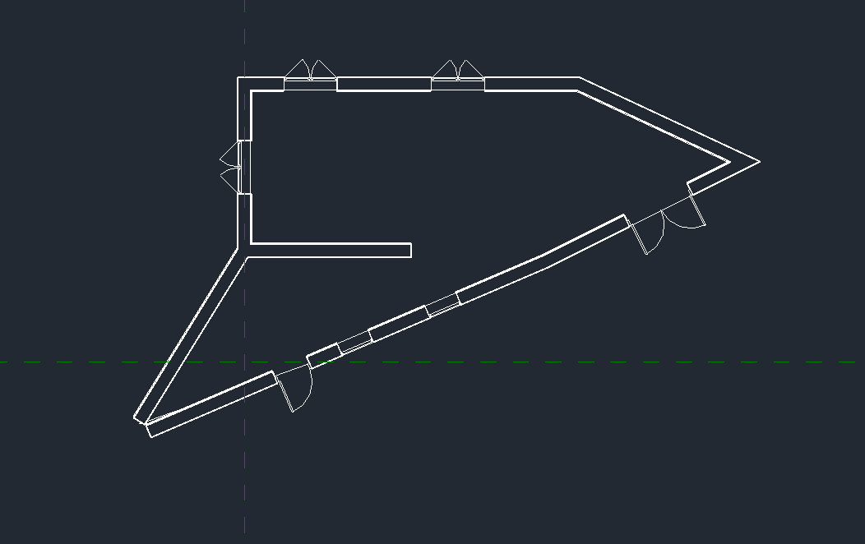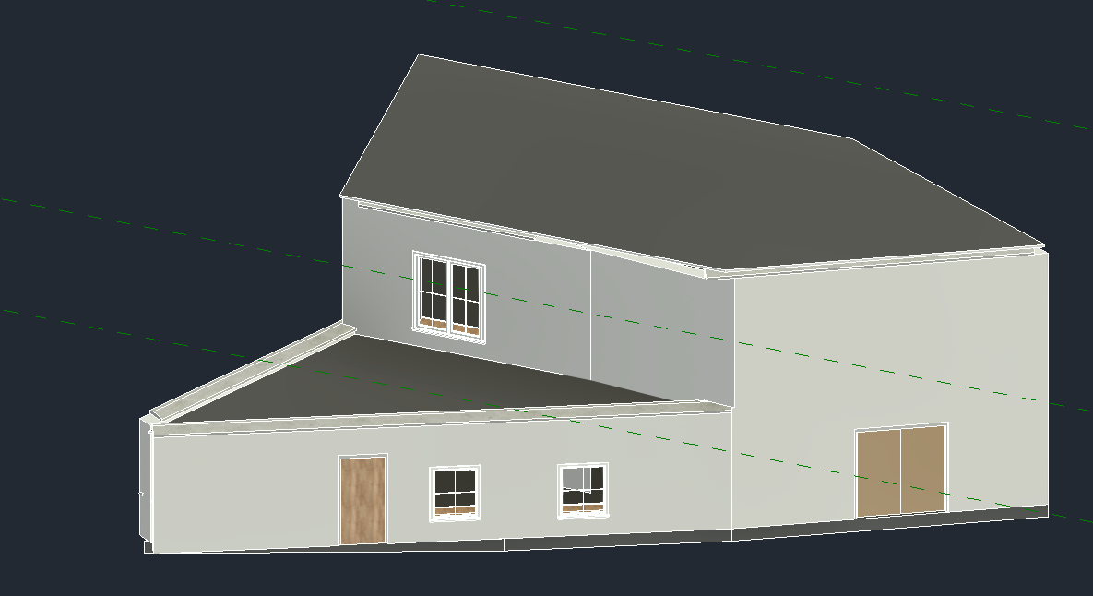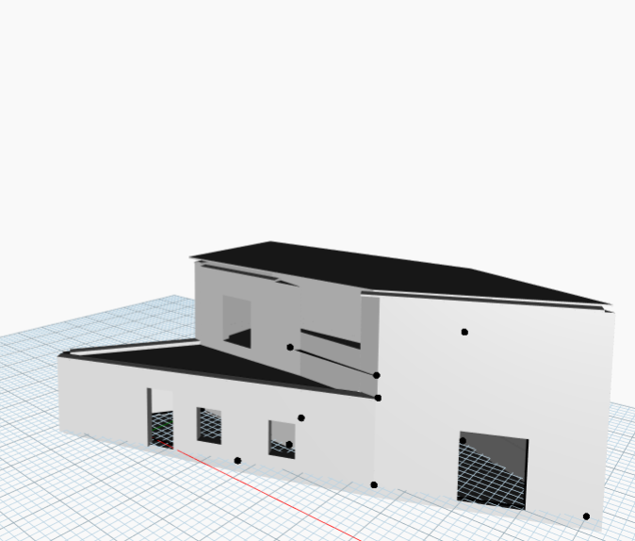
As shown in the above figures, parametric modelling is used to change the parameters to model structures of different types. Solar panels and roof gardens are designed to be placed on the roof to aim for a sustainable society. Walls are made of newly developed sustainable materials that can increase the sustainability of living. Water and electricity-saving systems can also be used in the house design.

