WorkShop02

***P01:***

|  |
| --- |
| **Guitar** |
| - String serialNumber;  - int price;  - String builder;  - String model;  - String backWood;  - String topWood; |
| + Guitar() {…}  + Guitar( String serialNumber, int price, String builder, String model, String backWood, String topWood) {…} :void  + getSerialNumber(){}:String  + getPrice(){}: int  + getbuilder(){}:String  + getmodel(){}:String  + getbackWood(){}:String  + gettopWood(){}:String  + setSerialNumber(String serialNumber){}: void  + setPrice(int price) {}: void  + setBuilder(String builder) {}: void  + setModel(String model) {}: void  + setBackWood(String backWood) {}: void  + setTopWood(String topWood) {}: void  + createSound() {}: void |

***P02:*** - code: class guitar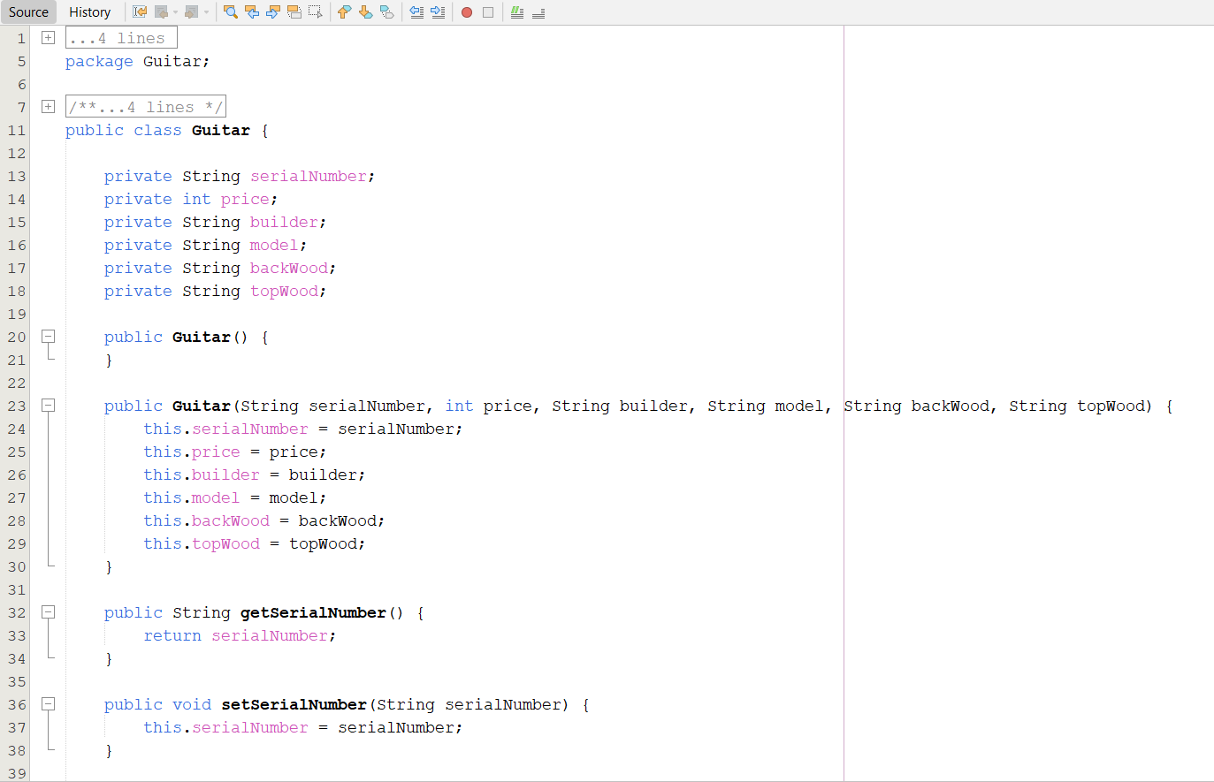 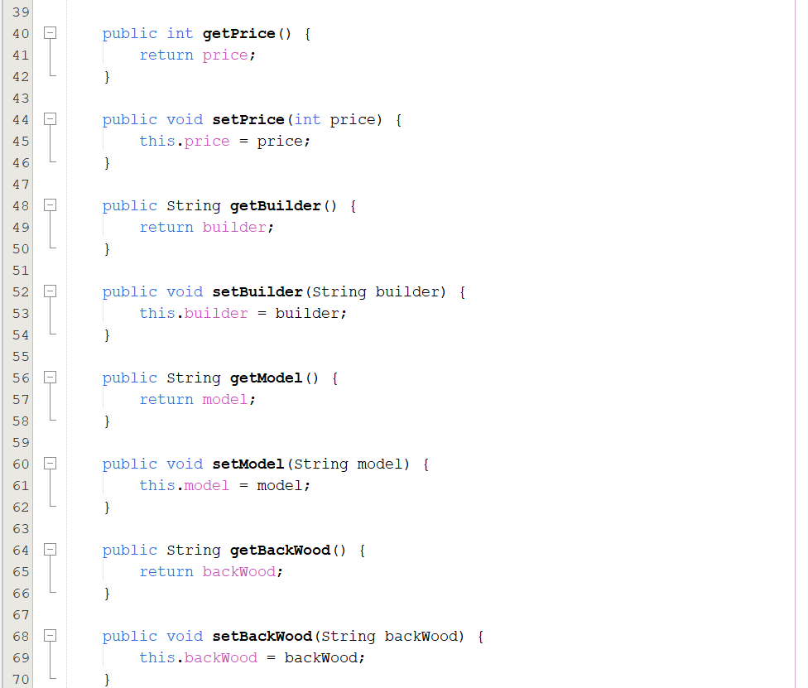

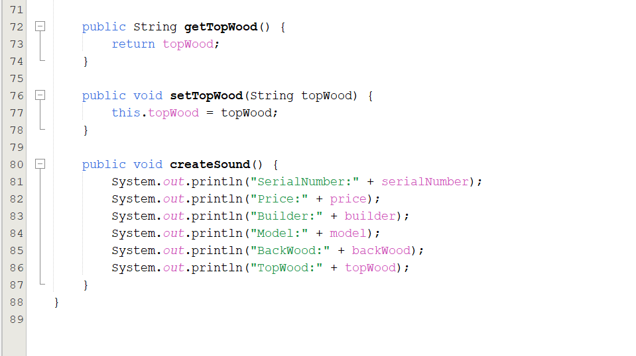

* Code: class Tester

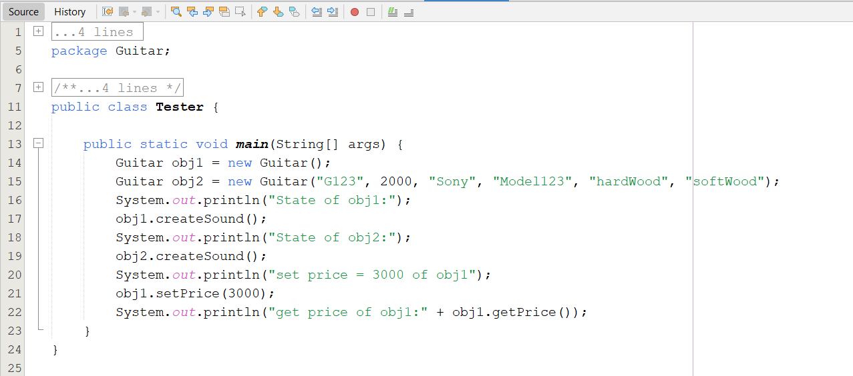

* Result:

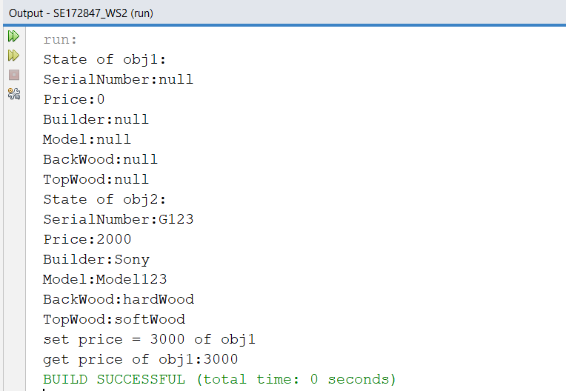

***P03:***

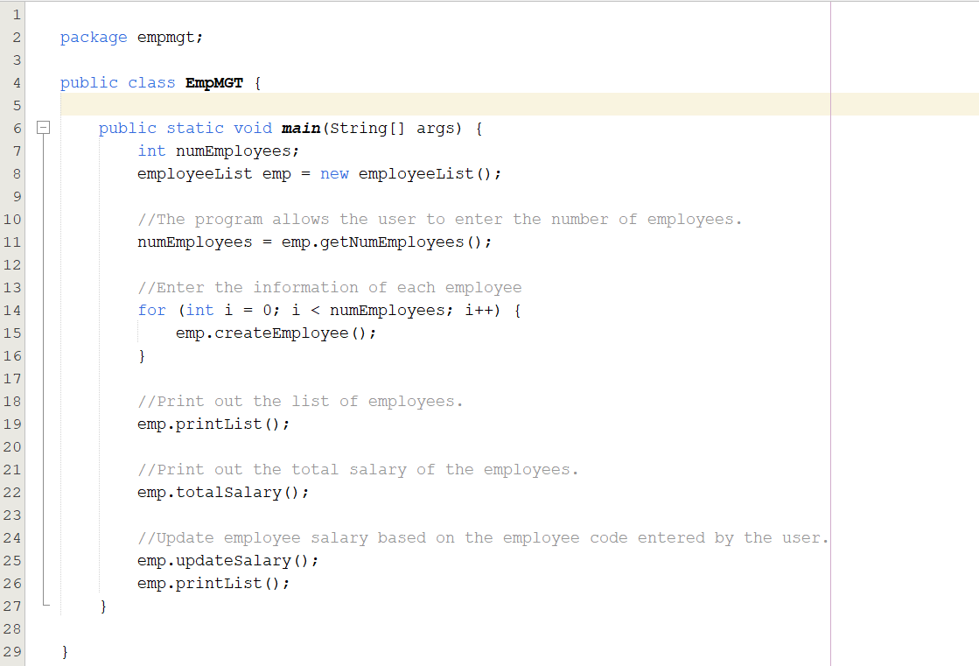

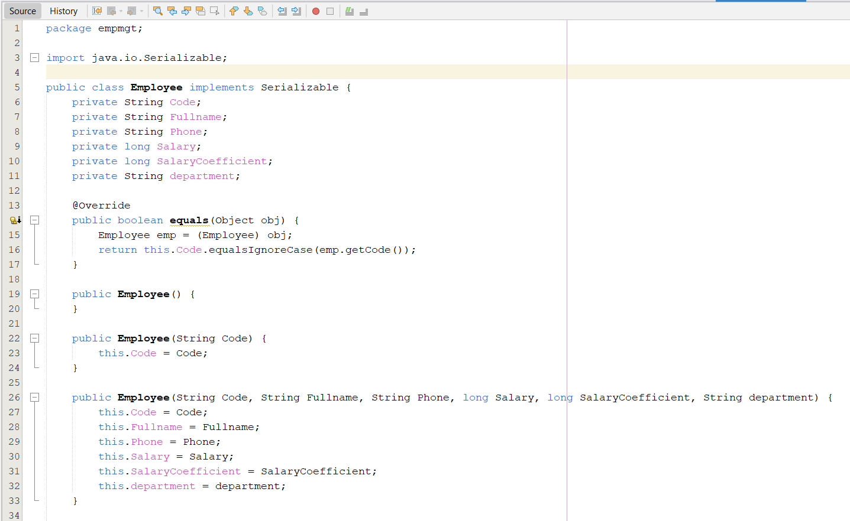 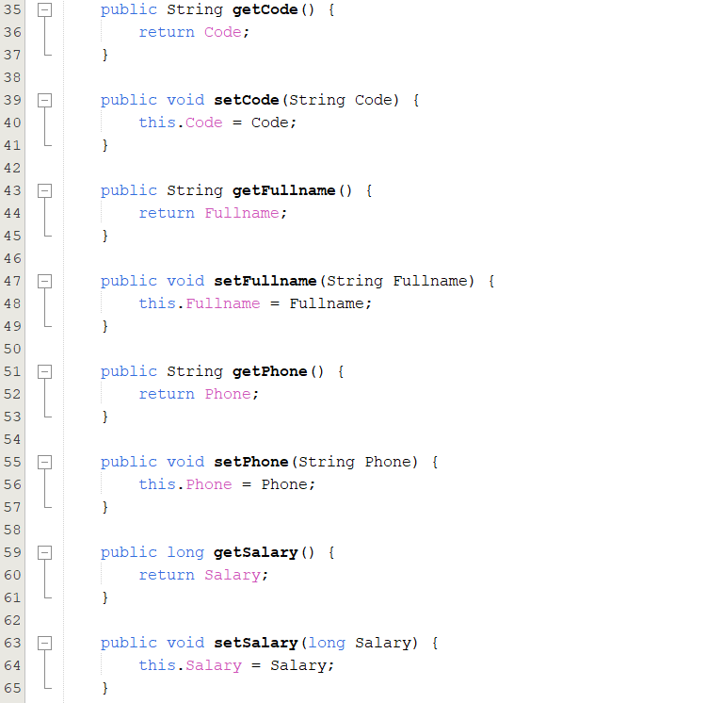

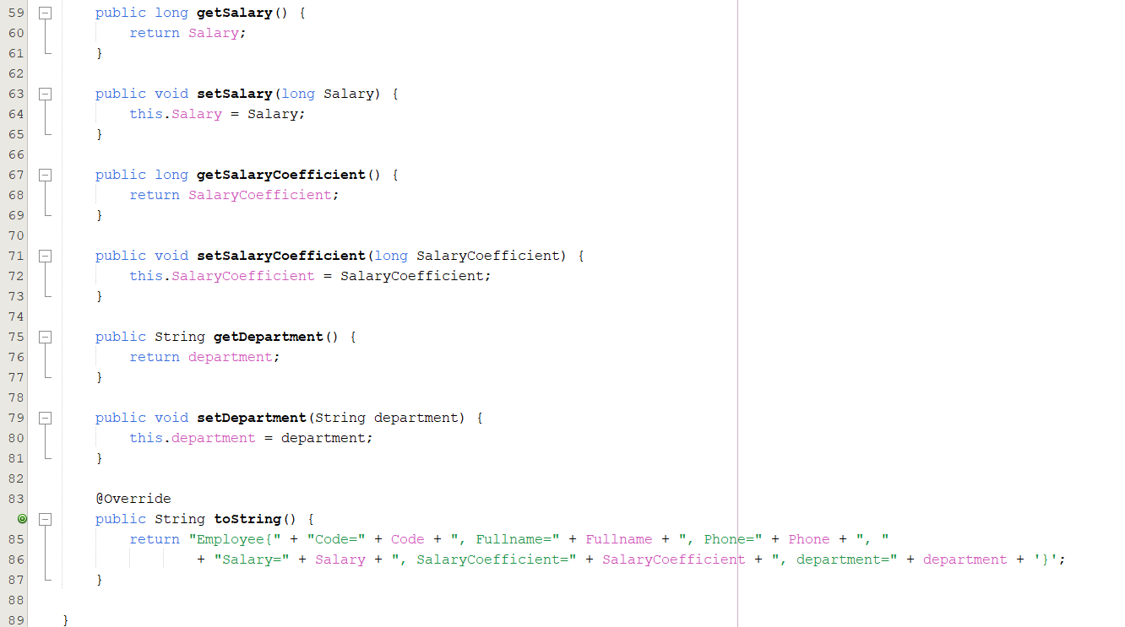

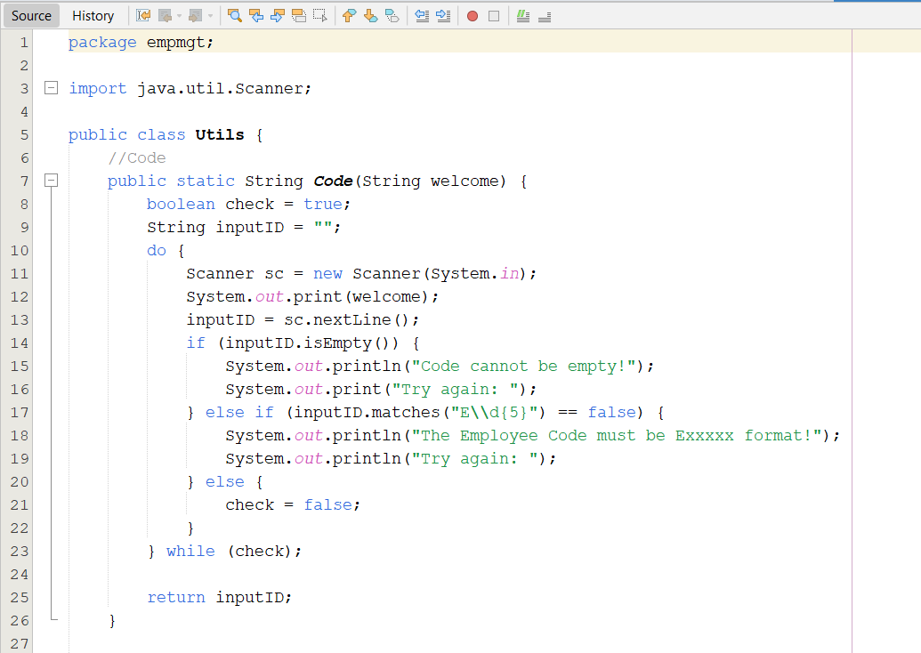

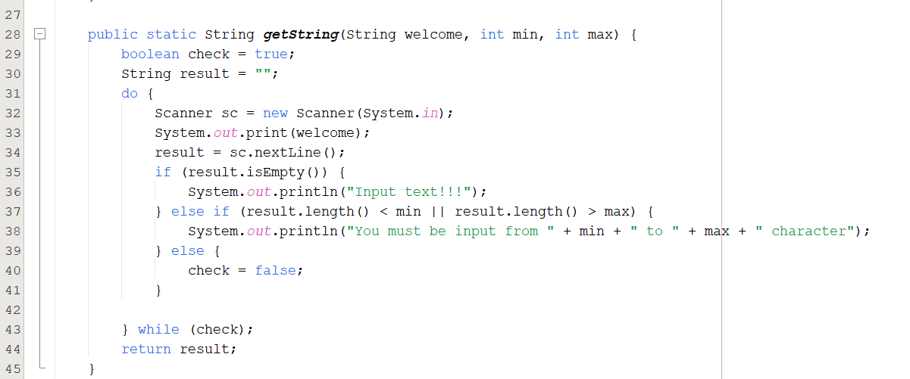

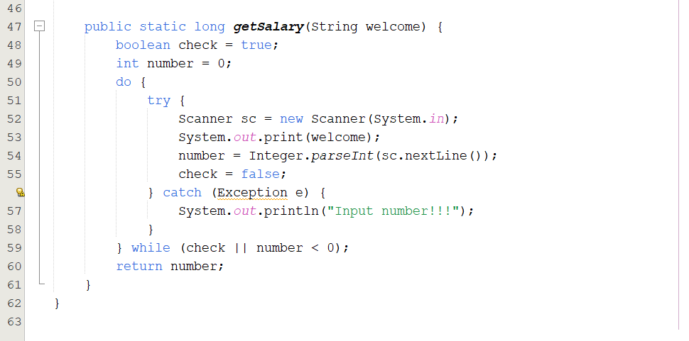

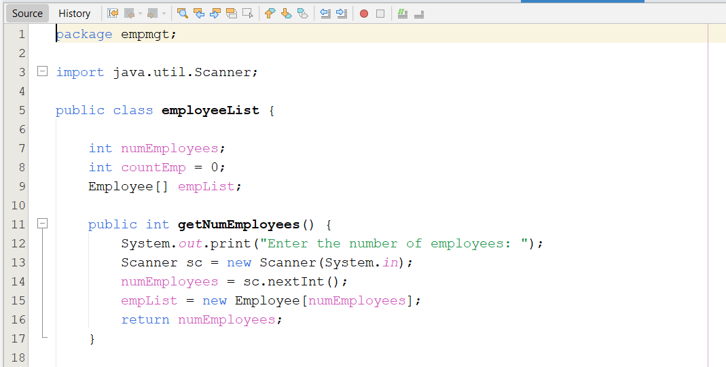

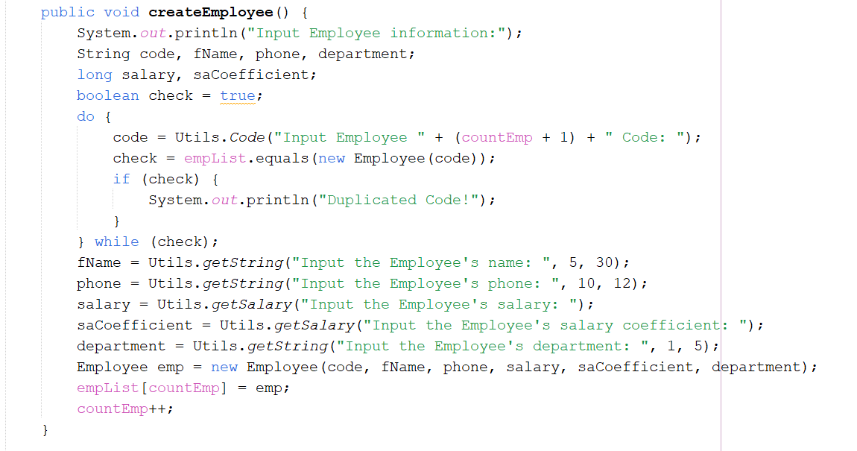

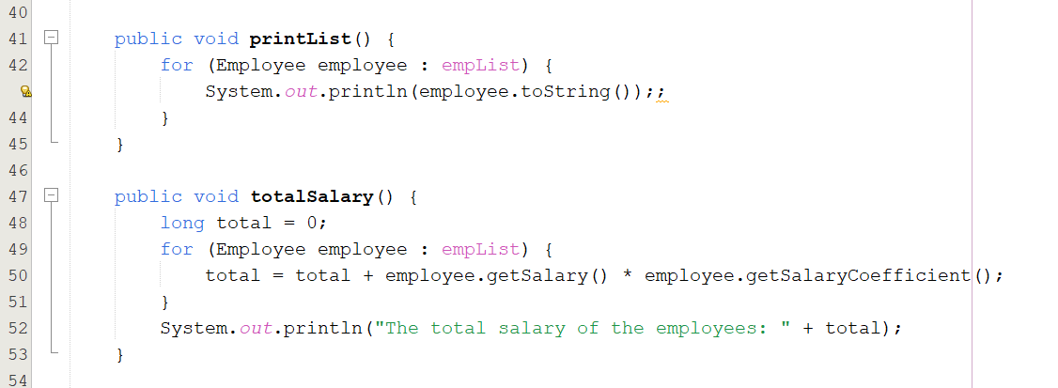

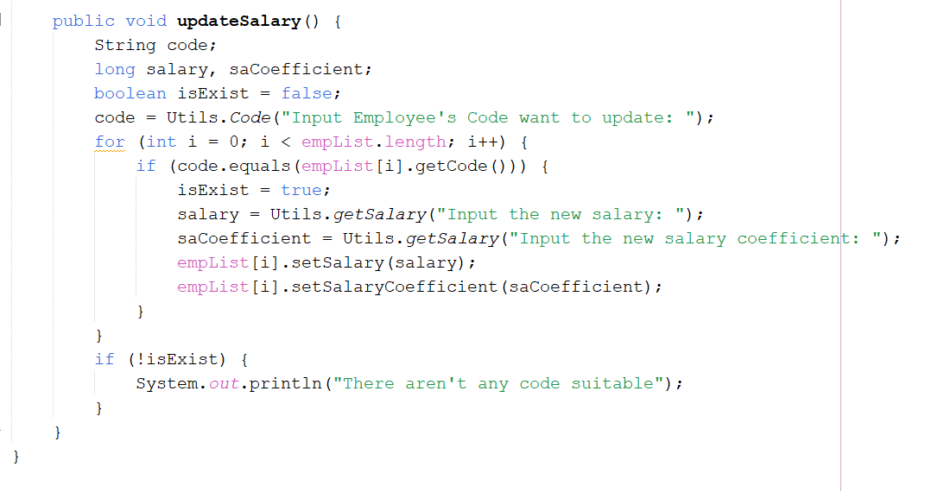

* Result:

