Workshop #3: Exceptions

**Learning Outcomes:**

Upon successful completion of this workshop, you will have demonstrated the abilities to:

* Practice handling errors in your program.
* Describe to your instructor what you have learned in completing this workshop.

**Requirements:**

**Part1: [3 points]**

Write a Java program to accept a string and print out it. If the string does not match SExxx(x is digit) then a message “the string is invalid” is printed out. Using do..while to input again.

***Hint: In library class String, you should use the method matches() to do this, use try-catch block and use throws to handle errors.***

The user interface may be:

Input the string 1: I love u  
the string is invalid

Input the string 1: SE123  
the string is SE123

**Step by step workshop instructions:**

Background:In this workshop, you will use the pattern string( also called regular expression, see more [What is a Regular Expression? - Definition from Techopedia](https://www.techopedia.com/definition/25843/regular-expression#:~:text=-%20Definition%20from%20Techopedia%20Definition%20-%20What%20does,and%20concise%20means%20to%20match%20strings%20of%20text.)). You should read the document to complete the exercise.

**Task 1: use try-catch**

* In the project “Workshop3”, create a new file named “Part1.java”
* In the method main, you type:

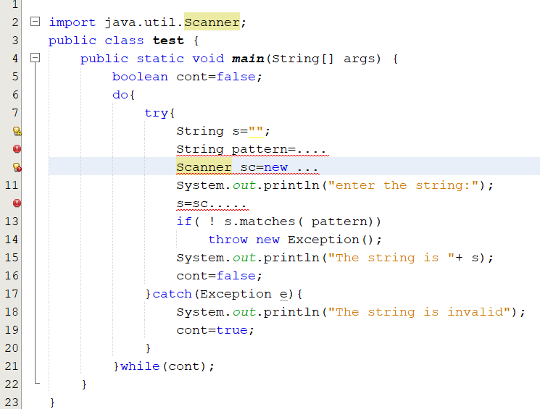

At the row 9, use rules of the regular expression to create a pattern string “SExxx”, x is digit

**Part 2 : Check data validity [ 7 points]**

Employee information includes (Code, Fullname, Age,Address,Salary).

Write a program that allows the user to enter employee information and then print out the results to the screen.

The program checks the validity of the data as described below:

* Code: Can't be empty and has length >=8. Use rules of the regular expression to create a pattern string “SExxxxxx”, x is digit.
* Fullname : Cannot be empty and has length >= 4.
* Age : From 24 to 45.
* Address : Cannot be empty and has length >= 20.
* Salary: From 5000000 to 20000000.

