**Specific Aims**

A central brain function is the generation of appropriate actions in response to sensory information. The striatum, the input nucleus of the basal ganglia, is critical to this process. The striatum receives glutamatergic projections from cortex and thalamus, as well as dopaminergic projections from the midbrain. These two types of inputs converge onto the projection neurons of the striatum, medium spiny neurons (MSNs). According to the classical model of basal ganglia function, MSNs compose two pathways: direct pathway MSNs (dMSNs), which promote action, and indirect pathway MSNs (iMSNs), which suppress action (*1*).

The classical model is based in part upon movement disorders in which dopamine signaling is dysregulated. A central hypothesis of this model is that dopamine has opposing effects on the two pathways: increasing activity in dMSNs and decreasing activity in iMSNs (*1*). While this question has been investigated in a number of in vitro experiments, dopaminergic modulation of dMSNs and iMSNs remains a highly controversial topic. In vitro studies rely upon a range of non-physiological manipulations of dopamine signaling and cell activity, and no experiments have examined the effects of dopamine on dMSNs and iMSNs in vivo (*2*). The lack of in vivo experiments represents a critical gap in our understanding of dopaminergic modulation of the striatum, and has implications for our understanding of motor disorders like Parkinson’s disease, as well as basic cognitive functions like decision-making.

Examining dopaminergic modulation of MSNs in vivo is inherently challenging, as it requires the identification of dMSNs and iMSNs, control over dopamine release, and reliable excitatory input. Until recently, this was impossible due to technical constraints. However, recent developments in optogenetics have made this question tractable. This proposal will take advantage of two color optogenetic techniques and sensory responses in striatum to examine how dopamine modulates dMSNs and iMSNs. To independently stimulate dopamine release in striatum and excite MSNs for the purposes of cell identification, I will use two excitatory opsins with different excitation wavelengths. To control excitation in MSNs, mice will be presented with auditory stimuli that generate rapid, reliable responses in MSNs.

This proposal will test the hypothesis **that dopamine bidirectionally modulates the responses of dMSNs and iMSNs in vivo**. To test this hypothesis, I will first establish auditory striatum as a tool for inducing short latency spiking responses in both dMSNs and iMSNs. I will then examine how optogenetically controlled dopamine release acutely modulates MSN firing responses to auditory stimuli. Finally, I will drive MSN plasticity by pairing optogenetic dopamine release with sensory stimuli, and measure the long term changes to MSN responses. The set of experiments outlined in this proposal will be the first in vivo study of dopaminergic modulation of identified dMSNs and iMSNs in both performance and learning.

**Aim 1: To define the responses of dMSNs and iMSNs to auditory stimuli.** To date, there is no data on the response properties of dMSNs and iMSNs in auditory striatum. Findings in whisker sensitive striatum suggest that either both pathways respond to whisker stimulation, or only dMSNs respond to whisker stimulation (*3, 4*). I hypothesize that both dMSNs and iMSNs in auditory striatum will spike in response to auditory stimuli, and that peak response size will be larger in dMSNs. To test this hypothesis, I will used an awake head fixed preparation to perform optogenetic identification of dMSNs and iMSNs and determine their sensory responses.

**Aim 2: To evaluate the acute effects of dopamine release on auditory responses in dMSNs and iMSNs.** Existing literature suggests that dopamine increases the excitability of dMSNs and decreases the excitability of iMSNs in vitro, but the effect of dopamine in vivo remains unknown (*2, 5, 6*). For example, preliminary slice data from our laboratory suggests that iMSNs are not modulated by the release of dopamine. I hypothesize that dopamine release will acutely enhance auditory responses of dMSNs and suppress auditory responses of iMSNs in vivo. I will investigate this hypothesis by providing auditory stimuli with and without coincident dopaminergic optogenetic stimulation while recording the firing response in identified dMSNs and iMSNs.

**Aim 3: To determine the sufficiency of dopamine release in driving plasticity in auditory responses of dMSNs and iMSNs.** Published in vitro experiments suggest that dopamine is necessary for long term plasticity in MSNs, strengthening responses of dMSNs and weakening responses of iMSNs to glutamatergic inputs (*7*). I hypothesize that repeated pairing of dopamine release with a specific auditory stimulus will result in changes to MSN responses to that stimulus: increased responses in dMSNs and decreased responses in iMSNs. To test this hypothesis, I will repeatedly play several auditory stimuli to which the targeted MSN responds, and pair optogenetic stimulation of dopamine terminals with only one stimulus. I will then determine whether repeated pairing of dopamine release and sensory stimulation results in changes to the response properties of individual identified MSNs.

**RESEARCH STRATEGY**

**1. SIGNIFICANCE:** The input nucleus to the basal ganglia, the striatum, is composed to two populations of projection neurons, direct pathway and indirect pathway medium spiny neurons (dMSNs and iMSNs). The classical model for the basal ganglia posits that dMSNs promotes movement while iMSNs suppress movement (*1*). A critical assumption of this model is that dopamine (DA) increases activity in dMSNs and decreases activity in iMSNs(*1*). While many in vitro studies have examined this hypothesis, we still do not know the in vivo function of dopamine release on dMSNs and iMSNs. As in vitro studies often rely upon non-physiological manipulations of recorded neurons, it is unclear if dopamine release will have similar effects in vivo as it does ex vivo. This proposal will be the first in vivo examination of dopaminergic modulation of striatal dMSNs and iMSNs, and will examine both the acute and longer term effects of dopamine in the striatum.

**1A. ORGANIZATION OF THE BASAL GANGLIA:** The basal ganglia are a series of subcortical nuclei important for the control of movement, decision-making, and learning. The input nucleus of the basal ganglia, the striatum, receives extensive glutamatergic inputs from cortex and thalamus and dense inputs from midbrain dopamine neurons. Neurons in the striatum receive convergent inputs from many areas of cortex, and are thought to mediate the association between sensory information and behavioral outputs (*2*). It is hypothesized that dopamine-driven plasticity is responsible for learning associations between sensory input and rewards. By selectively strengthening and weakening synapses projecting to striatum, it is thought that dopamine promotes the selection of contextually appropriate actions that maximize reward. Furthermore, dopamine is thought to motivate and invigorate actions via modulatory effects on striatal neurons (*8*).

The striatum is predominantly composed of medium spiny neurons (MSNs), a GABAergic projection neuron divided into two classes: D1 dopamine receptor-expressing direct pathway MSNs and D2 dopamine receptor and adenosine 2A (A2A) receptor-expressing indirect pathway MSNs (*9*). While morphologically and electrophysiologically indistinguishable, dMSNs and iMSNs are thought to modulate the output of the basal ganglia in opposite directions, and are therefore hypothesized to have distinct effects on action and movement, which has been supported by some optogenetic experiments (*1, 10*).

A central hypothesis of the classical model is that dopamine increases activity in dMSNs and decreases activity in iMSNs (*1*). Despite the importance of this hypothesis to our understanding of the function of the basal ganglia, no studies have examined the in vivo effects of dopamine release upon identified dMSNs and iMSNs. Given the hypothesized importance of striatal dopamine in learning and motivation, this is a critical gap in our understanding.

**1B. DOPAMINERGIC MODULATION OF MSNS:** While poorly studied in vivo, the effects of dopamine on MSNs have been examined in cultured cell and slice preparations for quite some time. These studies suggest that dopamine not only acutely modulates the excitability of dMSNs and iMSNs, but also is important for long term synaptic plasticity of glutamatergic inputs onto MSNs. Acute activation of dopamine receptors results in an increase in the excitability of dMSNs and a decrease in excitability of iMSNs (*2, 5, 6*). This acute modulation appears to be mediated in large part by changes in calcium channels. Activation of calcium channels in MSNs prolong depolarizations, while inhibition of calcium channels produces the opposite effect (*5, 6*). Dopamine receptor signaling is also necessary for striatal synaptic plasticity. Pairing activation of excitatory inputs with dopamine receptor activation appears to produce long lasting enhancement of responses in dMSNs and suppression of responses in iMSNs to glutamatergic input (*7*).

The only study examining in-vivo plasticity in striatum used electrical stimulation of cortex and the midbrain to examine how dopamine modulates MSN responses to cortical inputs in the rat (*11*). In these experiments, pairing electrical stimulation of the midbrain with cortical stimulation produced a potentiation of responses to cortical stimulation that was dependent upon D1 receptors (*11*). While this study is uninformative as to different dopaminergic regulation of dMSNs and iMSNs, it suggests that measurable changes in the responses of MSNs to cortical input can be induced within minutes.

While existing studies have shed light on dopaminergic modulation of the striatum, they suffer from many caveats. In vitro studies have used pharmacological manipulation of dopamine receptors to investigate dopamine signaling in the striatum, and ignore other elements of the striatal microcircuit, including dopamine receptor expression interneurons. The existing in vivo data does not identify dMSNs and iMSNs, and also utilizes non-specific electrical stimulation of the midbrain and cortex. To rigorously investigate the role of dopamine on identified dMSNs and iMSNs in vivo, a study must have a reliable method for identification of dMSNs and iMSNs, control over dopamine release in the striatum, and control over a defined set of glutamatergic inputs.

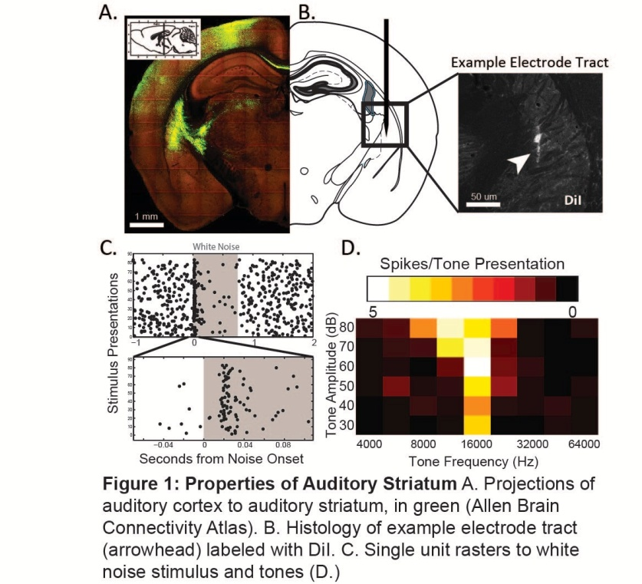**2. APPROACH:**

**2A. AUDITORY STRIATUM AS A TOOL TO INVESTIGATE DOPAMINERGIC MODULATION OF STRIATUM:** The auditory striatum offers two key advantages to a study of dopaminergic modulation of MSNs: auditory stimuli provoke short latency reliable responses in MSNs and existing literature suggests that the auditory striatum is a site for experience dependent plasticity.

At rest, MSNs typically exhibit firing rates between 0-3 Hz. This low firing rate makes it difficult to detect decreases in firing rate. Auditory striatum offers a solution to this problem. Auditory striatum receives dense inputs from both auditory cortex and medial geniculate thalamus (Fig. 1A). In preliminary recordings performed in awake head-fixed mice (Fig. 2A,B), MSNs in mouse auditory striatum exhibit frequency selective spiking responses to pure tones with short latency (20-40 ms), consistent with findings in the rat (Fig.1C,D) (*12*). The advantages of auditory striatum over other sensory modalities (somatosensory and visual) are short response latency (compared to visual responses), and easy manipulation of the sensory stimulus (compared to changing whisker stimulation) both in terms of stimulus magnitude (tone loudness) and stimulus specificity (tone frequency).

Auditory striatum also appears to be a site of dopaminergic modulation and of behavioral plasticity. Rat auditory striatum exhibits enhanced firing responses to auditory stimuli in the presence of a D1 receptor agonist (*13*). Furthermore, the auditory striatum of rats trained to distinguish specific tones exhibits enhanced responses to trained tones (*14, 15*). These findings suggest that dopamine release in auditory striatum will modulate firing of MSNs, and that auditory striatum is a site for experience dependent plasticity.

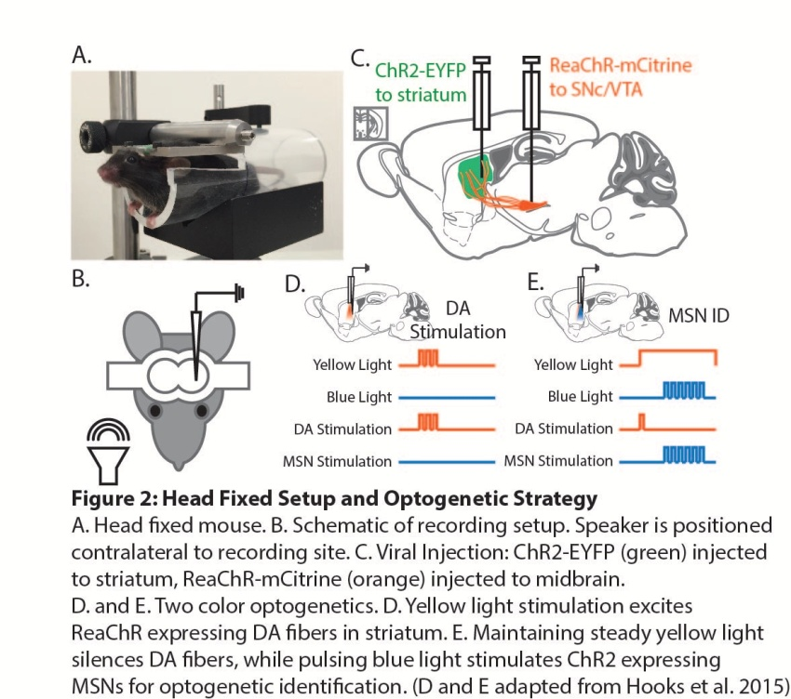**2B. OPTOGENETIC TECHNIQUES FOR IDENTIFYING MSNs AND STIMULATING DOPAMINE RELEASE:** In order to independently activate MSNs (to identify dMSNs/iMSNs) and dopamine terminals (to stimulate dopamine release) in Aims 2 and 3, this proposal will take advantage of optogenetic tools for two color manipulation of neural circuits developed in the Svoboda laboratory. I will combine the use of the excitatory opsin, channelrhodopsin-2 (ChR2) with the red-shifted excitatory opsin, ReaChR. ReaChR has a red-shifted excitation spectrum optimized for 590-630nm light, outside the range of ChR2 excitation (*16*). While pulses of yellow (590 nm) light activate ReaChR-expressing axons, continuous yellow light inactivates axons and stops action potential transmission (*16*). I propose to express ReaChR in midbrain dopamine neurons, and express ChR2 in dMSNs or iMSNs (Fig. 2C). To release dopamine, I will flash yellow light into the auditory striatum, selectively activating dopamine terminals (Fig. 2D). To excite MSNs for optogenetic identification, I will maintain constant yellow light and pulse blue light (473 nm, 5 mW power, 10 ms duration, 0.5 Hz pulse frequency) to selectively activate ChR2 expressing MSNs (Fig. 2E) (*16*). MSNs will be identified based on published criteria (*16, 17*).

By combining the advantages of auditory striatum with novel optogenetic tools, this proposal will perform the first in vivo investigation of the dopaminergic modulation of identified dMSNs and iMSNs.

**AIM 1: TO DETERMINE THE RESPONSES OF dMSNS AND iMSNS TO AUDITORY STIMULI**

**Hypothesis**: Both dMSNs and iMSNs will have spiking responses to auditory stimuli, and peak dMSN responses will be larger.

**Rationale**: In order to utilize auditory stimuli as a method to excite dMSNs and iMSNs, I must first determine the response properties of the two pathways. The only publications directly examining responses of MSNs to sensory stimuli have recorded from whisker sensitive dorsolateral striatum. One publication utilized anesthetized animals and found sensory responses in both dMSNs and iMSNs(*4*). The other utilized awake trained animals, and found only dMSNs exhibited sensory responses (*3*). I hypothesize that the naive anesthetized animal will be more similar to the naive awake animal than the trained awake animal. Therefore, I hypothesize that both dMSNs and iMSNs will have spiking responses to auditory stimuli, and that peak responses in dMSNs will be larger. By performing recordings in optogenetically identified dMSNs and iMSNs, I will test the hypothesis that both pathways exhibit responses to auditory stimuli and examine whether dMSNs have larger peak responses.

**Methods:** To examine the response properties of dMSNs and iMSNs, I will utilize optogenetic labeling techniques and acute extracellular single unit recordings in awake animals. D1-Cre and Adora-2a-Cre lines will label dMSNs and iMSNs respectively. Cre animals will be injected in auditory striatum with an adeno-associated virus (AAV) containing Cre dependent ChR2 (AAV5-DIO-ChR2), and recover for a month to ensure expression of ChR2. I will then implant mice with head fixation devices and wait seven days for recovery from surgery. The day of the recording, craniotomies will be made over auditory striatum. During recordings, mice will be head fixed, awake, and restrained inside an acrylic tube (Fig. 2A,B). The silicon recording probe with an attached optical fiber will be coated in DiI stain to localize the recording path in post-hoc histology. I will then target the probe to auditory striatum by stereotaxic coordinates. Once the probe is stabilized, MSNs will be identified using 473 nm light pulses, following published protocol (*17*). Following the identification protocol, I will determine whether any neurons exhibit sound responses by presenting white noise bursts from an electrostatic speaker (TDT ES1/ED1) placed contralateral to the recording site (Fig. 2B). If there is a spiking response to white noise, I will determine the frequency tuning of the response by presenting a randomized set of tone pips (100 ms, 5 ms on/off ramp) covering a range of frequencies and amplitudes (4-64 kHz, 30-80dB, 20 repetitions of each tone/frequency). Following completion of recordings, animals will be processed for histology, and recording positions will be reconstructed from electrode tracts in the brain to determine the position of recorded units. Based on power calculations (2 sample, 1 sided, μa= 15+5 μb= 10+6, α = 0.05, β = 0.2), I will record 20 dMSNs and 20 iMSNs.

Data will be analyzed by cell type for the percentage of ChR2-labeled neurons responsive to sound stimuli. Of the neurons responding to auditory stimuli, firing responses will be analyzed for latency, best frequency, and peak response. Peak response will be defined as the largest average response to a tone of specific amplitude. Following this analysis, population responses between dMSNs and iMSNs will be compared using a rank sum test to identify differences between the two populations.

**Expected Results:** Based on preliminary recordings, dMSNs and iMSNs are expected to respond to white noises and pure tones with a latency of 20-40 ms. The average response will be 1-3 spikes per tone presentation (Fig. 1C). Spiking responses will remain consistent across multiple tone presentations. I further expect that the peak response for dMSNs will be larger than peak responses for iMSNs. Best frequencies of both dMSNs and iMSNs are expected represent the range of frequencies presented (4-64 kHz).

**Alternative Outcomes, Challenges and Solutions:** Based on published work using somatosensory stimuli, it is possible that only dMSNs will exhibit responses to auditory stimuli (*3*). Extracellular recordings will not distinguish between a subthreshold response and no response. However, these can be differentiated using optogenetic tools and slice physiology. In these experiments, D1-tmt mice, which label dMSNs with the red fluorophore tdTomato, would differentiate dMSNs from iMSNs. ChR2 would be expressed in auditory cortex or auditory thalamus, and acute slices of auditory striatum would be prepared. Pairs of labeled (dMSN) and unlabeled (iMSN) cells would be patched, and blue light would be used to excite cortical/thalamic inputs. With access to membrane voltage data, I would be able to distinguish a total lack of responses from subthreshold responses. In the event that only dMSNs spike in response to auditory stimuli, then Aims 2 and 3 will focus on dMSNs only.

**AIM 2: TO EVALUATE THE ACUTE EFFECTS OF DOPAMINE TERMINAL STIMULATION ON MSN SENSORY RESPONSES**

**Hypothesis:** Optogenetic stimulation of striatal dopamine terminals will enhance spiking in dMSNs and suppress spiking in iMSNs in response to sensory stimuli.

**Rationale:** While acute dopaminergic modulation of dMSNs and iMSNs has been studied in vitro, there has been no confirmation of these findings in vivo, where striatal microcircuitry and ongoing inputs from cortex make the situation more complex. Demonstrating that in vivo dopamine release enhances dMSN responses while suppressing iMSN responses will elucidate the effects of dopamine release on striatal activity in the awake animal. As acute dopaminergic modulation of MSNs is thought to underlie changes in motivation and vigor, establishing the electrophysiological effects of dopamine release will help understand how activity in the 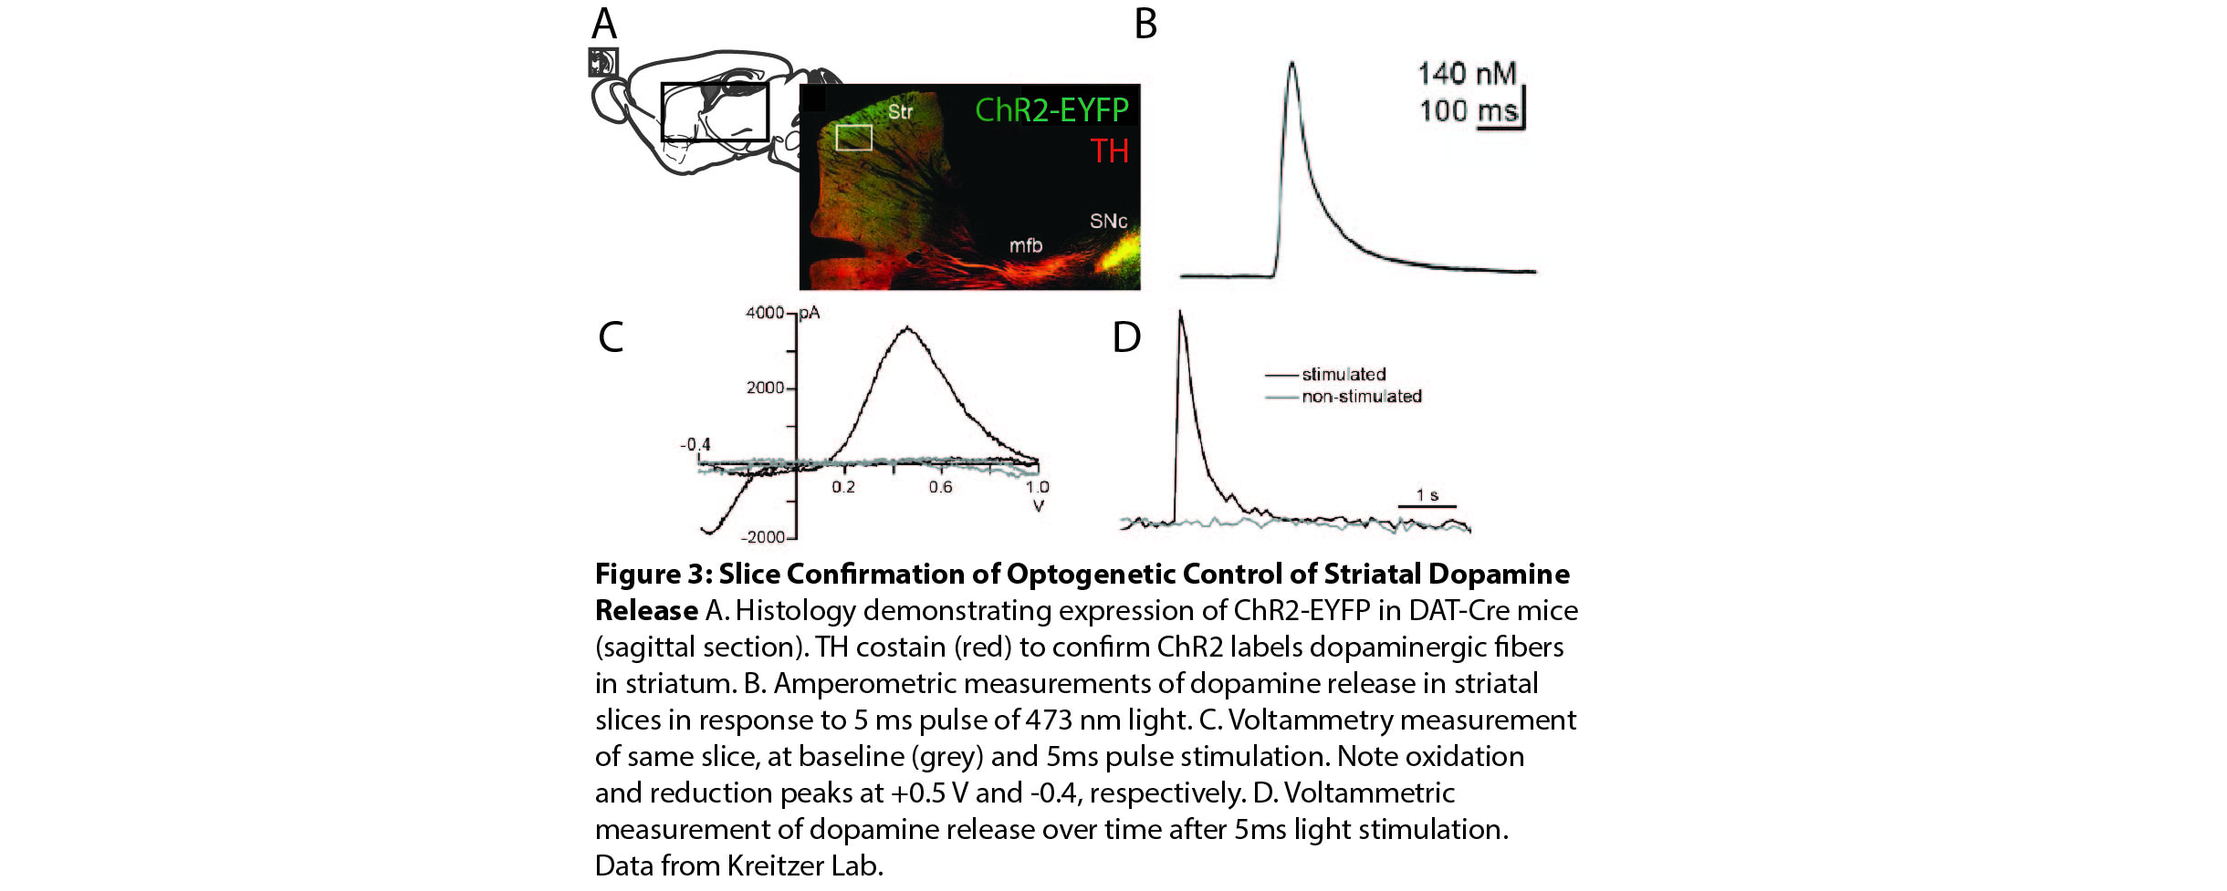striatum translates to action.

**Methods:** Experiments will use the same head-fixed recording preparation from Aim 1. In this Aim, we will cross D1 or A2A-Cre animals (labeling dMSNs and iMSNs respectively) with DAT-Cre animals (which label dopaminergic neurons). This aim will utilize the two color optogenetic system outlined in section 2B.

Following viral injection, animals will be processed for recordings as outlined in Aim 1. I will then use auditory stimuli to determine MSN auditory response properties. Three specific tone frequencies will be selected that provoke maximal, moderate, and no response in recorded cells (Fig.4a). Mice will receive these three tones in randomized order (100 ms tones delivered at 0.5-0.3 Hz). On 10% of trials, optogenetic stimulation of dopamine terminals (595 nm, 2-10 mW laser power, 1 x 5ms pulse) will precede the tone by 200 ms. These stimulation parameters are based on preliminary data from our laboratory (Fig. 3). Based on power calculations (2 sample, 1 sided, μa= 2.5+1.5 μb= 3.25+1.95, α = 0.05, β = 0.2), a total of 120 dopamine stimulation trials and 1200 total trials will be performed. I will then determine the frequency tuning of the recorded neurons again. After complete evaluation of tuning, MSNs will be identified as outlined in section 2B. Based on power calculations (2 sample, 1 sided, μa= 3.25+1.95 μb= 1.75+1.5, α = 0.05, β = 0.2), I will record 17 dMSNs and 17 iMSNs.

Following these experiments, sensory responses of dMSNs and iMSNs will be analyzed. First, a signed rank test will be applied to each type of auditory stimulus (maximal, moderate, and non-re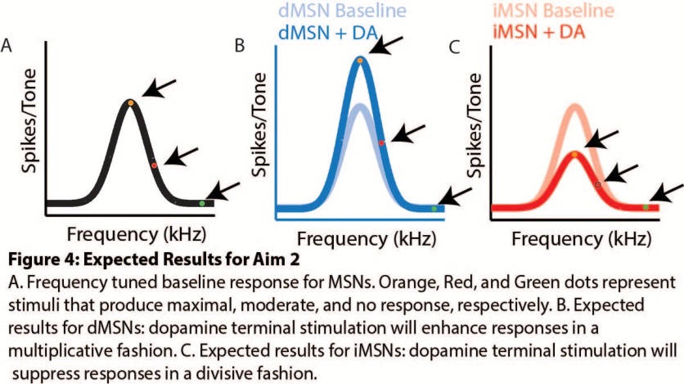sponsive) to determine if dopamine terminal stimulation alters the responses of the MSN to the stimulus. I will then determine if there is any difference in the tuning properties of the MSN before and after dopamine stimulation, to ensure there are no changes due to learning or plasticity. Finally, I will determine differences between dMSNs and iMSNs by comparing average changes in each group with a rank sum test.

**Expected Results:** Based on published in vitro data, I expect dMSN spiking to be enhanced 30-100% and iMSN spiking suppressed by 25-100% (*5, 6*). I expect that this modulation of responses will exhibit multiplicative/divisive properties, with maximal change for the tone provoking the maximal response, and no change for non-responsive tones (Fig. 4). This is because it is hypothesized that much of the effect of dopamine on MSNs is via activation/inactivation of calcium channels, which can prolong large depolarizations. Finally, I expect that a large proportion of all MSNs will exhibit rapid and transient inhibitions aligned to optogenetic stimulation of dopamine fibers, as dopaminergic terminals often corelease GABA (*18*).  
**Alternative Outcomes, Challenges and Solutions:** Ex vivo data from our laboratory suggests that phasic release of dopamine on spiking MSNs enhances firing rates of dMSNs, but has no effect on firing rate of iMSNs (Fig. 5). I might therefore expect that our in vivo experiments would recapitulate these findings, with a 100% enhancement of dMSN responses and no change to iMSN responses. Alternatively, it is possible that my stimulation protocol will induce lasting changes in the frequency responses of MSNs. In this event, I will reduce the percentage of stimulated trials from 10% to 5% to minimize learning effects.

Finally, while two color optogenetic manipulation has been validated, it may fail due to intrinsic properties of dopaminergic neurons. An alternative would be to utilize intersectional genetic methods. I would infect auditory striatum with a CAV-flp, which will undergo retrograde transport to the SNc. I will then infect the auditory striatum with DIO-ChR2 for photo-tagging, and the SNc with a DIO-frt-C1V1 for excitation of dopamine neurons. C1V1 does not traffic to terminals, so it will not interfere with stimulation of auditory striatum (*16*). I would then stimulate dopamine neurons with an optical fiber implanted directly in the SNc, while I would stimulate ChR2 in MSNs with the fiber attached to the probe.

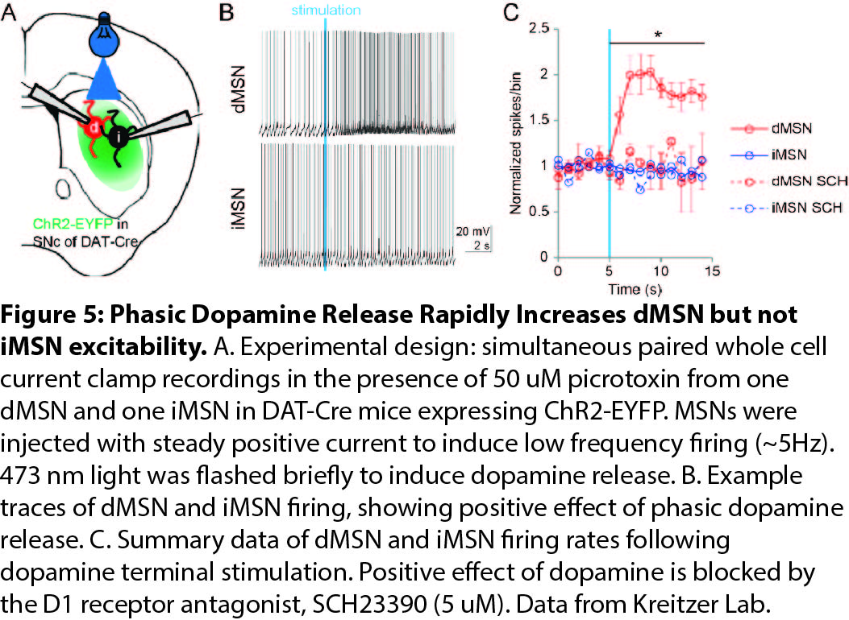**AIM 3: TO DETERMINE THE SUFFICIENCY OF DOPAMINE IN INDUCING PLASTICITY IN MSNs**

**Hypothesis:** Following pairing of dopamine release with specific tones, dMSNs will develop enhanced responses to the paired tone, while iMSNs will exhibit suppressed responses to the paired tone.

**Rationale:** Dopaminergic modulation of MSN synaptic plasticity is thought to be a central mechanism for learning in the striatum (*2*). Existing studies suggest that plasticity can be induced in the striatum over short time scales in vitro and in vivo (*7, 11, 19*). However, there is no in vivo evidence of dopamine-driven plasticity in identified MSNs. Experiments in auditory cortex have demonstrated that plasticity can be generated over the course of minutes by pairing auditory stimuli with release of neuromodulators (*20*). This aim adopts these methods to investigate dopaminergic modulation of MSNs.

**Methods:** I will utilize the same Cre and viral strategy as outlined in Aim 2. During acute recordings, I will locate putative MSNs, identify them using ChR2 stimulation, and identify their response properties to auditory stimuli. Based on this initial characterization, I will select a tone frequency and amplitude that provokes a sub-maximal response in the recorded neuron (Fig. 6A, yellow dot). This tone will be repeatedly played to the animal, preceded by 200 ms with dopamine terminal stimulation (595 nm light, 2-10 mW laser power, 10x5 ms pulses at 30Hz) at 0.5 Hz for a total of 5 minutes (150 repetitions of pairing). During the pairing, two distracter tones will also be played for an equal number of times (with order randomized) to serve as controls for the number of tone exposures. This pairing protocol is based on published protocols that have induced plasticity in striatal slices and in auditory cortex (*19, 20*). Following this pairing protocol, I will re-examine the frequency tuning properties of the MSN. Based on 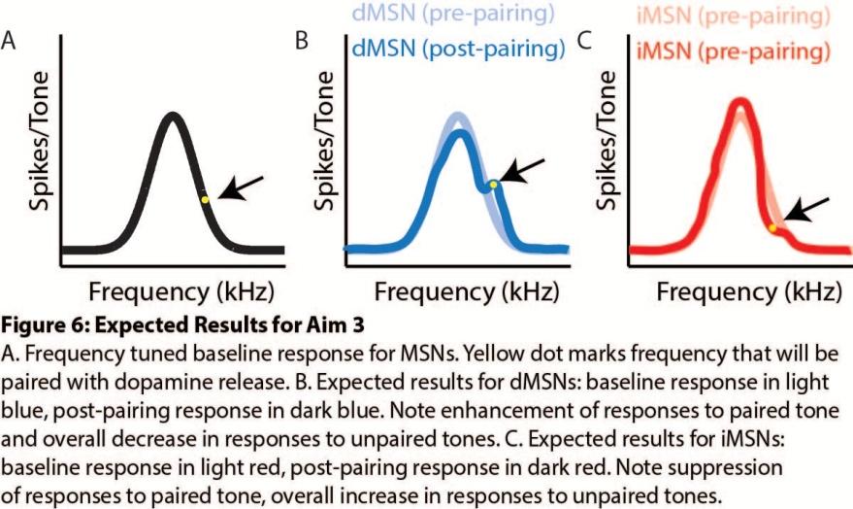power calculations (2 sample, 1 sided, μa= 3.25+1.95 μb= 1.25+1.5, α = 0.05, β = 0.2), I will collect data from 10 dMSNs and 10 iMSNs.

I will analyze responses of MSNs to tones by calculating the average number of spikes per tone presentation. I will then compare the responses of MSNs to the paired tone from before and after pairing with dopamine using a signed rank test. Finally, I will compare dMSNs and iMSNs with a rank sum test.

**Expected Outcomes:** Based on existing in vitro data, I expect that the pairing protocol utilized in this proposal will alter the responses of MSNs to the paired tone, enhancing dMSN responses by 40%, while reducing iMSN responses by 50% (Fig. 6B,C). This reduction may be larger than predicted, as reducing membrane voltage changes if these changes result in subthreshold responses. I expect that in dMSNs, there will be a reduction in responses to unpaired tones, and in iMSNs, there will be an increase in responses to unpaired tones. This compensatory change to the responses of neurons has been seen in plasticity experiments in cortex (*20*).

**Alternative Outcomes:** Existing experiments inducing in vivo plasticity in striatum have only reported D1 receptor dependent potentiation, so I might expect that our protocol would enhance responses in dMSNs and have no effect on iMSNs (*11*). This might suggest depression of iMSN responses is induced through alternative mechanisms, potentially including long term levels of dopamine or other signaling molecules.

**Challenges and Solutions:** This aim has the same technical challenges as in Aim 2, as well as the challenge of inducing plasticity in vivo. In an animal learning from a behavioral task, a number of other inputs might be active, including other sensory, motor, and neuromodulatory inputs. If I cannot induce plasticity with a pairing protocol and find my techniques are functioning properly, it may be that I need a coincidence of various inputs to auditory striatum to induce plasticity. I will examine this by first performing retrograde tracing studies from auditory striatum using retrobeads to determine inputs to auditory striatum. I will then attempt to excite other input regions with optogenetic techniques while performing the pairing protocol, to determine if other inputs are necessary for striatal plasticity.

**References:**

1. R. L. Albin, A. B. Young, J. B. Penney, *Trends in Neurosciences* **12**, 366 (1989).

2. S. J. D. Gerfen C. R, *Annual Review of Neuroscience* **29**, 997 (2012).

3. T. Sippy, D. Lapray, S. Crochet, Carl C. H. Petersen, *Neuron*, (2015).

4. R. Reig, G. Silberberg, *Neuron* **83**, 1200 (2014).

5. S. Hernández-López, J. Bargas, D. J. Surmeier, A. Reyes, E. Galarraga, *The Journal of neuroscience : the official journal of the Society for Neuroscience* **17**, 3334 (1997).

6. S. Hernandez-Lopez *et al.*, *The Journal of Neuroscience* **20**, 8987 (2000).

7. W. Shen, M. Flajolet, P. Greengard, D. J. Surmeier, *Science (New York, N.Y.)* **321**, 848 (2008).

8. D. J. Surmeier, J. Ding, M. Day, Z. Wang, W. Shen, *Trends in neurosciences* **30**, 228 (2007).

9. C. R. Gerfen *et al.*, *Science (New York, N.Y.)* **250**, 1429 (1990).

10. A. V. Kravitz *et al.*, *Nature* **466**, 622 (2010).

11. J. N. J. Reynolds, B. I. Hyland, J. R. Wickens, *Nature* **413**, 67 (2001).

12. F. Bordi, J. LeDoux, *The Journal of neuroscience : the official journal of the Society for Neuroscience* **12**, 2493 (1992).

13. E. Arnauld, Y. Jeantet, J. Arsaut, J. Demotes-Mainard, *Molecular Brain Research* **41**, 27 (1996).

14. Q. Xiong, P. Znamenskiy, A. M. Zador, *Nature* **521**, 348 (2015).

15. P. Znamenskiy, A. M. Zador, *Nature* **497**, 482 (2013).

16. B. M. Hooks, J. Y. Lin, C. Guo, K. Svoboda, *Journal of Neuroscience* **35**, 4418 (2015).

17. Thomas K. Roseberry *et al.*, *Cell* **164**, 526 (2016).

18. N. X. Tritsch, J. B. Ding, B. L. Sabatini, *Nature* **490**, 262 (2012).

19. S. Yagishita *et al.*, *Science* **345**, 1616 (2014).

20. R. C. Froemke *et al.*, *Nature neuroscience* **16**, 79 (2013).