A unified repertoire of indel mutational signatures in 6,975 tumors
Mo Liu1*#, Mi Ni Huang2*, Xue Ming Wu1*, Ying Yang1, Runtian Yao2, Qi Zheng1, Runxi Shen3, Steven G. Rozen4#
1 Sino-French Hoffmann Institute, School of Basic Medical Sciences, The First Affiliated Hospital, Guangzhou Medical University, Guangzhou, Guangdong 511436, China
2 Molecular Cancer Research Center, Zhongshan School of Medicine, Sun Yat-sen University Shenzhen Campus, Shenzhen, 518107, China
3 Imaging Platform, Broad Institute of Harvard and MIT, Cambridge, Massachusetts, United States
4 Department of Biostatistics and Bioinformatics, Duke University School of Medicine, Durham, North Carolina, 27710, United States
# Corresponding authors: E-mails: mo.liu@gzhmu.edu.cn, steverozen@pm.me
* These authors contributed equally

Notes: 7 display items allowed (We will have 1 table and 6 main figures)
Word Count: The main text should be under 7,000 words. This count includes the figure legends but excludes the STAR Methods, supplemental legends, and references.
- Supplemental Items: You may include additional display items as supplemental information at the editor's discretion. For Cell Research Articles, this is often up to 7 supplemental figures.
- Mandatory Items: You must also include a Graphical Abstract (exactly 1,200 x 1,200 pixels) and 3–4 Highlights (each 85 characters or fewer). [1, 2, 3, 4]

Summary

We present a unified repertoire of indel mutational signatures in 6,975 tumors across 36 cancer types. Small insertions and deletions ("indels") are an important under-studied class of mutations. Koh, Nanda, and colleagues recently introduced two richer indel classifications, with 89 and 476 indel types. We identified signatures separately in the two new classification schemes and the widely used 83-type classification scheme using two algorithms. We identified 44 89-type signatures and their 476-type counterparts; 26 are new. Because lossless translation between the 83-type and newer schemes is impossible, we used tumors dominated by single signatures to exhaustively map correspondences across classifications. The 89- and, especially, the 476-type schemes distinguish signatures and spectra that the 83-type scheme cannot. We release software for generating and plotting spectra in the new classifications. An accompanying web site enables exploration of signatures and their cross-classification relationships and provides a service to construct spectra from VCF files.

150
Highlights
- Unified indel repertoire across 6,975 genomes with lossless mapping schemes
- Discovery of 26 novel 89-type and 11 novel 83-type indel mutational signatures
- Integrative topography across transcription, replication, and genic regions
- Web portal and software for systematic indel browsing and VCF analysis

Introduction
Somatic mutations are caused by various mutational processes and represent a driving force behind tumorigenesis and cancer development (Alexandrov et al. 2014). These mutations can result from either endogenous sources, such as 5-methylcytosine deamination or defective DNA repair mechanisms (Davies et al. 2017; Cooper et al. 2010; Grolleman et al. 2019; Boot et al. 2022), or exogenous sources, including exposure to chemical carcinogens in tobacco smoke or certain herbal medicines (Alexandrov et al. 2016; Ng et al. 2017; Dziubańska-Kusibab et al. 2020; Boot et al. 2020). Mutational signature analysis provides insights into cancer etiology, prognosis, prevention, evolution, and mutational signatures can also serve as biomarkers for mutagenic exposures
By “mutational signatures” we mean distinctive patterns of mutations left on genomes by mutagenic processes or exposures. They can be identified by exposing cultured cells, organoids, or experimental animals to suspected mutagens or perturbing DNA repair pathways and then sequencing the affected genomes (Boot et al. 2018; M. N. Huang et al. 2017; Kucab et al. 2019; Caipa Garcia et al. 2024; Riva et al. 2020). In addition, machine learning can identify mutational signatures as latent factors that explain the patterns of mutations in large collections of somatic mutation data (Alexandrov et al. 2020, 2014; Nik-Zainal et al. 2012; Degasperi et al. 2022; Chen et al. 2024; Jin et al. 2024; Koh et al. 2025). For example, data mining of upper tract urothelial cancers (UTUC) from Taiwan initially identified the aristolochic acid (AA) single-base substitution (SBS) signature (Hoang et al. 2013; Poon et al. 2013). Subsequent analysis revealed that this signature was also present in bladder, kidney, and liver cancers (Ng et al. 2017; Poon et al. 2015). More recently, data mining of Chinese liver cancer genomes and experiments in cell culture showed that AA also generates double-base-substitution (DBS) signatures and, relevant to the current study, small insertion-and-deletion (indel) signatures (Figure 1) (Chen et al. 2024).
Mutational signature research has tended to focus less on indel rather than SBS signatures, and symptomatic of this COSMIC v3.5 catalogs only 25 indel signatures compared to 78 SBS signatures. Nevertheless, indel signatures can yield important information for cancer classification, epidemiology, and treatment and for understanding DNA repair and mutagenic mechanisms. Examples include identification of tumors with homologous recombination deficiency or with mismatch repair deficiency (M. Huang et al. 2015; Koh et al. 2025; Davies et al. 2017) and a rare indel hypermutator phenotype due to a mutation in topoisomerase 2 alpha (Boot et al. 2022).
The first widely used classification of indels recognized 83 indel types, Alexandrov et al. 2020and recently (Koh et al. 2025) proposed two classification schemes, one with 89 types of indel and one with 476 types (Figure 1).
The older, 83-type scheme primarily categorizes indels based on the number of bases inserted or deleted, and for single-base insertions and deletions the identity of the deleted or inserted base (conventionally shown as pyrimidines, C or T). For these single-base indels, the classification also considers the number of flanking C or T residues (Figure 1A). Indels longer than 1 base are further classified by their occurrence within repetitive sequences (i.e. microsatellites, simple tandem repeats). For deletions of ≥2 bases the 83-type system classification also encodes the presence of microhomology. Microhomology is a hallmark of error-prone DNA repair by non-homologous end-joining, which operates when repair by homologous recombination is not available, notably in BRCA-deficient tumors. For example, the 3-base deletion (ACA|TCA|GG→ACAGG) exhibits a 2-base microhomology (CA).
One of the new classification schemes is based on 476 types of indel and one is based on 89 types, which mainly consolidates similar mutation types in the 476-type classification into coarser-grained mutation types (Koh et al. 2025) (Figure 1, Table S1). A prominent distinction is that, unlike the 83-type classification scheme, both the new classifications distinguish different types indels of a single T or C according to the non-T (respectively, non-C) flaking bases. This dramatically improves discrimination between mutational spectra and signatures containing single-base indels, which are present in most signatures.
For example, the 83-type classification distinguishes deletions of single Ts only by the number of T’s at the site of the deletion: 1, 2, 3, 4, 5, or ≥ 6 Ts (Figure 1A). By contrast, the 89-type classification distinguishes among deletions of T according to bases preceding or following the sequence of Ts at the site of the deletion. However, it groups together deletions of T from sequences of 1, 2, 3, or 4 T, and groups together deletions of sequences of 5, 6, 7, ,8 and Ts. Thus, for example, deletions of ATA→AA or ATTA→ATA are distinguished from deletions of CTA→CA or CTTA→CTA, but the deletions CTA→CA and CTTTTA→CTTTA have the same classification. The 476-type classification scheme provides fined-grained distinctions among deletions of a single C or T that combine the distinctions in the 83 and 89-type system. The 476-type classification scheme shows, for example, that in the signature in Figure 1 (InsDel23), the most prominent deletions are ATA→AA, CTA→CA, and GTA→GA. The classifications of indels of 2 or more bases are less intuitive. Table S1 provides a mapping from the 476-type classification to the 89 and 83-type classifications, as well as multiple examples of each category of deletion.
Here, we analyzed somatic indels in 6,975 whole genomes to create a comprehensive collection of indel signatures in all three classification schemes using approaches based on hierarchical Dirichlet processes and on non-negative matrix factorization. We systematically matched the 476-type signatures to 89-type signatures by collapsing the 476-type signatures to 89-type signatures and comparing the collapsed signatures to signatures identified in the 89-type classification. We used tumor samples with spectra dominated by single signatures to map signatures in the 83-type classification to signatures in the other two classifications. We further profiled signatures’ replication timing, asymmetry between genic and intergenic regions and asymmetry between leading and lagging replication strands, providing insights into mutational processes underlying the signatures. We also tallied their associations to SBSs and to sex within individual cancer types. Finally, in addition to the supplementary information provided here, we also provide a web site to facilitate exploration of these signatures (https://indelsigbrowser.shinyapps.io/main/)

Results

Repertoire of indel signatures based on de novo signature discovery
We identified indel signatures in all three classifications from a total of 6,975 cancer genomes encompassing 36 cancer types using a method based on hierarchical Dirichlet processes (Liu et al. 2023), and a method based on non-negative matrix factorization (Islam et al. 2022). The extracted signatures were broadly consistent between the two methods (Tables 1, S2-S8, https://indelsigbrowser.shinyapps.io/main/). We identified 44 mutational signatures in the new 89-type classification and, independently, the 44 corresponding signatures in the new 476-type classification. We assessed concordance between signatures identified in two classification systems by collapsing the 476-type signatures to their 89-type counterparts and comparing them to signatures extracted in the 89-type classification. Mean cosine similarity was > 0.989 (median > 0.994, minimum > 0.951), providing evidence that these signatures constitute latent factors robust to the feature set in which they were discovered. Further evidence of their robustness derives from the identification of tumor spectra dominated by a single signature. For 35 of the 44 signatures, we identified tumor spectra with > 0.95 cosine similarity, and 39 of the signatures had tumor spectra with > 0.90 similarity (Table 1). Of the 44 signatures identified in the 89-type classification, similar signatures were previously described for 18 (Koh et al. 2025). We also carried out signature discovery in spectra in the 83-type classification, and discovered 34 signatures, of which 20 were similar to signatures in the COSMIC reference set, and 3 additional signatures were similar to signatures identified in (Jin et al. 2024b) (Table 1).
Because lossless translation between signatures in the 83-type and the two new classification schemes is impossible (Table S1), we used tumor mutational spectra dominated by individual signatures to systematically elucidate signature correspondences across classification schemes. Table 1 shows the correspondences, with details and discussion in https://indelsigbrowser.shinyapps.io/main.
<INSERT MORE INFO ON ATTRIBUTION and MSI-non-MSI split and hypermutator-versus-non-hyper-mutator split> In several cases, the 89 and 476 type systems were able to distinguish signatures that the 83-type system merged. This is clearest for deletions of single T bases from tracts of ≥ 6 Ts, which in the older, 83 type classification, constitute a single class of > 8.5 million deletions out of 9.5 million deletions of a single T and out of 18.4 million deletions in total. In COSMIC reference signature ID2 in the 83-type classification consists exclusively of this class of deletions. The new indel classifications divide ID2 into three signatures. Among these, InsDel2b is dominated by deletions of T from tracts of 5 to 7 Ts. InsDel2a and InsDel2c are dominated by deletions of ≥ 8 Ts but are distinguished by InsDel2a’s preference of flanking A bases and InsDel1c’s preference for flanking C bases. Insdel2b and InsDel2c are strongly enriched among MSI-H tumors <This is currently figure 5; move this text to the attribution section>
Like deletions of single T bases from long poly-T tracts, insertions of single T bases into tracts of ≥ 5 Ts also showed that the 89 and 476-type systems distinguish signatures that the 83-type classification does not. In the data we analyzed there were 3.3 million insertions of single T bases into tracts of ≥ 5 Ts, which in the 83-type system constitutes a single mutation class, and COSMIC reference signature ID1 consists exclusively of this class of insertions. The new indel classifications divide ID1 into three signatures. Among these, InsDel1a has the largest proportion of insertions into tracts of ≥ 8 Ts and InsDel1b has the smallest proportion, while InsDel1c has an intermediate proportion. Compared to InsDel1b, InsDel1a and InsDel1c have larger proportions of A to the left of the poly-T tract and G to the right, and smaller proportions of C to the left of the poly-T tract with C or A to the right. Several tumors with high proportions of InsDel1b (> 0.4) have mutation in the proofreading domain of polymerase epsilon (Table S9).
Two cases where the 89-type classification misses clear differences. While the 89-type classification system on the whole better discriminates signau, there were two cases in which the 83-type and 476 type systems clearly differentiated signatures that were almost identical to the 89-type system. One case consisted of InsDel13 and InsDel_C. These are nearly identical in the 89-type system, which groups deletions of single Ts in stretches of 1, 2, 3, or 4 Ts as a single deletion type. However the 83 and 476 type systems show that InsDel_C has deletions of 1 T from ATA (ATA→AA), while InsDel13 has deletions of T from ATTA (ATTA→ATA, Sup Figure S1A). The other case consisted of InsDel11 and InsDel16. InsDel11 has insertions of one C next to an isolated C (C with non-Cs on each side, e.g. ACG→ACCG) and insertion of a one T next to an isolated T (e.g. GTG→GTTG). InsDel16 has insertion of one C between non-Cs (e.g. AT→ACT), and insertion of one T between non-Ts (e.g. AG→ATG, Sup Figure S1B). Again, the 89-type system does not capture these differences, while the 83 and 476-type systems do.
New insights
Deletions caused by aristolochic acid. One example of the benefits of the new classification schemes is that it reveals that the most common AA-related deletions of single Ts are deletions of single Ts, while the 89-type collapses these to a single type consisting of deletions of 1 to 4 Ts in various flanking contexts. Both the 476 and the 89-type classifications show that deletions of T are most often associated with a flanking A, which one might speculate is related to the adenine adducts caused by AA. These adenine adducts are also thought to be responsible for the predominance of A→T single base substitutions in the AA SBS signature and of the frequent involvement of adenines in the AA DBS signatures
APOBEC3A activity and InsDel_Aβ. We identified InsDel_Aβ, an indel signature that in the 476-type classification consists primarily of 1 bp C deletions TCA→TA and TCT→TT deletions (Figure S1C, right sub-panel). Thus, InsDel_Aβ mutates the same sequences as SBS2 (TCA→TTA and TCT→TTT) and SBS13 (TCA→TGA and TCT→TGT), which are canonical APOBEC SBS signatures, and experiments in cell culture have shown that APOBEC3A induces primarily TC→T mutations (DeWeerd et al. 2022). This signature was was also noted in (Koh et al. 2025). In parallel, we discovered the corresponding 83-type indel signature, ID_A, which, compared to C_ID9, is more similar to the experimental indel spectrum in (DeWeerd et al. 2022). Notably compared to ID9, ID_A lacks the prominent 1 bp T deletions present in C_ID9 (Figure S1C, left sub-panel). In addition, the corresponding InsDel9 476-type signature also many deletions of a single C following A or G, which are essentially absent in InsDel_Aβ.
STEVE DEFINITE NEED PARAGRAPH N_beta is the new ID2
A similar pattern was observed for ID_N, which was found in all cancer types. Its sub-signature, InsDel_Nα, was specifically linked to POLE mutations and mismatch repair deficiency, whereas InsDel_Nβ was prevalent across a broad range of cancer types.

Associations between indel signatures and SBS signatures <FOR STEVE TO REVIEW>
We further analyzed the correlations between the indel signature activities we derived and SBS signature activities from <use reference> Degasperi et al. (Tables S10, S11). Using unsupervised hierarchical clustering, we grouped mutational signatures into several distinct modules (Figure 5). The APOBEC-related cluster includes SBS2 and SBS13 and showed moderate correlations with ID_A and InsDel_Aβ. The homologous recombination deficiency (dHR) cluster, consisting of SBS3 and SBS8, was strongly associated with InsDel6 and InsDel9 (Figure 5, “HR defects”). UV-related signatures, such as SBS7a, SBS38, InsDel13, and InsDel_H, also clustered together, reflecting their shared etiology. The cluster related to POLE proofreading mutations was defined by the strong links between InsDel1b, InsDel_K, and SBS10a. Additional analysis of tumor somatic mutations confirmed that these signatures are associated with dysfunctional POLE proofreading and/or mismatch repair (see Table POLE/mmr checking).
Within the mismatch repair deficiency (MMR) cluster, we observed a strong network of correlations between SBS6, SBS26, SBS44, and a group of indel signatures, including C_ID2, InsDel2b, InsDel2c, InsDel7, InsDel_D, and InsDel_J (Figure 5, “MMR defects”). Another notable group, the “Liver” cluster, included InsDel_B, InsDel5a, and InsDel5b. These signatures, which exhibit clock-like mutational behavior, correlated strongly with SBS12 and SBS16. Both SBS12 and SBS16 are commonly found in liver tumors, suggesting these indel signatures highlight a specific clock-like process relevant to hepatocellular carcinogenesis.
The 89-type taxonomy also allowed us to better resolve the relationships within previously broader categories. For instance, the three signatures derived from C_ID1 (InsDel1a, InsDel1b, and InsDel1c) each showed distinct correlation patterns. InsDel1a closely recapitulated the correlation profile of the original C_ID1, and frequently co-occurred with SBS88, SBS17, and SBS93, which are prominent in the “GI-ROS” cluster associated with gastrointestinal and reactive oxygen species-related mutagenesis. In contrast, InsDel1b was linked to POLE proofreading errors, while InsDel1c was more frequently associated with liver cancer signatures.
These correlation patterns provide insight into the possible origins of previously uncharacterized SBS signatures. For example, SBS92 closely mirrored the correlation profile of SBS4, largely through its strong associations with C_ID3 and InsDel3b, pointing toward a potential link with tobacco smoking (Figure 5, “Lung Tobacco Smoking”). In the GI-ROS cluster, which includes signatures common in gastrointestinal tumors (SBS17, SBS18, SBS1, SBS88, and SBS93), we observed that C_ID18/InsDel18, ID_N, and InsDel_Nβ were more tightly linked to signatures typically seen in the GI tract. SBS93, in particular, shows a strong transcriptional strand bias, suggesting its association with specific DNA adducts in the GI tract and a possible connection to C_ID14/InsDel14. Meanwhile, C_ID1 and InsDel1a exhibited stronger correlations with SBS1 and SBS18, supporting their association with mutagenesis driven by reactive oxygen species (Figure 5, “GI-ROS”).

Topography of indel mutational signatures <MO EDIT>
Interesting – ID_K lagging strand enrichment related to POLE
We evaluated the interplay between our the 83-type signatures that we identified and several genomic topographical features. Transcription-coupled nucleotide excision repair was known to cause transcription strand asymmetries, since DNA bulky adducts on the transcribed strand will be preferentially repaired in the transcription active region across the genome (add cite). Transcription strand asymmetries were shown in 17 out of 33 83-type signatures (Figure 6A, Figure S2C, Table S12). Signatures attributed to exogenous mutational processes, such as C_ID3 (tobacco smoking exposure), C_ID14 (correlated with SBS93) and C_ID18 (colibactin exposure), showed consistent transcription strand bias with mutations enriched in the transcribed strand. Another exogenous mutational signature C_ID13, which is attributed to UV exposure, showed enrichment in the un-transcribed strand. This is due to the damage caused by UV happened on cytosine instead of guanine. In 83-type signatures associated with defective endogenous mutational processes, enriched mutations on the un-transcribed strand were observed for C_ID1 (slippage during DNA replication) and C_ID5 (clock-like signature), while enriched mutations on the transcribed strand were observed for ID_F (topoisomerase-1 (TOP1) associated mutagenesis stemming from RNase H2 deficiency). Interestingly, 3 defective MMR signatures also showed transcription strand asymmetries in different directions, with two of them (C_ID7 and ID_K) having enriched mutations on the transcribed strand, and one of them (ID_N) having enriched mutations mainly on the un-transcribed strand. Replication strand asymmetries were observed in 12 out of 33 83-type signatures (Figure 6B, Figure S2B, Table S12). Similar to transcription strand asymmetries, most signatures attributed to either exogenous mutagenic or defective endogenous mutational processes showed bias towards the replication leading or lagging strand. For example, 3 defective MMR signatures exhibited replication strand bias either mainly on the leading strand (ID_K) or on the lagging strand (C_ID7 and ID_N).
We also examined the mutation enrichment of 83-type signatures in genic and intergenic regions (Figure S4A). Most signatures showed mutation bias towards intergenic regions, while 6 signatures showed enrichment in genic regions (Figure 6C). Among the 6 signatures, 5 of them were associated with defective endogenous mutational processes, including C_ID8 (Repair of DNA double strand breaks by NHEJ), C_ID17(TOP2A K743N mediated mutagenesis), ID_F (TOP1-mediated mutagenesis) and ID_L (defective MMR). Another 2 signatures with mutation enriched in genic regions were of unknown etiology (C_ID4, ID_E).
The effect of DNA replication timing was also observed in many 83-type signatures (Figure 6D, Figure S3, Table S13). Most signatures were consistently enriched in late-replicating regions across different cancer types, while only two signatures, C_ID10 and C_ID17 (TOP2A K743N mediated mutagenesis), showed enrichment in early-replicating regions. Four signatures were un-affected by replication timing in the majority of cancers presenting this signature, including C_ID1 (Slippage during DNA replication), C_ID5 (Clock-like signature), C_ID18 (Colibactin exposure), and two defective MMR signatures (ID_7 and ID_K). Interestingly, several signatures showed cancer-specific enrichment in replication timing, including C_ID8 (Repair of DNA double strand breaks by NHEJ) and ID_F (TOP1-mediated mutagenesis). For example, ID_F showed enriched mutations in late replication regions in bladder cancer, while in skin cancer it showed the opposite trend. For 89-type signatures, we conducted similar analysis without simulation data. The majority of signatures showed enrichment in late-replicating regions, which is consistent with what we observed 83-type signatures (Figure S4, Table S14). InsDel_L, the corresponding signature of ID_L, showed the same stomach cancer specific enrichment in early replication regions, which strengthen the correlation between 83-type and 89-type signatures.

New indel type classifications reveal an accurate signature of RNase H2 deficiency
Cells with RNase H2 deficiency cannot efficiently remove ribonucleotides that had previously been incorporated into genomic DNA, and this sets the stage for topoisomerase-1 (TOP1) associated mutagenesis. This was previously proposed to generate indel signature ID4 (Jin et al. 2024; Reijns et al. 2022; Koh et al. 2025). However, we detected a new indel signature, InsDel_F, which better corresponds to RNase H2 deficiency experimental data than ID4 (Figure 7). The profile of deletions of ≥2 bases is very different between InsDel_F and ID4: InsDel_F has distinctively high proportions of (i) 2-base deletions with microhomology (almost all TCT → T or TGT → T) and (ii) 2-base deletions from paired 2-base doublets (most often CTCT → CT). InsDel4 has much lower proportions of these two deletion types and also has additional prominent deletion types that are essentially absent in InsDel_F. These additional deletion types are mainly deletions of 3 or 4 bases with microhomology and deletions of 3 or 4 bases from paired doublets (e.g. TCTTCT → TCT, GTTTGTTT → GTTT). <Put the mice first> The spectra in RNase H2 deficient cell lines consist of signatures due to mutational processes intrinsic to the parental cell line combined with high proportions of mutations characteristic of InsDel_F (Figure S5). Like InsDel_F, these cell-line spectra have 2-base deletions with microhomology and2 2-base deletions from paired 2-base doubles while conspicuously lacking the 3- and 4-base deletions present in InsDel4. Similarly, RNase H2 deficient mouse tumors have high proportions of the 2-base deletions characteristic of InsDel_F and again, like InsDel_F, lack the 3 and 4 base deletions present in InsDel4.

Demographic Associations with Gender and Age STEVE REVIEW
To explore potential gender biases in mutational processes, we systematically compared signature activities between males and females using two-sided Fisher’s exact tests. After applying Benjamini–Hochberg adjustment (q < 0.2), nine significant gender-associated signatures were identified, underscoring a striking polarity across tumor types (Figure S6A, Table S15). Male-enriched mutational processes predominated in lung, liver, and "Other" cancer categories. Specifically, lung cancer showed significant male association with InsDel3b (OR = 0.367, q = 0.061) and C_ID3 (OR = 0.397, q = 0.188), signatures previously linked to tobacco exposure, suggesting that higher smoking-related mutational burdens contribute to this enrichment among men. In liver cancer, a similar male predominance was observed for InsDel5a (OR = 0.481, q = 0.118; clock-like) and InsDel8/C_ID8 (OR = 0.271, q = 0.184; associated with DSB repair by NHEJ and age). The "Other" tumor group exhibited male bias in C_ID19 (OR = 0.424, q = 0.188) and InsDel19b (OR = 0.448, q = 0.197). In contrast, female-enriched signatures were found in esophageal and lymphoid malignancies, most notably in esophageal cancer for InsDel1a (OR = 3.85, q = 0.061) and C_ID1 (OR = 3.22, q = 0.188), as well as InsDel1c (OR = 2.63, q = 0.194) in lymphoid cancers. No additional signature–cancer type combinations reached a q-value below 0.2. Collectively, these findings suggest that specific mutational processes and their underlying biological processes might be modulated by gender, shaping distinct patterns of cancer susceptibility and progression.
To characterize the "clock-like" behavior of these signatures, we examined correlations between signature activity and patient age at diagnosis using Spearman correlation analyses across the pan-cancer cohort (Figure S6B). We found that C_ID1, InsDel1a, C_ID5, and InsDel5a showed robust, age-associated "clock-like" mutagenesis in multiple cancer types, as well as across the overall genome. More specifically, C_ID5 and InsDel5a correlated with age in prostate, pancreas, liver, and kidney cancers, while C_ID1 and InsDel1a were age-associated in breast, prostate, and pancreas cancers. Other clock-like signatures demonstrated pronounced tissue specificity; for example, InsDel9 showed a more attenuated relationship between age and mutational accumulation in prostate cancer, while InsDel10 displayed clear clock-like properties in pancreatic cancers. Additionally, some signatures, such as InsDel5b, InsDel5c, and C_ID4/InsDel4, were correlated with age when considering all tumor types collectively but did not show significant associations in any single cancer type (Table S16). However, these broad pan-cancer associations likely reflect weak or heterogeneous age dependencies spread across multiple tumor types, rather than strong, tissue-specific age effects.
Taken together, these analyses reveal a demographic landscape of mutational mechanisms, indicating that genomic instability is sculpted by both sex-specific biological influences and tissue-dependent aging processes.

Discussion
In this study, we analyzed somatic indels in 6,975 whole-genome tumor samples spanning 36 cancer types and established a comprehensive repertoire of indel mutational signatures across the 83-type, 89-type, and 476-type classification systems. By combining de novo signature discovery with systematic cross-classification mapping, we show that the 89-type and 476-type taxonomies provide substantially greater resolution than the conventional 83-type scheme, particularly for single-base insertions and deletions in context-dependent sequence environments. This expanded framework not only clarifies correspondences among previously reported signatures, but also enables the identification of novel signatures, including ID_F and InsDel_F, which are associated with TOP1-related mutagenesis and RNase H2 deficiency. In addition, we identified six 89-type and 476-type signatures, together with four 83-type signatures, that are strongly enriched in high-mutation-burden tumors, and further refined the interpretation of indel processes linked to mismatch repair deficiency and/or POLE/POLD proofreading dysfunction.
The recently developed 89-type taxonomy by Koh et al. provided a new framework for classifying indels, particularly facilitating finer resolution of 1 bp T insertions and deletions in different contexts, and enabled more nuanced exploration of the genetic consequences of MMR defects. Koh et al., built a 37-signature indel database was derived from 4,775 genomes across seven cancer types. However, challenges remain in connecting the nomenclature of the 89-type signatures to the established 83-type system, as well as in translating between these classification schemes.
A major strength of this study is the systematic mapping between the conventional 83-type scheme and the newer 89-type and 476-type indel taxonomies. Because translation across these classification systems is inherently imperfect, direct comparison of signatures is not straightforward. By leveraging tumors dominated by single mutational processes, we established robust correspondences among signatures identified in all three frameworks. This unified mapping not only improves continuity with legacy studies based on the 83-type classification, but also provides a practical reference structure that will facilitate future indel signature analyses using the more informative 89-type and 476-type schemes.
The new indel framework also refined the interpretation of several biologically important mutational processes. Notably, the new TOP1-associated signatures, ID_F and InsDel_F, were more consistent with RNase H2 deficiency than previously recognized indel patterns. The enrichment of microhomology-mediated deletions and paired doublet deletions in these signatures supports a mechanistic link between RNase H2 dysfunction and a characteristic indel spectrum. Similarly, we identified multiple signatures strongly associated with microsatellite instability, and the finer resolution of the new taxonomies allowed us to distinguish MSI-related signatures that were previously aggregated or less clearly resolved. Given the clinical relevance of MSI and mismatch repair deficiency, this improved annotation may have direct utility for tumor classification and therapeutic stratification.
Our integrative analyses also examined the relationships between indel signatures and SBS signatures. The clustering of APOBEC-, UV-, HR-, MMR-, and POLE-related signatures is consistent with shared or linked mutational processes across mutation classes, supporting the idea that indel mutational signatures often arise in the context of broader mutational programs. These associations provide an additional layer of biological interpretation and help connect indel signatures to established mutagenic pathways.
We also investigated the genome-wide topographical features associated with indel signatures, including transcriptional strand bias, replication strand bias, genic distribution, and replication timing. Notably, because the COSMIC catalog does not provide such topographical annotations for many indel signatures, our analysis in this large cohort helps fill an important gap in the current knowledge base. The observed associations highlight the influence of DNA repair and replication dynamics on indel formation and suggest that genomic context contributes to the emergence and distribution of distinct indel patterns. Together, these analyses provide a more comprehensive view of the biological determinants of indel mutagenesis.
Importantly, the 89-type system is not uniformly superior in all settings. Although it improves resolution for indels occurring in long poly-T tracts, it also compresses indels of length greater than or equal to 2 bp, and in some cases may merge biologically distinct patterns that are separated in the 83-type framework. For example, the relationships between InsDel_C and InsDel13, as well as between InsDel11 and InsDel16, suggest that some signatures with distinct sequence preferences in the 83-type system are represented together in the 89-type taxonomy. By analyzing a larger and more diverse cancer genome cohort, we not only expanded the existing indel signature database, but also systematically linked and unified the nomenclature of the 83-type and 89-type signatures. Taken together, these results suggest that although the 89-type taxonomy represents an important advance, further refinement of indel classification will be needed to fully capture the diversity of indel mutational processes. The unified framework presented here should therefore support more consistent interpretation of current signatures and provide a foundation for future development of an even more informative indel taxonomy.

Materials and methods

Data sources
Somatic indel calls from the ICGC/TCGA (International Cancer Genome Consortium/The Cancer Genome Atlas) Pan-Cancer Analysis of Whole Genomes Consortium and associated clinical characteristics were obtained from the ICGC data portal (https://dcc.icgc.org/releases/current/Projects/, which has been retired. The data were downloaded on 9 May, 2024). Hartwig Medical Foundation (Hartwig) through standardized procedures and request forms that can be found at https://www.hartwigmedicalfoundation.nl/en/appyling-for-data/. Clinical traits such as cancer type, age and gender of the Hartwig genomes were found from supplementary files of Priestley et al., 2019. These data was also provided are available in Table S16 in (Priestley et al. 2019).

De novo Mutational signature extraction
De novo mutational signature extraction was performed using two complementary tools applied to the 83-type, 89-type, and 476-type mutational spectra. A stratified strategy was adopted to capture rare and cancer-specific signatures, encompassing analyses of all genomes, specific cancer types, high-TMB samples, and the PCAWG and Hartwig cohorts individually.
For the hierarchical Dirichlet process–based approach, mSigHdp (v2.1.2) was used. When analyzing all samples, cancer type was used to define the hierarchical structure of the model. For analyses restricted to individual cancer types or to genomes with high tumor mutational burden, de novo signatures were extracted using two-layer hierarchical Dirichlet process (HDP) mixture models. In all mSigHdp analyses, the following parameters were applied: seedNumber = 1234, burnin = 1000, burnin.multiplier = 20, post.n = 200, post.space = 100, num.child.process = 20, gamma.alpha = 1, and gamma.beta = 50. For analyses including all samples or genomes with high tumor mutational burden, an additional downsampling step was applied (downsample_threshold = 3000) to reduce computational time.
In parallel, de novo mutational signatures were extracted using the Non-negative matrix factorization based approach (NMF), SigProfilerExtractor (v1.1.24). For analyses including all genomes, NMF was performed with the number of signatures evaluated between 10 and 40 (minimum_signatures = 10; maximum_signatures = 40). For analyses restricted to individual cancer types or to genomes with high tumor mutational burden, the number of signatures evaluated ranged from 2 to 20 (minimum_signatures = 2; maximum_signatures = 20). Each factorization was repeated 100 times (nmf_replicates = 100), with all other parameters set to their recommended default values. Most signatures were extracted at the “Optimal Solution” identified by SigProfilerExtractor, although several rare signatures were identified in alternative solutions.

Match 83-type and 83-type signatures into reference signatures
For 83-type signatures, the signatures were matched to previously identified COSMIC signatures (v3.5, https://cancer.sanger.ac.uk/signatures/id/). For 89-type signatures, the signatures supported by both mSigHdp and SigProfilerExtractor were matched to the signatures reported in Koh et al. A detailed comparison can be found at Table 1.
We compared all de novo signatures supported by both mSigHdp and SigProfilerExtractor to the published signatures and categorized them into three groups: (1) known signature: if an extracted signature has a cosine similarity of ≥ 0.85 with a COSMIC signature; (2) merged signatures: if an extracted signatures can be reconstructed by at most 3 COSMIC signatures with a reconstructed similarity of ≥ 0.9; (3) novel signatures: the extracted signatures do not fit into the known signatures or the merged signatures. We focused on (1) and (3) in this study.

Assignment of signature activity to each individual genome
To leverage the resolution of both the 83-type and 89-type mutational signatures, we constructed a unified 172-type reference set and applied SigProfilerAssignment to decompose the 172-type spectra in low-TMB tumors (indels < 5,000). In contrast, high-TMB tumors (indels ≥ 5,000), as well as tumors where 1-bp T insertions or deletions in at least five poly-T tracts account for ≥50% of the mutations (Table S17), often exhibited highly sparse spectra. This sparsity further masks other mutational signals. Therefore regarding these cases, we employed mSigAct, estimating likelihoods under a multinomial distribution. This was performed in a two-step computational framework. First, we applied the find_best_reconstruction_QP function from the mSigTools R package (v1.0.7), which performs fast signature attribution via quadratic programming optimization. Second, we refined these initial estimates using the PresenceAttributeSigActivity function from the mSigAct R package. Final signature assignments were obtained by integrating results from SigProfilerAssignment for low-TMB tumors and mSigAct for high-TMB tumors.

Simulating synthetic cancer datasets
We generated synthetic cancer datasets in 83-type indels using SigProfilerSimulator (https://bmcbioinformatics.biomedcentral.com/articles/10.1186/s12859-020-03772-3).

Annotating somatic indels based on transcribed versus un-transcribed strand
We followed the method in (https://doi.org/10.1016/j.celrep.2023.112930). Briefly, somatic indels were called with respect to the + strand of the reference genome and further annotated in regard to the pyrimidine base(s) of the insertion/deletion. Thus, indels with only C or T bases were annotated as + strand mutations; indels with only A or G bases were annotated as – strand mutations. The remaining indels were not included in the analysis. Next, + strand indels in protein coding genes were further subclassified as transcribed (template) if the gene’s sense strand was on the + strand of the genome, or else un-transcribed (sense). The logic was inverted for – strand indels. Indels in bidirectionally transcribed regions were ignored.

Annotating somatic indels based on leading versus lagging replication strand
Replication strand was determined by wavelet-smoothed replication-timing signal data that indicated both “valleys” (replication termination zones) and “peaks” (replication initiation zones) (https://hgdownload.cse.ucsc.edu/goldenPath/hg19/encodeDCC/wgEncodeUwRepliSeq/). Valleys and peaks were sorted by the genomic coordinate in ascending order. In regard to + strand of the reference genome, replication timing signals were examined for consecutive stretches of the genome (from valley to peak or form peak to valley), with positive slope corresponded to leading strand regions and negative slope corresponded to lagging strand regions. Then for the - strand of the reference genome, leading regions (- slope) and lagging regions (+slope) were automatically acquired. Similar to the annotation for transcription, indels were first annotated as + or – strand mutations based on the pyrimidine bases. Next, indels were counted as being on leading strand or lagging strand based on their occupancy in a leading or lagging region.

Detecting strand asymmetries across cancer types
Strand asymmetry analyses were based on the assignment of signature probabilities to each individual indel mutation. Only indels with the probability greater than or equal to 0.50 to a certain indel signature were retained. For each indel signature and for all cancer types having this mutational signature, we retrieved the number of indels on each strand/region. In strand asymmetries analyses, only cancer types with at least 1,000 somatic mutations unambiguously attributed to an individual mutational signature were included.
For each strand asymmetry analyses (genic and intergenic region asymmetry, transcription strand asymmetry, replication strand asymmetry), indel mutations were split into two types and counted (genic vs intergenic mutation, leading strand vs lagging strand mutation, un-transcribed strand vs transcribed strand mutation). The two types were denoted as +/- strand mutations strand mutations in all three cases. The ratio of real somatic indels and the ratio of simulated somatic indels was calculated separately:
strand ratio = (+ strand_mutation_counts)·(- strand_mutation_counts)⁻¹

We calculated the osdds ratio between the strand ratio of real somatic indels and the strand ratio of simulated somatic indels.

We then calculated p values were calculated for the odds ratio using Fisher’s exact test. Only strand asymmetries with p value > 0.05 were considered showing strand asymmetries.

For a given cancer type, for e.g. genic vs non-in a sup table

genic non-genic
real 100 600
syn 100 300

Analyses of replication timing across cancer types
Replication timing data were obtained from (https://genomebiology.biomedcentral.com/articles/10.1186/s13059-018-1509-y) The replication time signals were sorted in a descending order and subsequently divided into deciles. Somatic indels were counted within the corresponding deciles based on their overlap with the replication domains in the examined deciles. As with other analyses, for each individual indel signature, the reported replication timing analyses included only cancer types with at least 1,000 somatic mutations unambiguously attributed to it.
Replication timing mutation counts were generated for both real and simulated somatic indels. To classify whether the replication timing mutation density was increasing, flat, or decreasing, two linear regression models were fitted to the values of the real somatic indels count R = (R₁, R₂, R₃, … R₁₀) and the values of simulated somatic indel counts S(X₁, X₂, X₃, … X₁₀), respectively. The two models are lm(R ~ c ) and lm(S ~ c), where

replication timing denotes a vector c = (1,2,3 … 10).
The replication timing trend for an 83-type signature was determined for both real and simulated data. An indel signature was considered to be generally unaffected by replication timing if the slope m was not statistically significant from a flat line. Otherwise, with the slope m statistically significant from a flat line, an ID signature was considered to be increasing from early to late replicating regions if the slope m > 0, and was considered to be decreasing from early to late replicating regions if the slope m < 0.
If the trends of a certain 83-type signature for the two datasets (real and simulated data) were different, the relative trend for real data comparing the simulated data was the final trend for the 83-type signature. Otherwise, if the trends of a certain 83-type signature for the two dataset were the same, a third multiple linear regression model was fitted: lm(R ~ S + c)

Similarly, the final trend of an 83-type signature were determined by the significance of the coefficient of replication timing. If it is not significant, an 83-type signature was considered to be generally unaffected by replication timing. Otherwise, if the coefficient of replication timing > 0, an 83-type signature was considered to be increasing from early to late replicating regions; if the coefficient of replication timing < 0, an 83-type signature was considered to be decreasing from early to late replicating regions.
For an 89-type signature, the replication timing trend was determined by real data only. A linear regression model was fitted for real mutation counts within the corresponding replication timing deciles. Same as 83-type signatures, the significance of the model and the value of the slope m determined the increasing, decreasing, flat trends.

MSI/MSS status and high/low TMB status
For PCAWG genomes, the MSI (microsatellite instability) status was evaluated by the PCAWG working group and obtained from the synapse repository (https://www.synapse.org/#!Synapse:syn8016399, the data was downloaded on May 2022). For Hartwig genomes, the MSI status was downloaded from the supplementary data of Priestley et al., 2019. The genomes with >5,000 IDs were labelled as high TMB tumors. The thresholds were selected based on the minimum number of mutations of the pre-defined MSI tumors. We then used MSI-seq to predict the MSI status of high TMB tumors.

Extended sequence context analysis
To analyze a specific signature and indel type of interest, we first identified the 5 genomes with the highest contribution of the corresponding signature activity. From these genomes, we extracted all indels of the relevant type. We then examined the nucleotide sequence within a 21-base pair window centered on each indel site (±10 nucleotides from the indel position). For each position within this window, we calculated the frequency of each nucleotide (A, T, C, and G). The logo was plotted based on the frequency matrix by seqLogo function of seqLogo R package (version 1.71.0)

Funding
The work was supported by the Young Scientists Fund of the National Natural Science Foundation of China (Grant No. 32500546), Natural Science Foundation of Guangdong Province, China (Grant No. 2026A1515010445), International Science and Technology Innovation Cooperation between Governments for National Key R&D Program Projects (2023YFE0107700), Guangzhou Municipal Science and Technology Bureau (2025A04J4304), Shenzhen Science and Technology Innovation Program (JCYJ20250604174809012).

Author contributions
M.L. and S.G.R. conceived the project and designed the analyses. M.L. and S.G.R. designed computational analysis. M.L., Q.Z. and Y.Y. performed mutational signature extraction, attribution and characterization computational analysis. M.H. and R.Y. characterized the topography of 83-type mutational signatures. R.S. performed the AUROC analysis. M.L., X.M.W. and S.G.R. designed the website. Data interpretation and manuscript write-up were carried out by M.L., M.H., and S.G.R., with contributions from all other authors. All authors reviewed and approved the final manuscript.

Reference
Alexandrov, Ludmil B., Young Seok Ju, Kerstin Haase, et al. 2016. ‘Mutational Signatures Associated with Tobacco Smoking in Human Cancer’. Science 354 (6312): 618–22. https://doi.org/10.1126/science.aag0299.
Alexandrov, Ludmil B., Jaegil Kim, Nicholas J. Haradhvala, et al. 2020. ‘The Repertoire of Mutational Signatures in Human Cancer’. Nature 578 (7793): 94–101. https://doi.org/10.1038/s41586-020-1943-3.
Alexandrov, Ludmil B., Serena Nik-zainal, David C. Wedge, and Samuel A. J. R. Aparicio. 2014. Signatures of Mutational Processes in Human Cancer. 500 (7463): 415–21. https://doi.org/10.1038/nature12477.Signatures.
Boot, Arnoud, Mi Ni Huang, Alvin W. T. Ng, et al. 2018. ‘In-Depth Characterization of the Cisplatin Mutational Signature in Human Cell Lines and in Esophageal and Liver Tumors’. Genome Research 28 (5): 654–65. https://doi.org/10.1101/gr.230219.117.
Boot, Arnoud, Mo Liu, Nicole Stantial, et al. 2022. ‘Recurrent Mutations in Topoisomerase IIα Cause a Previously Undescribed Mutator Phenotype in Human Cancers’. Proceedings of the National Academy of Sciences 119 (4): e2114024119. https://doi.org/10.1073/pnas.2114024119.
Boot, Arnoud, Alvin W. T. Ng, Fui Teen Chong, et al. 2020. ‘Characterization of Colibactin-Associated Mutational Signature in an Asian Oral Squamous Cell Carcinoma and in Other Mucosal Tumor Types’. Genome Research 30 (6): 803–13. https://doi.org/10.1101/gr.255620.119.
Caipa Garcia, Angela L., Jill E. Kucab, Halh Al-Serori, et al. 2024. ‘Tissue Organoid Cultures Metabolize Dietary Carcinogens Proficiently and Are Effective Models for DNA Adduct Formation’. Chemical Research in Toxicology 37 (2): 234–47. https://doi.org/10.1021/acs.chemrestox.3c00255.
Chen, Lei, Chong Zhang, Ruidong Xue, et al. 2024. ‘Deep Whole-Genome Analysis of 494 Hepatocellular Carcinomas’. Nature, ahead of print, March 21. https://doi.org/10.1038/s41586-024-07054-3.
Davies, Helen, Dominik Glodzik, Sandro Morganella, et al. 2017. ‘HRDetect Is a Predictor of BRCA1 and BRCA2 Deficiency Based on Mutational Signatures’. Nature Medicine 23 (4): 517–25. https://doi.org/10.1038/nm.4292.
Degasperi, Andrea, Xueqing Zou, Tauanne Dias Amarante, et al. 2022. ‘Substitution Mutational Signatures in Whole-Genome–Sequenced Cancers in the UK Population’. Science 376 (6591). https://doi.org/10.1126/science.abl9283.
DeWeerd, Rachel A., Eszter Németh, Ádám Póti, et al. 2022. ‘Prospectively Defined Patterns of APOBEC3A Mutagenesis Are Prevalent in Human Cancers’. Cell Reports 38 (12): 110555. https://doi.org/10.1016/j.celrep.2022.110555.
Dziubańska-Kusibab, Paulina J., Hilmar Berger, Federica Battistini, et al. 2020. ‘Colibactin DNA-Damage Signature Indicates Mutational Impact in Colorectal Cancer’. Nature Medicine 26 (7): 1063–69. https://doi.org/10.1038/s41591-020-0908-2.
Hoang, Margaret L., Chung-Hsin Chen, Viktoriya S. Sidorenko, et al. 2013. ‘Mutational Signature of Aristolochic Acid Exposure as Revealed by Whole-Exome Sequencing’. Science Translational Medicine 5 (197). https://doi.org/10.1126/scitranslmed.3006200.
Huang, Mi Ni, Willie Yu, Wei Wei Teoh, et al. 2017. ‘Genome-Scale Mutational Signatures of Aflatoxin in Cells, Mice, and Human Tumors’. Genome Research 27 (9): 1475–86. https://doi.org/10.1101/gr.220038.116.
Huang, Mini, John R. McPherson, Ioana Cutcutache, Bin Tean Teh, Patrick Tan, and Steven G. Rozen. 2015. ‘MSIseq: Software for Assessing Microsatellite Instability from Catalogs of Somatic Mutations’. Scientific Reports 5 (1): 13321. https://doi.org/10.1038/srep13321.
Islam, S. M. Ashiqul, Marcos Díaz-Gay, Yang Wu, et al. 2022. ‘Uncovering Novel Mutational Signatures by de Novo Extraction with SigProfilerExtractor’. Cell Genomics 2 (11). https://doi.org/10.1016/j.xgen.2022.100179.
Jin, Hu, Doga C. Gulhan, Benedikt Geiger, et al. 2024. ‘Accurate and Sensitive Mutational Signature Analysis with MuSiCal’. Nature Genetics 56 (3): 541–52. https://doi.org/10.1038/s41588-024-01659-0.
Koh, Gene Ching Chiek, Arjun Scott Nanda, Giuseppe Rinaldi, et al. 2025. ‘A Redefined InDel Taxonomy Provides Insights into Mutational Signatures’. Nature Genetics, ahead of print, April 10. https://doi.org/10.1038/s41588-025-02152-y.
Kucab, Jill E., Xueqing Zou, Sandro Morganella, et al. 2019. ‘A Compendium of Mutational Signatures of Environmental Agents’. Cell 177 (4): 821-836.e16. https://doi.org/10.1016/j.cell.2019.03.001.
Liu, Mo, Yang Wu, Nanhai Jiang, Arnoud Boot, and Steven G. Rozen. 2023. ‘mSigHdp: Hierarchical Dirichlet Process Mixture Modeling for Mutational Signature Discovery’. NAR Genomics and Bioinformatics 5 (1): lqad005. https://doi.org/10.1093/nargab/lqad005.
Ng, Alvin W. T., Song Ling Poon, Mi Ni Huang, et al. 2017. Aristolochic Acids and Their Derivatives Are Widely Implicated in Liver Cancers in Taiwan and throughout Asia. https://www.science.org.
Nik-Zainal, Serena, Ludmil B. Alexandrov, David C. Wedge, et al. 2012. ‘Mutational Processes Molding the Genomes of 21 Breast Cancers’. Cell 149 (5): 979–93. https://doi.org/10.1016/j.cell.2012.04.024.
Poon, Song Ling, Mi Ni Huang, Yang Choo, et al. 2015. ‘Mutation Signatures Implicate Aristolochic Acid in Bladder Cancer Development’. Genome Medicine 7 (1): 38. https://doi.org/10.1186/s13073-015-0161-3.
Poon, Song Ling, See-Tong Pang, John R. McPherson, et al. 2013. ‘Genome-Wide Mutational Signatures of Aristolochic Acid and Its Application as a Screening Tool’. Science Translational Medicine 5 (197). https://doi.org/10.1126/scitranslmed.3006086.
Priestley, Peter, Jonathan Baber, Martijn P. Lolkema, et al. 2019. ‘Pan-Cancer Whole-Genome Analyses of Metastatic Solid Tumours’. Nature 575 (7781): 210–16. https://doi.org/10.1038/s41586-019-1689-y.
Reijns, Martin A. M., David A. Parry, Thomas C. Williams, et al. 2022. ‘Signatures of TOP1 Transcription-Associated Mutagenesis in Cancer and Germline’. Nature 602 (7898): 623–31. https://doi.org/10.1038/s41586-022-04403-y.
Riva, Laura, Arun R. Pandiri, Yun Rose Li, et al. 2020. ‘The Mutational Signature Profile of Known and Suspected Human Carcinogens in Mice’. Nature Genetics 52 (11): 1189–97. https://doi.org/10.1038/s41588-020-0692-4.

89-Type  Signature ID | Cosine 476-Type Sig Collapsed to 89-Type | Cosine 89-Type Sig vs Best Match Spectrum | Koh et al. Sig | Cosine 89-Type Sig vs Koh et al. | 83-Type Sig ID | Jin et al. Sig | Cosine vs Jin et al.
InsDel1a | 0.9923 | 0.9831 | InD14 | 0.9023 | C_ID1 | ID1* | 0.9849
InsDel1b | 0.9925 | 0.9850 | InD15 | 0.9796 | C_ID1 | ID1* | 0.9849
InsDel1c | 0.9819 | 0.9675 | InD14* | 0.9415 | C_ID1 | ID1* | 0.9849
InsDel2a | 0.9853 | 0.9710 | InD2a | 0.9824 | C_ID2 | ID2* | 0.9932
InsDel2b | 0.9858 | 0.9645 |  |  | C_ID2 | ID2* | 0.9932
InsDel2c | 0.9842 | 0.9744 |  |  | C_ID2 | ID2* | 0.9932
InsDel3a | 0.9515 | 0.9738 |  |  | C_ID3 | ID3* | 0.9403
InsDel3b | 0.9970 | 0.9952 | InD3b | 0.9527 | C_ID3 | ID3* | 0.9403
InsDel4 | 0.9955 | 0.9845 | InD4a | 0.9820 | C_ID4
InsDel5a | 0.998 | 0.991 | InD29 |  | C_ID5
InsDel5b | 0.995 | 0.983 |  |  | C_ID5
InsDel5c | 0.957 | 0.934 |  |  | C_ID5
InsDel6 | 0.998 | 0.995 | InD6 | 0.974 | C_ID6 | ID6 | 0.916
InsDel7 | 0.998 | 0.997 | InD7 | 0.980 | C_ID7**
InsDel8 | 0.994 | 0.991 | InD8 | 0.981 | C_ID8 | ID8 | 0.968
InsDel9 | 0.999 | 0.926 | InD9b | 0.917 | C_ID9
InsDel10 | 0.957 | 0.846 |  |  | C_ID10** | ID10 | 0.902
InsDel11 | 1.000 | 1.000 |  |  | C_ID11 | ID11a | 0.998
InsDel12 | 0.991 | 0.970 |  |  | C_ID12 | ID12 | 0.937
InsDel13 | 0.996 | 0.991 | InD13* | 0.989 | C_ID13 | ID13 | 0.958
InsDel14 | 0.988 | 0.995 | InD12 | 0.983 | C_ID14 | ID14 | 0.958
InsDel15 | 1.000 | 0.997 |  |  | C_ID15
InsDel16 | 1.000 | 1.000 |  |  | C_ID16
InsDel17 | 1.000 | 1.000 |  |  | C_ID17
InsDel18 | 0.999 | 0.996 | InD18 | 0.996 | C_ID18 | ID18 | 0.909
InsDel19a | 0.991 | 0.949 |  |  | C_ID19
InsDel19b | 0.994 | 0.992 |  |  | C_ID19
InsDel23 | 0.995 | 0.961 |  |  | C_ID23
InsDel_Aα | 0.997 | 0.810 |  |  | ID_A
InsDel_Aβ | 0.979 | 0.936 | InD9a | 0.965 | ID_A
InsDel_B | 0.992 | 0.987 |  |  | ID_B
InsDel_C | 0.997 | 0.971 | InD13 | 0.927 | ID_C
InsDel_D | 0.975 | 0.988 | InD1 | 0.926 | ID_D
InsDel_E | 0.988 | 0.978 |  |  | ID_E
InsDel_F | 0.999 | 0.993 |  |  | ID_F | ID4 | 0.973
InsDel_G | 0.997 | 0.955 |  |  | ID_G | ID11b | 0.947
InsDel_H | 0.954 | 0.821 |  |  | ID_H
InsDel_I | 0.999 | 1.000 |  |  | ID_I | ID25 | 0.932
InsDel_J | 0.975 | 0.563 |  |  | ID_J**
InsDel_K | 0.996 | 0.857 | InD20 | 0.949 | ID_K | ID26 | 0.981
InsDel_L | 0.998 | 0.966 |  |  | ID_L
InsDel_M | 0.994 | 1.000 |  |  | ID_M
InsDel_Nα | 0.990 | 0.984 | InD16b | 0.923 | ID_N
InsDel_Nβ | 0.995 | 0.985 | InD21 | 0.905 | ID_N
Table 1. Information of the 89-type indel signatures and their corresponding 83-type signatures.
This table summarizes the correspondence between the 89-type indel signatures and signatures from the 476-type collapsed set, the 89-type signatures reported in Koh et al., and the 83-type signatures reported in Jin et al.. For each 89-type signature, we report the cosine similarity to the corresponding collapsed 476-type signature spectrum, the cosine similarity between the 89-type signature and its best-matching spectrum, the closest matching signature from Koh et al. and its cosine similarity, and the closest matching signature from Jin et al. and its cosine similarity.
* This is the signature with the best match to the given type-89 signature.
** indicates that in the linking tumor's spectrum, insertions of single Ts in long poly-T contexts were set to 0 before calculating cosine similarity to the 83-type signature.

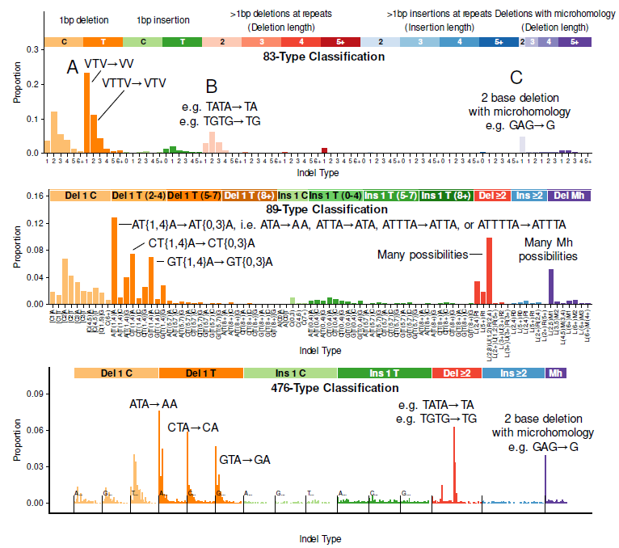
Figure 1 The aristolochic acid (AA) indel signatures in the 83-type, 89-type and 476-type classification schemes (signature 23).

(A) Looking at labeled bars from left to right, at the 83-type classification highest bar is labeled VTV→VV, indicating a the deletion of a single T (thymine) surrounded by non-thymines (V, the preceding V and following V can be different bases, e.g. ATC→AC). Still in the 83-type classification, the second most frequent deletion is a deletion of single T from TT flanked by non Ts (VTTV→VTV). In the 89-type classification there is a many-to-many representation of these (and other mutations) to a peak labeled AT{1,4}→AT{0,3}A, which indicates 4 possible types of mutations as indicated in the figure ATA→AA, ATTA→ATA, ATTTA→ATTA, and ATTTTA→ATTTA. To the right are analogous deletions from e.g. CTA→CA, CTTA→ CTA, etc, and then further to the right, GTA→GA, GTTA→GTA, etc. Finally, the 476-type classification makes clear that in fact the main deletions are ATA→AA, CTA→CA, and GTA→GA.

(B) Further to the left in the 83-type classification there are three light orange bars, with the highest labeled “e.g. TATA→TA, e.g. TGTG→TG” these bars represent 2-base deletions, with the highest bar representing a the deletion of a 2-base unit from the 2-base unit duplicated (e.g. a 2-base unit TA, in the duplicated 2-base unit TATA, with the deletion being TATA→TA). The classification does not capture information on the bases involved. In the 89-type classification, these are captured in the tall red bar labeled “many possibilities”, which represents a wide range of deletions, up to deletions such as ATATATAT→AT, which are essentially absent in this signature. The tallest of the corresponding bars in the 476-type classification is labeled “e.g. TATA→TA, e.g. TGTG→TG”, in one-to-one correspondence with the the light orange bar in the 83-type classification with the same label. Like the 83-type classification, the 476-classification does not capture the identity of the bases involved for these deletions.

(C) At the far right, in the 83-type-classification, the light purple bar indicates 2-base deletions with microhomology, e.g. GAG→G, where the G flanking the deletion is the microhomologous base. The bases involved are not captured, and other possibilities include GTG→G, TAT→T, and many others. In the 89-type classification these and many other possible deletions are represented by the peak “Many Mh possibilities”, which includes, in addition, deletions such as ATCGTA→A, which are essentially absent from this signature. In the 476-type classification, as in the 83-type classification, the highest bar is labeled “2 base deletions with microhomology”, and it represents the same set of mutations as the corresponding bar in the 83-type classification. However, in general, even for the 476 classification there is many-to-many mapping of deletions and insertions of more than 1 base between the 83-type and 476-type classifications (Table S1).

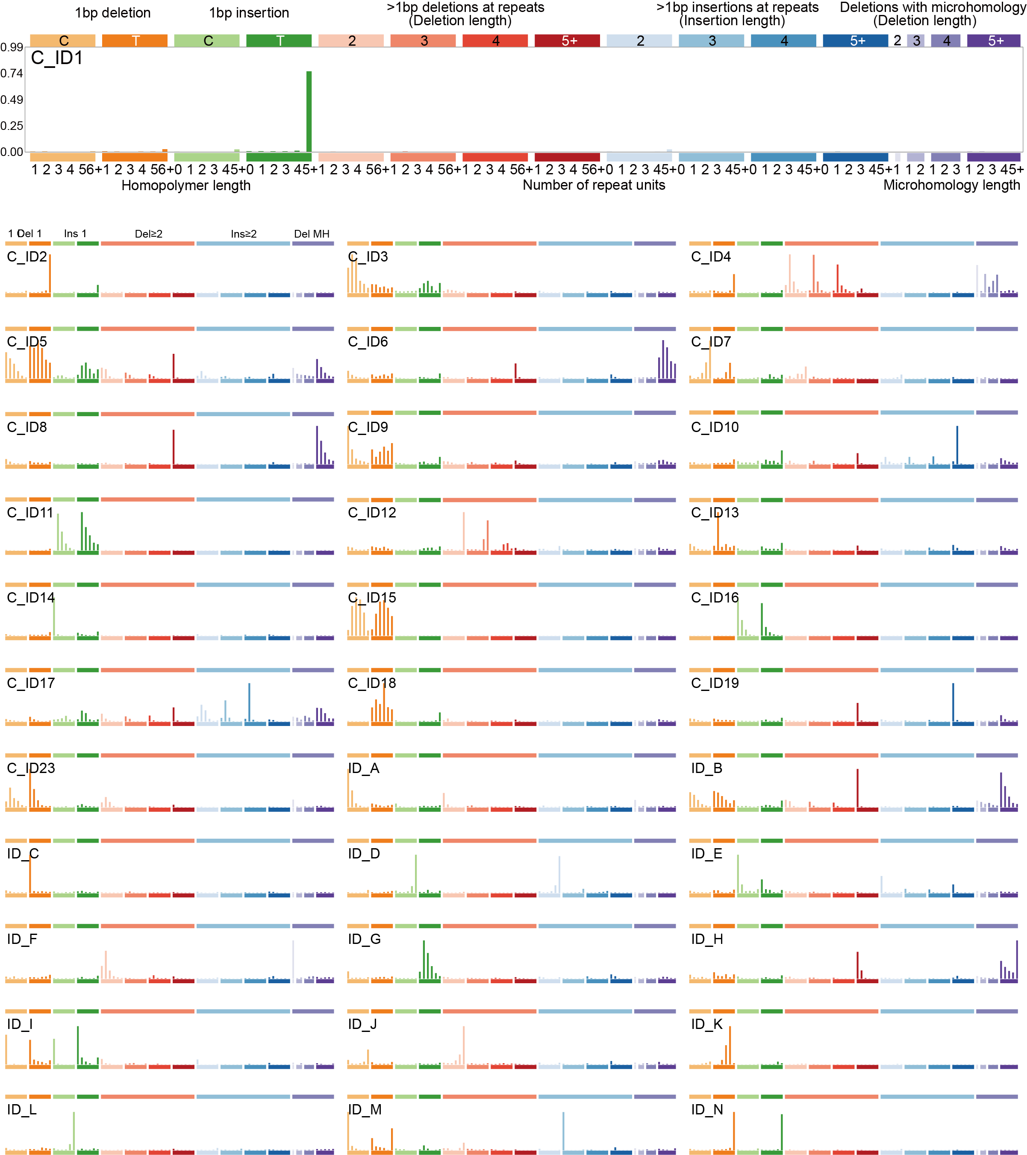

Figure 2 Profiles of signatures extracted in the 83-type classification scheme
The x-axes represents indel categories and the y-axes indicate the proportion of each indel category within each signature. Signatures C_ID1 through C_ID23 match reference signatures in COSMIC 3.5 and follow the same numbering. For example C_ID1 matches ID1. The remaining signatures, ID_A through ID_O were not present in COSMIC 3.5.

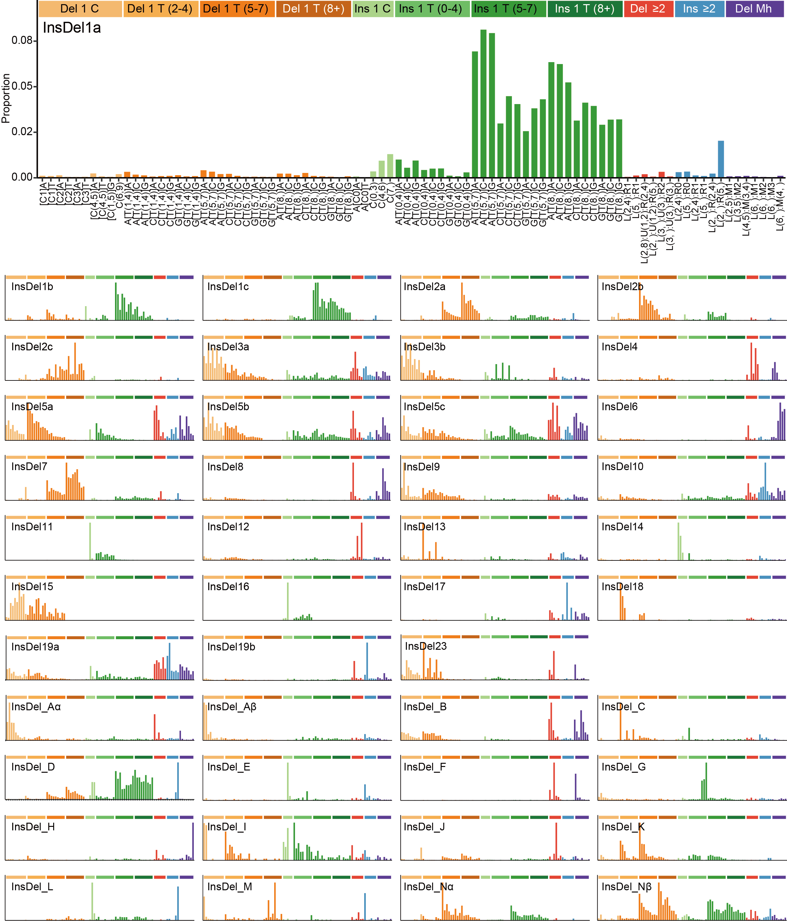
Figure 3 Profiles of signatures extracted in the 89-type classification scheme
The x-axes represent indel categories and the y-axes indicate the proportion of each indel category within each signature. For those signatures that correspond to reference signatures in COSMIC 3.5 we use the same numbering, with sub-labels (a, b, c, d) when a single signature in the 83-type classification maps to multiple signatures in the 89-type classification. We use the identifier prefix “InsDel” to distinguish these signatures from signatures in COSMIC (prefix “ID”) and Koh et al., 2025 (prefix InD)

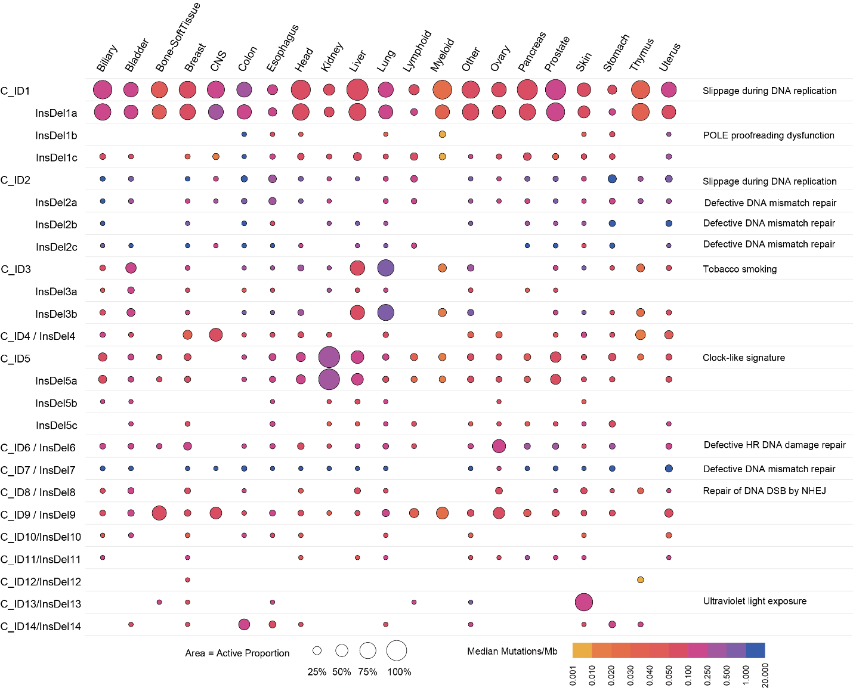
Figure 4a Activity of 83-type and 89-type mutational signatures across cancer types (part1, InsDel1a to InsDel14)
The color indicates the median number of mutations due to the exposure (mut/Mb) and the size indicates the proportion of samples bearing the given signature in the given cancer type.

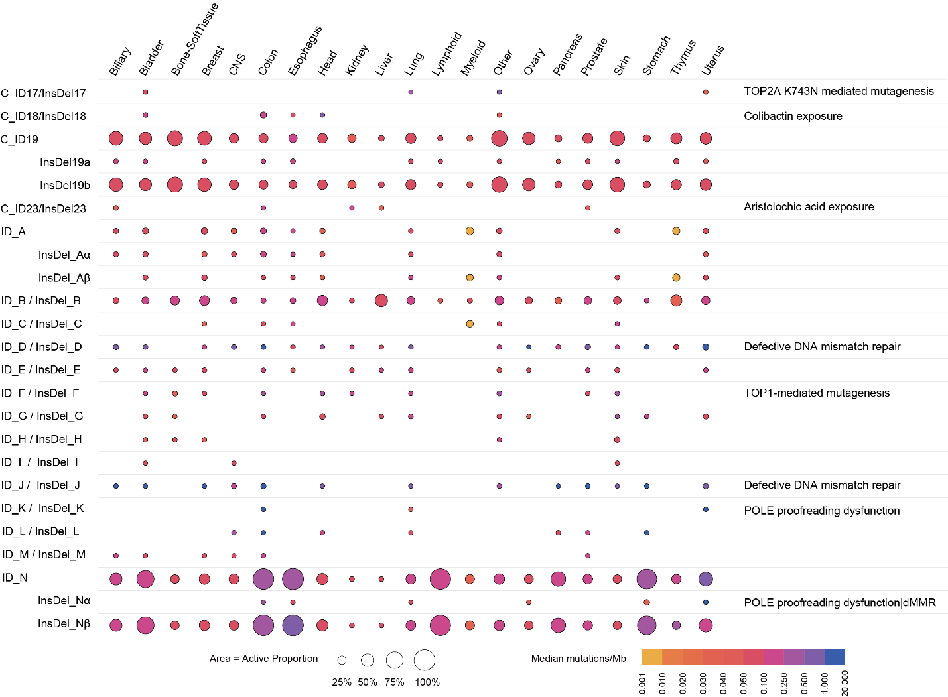
Figure 4b Activity of 83-type and 89-type mutational signatures across cancer types (part1, InsDel17 to InsDel_Nβ)
The color indicates the median number of mutations due to the exposure (mut/Mb) and the size indicates the proportion of samples bearing the given signature in the given cancer type.

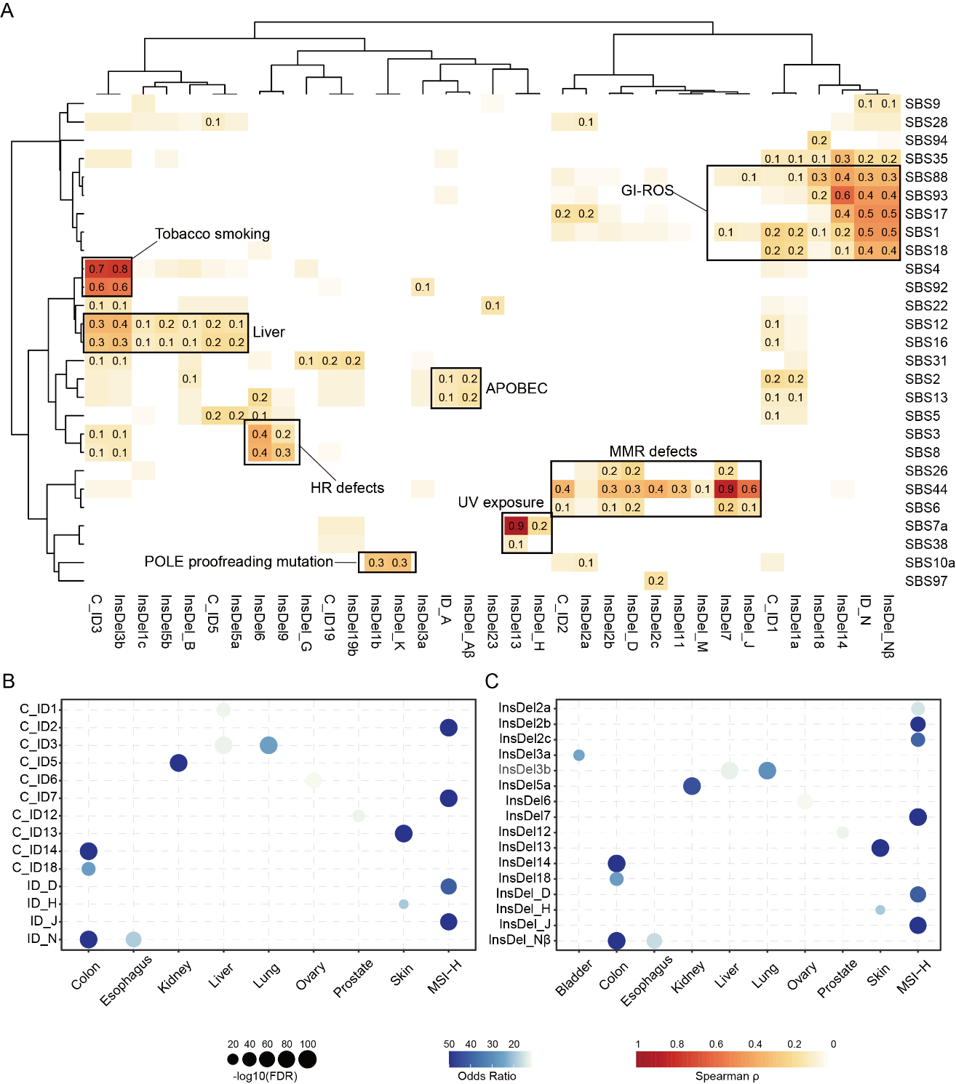
Figure 5 Association of 83-type/89-type indel signatures with SBS signatures and cancer types
(A)The heatmap of Spearman correlation coefficients between 83-type and 89-type indel signatures and various SBS signatures. Signatures were excluded if all correlation coefficients were between –0.1 and 0.1. The color intensity reflects the strength of the correlation, with darker colors indicating stronger correlations. Unsupervised hierarchical clustering of both rows and columns identified seven biological modules: MMR (DNA mismatch repair) defects, GI-ROS (Gastrointestinal-Reactive Oxygen Species), UV exposure, Liver, HR (DNA homologous recombination repair) defects, Lung tobacco smoking and APOBEC mutagenesis. Each signature is annotated according to the cluster to which it belongs.
(B) Enrichment of 83-type signatures in cancer types and MSI status. Dot size indicates the odds ratio from Fisher’s exact test comparing the number of samples with exposure>0 of the indel signature in each cancer type versus the remaining samples. Dot color represents the false discovery rate (FDR) after multiple-testing correction. Larger dots indicate stronger enrichment, and darker colors indicate more significant associations.
(C) Enrichment of 89-type signatures in cancer types and MSI status. Dot size indicates the odds ratio from Fisher’s exact test comparing the number of samples with exposure>0 of the indel signature in each cancer type versus the remaining samples. Dot color represents the false discovery rate (FDR) after multiple-testing correction. Larger dots indicate stronger enrichment, and darker colors indicate more significant associations.

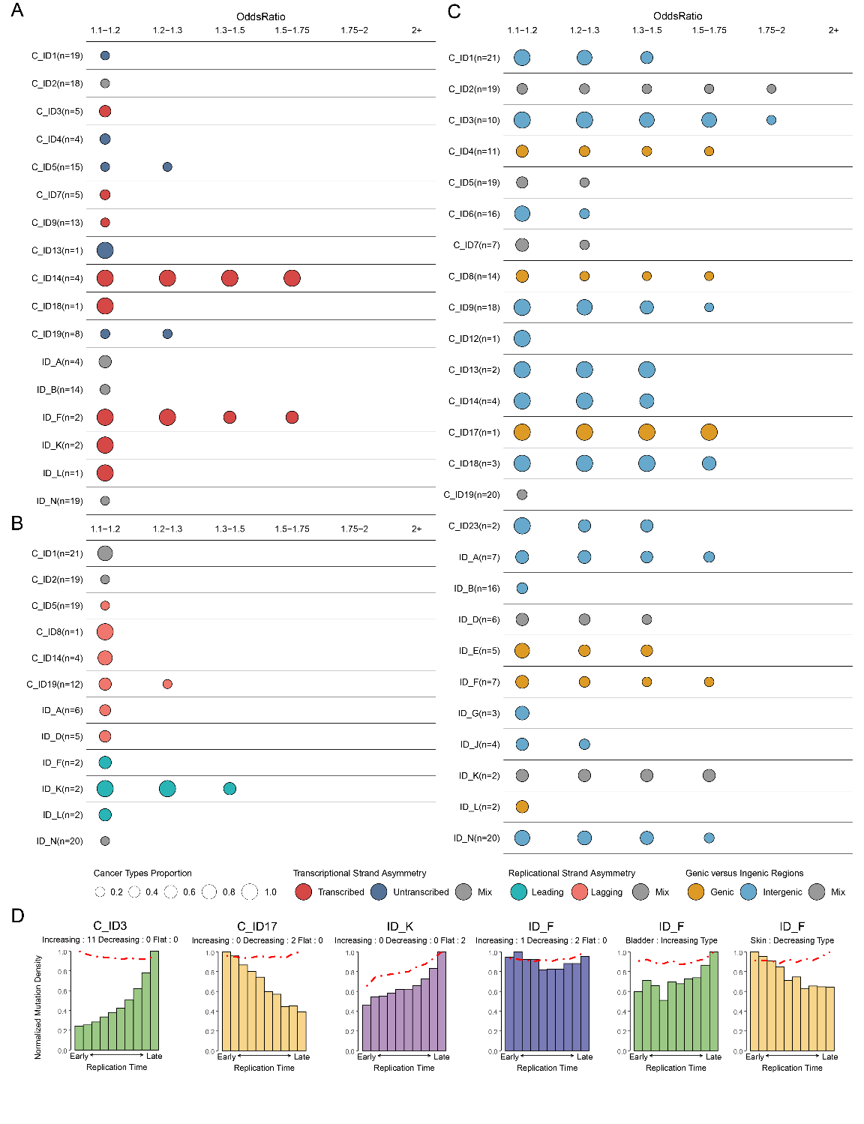
Figure 6. 83-type mutational signatures asymmetries in strands, replication timing and DNA regions.
(A) Enrichment of mutations in genic and intergenic regions for 83-type signatures. Each row represents one 83-type signature, where n reflects the number of cancer types in which the signature was found. Signatures consistently enriched in genic and intergenic regions with p values > 0.05 (Fisher’s exact test) are shown in circles with yellow and light blue colors, respectively. Grey colors indicate inconsistent enrichments in different cancer types. Columns display the odds ratio between the ratio of real mutations and the ratio of simulated mutations (See Methods). Only odds ratios above 1.10 are shown. Circle sizes reflect the proportion of cancer types exhibiting specific enrichment in DNA regions in a signature.
(B) Replication strand asymmetries of 83-type signatures. Data are presented in a format similar to the one in panel (A), with green and orange colors indicating replication strand asymmetries on the lagging and leading strands, respectively.
(C) Transcription strand asymmetries of 83-type signatures. Data are presented in a format similar to the one in panel (A), with red and dark blue colors indicating transcription strand asymmetries on the transcribed and untranscribed strands, respectively.
(D) 83-type signatures associated with early and late replication timing. Mutation densities of 83-type signatures per decile (y axes) are presented for early (left) to late (right) replication domains. Real mutations for signatures are shown as bars, and simulated mutations are shown as red dashed lines. As shown on top of each plot, green bars indicate signatures consistently associated with late replication timing across cancer types (e.g., C_ID3); yellow bars indicate signatures consistently associated with early replication timing across cancer types(e.g., C_ID17); purple bars indicate signatures not affected by replication timing across cancer types(e.g., ID_K); blue bars indicate signatures showing inconsistent trend across cancer types(e.g., ID_F)..
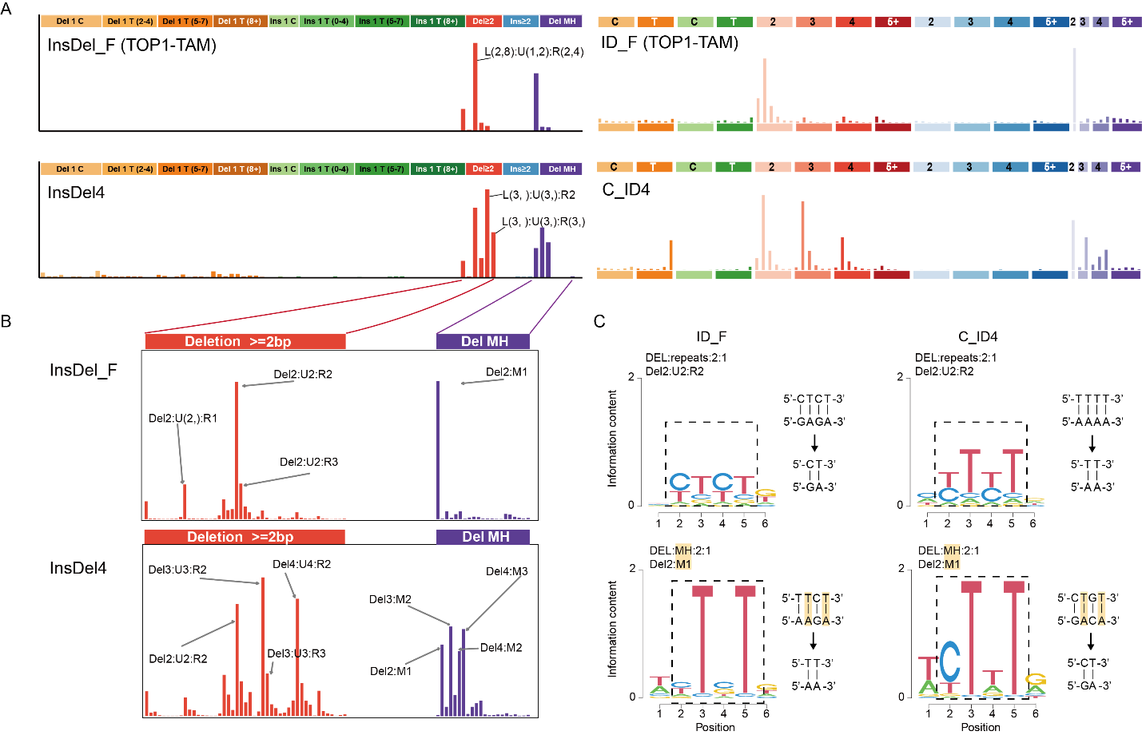
Figure 7 Novel signature caused by RNase H2 deficiency and topoisomerase-1-associated mutagenesis (TOP1-TAM)
(A) The mutational signature of RNase H2 deficiency (InsDel_F in the 89-type classification, ID_F in the 83-type classification), and a previously identified mutational signature (InsDel4, C_ID4).
(B) Deletions of ≥ 2 bases in the 476-type classification scheme in InsDel_F compared to InsDel4. InsDel4 has substantial proportions of deletions of 3 and 4 bases (Del3:U2:R2, Del4:U4:R2, Del3:M2, Del4:M2, Del4:M3) that are essentially absent in InsDel_F. Refer to panel B for additional explanations of the mutation labels.
(C) Logos of the sequence contexts of 2-base deletions in 5 samples with the highest InsDel_F activity (left) compared to 5 samples with the highest InsDel4 activity (right). The sequence contexts of the 2-base deletions in InsDel_F are on the whole different from the contexts of 2-base deletions in InsDel4. In the lower two sections (DEL:MH:2:1, 2-base deletions with 1 base of microhomology), the microhomologous bases (T:A) are shaded orange.

