Spring boot kafka笔记
1、导spring-kafka包
<dependency>
<groupId>org.springframework.kafka</groupId>
<artifactId>spring-kafka</artifactId>
</dependency>

2、配置application.properties
spring.application.name=kafka-producer-demo
server.port=8080
#============== kafka ===================
spring.kafka.bootstrap-servers=localhost:9092
spring.kafka.listener.concurrency= 3
#=============== provider =======================
spring.kafka.producer.retries=0
spring.kafka.producer.batch-size=16384
spring.kafka.producer.buffer-memory=33554432
spring.kafka.producer.key-serializer=org.apache.kafka.common.serialization.StringSerializer
spring.kafka.producer.value-serializer=org.apache.kafka.common.serialization.StringSerializer
#=============== consumer =======================
spring.kafka.consumer.group-id=test
spring.kafka.template.default-topic=test
spring.kafka.consumer.auto-offset-reset=earliest
spring.kafka.consumer.enable-auto-commit=true
spring.kafka.consumer.auto-commit-interval=100
spring.kafka.consumer.key-deserializer=org.apache.kafka.common.serialization.StringDeserializer
spring.kafka.consumer.value-deserializer=org.apache.kafka.common.serialization.StringDeserializer

- Kafka生产者，用KafkaTemplate发送消息
@Component
public class KafkaSender {

protected final Logger logger = LoggerFactory.getLogger(this.getClass());

@Resource
private KafkaTemplate<String,String> kafkaTemplate;

public void send(String msg) {
logger.info("KafkaSender发送消息,消息内容: {}", msg);
try {
kafkaTemplate.send("test", UUID.randomUUID().toString(), msg);
}catch (Exception e){
logger.error("KafkaSender发送消息异常",e);
}
}
}

4、Kafka消费者，用@KafkaListener监听消费
@Component
public class KafkaConsumer {

protected final Logger logger = LoggerFactory.getLogger(this.getClass());

@KafkaListener(topics = {"${spring.kafka.template.default-topic}"})
public void listen(ConsumerRecord<?, ?> record) {
try {
logger.info("kafka的key: " + record.key());
logger.info("kafka的value: " + record.value().toString());
} catch (Exception e) {
logger.error("kafka接收消息异常",e);
}
}
}

4、启动类，加@EnableKafka开启kafka
@SpringBootApplication
@ComponentScan({"com.example.kafka.demo"})
@EnableKafka
public class SpringbootKafkaDemoApplication {
public static void main(String[] args) {
SpringApplication.run(SpringbootKafkaDemoApplication.class, args);
}
}

5、先启动消费者，再执行下面生产者发送消息单元测试
@RunWith(SpringRunner.class)
@SpringBootTest(classes = SpringbootKafkaDemoApplication.class)
public class KafkaSenderTest{

@Autowired
private KafkaSender sender;

@Test
public void send() throws Exception {
sender.send("KafkaSender发送消息test");
}
}

执行后查看生产者：
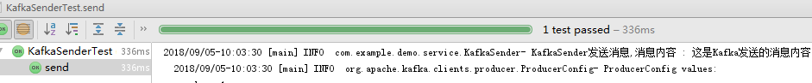

执行后查看消费者：

