**Introduction**

The ability to accurately calculate distances in space was long sought after. The introduction of standard candles or instances in space that are used to gauge distances to other nearby objects resolved this issue. Generally, these standard candles are able to provide distance estimations due to some form of inherent nature of the object. Type 1a supernovae (SNe 1a) are often included in the set of standard candles due to their standardized peak luminosity. Thus, with relatively simple calculations, one can calculate the distance to these kinds of supernova by comparing the apparent magnitude with the known absolute magnitude at its peak.

The reasoning behind the consistency of the peak luminosity is that SNe 1a are uniquely formed through binary star systems, where at least one of the stars is a white dwarf. As the white dwarf strips its companion star and increases in size, it edges closer to the Chandrasekhar limit of ~1.4M☉, or the critical mass of a white dwarf still being held through electron degeneracy pressure. When this limit is surpassed, electron degeneracy fails, and the resulting runaway reaction is a SN 1a. Since the mass and explosion process are effectively the same for most SNe 1a, it intuitively makes sense that the peak luminosity is similar.

However, upon closer inspection of SNe 1a light curves, we discover that the peak luminosity is not completely standardized and in fact fluctuates between +/- 0.3 magnitudes. We further observe that the rate of decay of luminosity is not consistent throughout all SNe 1a. This relationship is referred to as the Phillips relationship and details the luminosity decline rate relation. This report seeks to not only confirm the proven relationship but also to expand upon these findings and seek out potential correlations between decay rate and other factors of the SNe 1a.

**Data**

The data that I used is primarily extracted from the Open Supernova Catalog. In order to gather the amount of data that was required to be processed, I used the API that the website offered. Thus, I wrote a script that would pull all available SNe1a in the database and their respective light curve measurements.

In order to keep consistent with the requirements that the Phillips paper outlined, I have only selected supernovas that satisfy the three requirements set forth in the original paper.

1. *Precise Optical Photometry*

A major concern of the paper was the inaccuracies of photographic photometry and selectively only included supernovas with photometric data collected through photoelectric or CCDs. However, photometry technology has progressed significantly since the paper’s publication and modern photometry is largely concentrated in CCDs – rendering photographic photometry effectively obsolete and unused.

1. *Well-sampled Light Curves*

The paper outlines a need for any photometry measurements to have continued at least 20 days after the peak luminosity. In addition, Phillips arbitrarily defines that the light curve must be sampled well enough to prevent any large interpolations. In my sampling, I chose to keep the existing criteria and additionally add that there must be at least 1 light curve measurement for every 5 days in order to concretely define the large interpolation prevention.

1. *Accurate Relative Distance*

Phillips chooses to only find supernovae that have accurate host galaxy distance measurements, specifically restricting acceptable distance measurements to Tully-Fisher (TRF) and surface brightness fluctuations (SBF). Similarly to (1), we find that distance measurement capabilities to have increased significantly since the paper has published. In addition, TRF and SBF are restricted to ~100Mpc while the SNe 1a can act as standard candles to distances of ~3000Mpc. Thus, we choose to select any supernovae that simply have any other method of distance detection, softening the original SBF and TRF restrictions.

With these restrictions in mind, my script would have to eliminate supernovae that did not qualify as acceptable. As my preliminary goal was to simply verify the accuracy of the Phillips’ relationship, I needed to also calculate the percentage of supernovae that passed the restrictions but also fell within the range of the Phillips’ relationship.

**Results**

The first results that we sought were to find the accuracy of Phillips’ model, specifically targeting the B (λ = 445 nm), V (λ = 551 nm), and I (λ = 806 nm) magnitudes. For each of the following bands, Phillips’ regression shows that

$M_{max}=-21.726+2.698∆m_{15}(B)$

$M_{max}=-20.883+1.949∆m_{15}(V)$

$M_{max}=-19.591+1.076∆m_{15}(I)$

where $∆m_{15}(B)$, $∆m_{15}(V)$, and $∆m_{15}(I)$ are the change of B, V and I-magnitudes of the supernova in the span of 15 days after the peak luminosity respectively.

After processing all SNe1a from the Open Supernova Catalog, we first eliminated any supernovae that did not satisfy Phillips’ requirement (2) and (3). After that, we calculated $∆m_{15}$ of each of these supernovae. This was not as straightforward as we had hoped as the Phillips relationship uses absolute magnitudes for their regressions. Thus, we compensated by finding the luminosity distance to each of these supernovae and calculating the absolute magnitude of the mpeak by using the following relationship:

$M_{absolute}=m_{apparent}-5(\log_{10}D_{L}-1)$

Finally, since we now know the absolute magnitude of the peak, we were able to plug in each supernovae’s calculated $∆m_{15}$ into their respective Phillips’ regressions and compare the expected Mmax with the actual mpeak. The Phillips paper also suggested several error margins for the regressions based on the type of band magnitude and we used these same error margins for our accuracy tests as we did see a need to change them. Our calculated percentages are displayed in Figure A.

  
Figure A. Accuracy test results using Phillips’ regressions and error margins

Surprisingly, all of the Phillips regressions only moderately accounts for the relationship between the rate of decay and the peak magnitude. While the B-band regression is significantly more accurate than the other two bands, it still does not seem as strong as it should be. Moving forward from here, we decided to attempt to find a better regression that would more accurately depict the relationship.

In order to calculate the regressions, we modified our script to generate three CSVs for each band where the files contained the SN identifier, the peak magnitude, and the magnitude 15 days after the peak. We then plotted and ran ordinary least-squares on the data. Linear regression results can be seen in Figure B, C and D.

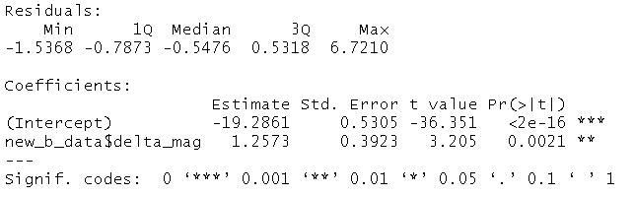   
Figure B. OLS results for B-band

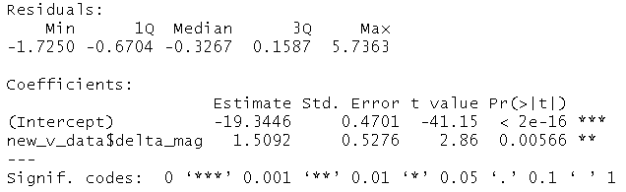  
Figure C. OLS results for V-band

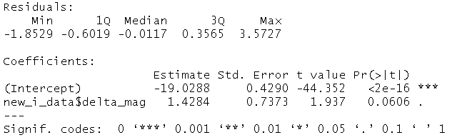  
Figure D. OLS results for I-band

We see that both the intercept and the 15 day magnitude delta parameters are significant in the regression – except for in the I-band. With these new regressions, we propose that the following relationships will be a better fit for our data:

$M_{max}=-19.286+1.257∆m_{15}(B)$

$M_{max}=-19.345+1.509∆m_{15}(V)$

$M_{max}=-19.029+1.428∆m_{15}(I)$

To test our new regressions, we reran our script on our supernovae data to see if there was any improvement in the accuracy test.

  
Figure E. Accuracy test results using our own regressions but same error margins.

We can see that while the B-band is less accurate by a slight margin, there are significant improvements in the V and I band accuracy.

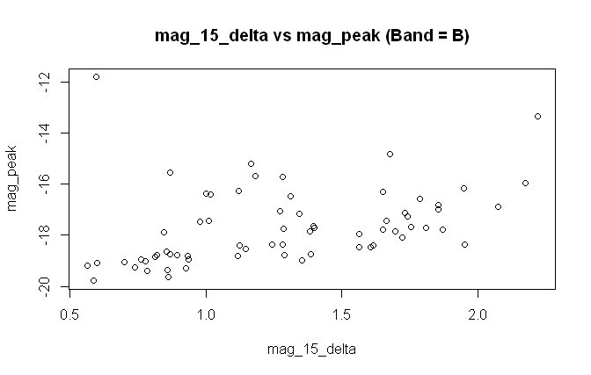

**Conclusion**

Phillips’ dataset of six supernovae was incredibly small and thus we sought an improvement on his regressions based on the much robust supernovae datasets that we have today. We discovered that the percentage of current supernovae data that fit under Phillips’ relationship is relatively low. To find out own relationship, we then used the supernovae data that we had gathered and discovered an updated relationship

**Bibliography**

<http://articles.adsabs.harvard.edu/cgi-bin/nph-iarticle_query?db_key=AST&bibcode=1977SvA....21..675P&letter=.&classic=YES&defaultprint=YES&whole_paper=YES&page=675&epage=675&send=Send+PDF&filetype=.pdf>

<https://courses.lumenlearning.com/astronomy/chapter/the-extragalactic-distance-scale/>

<https://astroquery.readthedocs.io/en/latest/simbad/simbad.html#query-an-identifier>

<http://articles.adsabs.harvard.edu/cgi-bin/nph-iarticle_query?db_key=AST&bibcode=1977SvA....21..675P&letter=.&classic=YES&defaultprint=YES&whole_paper=YES&page=675&epage=675&send=Send+PDF&filetype=.pdf>

<https://www.astro.princeton.edu/~burrows/classes/541/fraisse_talk.pdf>

<http://hyperphysics.phy-astr.gsu.edu/hbase/Astro/snovcn.html#c4>

<http://universe-review.ca/R08-04-degeneracy.htm>

<http://astronomy.swin.edu.au/cosmos/L/Luminosity-Decline+Rate+Relation>

<http://www.astronomy.ohio-state.edu/~ryden/ast162_5/notes20.html>

<https://github.com/astrocatalogs/OACAPI>

<https://github.com/astrocatalogs/schema>

<https://github.com/astrocatalogs/OACAPI>

<https://arxiv.org/pdf/1209.4692.pdf>

<http://simbad.u-strasbg.fr/simbad/>

<https://sne.space/>