
Delphi Electronics & Safety
Wireless Europe

Software Design Document

Process Manager
Prepared for customer-independent

Document: SDD-10017133-400.01
Date: 14 Nov 2006 Version: 2.0
Prepared by: Lukasz Ptak, Michal Gebolys
Delphi Electronics & Safety, Technical Center Krakow
ul. Podgorki Tynieckie 2, 30-399 Krakow, Poland

Revision History

Version | Date | Author / Department | Change Description | Approved by
1.0 | 17 June 2004 | Michal Gebolys | Initial Document
2.0 | 14 Nov 2006 | Lukasz Ptak | Updated document template

Table of Contents

1 Introduction 3
1.1 Scope 3
1.2 Overview 3
1.3 Constraints / Limitations 3
2 Global Data Structure and Shared Data Function 3
2.1 Global structures 3
2.2 Global macros 4
3 External Design 4
3.1 Interfaces 4
3.2 Dependencies 4
3.3 External Behavior 5
3.3.1 System start-up 5
3.3.2 System shutdown 6
4 Internal Design 6
4.1 Static Description 6
4.1.1 Architectural Design 6
4.1.2 Process configuration file 8
4.1.3 Process configuration sets 8
4.2 Dynamic Description 8
4.2.1 State diagram of a process 8
4.2.2 State diagram of the Process Manager 10
4.3 Thread Model and Internal Communication 11
5 Usage Guidelines 11
5.1 Configuration file format 11
5.1.1 Configuration options 13
5.2 Starting the Process Manager 14
5.2.1 Syntax of the command line 14
5.3 Terminating the Process Manager 14
6 Critical For Testing 15
7 Open Issues 15
8 Assumption 15
9 Document References 15
10 Traceability 15
11 Planned Test Strategy and Test Criteria 16
12 Lessons learned 16
13 Abbreviations and Acronyms 16

Introduction

Scope
This document describes the high level design of the Process Manager application. The design is based on the requirements specified in the document [1].

Overview
The Process Manager is responsible for launching and supervising all processes defined in a configuration file. In particular, it is responsible for system start-up, shutdown and monitoring applications (processes) state. When application finishes its initialization phase it is expected to notify the PM. The Process Manager monitors applications and in case of its termination the PM can restart this application respect to its configuration parameters.

Constraints / Limitations
Process Manager is limited to handle up to 32 configurations which means that every “-c” parameter in configuration file must be a number from 0 to 31.

Global Data Structure and Shared Data Function
Communication between Process Manager and other applications is based on SAL message framework. More detailed message description can be found in sections: 4.2.1. and 4.2.2.

Global structures

Structure name: | Ev_Start_App_T
Description: | Event sent by an application to the Process Manager to start an application.
Structure field | Field description
int app_id | Application’s id to be started

Structure name: | Ev_App_Exit_T
Description: | Event published by the Process Manager when an application terminates.
Structure field | Field description
int app_id | Application’s id to be terminated
int return_code | Application return code

Structure name: | Ev_Set_System_Config_T
Description: | Event sent by an application to the Process Manager to set new system configuration.
Structure field | Field description
int system_config | System config number to be set

Structure name: | Ev_System_Config_Reached_T
Description: | Event published by the Process Manager when system configuration is reached.
Structure field | Field description
int system_config | Current configuration number

Global macros

Macro name: | Get_App_Id
Description: | Gets an application id from received message. The message can be SAL_Message_T type for C or SALMessage for C++, i.e.
Parameter | Parameter description
msg | Message from which application id is to be extracted

Macro name: | Get_Terminated_App
Description: | Gets id of terminated application from received message. The message can be SAL_Message_T type for C or SALMessage for C++, i.e.
Parameter | Parameter description
msg | Message from which terminated application id is to be extracted

Macro name: | Get_Return_Code
Description: | Gets application's return code from received message. The message can be SAL_Message_T type for C or SALMessage for C++, i.e.
Parameter | Parameter description
msg | Message from which application's return code is to be extracted

Macro name: | Get_New_System_Config
Description: | Gets a new system coniguration from received message. The message can be SAL_Message_T type for C or SALMessage for C++, i.e.
Parameter | Parameter description
msg | Message from which new system coniguration is to be extracted

Macro name: | Get_System_Config
Description: | Gets the reached system coniguration from received message. The message can be SAL_Message_T type for C or SALMessage for C++, i.e.
Parameter | Parameter description
msg | Message from which reached system coniguration is to be extracted

External Design

Interfaces
Refer to section 2.

Dependencies
The following diagram depicts the dependencies that Process Manager has with other applications/frameworks or components in the system:

SAL2
Debug
Trace
Utilities
Process
Manager
Figure 1: External Dependencies

The description of the external components is as follows:
- SAL2: System Abstraction Layer version 2 is used for making the Process Manager platform (QNX and Windows) independent.
- Debug Trace: Process Manager will use the Debug Trace interfaces for debugging and printing debug prints.
- Utilities: Process Manager uses various general utilities interfaces

External Behavior

System start-up
During system start-up the Process Manager is responsible for starting up the processes. It starts the processes from the default configuration first. After receiving the EV_SET_SYSTEM_CONFIG message the PM upgrades the current configuration by terminating the processes not present in the new configuration and starting up the additional ones.
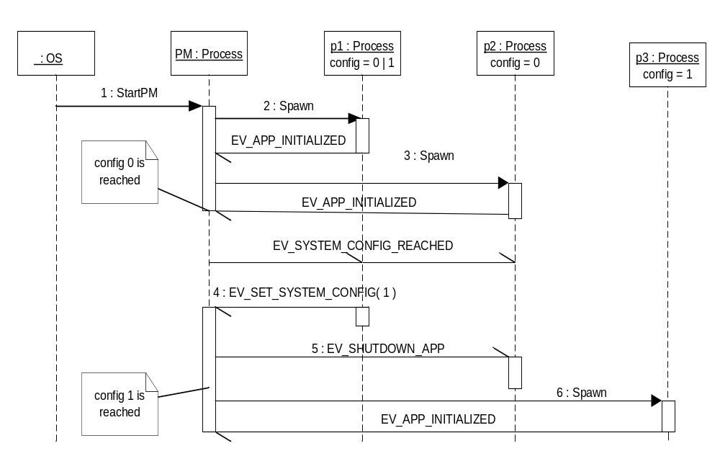
Figure 2: Sequence diagram of system startup

Figure 2 presents scenario where the PM initially starts processes p1 and p2 from configuration 0 and next after receiving a message from p1 brings system to configuration 1 by terminating p2 and starting p3.

System shutdown
During system shutdown the Process Manager is responsible for shutting down gracefully the processes. It terminates processes in reverse order as they are listed in the configuration file. The power management application removes power when it receives EV_SHUTDOWN_APP message.

Internal Design

Static Description

Architectural Design
Process Manager is designed to work together with SAL2 applications. Figure 3 presents how the PM collaborates with different kinds of processes.

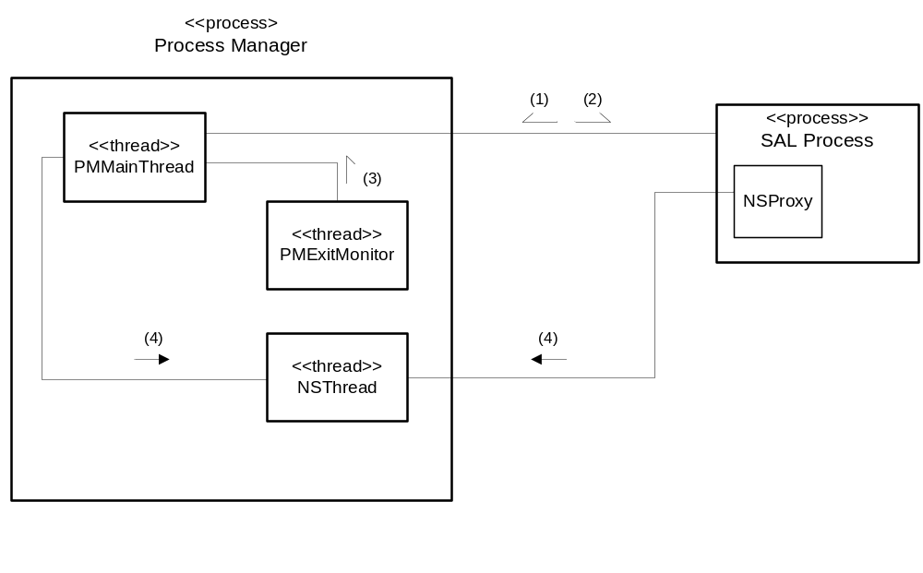
Figure 3: Process Manager system architecture

- Process Manager – the program that is responsible for supervising SAL2 processes
- SAL2 Process – an application that communicates with PM using asynchronous SAL2 API [2]. If the process is interested in receiving messages from PM it should subscribe to them.

- PMMainThread – the central part of the Process Manager. It contains process registry and is responsible for processing all messages, in particular it delivers events to process state machines and publishes events. It is the only thread which accesses the processes registry so it is not required to provide mutual exclusion for the registry.

- PMExitMonitor – the thread without a message queue. It waits for a child processes to exit. If this situation occurs it sends a message to the PMMainThread.

- NSThread – implements Name Server functionality (see [3])

Digits in the Figure 3 denote groups of messages exchanged between components. The following messages belong to each group:

(1) PM subscribes to following events sent by any of SAL2 Processes:
- EV_START_APP( appId )
- EV_APP_INITIALIZED
- EV_SET_SYSTEM_CONFIG( configId )
- EV_SYSTEM_SHUTDOWN

(2) SAL2 Processes can subscribe to the following events published by PM.
- EV_SHUTDOWN_APP
- EV_SYSTEM_CONFIG_REACHED( configId )
- EV_APP_EXIT( appId, retCode )

(3) PMExitMonitor sends a message with system process id directly to PMMainThread
- EV_PROCESS_EXIT( pid, retCode )
(4) SAL2 Processes send synchronous messages via NSProxy interface
- Name_Server_Bind()
- Name_Server_Unbind()
- Name_Server_Resolve()
- Name_Server_Unsubscribe_App()

Process configuration file
The process configuration file is an ASCII text file that contains series of configuration options for the processes controlled by the PM. These options are used by the PM to start, monitor and terminate these processes. When the PM starts it opens and then parses the configuration file. If there is at least one valid entry in the file the PM proceeds with starting and monitoring the process(es), otherwise it terminates. “Valid” means all required application options are provided. If the PM fails to open the configuration file it exits.

Process configuration sets
The Process Manager manages an actual system configuration. Configuration is defined as a set of running applications and is identified by an integer number from 0 to 31. There is a ‘-c<config-number>’ option in the configuration file which specifies to which configuration given application belongs. An application can belong to many configurations.
Once the PM is started it brings system to the default configuration. ‘0’ is the default configuration, it means that all processes with option ‘–c 0’ will be started. The default configuration can be changed by the PM’s command line option (see 5.2.1).

Dynamic Description

State diagram of a process
In the Process Manger’s view each process has its own state machine as shown in the Figure 4. The process can be in any of the following states:
- Uninitialized – process has not been spawned yet
- Loading – process is spawned
- Running – process is during its normal processing
- Shutdown – system shutdown is processing but the process is not being terminated yet
- Terminating – process is terminating

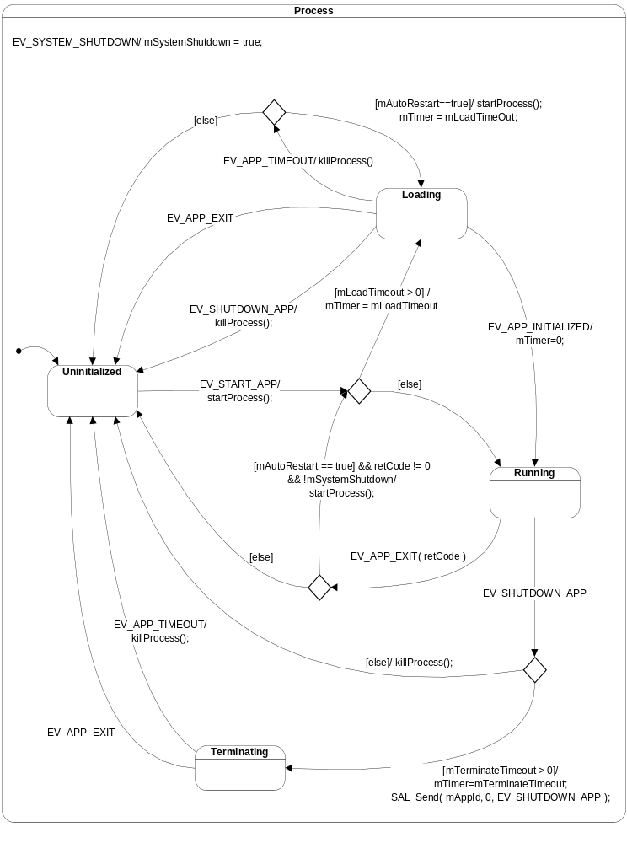
Figure 4: Process statechart

Each process reacts on events described in the following table:

Event | Description
EV_START_APP | Request to start process.
EV_APP_INITIALIZED | Application notifies that it is initialized.
EV_SHUTDOWN_APP | Request an application shutdown.
EV_APP_TIMEOUT | Internal event, process load time or terminate time expires.
EV_APP_EXIT( retCode ) | Process terminates.

State diagram of the Process Manager

Figure presents the statechart of the Process Manager. Symbol ^ denotes a message publish operation.
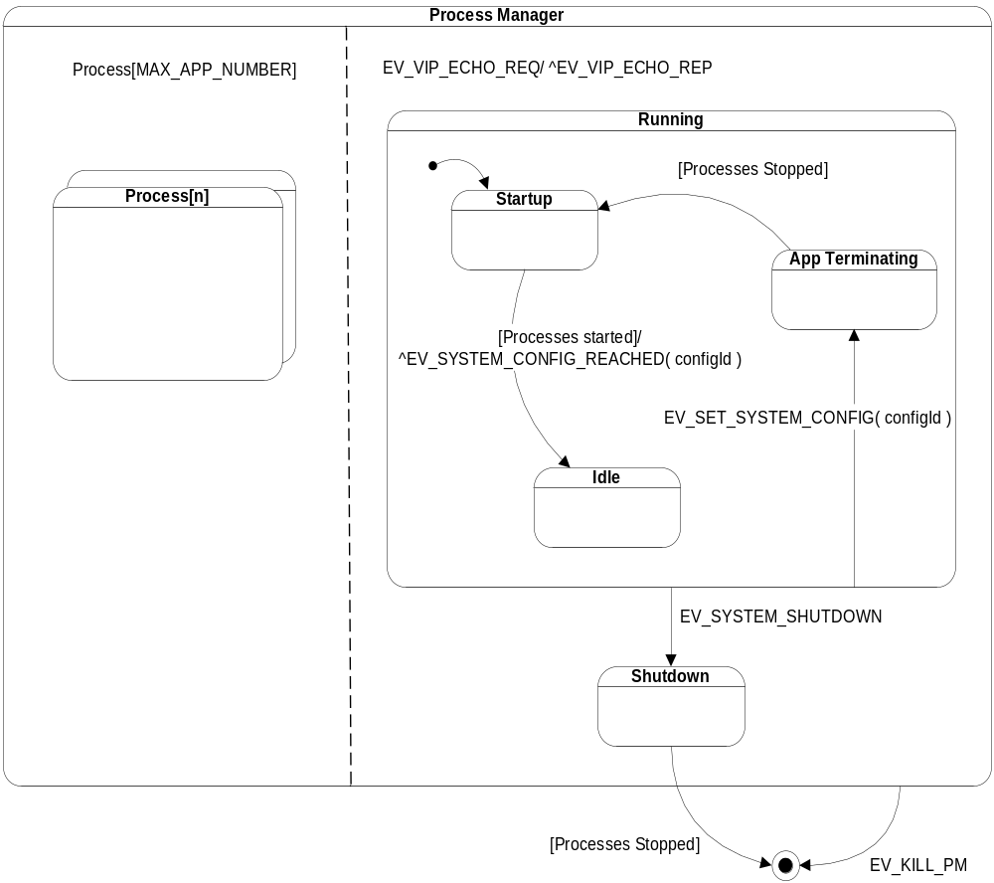

Figure 5: Process Manager statechart
State description:
- Startup – PM is starting applications from the current configuration.
- App Terminating – PM is terminating applications not present in the current configuration.
- Idle – PM is waiting for events to process.
- Shutdown – system shutdown is performing.

Events are described in the following table:

Event | Description
EV_SET_SYSTEM_CONFIG( configId ) | Application requests to change system configuration to configuration identified by configId.
EV_SYSTEM_SHUTDOWN | Application requests to perform the system shutdown.
EV_SYSTEM_CONFIG_REACHED( conigId ) | Event is published when all applications from the new configuration are in Running state.

Thread Model and Internal Communication
Refer to the diagram and description in section 4.1.1
The communication between these threads are based on SAL message framework.

Usage Guidelines

Configuration file format

The process configuration file consists of a sequence of lines that can be either a comment or a series of options for processes. Each process has a separate line in the process configuration file. The format of the configuration file can be defined by the following set of EBNF rules:

Configuration-file ::=

{ Comment New-line | Process-options New-line }* .

Comment ::=

‘#’ { Any-character-except-new-line }* .

Process-options ::=

{
‘-a’ Argument ^{M)} |
‘-c’ Configuration-set ^{M)} |
‘-d’ Working-directory ^{O)} |
‘-f’ Executable-file-path¹⁾ |
‘-l’ Load-time-out ^{O)} |
‘-n’ Process-name¹⁾ |
‘-p’ Process-priority ^{O)} |
‘-r’ ^{O)} |
‘-x’ Terminate-time-out ^{O)}
}* .

^{M)} – this option can appear any number of times
^{O)} – this option can appear at most once
¹⁾ – this option can appear exactly once

Argument ::=

Text .

Configuration-set ::=

Number .

Working-directory::=

Text .

Executable-file-path ::=

Text .

Load-time-out ::=

Number .

Process-name ::=

Text .

Process-priority ::=

Number .

Terminate-time-out ::=

Number .

Number - is a sequence of decimal digits.

Text - is a sequence of any characters except for space, double quote ‘”’, backslash ‘\’ and the new line. If the textual parameter is to contain spaces, the whole parameter should be surrounded by a pair of double quote characters (e.g. “word1 word2”). The double quote and backslash characters should be represented by ‘\”’ and ‘\\’ respectively (e.g. “AB C\”D\\E”). The following representations of texts not containing the space, double quote and backslash characters are equivalent: ABC and “ABC”. If a parameter contains the hyphen at the front, the whole parameter should be surrounded by a pair of double quote characters (e.g. –a “-b word”).

Configuration options

Option | Parameter | Type | Example | Description
-a | Argument | Text | -a “-v 3” | Argument passed to the child process. There can be any number of occurrences of this option.
-c | Configuration-set | Number | -c 2 | Configuration set identifier. An application can belong to several configurations.
-d | Working-directory | Text | -d /etc/audio | Current working directory.
-f | Executable-file-path | Text | -f /usr/bin/SystemMgr | The path of the executable file. If it contains only the executable file name, the environment variable ‘PATH’ will be used to search for the executable’s actual location in the file system. This option is mandatory.
-l | Load-time-out | Number | -l 10 | Load time-out value in seconds.
-n | Process-name | Text | -n "System Manager" | Symbolic name of the process. This option is mandatory.
-p | Process-priority | Number | -p 11 | Initial priority of the process.
-r | N/A | N/A | -r | Auto-restart flag. If present the process will be automatically restarted when timed out, its ‘main’ function returned non zero status or crashed. The process will be restarted only if it was spawned successfully.
-x | Terminate-time-out | Number | -x 10 | Terminate time-out value in seconds.

Here is an example of process configuration file’s contents. It consists of comments (first 5 lines) and configuration parameter for 6 processes (lines 6-11). There are 3 configurations defined.

1: # Defined configurations:
2: # 0 – core processes (default configuration)
3: # 1 – normal mode
4: # 2 – installation mode
5: #
6: -f ./ecd -l30 -n"ECD" -a"-c/dev/ser2" –c0 –c1 –c2
7: -f ./SelfDiag -l30 –x20 -n"self diagnostic" -a"0" –c0
8: -f ./RegistryManager -x10 -l30 -n"Registry Manager" -a"-d/home/registry/" –c0 –c1
9: -f ./SystemMgr -x10 -l30 -n"System Manager" -a"-p15" -a"-voff" –c0 –c1 –c2
10: -f ./FocusMgr –x5 –l20 -n"Focus Manager" –c1
11: -f ./InstallMgr -n"Install Mgr" –l9 –x10 –c2

Starting the Process Manager

On the target board ‘procman’ is invoked during startup of the system by ’/etc/rc’ script. In the test environment it can be started by ‘root’ user from the command line. There can be only one instance of the ‘procman’ process running in the system.

Syntax of the command line

procman –n | –f <config-file> [-c <default-configuration>][ -g <debug-group-mask> ] [ -l <log-file> ] [ -t ] [ -v <debug-level> ]

Option | Parameter | Description
-n | N/A | Run name server only. If this option is used the PM starts only the name server thread, configuration file is not parsed.
-f | config-file | Mandatory option that is used to pass the PM the location of the process configuration file unless ‘-n’ is used.
-c | Default-configuration | PM will start this configuration after parsing the configuration file. Configuration number 0 is starting by default.
-g | debug-group-mask | Diagnostic option that is used to switch on/off the debug groups. ProcessManager group has a corresponding ‘PM’ bit in ‘debug-group-mask’. Its actual numerical value can be found in ‘dt_groups.h’ header file (check the DebugTrace package).
-l | log-file | Diagnostic option that is used to redirect the debug output to the file ‘log-file’.
-t | N/A | Diagnostic option that is used to add time stamps to debug messages.
-v | debug-level | Diagnostic option that is used to set the debug level. Valid levels are: 1 (brief debugging), 2 (moderate debugging) and 3 (most detailed debugging).

For more detail information about Debug Trace options see [4].

Terminating the Process Manager

Usually the PM is terminated by the EV_SYSTEM_SHUTDOWN message sent by some application. In the test environment it can also be terminated by ‘root’ user sending the SIGINT signal (kill –2) to the ‘procman’ process. After receiving the SIGINT signal the PM terminates ungracefully all the processes that it had started up and then the PM terminates itself.
Note:
The PM handles only SIGINT signal. In case some other signal such as SIGTERM is sent to the PM, the PM is killed but its child processes are not. It is recommended to use SIGINT which does proper clean up of the child processes.

Critical For Testing
Refer to the [5] document.

Open Issues

No. | Issue | Comments / Proposed Solution | Person responsible | Issue to be resolved by date

Assumption

Document References

No. | Document Name | Version | Location
 | Process Manager Requirements Document |  | zeus/doc/ProcessManager/requirements/SRS-10014034-400.2.0.doc
 | SAL2 API and User Manual |  | zeus/doc/SAL2/requirements/SAL_API.doc
 | SAL2 Design Document |  | zeus/doc/SAL2/design/SDD-10014034-400.01.doc
 | Debug Trace User Manual |  | zeus/doc/DebugTrace/usage/dt_usage
 | Test Procedures and Test Cases |  | zeus/doc/ProcessManager/tests/STS-10014034-401.01.doc

Traceability

No. | Requirement ID | Fulfills  [ y/n ] | Testable  [ y/n ]
 | RPM-1 | Y | Y
 | RPM-2 | Y | Y
 | RPM-3 | Y | Y
 | RPM-4 | Y | Y
 | RPM-5 | Y | Y
 | RPM-6 | Y | Y
 | RPM-7 | N/A | N/A
 | RPM-8 | Y | Y
 | RPM9 | Y | Y
 | RPM-10 | Y | Y
 | RPM-11 | N/A | N/A
 | RPM-12 | N/A | N/A
 | RPM-13 | N/A | N/A
 | RPM-14 | Y | Y
 | RPM-15 | Y | Y
 | RPM-16 | N/A | N/A
 | RPM-17 | N/A | N/A
 | RPM-18 | Y | Y
 | RPM-19 | Y | Y

Planned Test Strategy and Test Criteria
Refer to the [5] document.

Lessons learned

No. | Explanation
 | When Process Manager comes across configuration file containing more then one, different configuration entries for the same application, it gets confused. Because of that, every application should have only one configuration entry.
 | When an application is restarted after crash it doesn't know if dependent application is already initialized. Therefore dependencies to the Process Manager should be added.

Abbreviations and Acronyms

Abbreviation | Explanation
PM | Process Manager
SAL2 | System Abstraction Layer ver. 2

The order of the options is irrelevant.

